ELEE 390 B – Developing Concurrent Software – Quiz

Please answer each question as completely as possible.

**Name:**

1. Briefly describe the Von Neumann architecture (you may draw a picture if necessary).

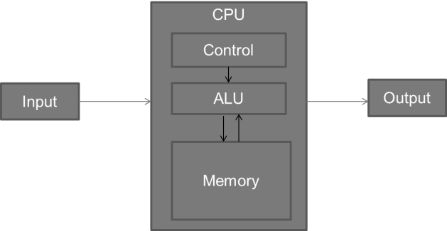

**(Modern CPU Architecture lecture, slide 7)**

2. What is “the free lunch” and why is it over?

**“The free lunch” is the process by which hardware manufacturers produce processors that improve the single-thread performance of programs, without any change to the programs. It is over because clock speeds are not increasing nearly has fast as they used to increase. (Modern CPU Architecture lecture, slide 10)**

3. Describe one benefit of distributed version control systems over client-server version control systems.

**Client-server version control systems do not scale (Distributed version control lecture, slide 4)**

4. What is the three-step process of Test Driven Design? Include the color associated with each step.

1. **Write test code to cause a failure (Red)**
2. **Write production code to cause the test to pass (Green)**
3. **Fix the production code with all tests passing (Refactor)**

**(TDD lecture, slide 4)**

5. What is Dennard Scaling?

* **All important factors in transistor design scale down by the same constant**
* **Transistor density increased**
* **Transistor switching delay decreased**
* **Transistor power usage decreased**

**(Dennard scaling lecture, slide 4)**

6. What is one reason Dennard Scaling is ending (we mentioned two reasons in class)?

* **Oxide thickness (Tox) can only get so small**
* **Leakage current is now a problem for power consumption**

**(Dennard scaling lecture, slide 7)**

7. What is the difference between a process and a thread?

**Threads share memory by default, processes do not. (Threads lecture, slide 3)**

8. What technique do we use to ensure that the join method will be called on a std::thread instance?

**RAII, with a guard class that owns the thread and calls the join method in its destructor. (Threads lecture, slides 23-28)**

9. What is the purpose of a mutex object?

**A mutex is a tool that allows a thread to have mutually exclusive access to shared data. (Mutexes lecture, slide 5)**

10. How can a deadlock occur?

**A deadlock can occur when a program has**

* + **Two different mutexes**
  + **Two threads**
  + **The two mutexes are locked in different orders**

**(Mutexes lecture, slide 8)**