**Question 1**

Do younger (those without as much seniority) tend to vote with their affiliated political party, or against (note, there is a personal preference in that those with less seniority are not lock step with party)?

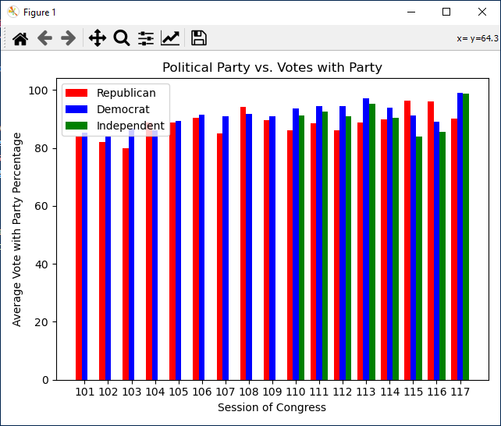 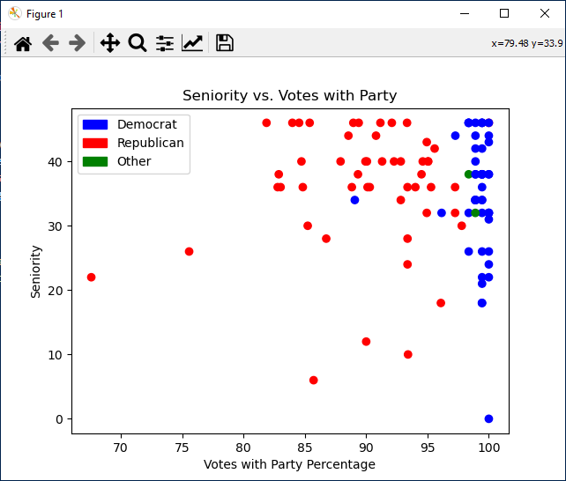

**Analysis**

First chart is pulled as a reference point to see the averages based by party over a period time of Session 101 (1989) to present. Note 2 things about them 1: both parties trend up, and 2: Republicans and Democrats flip as to who has the higher average.

Second Chart is of the 117 (current Senate) in which each senators seniority is quantified and is charted based on the calculated votes with party percentage (courtesy of ProPublica API).

Note: the Democratic grouping to the right indicating regardless of seniority, a much higher votes with party regardless of seniority. Note Democrats hold a majority in the Senate.

**Question 2:**

What does the data look like when Republicans control the senate (as in the 115th Session)

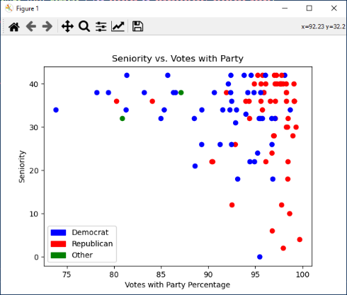**Analysis:**

In this example, we see now the Republicans skewing to the right and more in lock step (not as tight as the current session)

During this time frame, the Republicans controlled the House, Senate, and just obtained the presidency.

**Educated Statements:**

1. Age/seniority do not have much impact in way of “bucking the trend”
2. Voting with the party is more impacted by whether or not you are in the majority and by how close a margin that majority is along with which party has control of the Executive Branch.