Assignment 1 - Twitter from Temu

Let’s make a Twitter clone or parts of it, for non-political reasons.

# Features

The website should mainly consume an API and should support the following basic features.

* Post tweets
* Edit tweets
* Delete tweets
* List/show tweets
* Search for tweets
* Search for hashtags
* Make account
* List accounts
* Search for account

And other features you deem necessary for the site.

# Architecture

The system should be split up in three levels:

* User-interface level – Written in whatever you want, does not have to be pretty
* Processing level – With a REST API, using FastAPI or Flask, written Python
* Data level – Relational database of your choice, hosted where you want.

The web server should be its own service in Render. We will probably reuse this for assignment 2. The API and database can share a service. They will be updated in assignment 2. You can use different service provides if you want, like Railway, AWS/Azure/GCP.

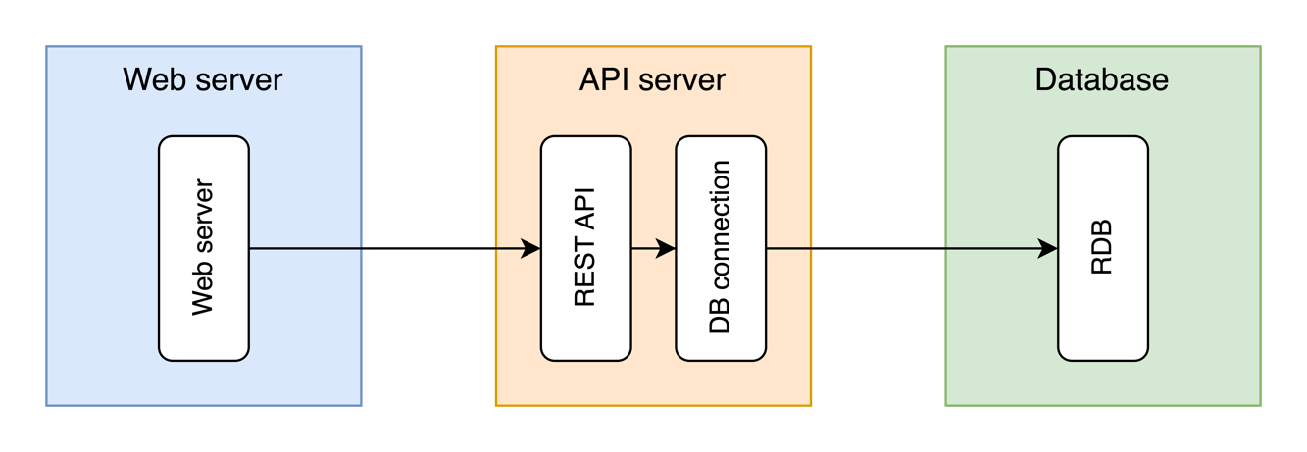

The main point of this assignment is the API server, so the exact SQL-ing, the website design quality and the correct use of JS frameworks are significantly less important. The API-DB-system should be usable by other services than the web server.

The plan is for assignment 2 to build on this system (mainly API-server). Consider this when making your system. The more extensible, the easier to continue later.

The system API should follow RESTful principles, and you should consider how to define it around the data sets we will get from a website like this.

# Report

The report should include basic documentation of your choices of technologies, the endpoints of your API, and the structure of your database, and anything else you deem useful for the reader. It can include illustrative diagrams, screenshots where necessary, code snippets, etc. It does not have to be long. A few pages. It should give the reader an introductory understanding to your system.

# Group

The group should be 2-3 students, though I will allow different group sizes if needed. The group should also be the same for assignment 1 and assignment 2, if at all possible.

# Deliverables

Deliver the following to Blackboard:

* Report (PDF-file)
* Repos (ZIP-files)