**INSTRUCTIONS**

**OS Tested:** Windows 10 64 bits

1. **Setup Arduino environment**

* Install Arduino IDE
* Upload Arduino script to Arduino board

1. **Using IR Sensor**
   1. **Circuit**

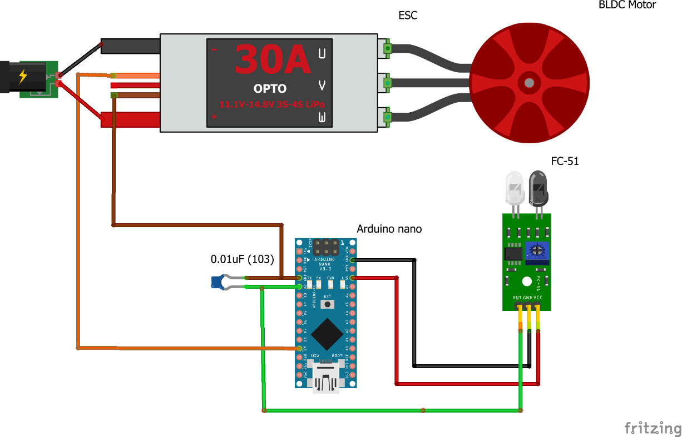

* 1. **Implementation**

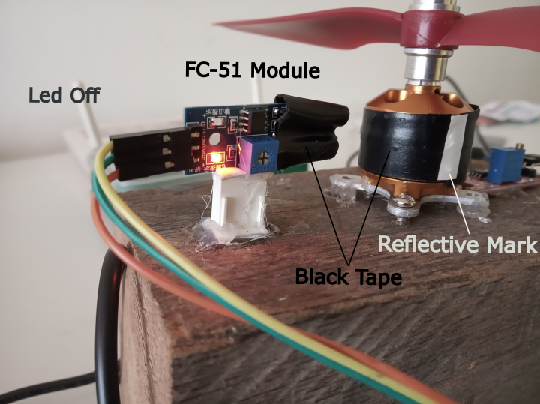 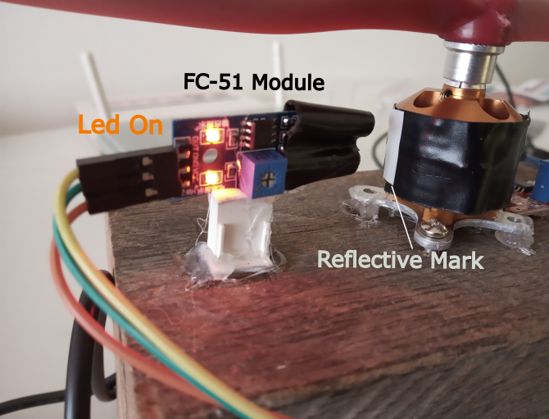

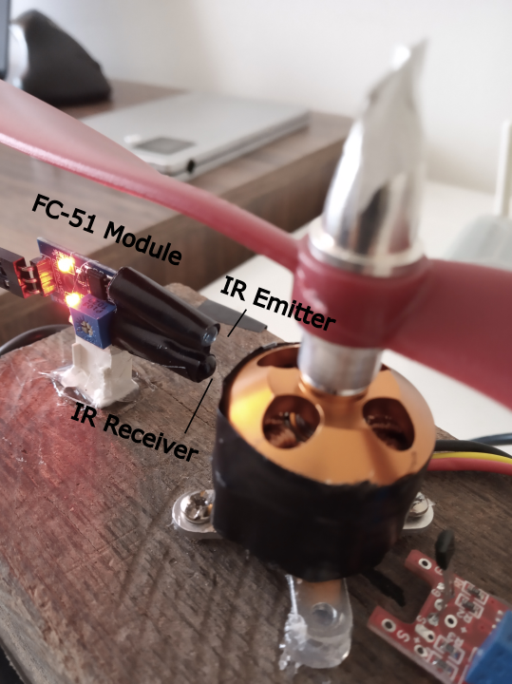

* 1. **Upload Arduino Sketch**
* Connect Arduino PC
* Open sketch *IR_Sensor_v2.ino* at path\BLDC_Speed_Control\IR_Sensor_v2
* Upload code to Arduino nano or Arduino Uno
  1. **Start motor**
* Disconnect ESC from energy source
* Connect Arduino PC
* Open Arduino IDE serial monitor
* Follow instructions showed in serial monitor

If you calibrated the motor and it does not be disconnected, you can choose normal operation.

Note: if the motor is disconnected from energy source or it shut down, it needs to be calibrated again.

1. **Using Hall Sensor**
   1. **Circuit with KY-024 Module**

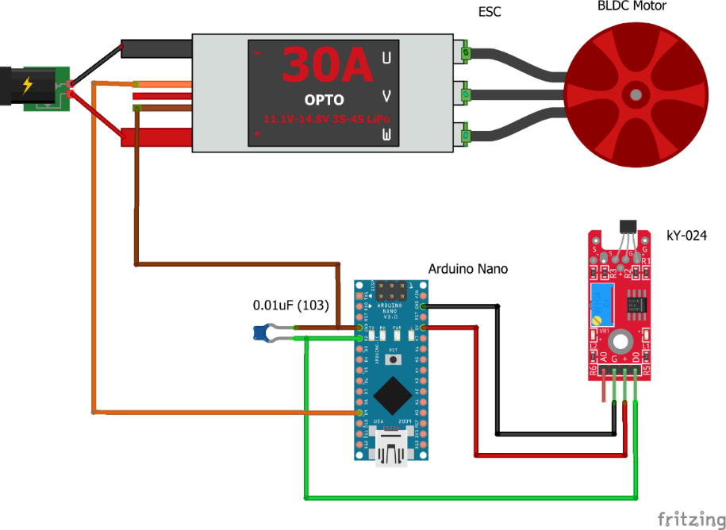

* 1. **Circuit with US1881 Hall sensor**

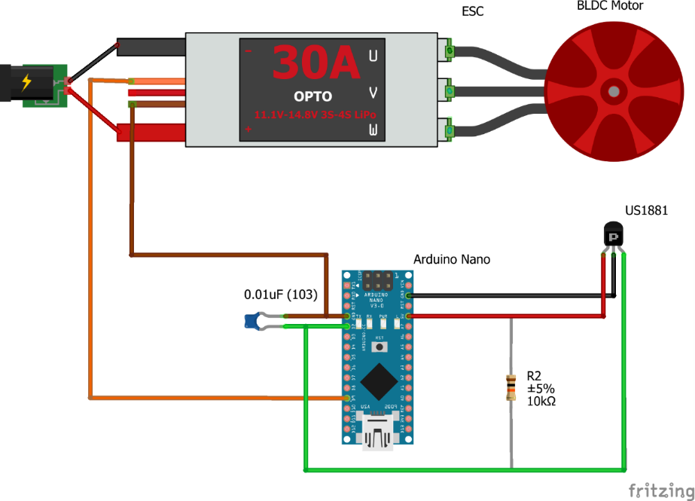

* 1. **Implementation**

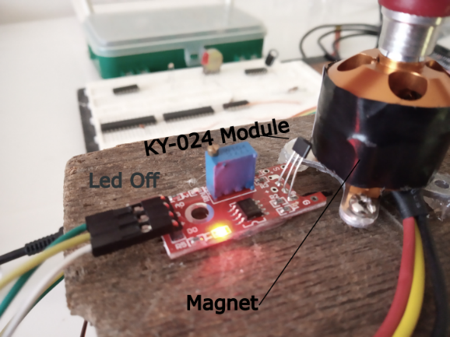 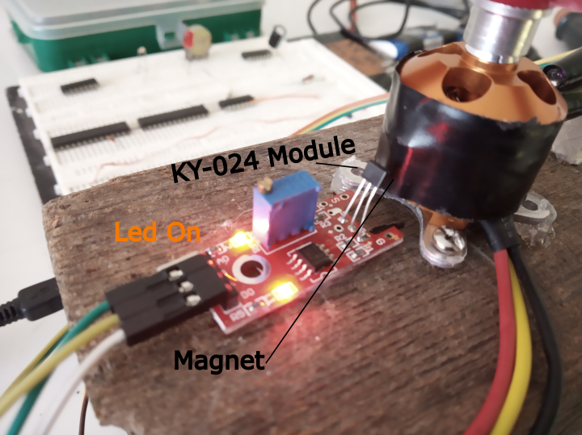

* 1. **Upload Arduino Sketch**
* Connect Arduino PC
* Open sketch *Hall_Sensor_v2.ino* at path\BLDC_Speed_Control\Hall_Sensor_v2
* Upload code to Arduino nano or Arduino Uno
  1. **Start motor**
* Disconnect ESC from energy source
* Connect Arduino PC
* Open Arduino IDE serial monitor
* Follow instructions showed in serial monitor

If you calibrated the motor and it does not be disconnected, you can choose normal operation.

Note: if the motor is disconnected from energy source or it shut down, it needs to be calibrated again.

1. **Change Setpoint**

Both *Hall_Sensor_v2.ino* and *IR_Sensor_v2.ino* have the line:



If you change the line a new target speed will be set.

1. **Change Serial signal of “Home position”**

Both *Hall_Sensor_v2.ino* and *IR_Sensor_v2.ino* have the line:



If you change the value, after that number of rotations a serial signal will print in serial monitor if the motor passes for sensor.