**INSTRUCTIONS**

**OS Tested:** Windows 10 64 bits

1. **Setup Arduino environment**

* Install Arduino IDE
* Upload Arduino script to Arduino board

1. **Using IR Sensor (“Home position” signal at D5)**
   1. **Circuit**

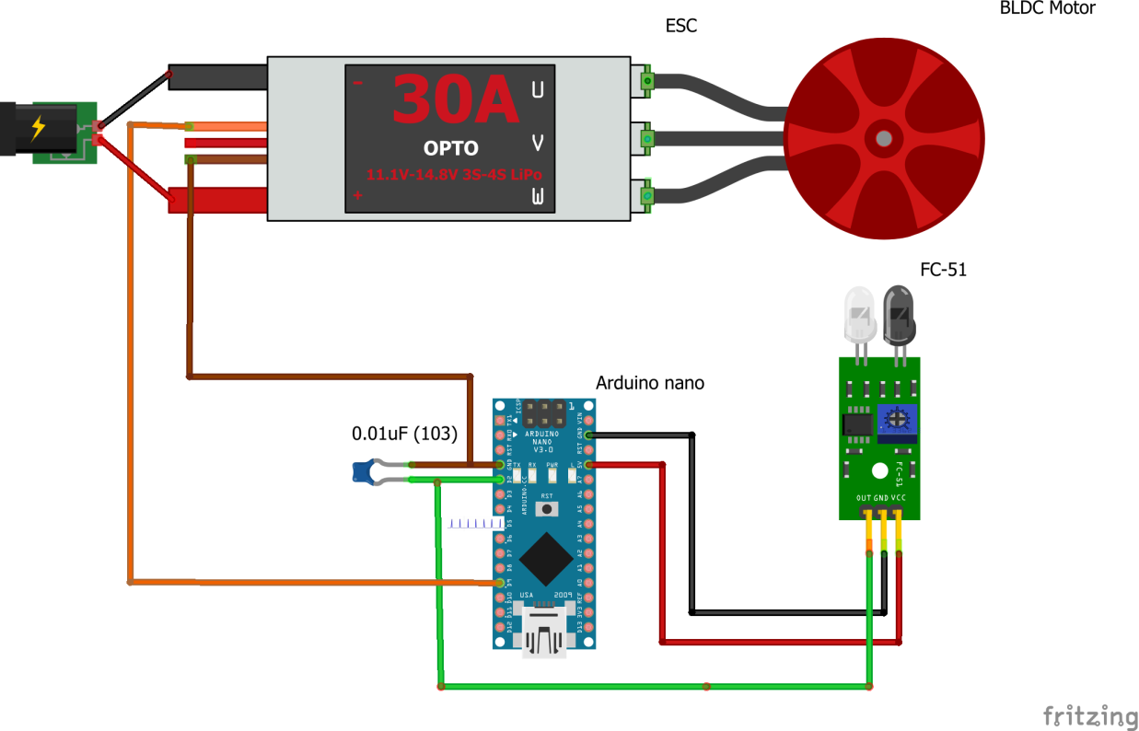

* 1. **Implementation**

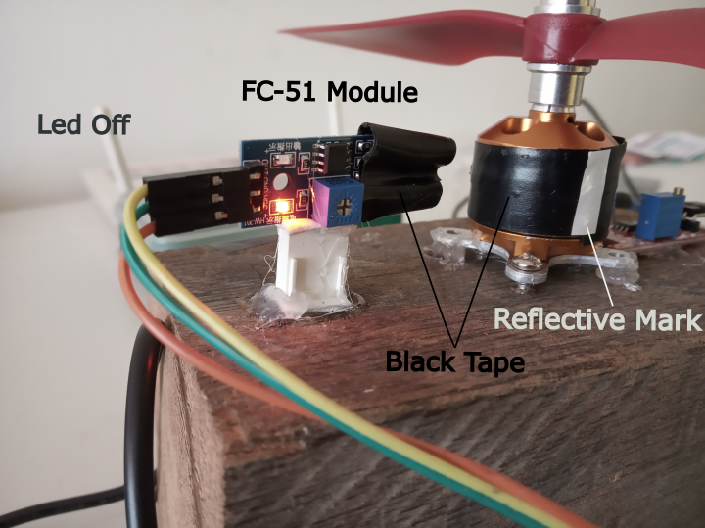 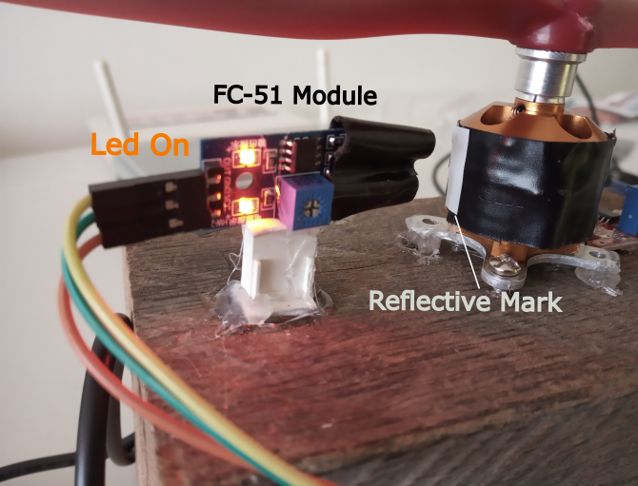

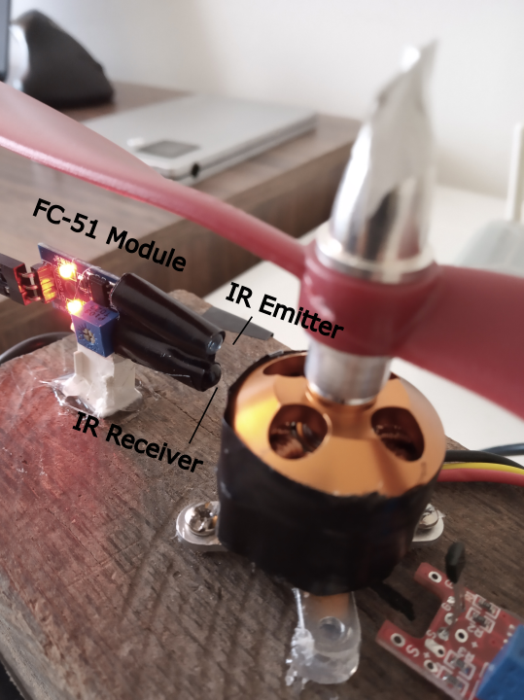

* 1. **Upload Arduino Sketch**
* Connect Arduino PC
* Open sketch *IR_Sensor_v3.ino* at path\BLDC_Speed_Control\IR_Sensor_v3
* Upload code to Arduino nano or Arduino Uno
  1. **Start motor**
* Disconnect ESC from energy source
* Connect Arduino PC
* Open Arduino IDE serial monitor
* Follow instructions showed in serial monitor
* Arduino will print “0” and “1”. “1” is printed when the motor is at home position and “0” when it is not.
* At D5 pin there is also an external signal for detect home position.

If you calibrated the motor and it does not be disconnected, you can choose normal operation.

Note: if the motor is disconnected from energy source or it shut down, it needs to be calibrated again.

1. **Using Hall Sensor**
   1. **Circuit with KY-024 Module (“Home position” signal at D5)**

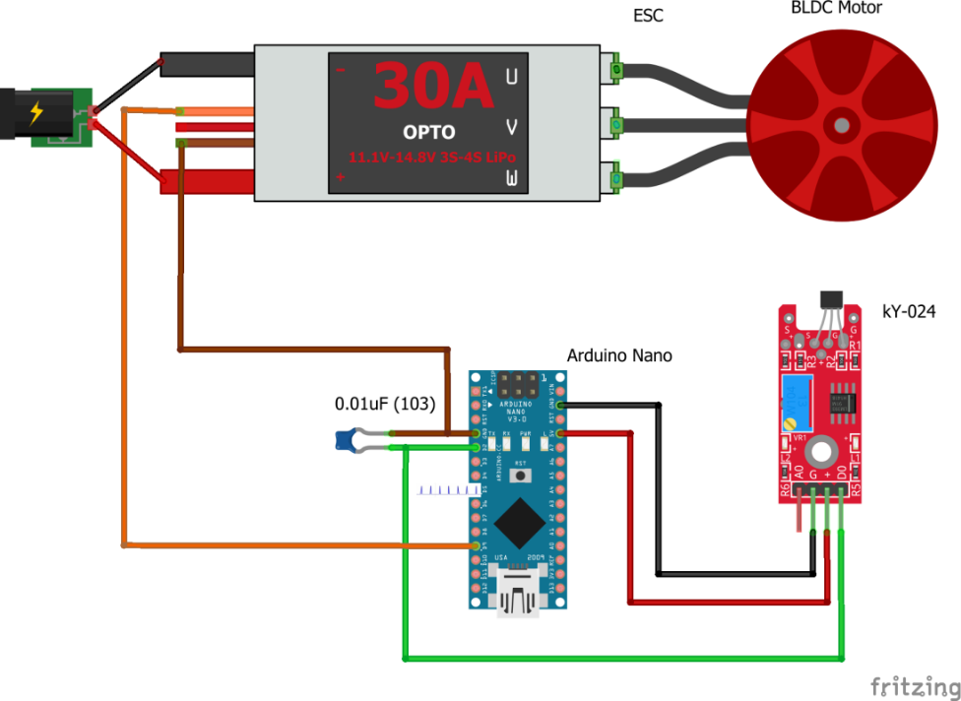

* 1. **Circuit with US1881 Hall sensor (“Home position” signal at D5)**

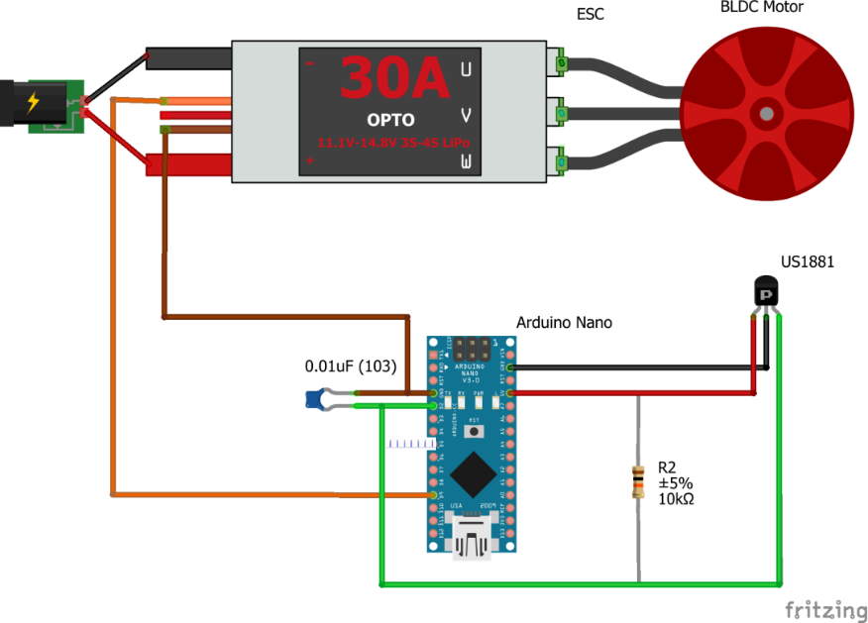

* 1. **Implementation**

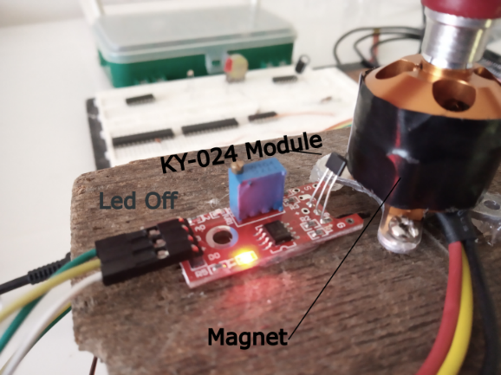 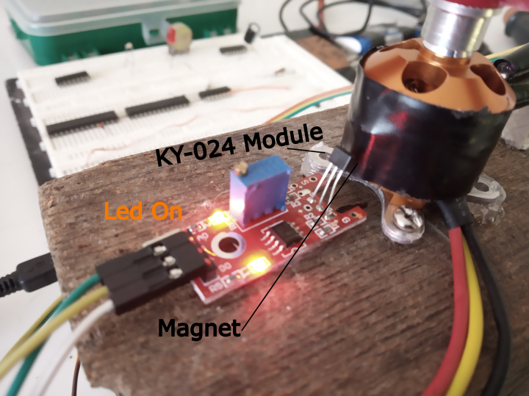

* 1. **Upload Arduino Sketch**
* Connect Arduino PC
* Open sketch *Hall_Sensor_v3.ino* at path\BLDC_Speed_Control\Hall_Sensor_v3
* Upload code to Arduino nano or Arduino Uno
  1. **Start motor**
* Disconnect ESC from energy source
* Connect Arduino PC
* Open Arduino IDE serial monitor
* Follow instructions showed in serial monitor
* Arduino will print “0” and “1”. “1” is printed when the motor is at home position and “0” when it is not.
* At D5 pin there is also an external signal for detect home position.

If you calibrated the motor and it does not be disconnected, you can choose normal operation.

Note: if the motor is disconnected from energy source or it shut down, it needs to be calibrated again.

1. **Change Setpoint**

Both *Hall_Sensor_v3.ino* and *IR_Sensor_v3.ino* have the line:



If you change the line a new target speed will be set.