**Interface A4988 Stepper Motor Driver Module**

1. **A4988 General Specifications**

|  |  |
| --- | --- |
| Minimum operating voltage | 8 V |
| Maximum operating voltage | 35 V |
| Continuous current per phase | 1 A |
| Maximum current per phase | 2 A |
| Minimum logic voltage | 3V |
| Maximum logic voltage | 5.5V |
| Microstep resolutions | Full, 1/2, 1/4, 1/8, 1/16 |

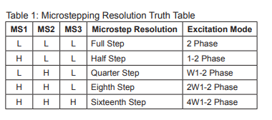

1. **Pinout**

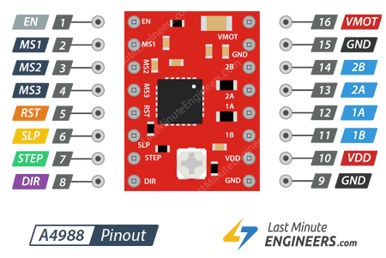

Note: It is important to put a 100Uf capacitor between motor power supply pins.

Note: It is important to use a heatsink or other cooling method for supply the necessary current amount needed by motor.

**VDD:** Internal logic circuitry (3V-5.5V)

**VMOT:** Motor power supply (8V-35V)

**MS1, MS2 &MS3:** Step resolution pins (By default LOW).

**STEP:** This input controls the microsteps of the motor. Each HIGH pulse forces a microstep. (The faster pulses generate faster rotation).

**DIR:** Controls de spinning direction of the motor. (HIGH=>clockwise; LOW=>counterclockwise)

**EN:** Enable pin, by default is enable. (HIGH=>disable; LOW=>enable).

**SLP:** Sleep pin, by default is High. (HIGH=>no sleep; LOW=>sleep mode).

**RST:** It is floating, it should connect to High. (HIGH=>active LOW=>reset).

**1B, 1A, 2A & 2B:** Driver’s output channels.

1. **Current limiting**

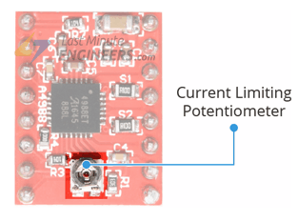

It is important, before using the motor, to limit the maximum amount of current flowing through the stepper coils and prevent it from exceeding the motor’s rated current. The next steps show to limit the current.

1. Look of the rated current of the motor in datasheet for example NEMA 8, 1.8 degree, 200 steps/rev, 10V, 600mA.
2. Disconnect all Step resolution pins. (full-step mode).
3. Hold the motor at a fixed position by not clocking the STEP input and connect it to logic power supply (5V)
4. Place the ammeter in series with one of the coils.
5. Using a screwdriver, adjust the current limit potentiometer until reach rated current of step 1.

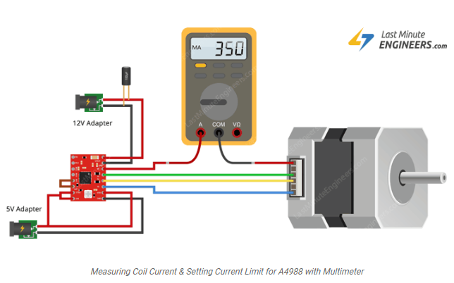

Note: Ever change in the logic voltage (VDD), needs to perform this adjustment.

1. **NodeMCU (ESP-12E) and A4988 Connection**

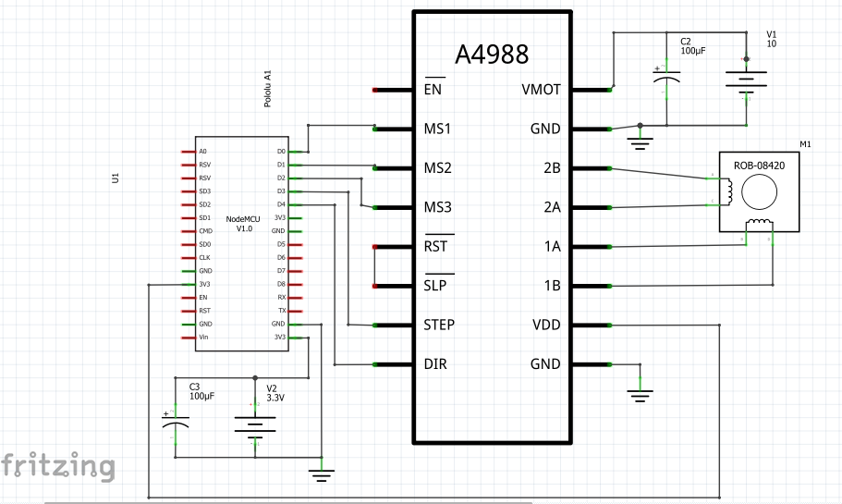

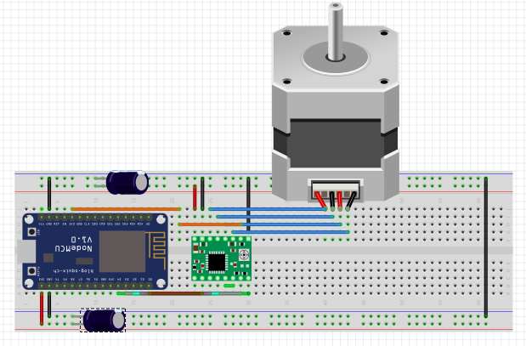

Source:

1. <https://lastminuteengineers.com/a4988-stepper-motor-driver-arduino-tutorial/>
2. <https://www.pololu.com/file/0J450/A4988.pdf>