Lab 2: Endpoint Screenshots
Mario Kart 8 API | Team G7 | INFO-I425
Each screenshot below shows one GET endpoint working: the request URL, the status code, and the JSON the API returned.
All 37 endpoints returned 200 OK. For endpoints that return a long list, the screenshot shows the first two items and notes how many were returned. The same requests are in the Postman collection (I425-G7_Lab2.postman_collection.json), with base_url set to http://127.0.0.1:8000.
Drivers
1. GET /drivers — Gets all drivers.
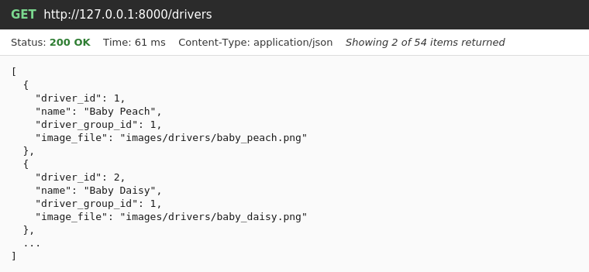
2. GET /drivers/{driver_id} — Gets one driver.
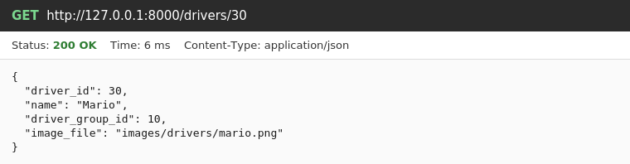
3. GET /drivers/{driver_id}/stats — Gets a driver's stats (its driver group).
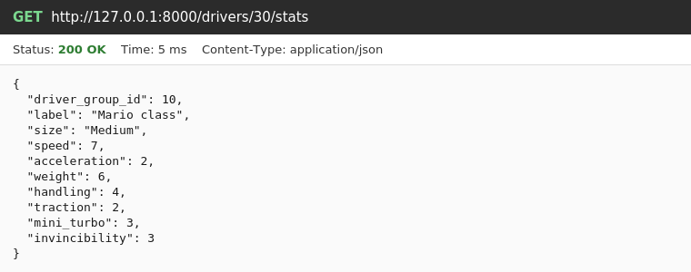
4. GET /drivers/{driver_id}/builds — Gets all builds that use a driver.
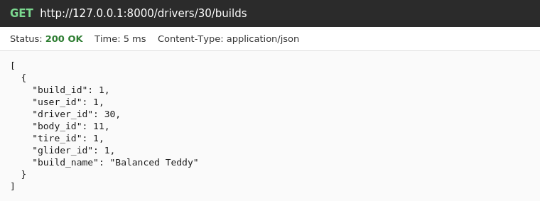
Driver Groups
5. GET /driver-groups — Gets all driver stat groups. Drivers in the same group have the same stats.
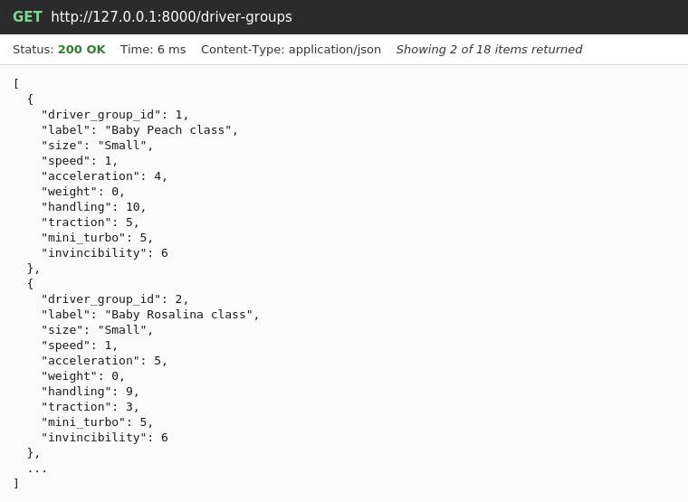
6. GET /driver-groups/{driver_group_id} — Gets one driver group and its stats.
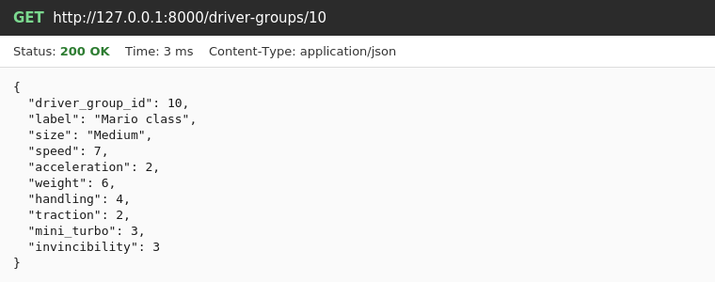
7. GET /driver-groups/{driver_group_id}/drivers — Gets all drivers in a driver group.
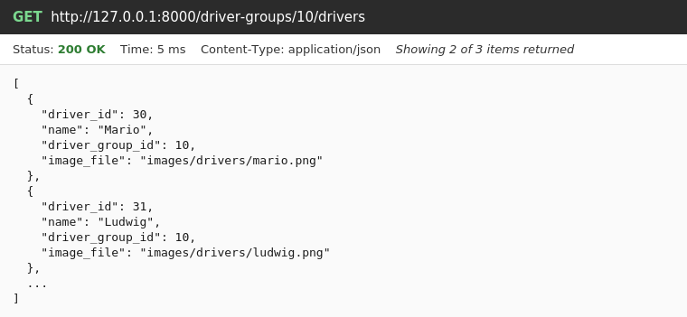
Bodies
8. GET /bodies — Gets all bodies.
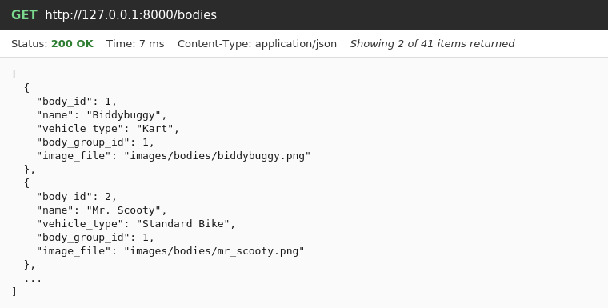
9. GET /bodies/{body_id} — Gets one body.
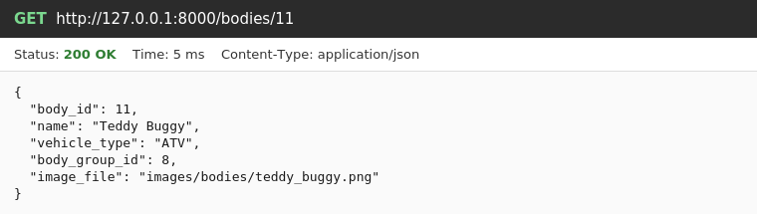
10. GET /bodies/{body_id}/stats — Gets a body's stats (its body group).
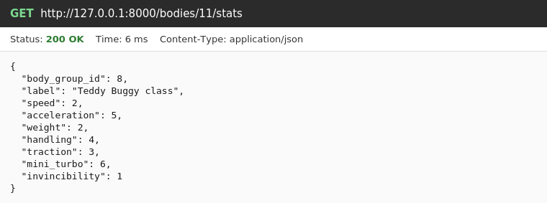
11. GET /bodies/{body_id}/builds — Gets all builds that use a body.
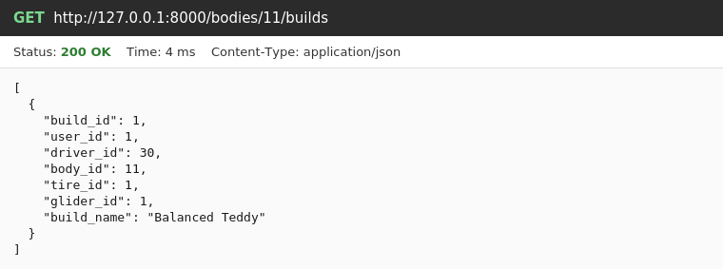
Body Groups
12. GET /body-groups — Gets all body stat groups. Bodies in the same group have the same stats.
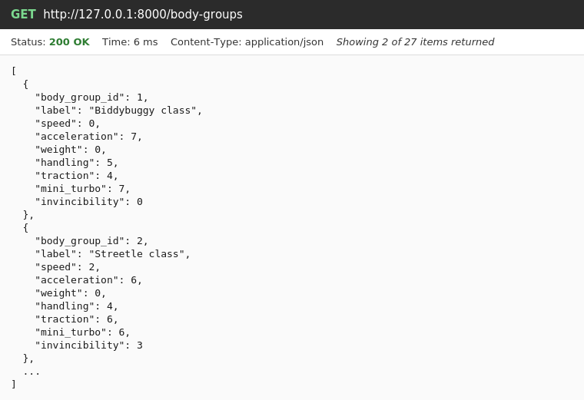
13. GET /body-groups/{body_group_id} — Gets one body group and its stats.
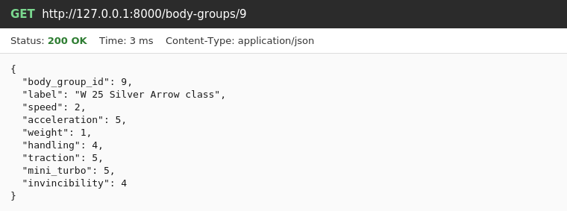
14. GET /body-groups/{body_group_id}/bodies — Gets all bodies in a body group.
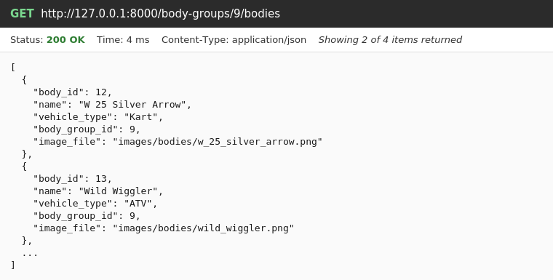
Tires
15. GET /tires — Gets all tires.
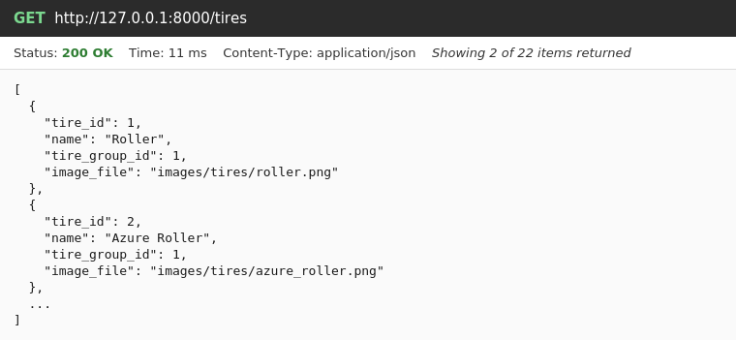
16. GET /tires/{tire_id} — Gets one tire.
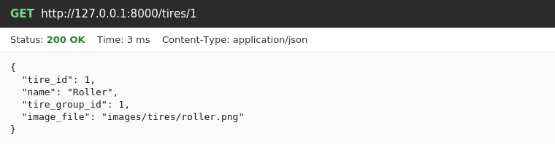
17. GET /tires/{tire_id}/stats — Gets a tire's stats (its tire group).
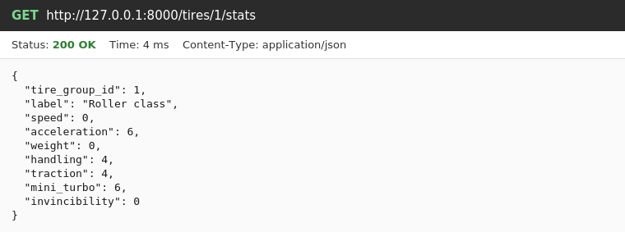
18. GET /tires/{tire_id}/builds — Gets all builds that use a tire.
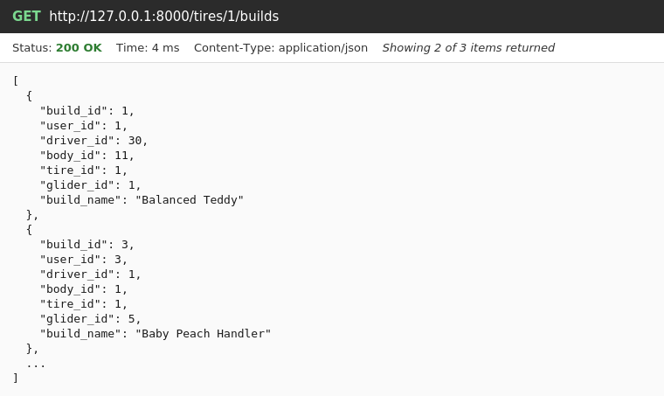
Tire Groups
19. GET /tire-groups — Gets all tire stat groups. Tires in the same group have the same stats.
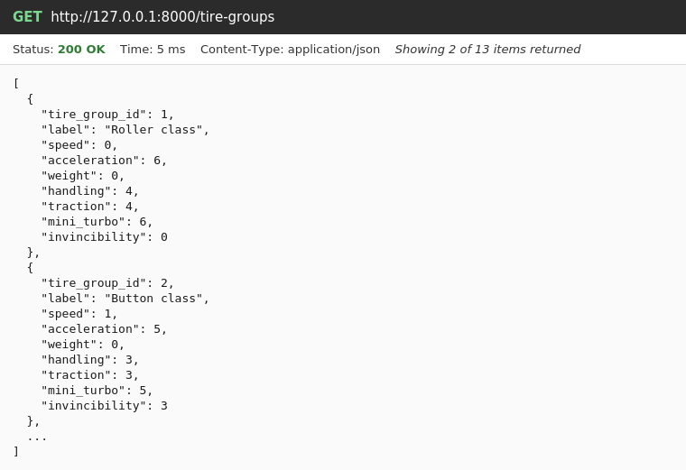
20. GET /tire-groups/{tire_group_id} — Gets one tire group and its stats.
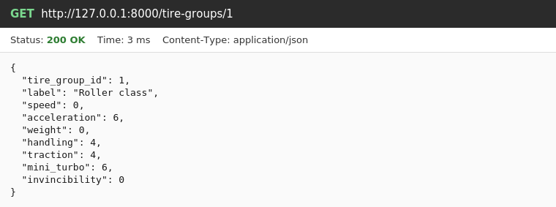
21. GET /tire-groups/{tire_group_id}/tires — Gets all tires in a tire group.
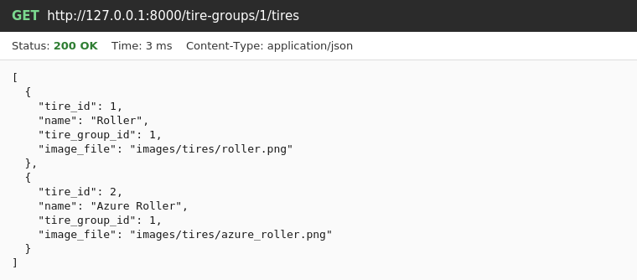
Gliders
22. GET /gliders — Gets all gliders and their stats.
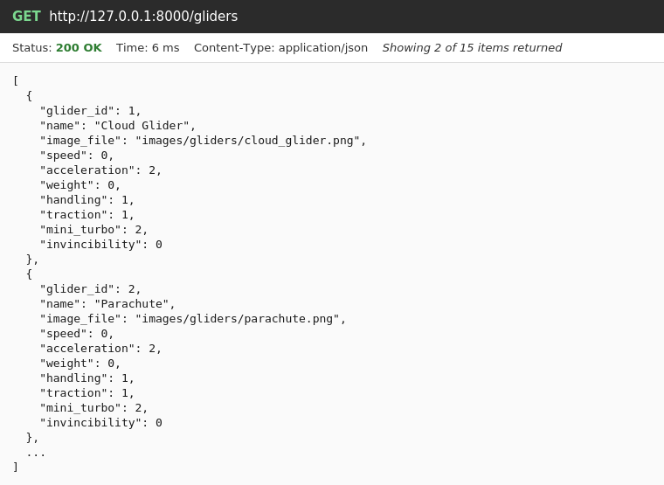
23. GET /gliders/{glider_id} — Gets one glider and its stats.
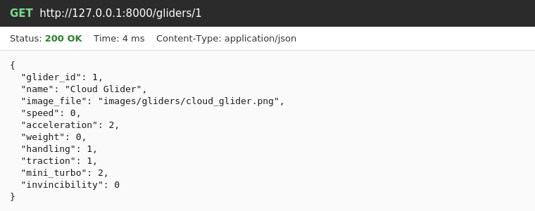
24. GET /gliders/{glider_id}/builds — Gets all builds that use a glider.
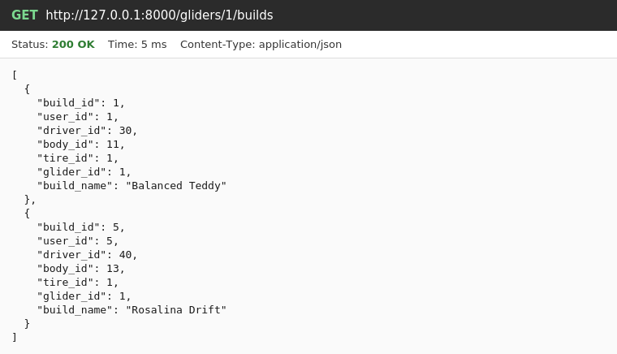
Users
25. GET /users — Gets all users.
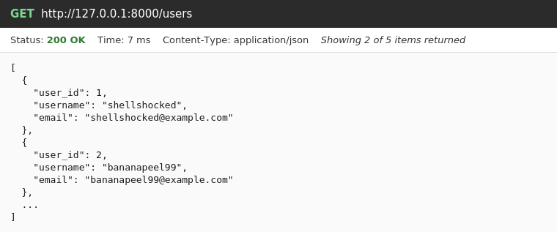
26. GET /users/{user_id} — Gets one user.
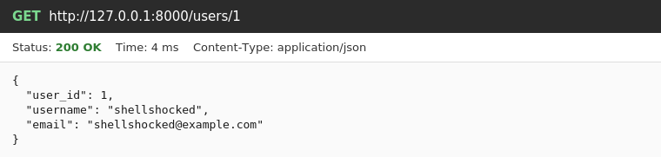
27. GET /users/{user_id}/builds — Gets all builds saved by a user.
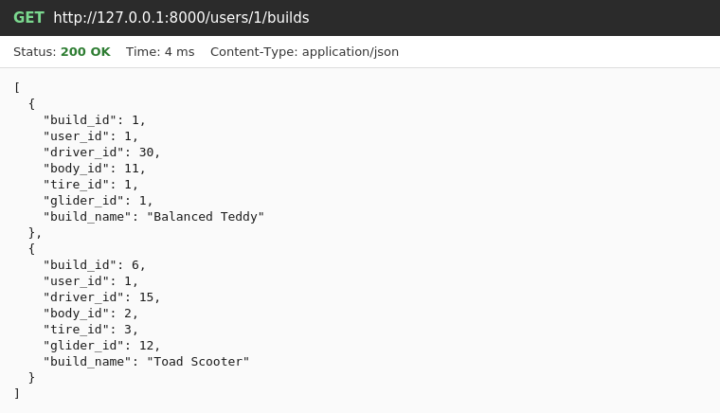
28. GET /users/{user_id}/builds/{build_id} — Gets one of a user's builds.
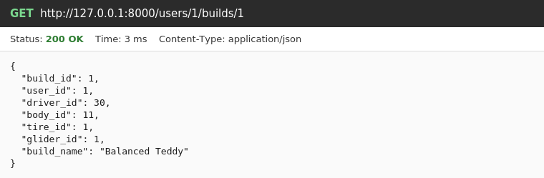
29. GET /users/{user_id}/ratings — Gets all ratings a user has given.
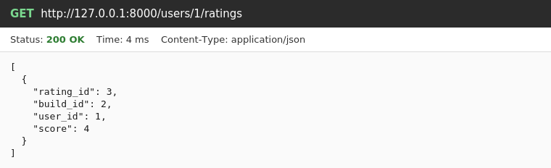
Builds
30. GET /builds — Gets all builds from all users.
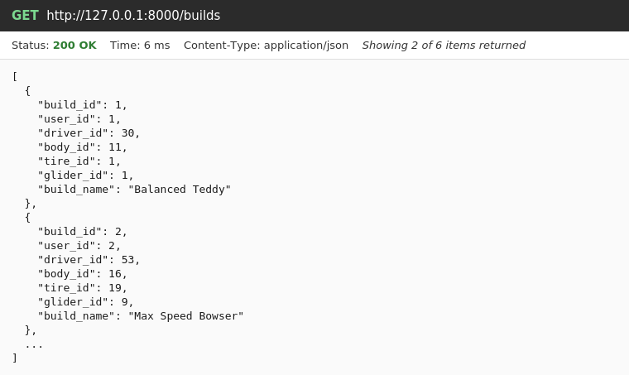
31. GET /builds/{build_id} — Gets one build.
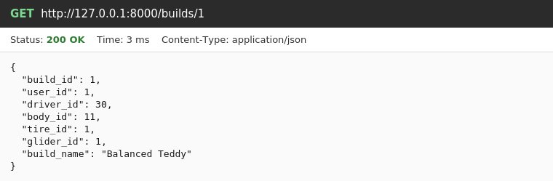
32. GET /builds/{build_id}/stats — Gets the combined stats of a saved build: the level and the in-game value for each stat.
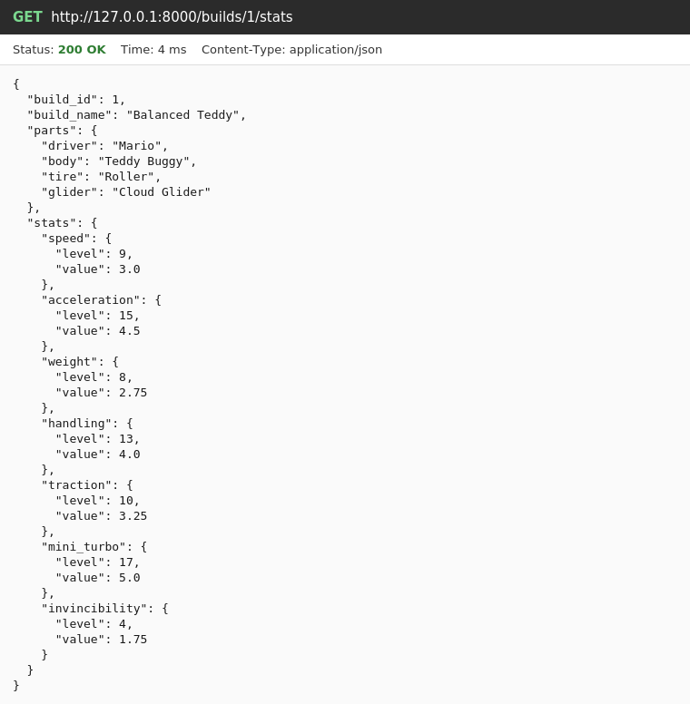
Ratings
33. GET /builds/{build_id}/ratings — Gets all ratings for a build.
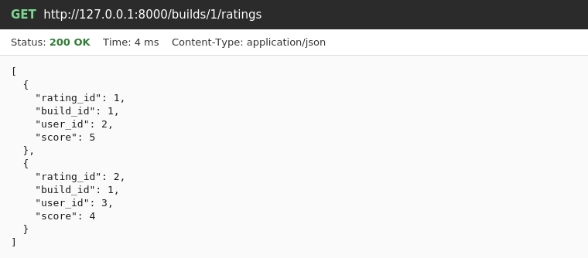
34. GET /builds/{build_id}/ratings/{rating_id} — Gets one rating for a build.
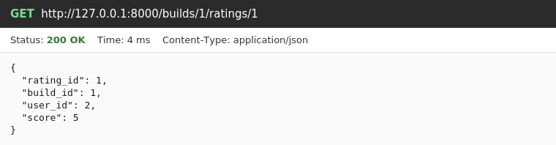
35. GET /ratings — Gets all ratings from all builds.
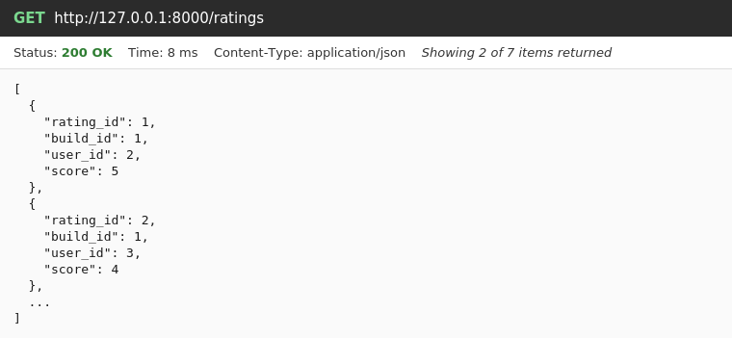
36. GET /ratings/{rating_id} — Gets one rating.
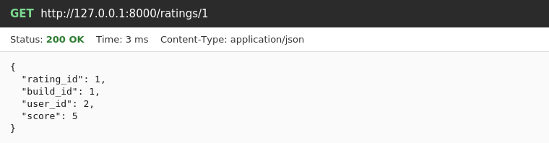
Combinations
37. GET /combinations — Calculates the stats for any combination of parts without saving it. Returns the level and the in-game value for each stat, including the hidden stats.
