Jon Reyes 109750965 jon.reyes@stonybrook.edu
Joon Lee joon.lee.1@stonybrook.edu
Billy Schweigert

CSE 305 – Project Assignment 1

Team/Dating Site Name
JewelBond - “Discover the Key to the Heart. Love’s Treasure Awaits”

ER Diagram
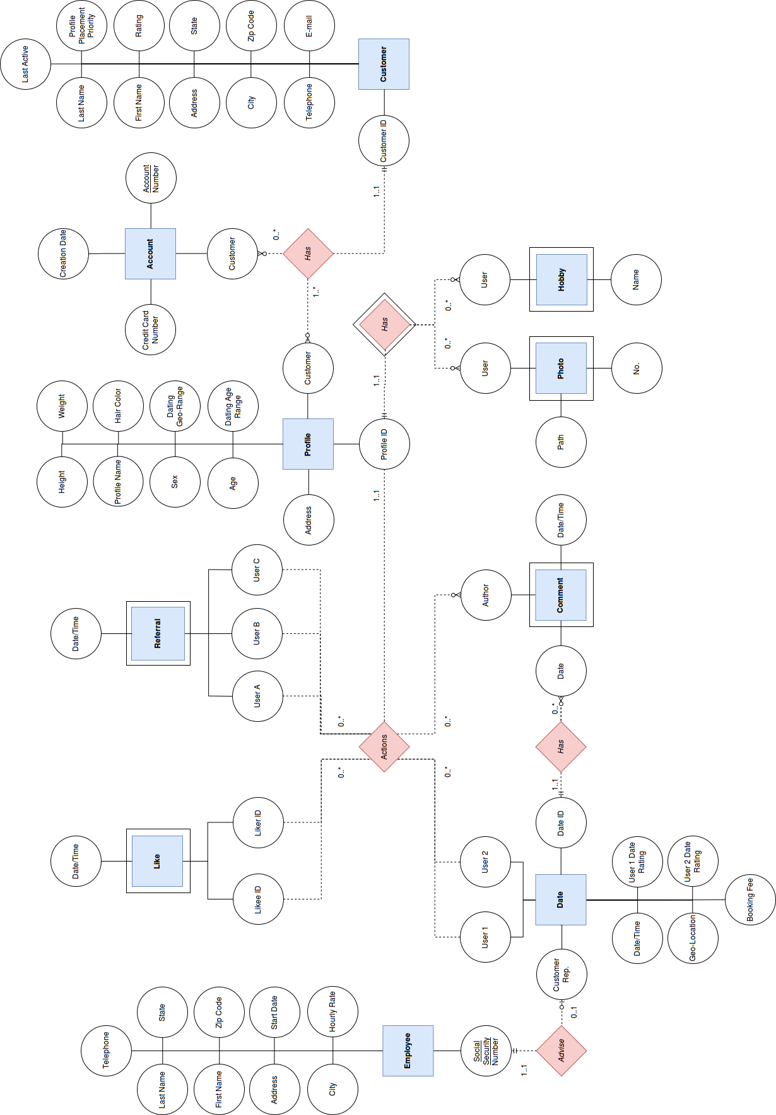

Relational Model
SQL Description

CREATE TABLE Customer(
CustomerId INTEGER,
LastName CHAR(25),
FirstName CHAR(25),
Address CHAR(50),
City CHAR(50),
State CHAR(2),
ZipCode CHAR(10),
Telephone CHAR(10),
Email CHAR(255),
ProfilePlacementPriority PPP,
Rating Rating,
LastActive DATETIME,
PRIMARY KEY(CustomerId)
)

CREATE TABLE Account(
AccountNumber INTEGER,
Customer INTEGER,
CreationDate DATE,
CreditCardNumber CHAR(16),
PRIMARY KEY(AccountNumber),
FOREIGN KEY(Customer) REFERENCES Customer(CustomerId)
)

CREATE TABLE Profile(
ProfileId CHAR(24),
ProfileName CHAR(24),
Customer INTEGER,
Age INTEGER,
Address CHAR(50),
Sex Sex,
Height DOUBLE,
Weight DOUBLE,
HairColor INTEGER,
DatingGeoRange INTEGER,
DatingAgeRangeBegin INTEGER,
DatingAgeRangeEnd INTEGER,
PRIMARY KEY(ProfileId),
FOREIGN KEY(Customer) REFERENCES Customer(CustomerId)
)

CREATE TABLE Photo(
PhotoNo INTEGER,
User CHAR(24),
Path CHAR(255),
PRIMARY KEY(PhotoId)
FOREIGN KEY(User) REFERENCES Profile(ProfileId)
)

CREATE TABLE Hobby(
User CHAR(24),
Name CHAR(20),
PRIMARY KEY(HobbyId)
FOREIGN KEY(User) REFERENCES Profile(ProfileId)
)

CREATE TABLE Like(
LikerId CHAR(24),
LikeeId CHAR(24),
DateTime DATETIME,
PRIMARY KEY(LikerId,LikeeId),
FOREIGN KEY(LikerId) REFERENCES Profile(ProfileId)
FOREIGN KEY(LikeeId) REFERENCES Profile(ProfileId)
)

CREATE TABLE Referral(
UserA CHAR(24),
UserB CHAR(24),
UserC CHAR(24),
DateTime DATETIME,
PRIMARY KEY(UserA,UserB,UserC),
FOREIGN KEY(UserA) REFERENCES Profile(ProfileId)
FOREIGN KEY(UserB) REFERENCES Profile(ProfileId)
FOREIGN KEY(UserC) REFERENCES Profile(ProfileId)
)

CREATE TABLE Date(
DateId INTEGER,
User1 CHAR(24),
User2 CHAR(24),
CustomerRep INTEGER,
DateTimeStart DATETIME,
DateTimeEnd DATETIME,
GeoLocation CHAR(),
BookingFee DOUBLE,
User1DateRating Rating,
User2DateRating Rating,
PRIMARY KEY(DateId),
FOREIGN KEY(User1) REFERENCES Profile(ProfileId),
FOREIGN KEY(User2) REFERENCES Profile(ProfileId),
FOREIGN KEY(CustomerRep) REFERENCES Employee(SSN)
)

CREATE TABLE Comment(
Author CHAR(24),
Date INTEGER,
DateTime DATETIME,
PRIMARY KEY(Author,Date,DateTime),
FOREIGN KEY(Date) REFERENCES Date(DateId)
)

CREATE TABLE Employee(
SSN INTEGER,
LastName CHAR(25),
FirstName CHAR(25),
Address CHAR(50),
City CHAR(50)
State CHAR(2),
ZipCode CHAR(10),
StartDate DATE,
HourlyRate DOUBLE,
PRIMARY KEY(SSN))

CREATE DOMAIN Sex CHAR(1)
CHECK( VALUE IN('M','F'))
CREATE DOMAIN PPP CHAR()
CHECK( VALUE IN('Super','Good','User'))
CREATE DOMAIN Rating CHAR(9)
CHECK( VALUE IN('Excellent','Very Good','Good','Fair','Poor'))

Rationale/Explanation

From the specification, obvious entities, corresponding attributes, and keys were simply produced accordingly.
For example, for the most part, categories of data are listed as entities and items of data are listed as attributes
This includes Customer, Profile, Referral, Like, Date, Employee.

Examining further, items of data that would become set valued attributes were converted to individual entities, since it is best for a column to only hold one value. This is with the exception of Physical Characteristics which was broken down into individual attributes of height, weight, and hair color within Profile, since these attributes have a 1 to 1 relationship.
New additional entities include Account, Photo, Hobby, and Comment.

All together the design has the following entities:
Customer
Profile
Referral
Like
Date
Employee
Account
Photo
Hobby
Comment

Next, entity relationships are examined.
Customers Have
Customers can have one or more Profiles.
Customers can have one or more Accounts.
Profiles and Accounts must be associated with a Customer.

Profiles Have
Profiles contain zero or more Photos.
Profiles contain zero or more Hobbies.
Photos and Hobbies must be associated with a Profile.

Profile Actions
Profiles can Like other Profiles.
Profiles can make a Referral for two other Profiles to Date;
Profiles can Date other Profiles.
Profiles can Comment on Dates.

Dates Have Comments

Employees Supervise Dates
Dates must be supervised by an Employee.
Employee may be vacant and does not always have to be supervising a Date.

Then, entity types.

Strong entities are independent of other entities and uniquely identified by a single attribute primary key.

Strong Entities Include:
Employee
Employees can exist w/o requiring the Supervision of a Date
Customer
Customers are uniquely identified by Customer Id independent of Profiles and Accounts

Weak entities are uniquely identified by a composite primary key that includes an attribute which is a foreign key reference to the primary key of a Strong entity which their existence is dependent upon.

Weak Entities Include:
Likes
Like(LikeeId,LikerId) depends upon Profile(ProfileId)
Referrals
Referral(UserA,UserB,UserC) depends upon Profile(ProfileId)
Comments
Comment(Author,Date,DateTime) depends upon Profile(ProfileId) and Date(DateId)
Photos
Photo(User,No) depends upon Profile(ProfileId)
Hobbies
Hobby(User,Name) depends upon Profile(ProfileId)

Not Sure:
Profiles - Strong?
Profile have Id but must be associated with Customer
Accounts - Weak?
Accounts have AccountNumber but cannot exist w/o Customer owner
Dates - Weak?
Dates have Id but cannot exist without participating Profiles

Finally, domains:

Sex
Must be Male or Female.

Profile Placement Priority
Categories include:
Super-User, Good-User, and User-User

Rating
Scale from:
Poor, Fair, Good, Very Good, Excellent

