Microsoft Corporation 2003 Annual Report

Your potential. Our passion.

Creating opportunities through innovation

At Microsoft, focusing on the needs of customers fuels our passion for
innovation. We believe innovative technology has the power to eliminate obstacles and create opportunities. Opportunities for people and businesses to realize their full potential. But there remains a great deal of work to make technology more affordable, easier to use, and less complex. Discovering new ways to help individuals be more productive and organizations more efficient is the inspiration for our investments in research and development. Delivering technology that enhances everyday life—at work and at play—is the core promise behind our comprehensive, integrated software platform. And since we know we can’t accomplish these goals alone, we’re building relationships with the world’s largest ecosystem of developers, channel partners, and hardware manu-facturers who share our vision. Everything we do begins with a focus
on customers. Every idea. Every solution. Every line of code.

Using technology to deliver strategic advantage

Large businesses have significant needs when it comes to information. Making information actionable is central to a company’s performance. The ability to collaborate and share ideas, to make better-informed decisions, and to connect with customers relies on effectively managing information. At the same time, reducing costs remains a long-term priority. For these reasons, the importance
of information technology as a strategic asset has never been greater. Microsoft® software is helping to create improvements in efficiency and productivity that companies need to stay competitive. We’re creating high-impact solutions that integrate across the organization, using technology to give our customers an essential business advantage.

Continuing to innovate the personal computing experience
Dynamic operating systems are vital to personal computing, especially as the needs of customers continue to evolve.
An increasingly mobile workforce is looking for better ways to stay connected. And users want to interact with computers more intuitively so they can manage information more easily. To meet these changing needs, the Windows® platform is delivering innovative personal computing experiences. Windows XP provides dramatic increases in reliability and ease of use, enabling people to do amazing things at home, at work, and everywhere in between. Our operating system for the Tablet PC offers all
the power of the desktop in an ultimately flexible and portable device. And Windows Mobile™ gives individuals the freedom to connect anytime and anywhere through a new generation of Pocket PCs and Smartphones. Together with the partners and
developers who help bring the Windows platform to life, Microsoft is creating powerful and familiar software that meets the
needs of customers now and in the future.


Helping businesses do more with less
With the flexibility to handle a diverse set of server roles depending on the needs of the customer, the recently launched Windows Server™ 2003 helps organizations do more with less. Microsoft Exchange Server remains the standard for enabling employees to communicate and collaborate easily and effectively. Microsoft SQL Server™ continues to be a benchmark for performance in enterprise data management while offering customers the lowest implementation and maintenance costs in
the industry. And Visual Studio® .NET offers a complete set of tools for developing enterprise solutions, letting businesses customize their unique business processes. At a time when companies are putting greater demands on smaller IT budgets, Windows Server System products provide customers with highly productive and cost-effective infrastructure that connects
the people, information, processes, and devices that move every organization forward.


Delivering software solutions for businesses of any size

Startups. Family-run companies. Independent manufacturers. From the dress shop on the corner to the custom motorcycle builder on another continent, small and mid-sized businesses are the engines of our local and global economies. And yet software innovations have historically been limited to organizations with larger IT budgets. To help businesses of any size succeed in today’s information-based economy, Microsoft offers a full range of affordable and easy-to-manage products and services that let owners devote more resources to growing their businesses. These products provide organizations with the solutions they need to thrive. Solutions that are life-sized for the big ideas of small and mid-sized businesses.

Building on the strength of our partner ecosystem
Small and mid-sized businesses are looking for more efficient business processes and more meaningful connections with customers to help them compete in the global marketplace. Together with a worldwide network of partners, Microsoft Business Solutions offers business management software specifically designed for small and mid-sized organizations. Microsoft Business Solutions delivers integrated solutions in the areas of enterprise resource management, customer relationship management, financial accounting, and reporting and analysis. These solutions, supported by a community of system integrators, accounting firms, independent software vendors, and other specialists at both the local and global level, provide the tools small and mid-sized businesses need to grow and succeed.


Transforming information into impact
Personal productivity is interrelated with business processes, team collaboration, and access to information. Microsoft Office 2003 optimizes the relationship between information workers and the systems that support them, delivering familiar and easy-to-use programs, servers, services, and solutions to connect people with the information and resources they need to drive business success. Enhanced support for XML enables users to connect customized information — such as sales reports — with automated business processes. New online workspaces can easily be created to share documents and conduct meetings over the Web. And OneNote™, a new note-taking program, combines the flexibility of handwriting with new ways to manage multiple forms of digital information. Through continued innovation, the world’s most popular productivity platform is helping improve the performance of individuals, teams, and organizations of any size.
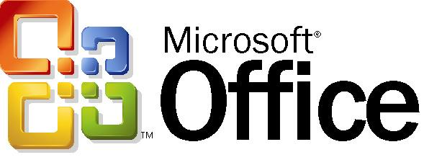

Powering the digital lifestyle

Playing games. Sharing photos. Listening to music. Searching the Internet.
Doing homework online. Communicating in real time with loved ones. From entertainment to interacting with the world around us, the home is center stage for the digital lifestyle. Now more than ever, people are looking for new ways to be more productive, stay connected, and have fun. To meet the needs of individuals and families alike, Microsoft offers integrated solutions for activities at the heart
of the 21st-century home. Through innovative hardware, software, and services, we’re addressing the key needs of consumers in the home—personal productivity, Internet connectivity, and digital entertainment.

Reinventing the gaming experience
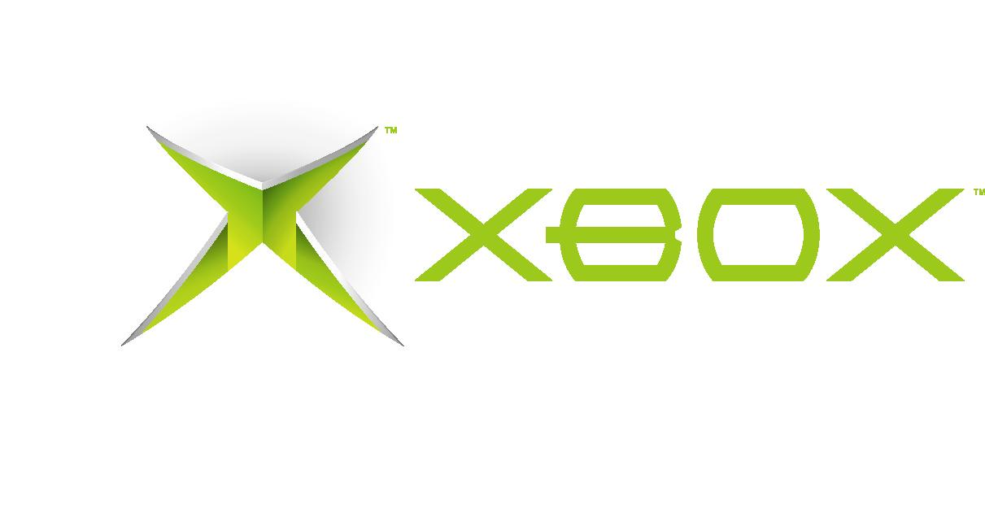
The definition of digital gaming is expanding. Exciting new software titles and services are coming together, allowing people to connect and play in ways previously unimagined. Xbox Live™, which already enables over 500,000 gamers to play online with friends anywhere in the world, offers new opportunities to compete and socialize. In addition to a vast array of popular titles and engaging gaming experiences, we’re also delivering new ways for users to enjoy music, DVD movies, and other media on Xbox®. Music Mixer increases the role music and digital photos play on the console, making it easy for players to integrate their favorite music with their favorite games, sing Karaoke, view slide shows, and more. These are some of the
ways we’re delivering the new entertainment experiences customers want from their game console.

Making the Web more useful
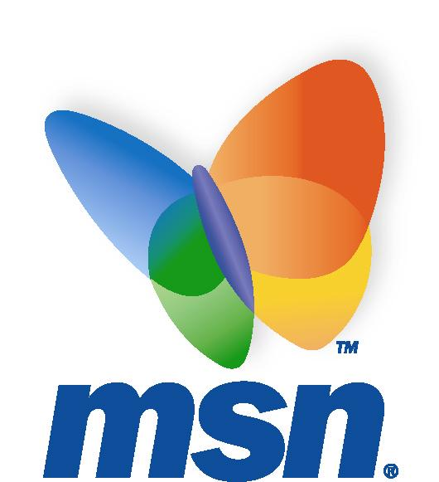
For consumers, the Web is an important means of connecting with friends and family, gathering and sharing information,
and getting things done. To help them get the most from the Web, MSN® delivers exciting new innovations to consumers by offering advanced communications tools, premium search capabilities, enhanced home productivity software, state-of-the-art parental controls, and new features that help protect against spam. By providing software and services that make it easier for consumers to enjoy the power of the Web, MSN is building a premier online experience.

Inspiring a new generation of thinkers

Our mission as a business and our mission as a corporate citizen are one
and the same: helping enable individuals and their communities to achieve
their full potential. As a company, our optimism and passion for innovation are balanced with our focus on creating real solutions for the tough challenges facing communities around the world. To help meet these challenges, last
year Microsoft contributed nearly $264 million in cash and software to nonprofit organizations striving to improve lives and strengthen communities. By providing innovative technology to help remove obstacles and create opportunities,
we affirm our belief in the ability of people to make the world a better place.

Using technology as a tool for change
Through computers and the Internet, modern technology is creating an era of unprecedented access to information. And yet there are individuals and communities that face a significant disadvantage because they do not have access to technology resources and training. With technical skills, supporting infrastructure, and the availability of more learning environments, an unlimited number of opportunities could be created for millions of people around the world. By providing technology resources and technology skills development through community-based learning centers, Microsoft’s Unlimited Potential program is designed to help create social and economic opportunities that can change people’s lives and transform communities.


Creating opportunities for 21st-century learners
Nowhere else is our mission to help individuals realize their potential more immediate and apparent than in education. Three key initiatives within the Partners in Learning program highlight Microsoft’s commitment to improving the learning experience.
A new program called Fresh Start for Donated PCs provides Windows operating systems for computers donated to schools without original licensing documentation. School Agreement Subscription offers software at significantly discounted prices to schools around the world. And Learning Grants provides cash investments to fund curriculum development and technology training for both students and teachers. While they address different needs, all of the initiatives within the Partners in Learning program recognize the importance of education in empowering learners to realize their true potential.

Shareholder Letter

Dear Shareholders, Customers, Partners, and Employees:
Fiscal 2003 was a year of important and exciting innovations, reflected in many new Microsoft products that advance our mission of enabling people and businesses throughout the world to realize their full potential.

Despite challenging economic conditions, revenue increased by $3.82 billion to $32.19 billion, and operating income grew by $1.31 billion to $13.22 billion. Revenue in each of Microsoft’s seven business segments grew by 11 percent or more.

During the year, the company’s senior leadership refined our strategy for achieving continued growth and success in the years ahead. To help you understand our approach to the possibilities before us, we would like to outline our business plan.

A challenging environment
Because Microsoft is making substantial investments today to enhance the power and value of an integrated computing platform, we are optimistic about the company’s long-term growth opportunities. Like any business, however, we face challenges in the near- and mid-term. We are addressing them head-on.

One of the most important challenges lies in serving business customers. Having recently invested in Y2K upgrades and the Internet, businesses want their future technology investments to do more and cost less. Many enterprises are migrating their server networks from proprietary hardware running the UNIX operating system to less expensive alternatives built on Intel microprocessors. Microsoft can benefit from this shift because we provide customers with comprehensive, end-to-end technology solutions and unmatched value. Last year, our server and tools revenue increased 16 percent.

Some organizations migrating from UNIX are considering noncommercial software such as Linux and OpenOffice. While the initial cost of acquiring a stripped-down, do-it-yourself operating system may seem attractive, a growing body of independent research shows that our integrated platform provides not only greater functionality but also lower total cost of ownership in most common business functions.

Today the Windows platform offers unmatched simplicity, security, choice of applications, and overall business value. Tomorrow the Windows advantage over the competition will continue to widen as we continue to invest in innovation.

Still, Linux and other noncommercial software present a challenge, and we are not complacent. We are working hard
to ensure that our products and services continue to improve and meet customer demands for value. We are committed to exceed our customers’ expectations for product reliability, security, and engineering excellence.

In order to take computing to the next level for customers, our business plan identifies six things we will do:

• Provide breakthrough, high-quality integrated innovation;
• Deliver best-in-class responsiveness to customers;
• Make our platform the best for developers;
• Deliver simple, high-value experiences and services;
• Ignite customer enthusiasm and tell the Microsoft story; and
• Build our talent pool and increase productivity.

Integrated innovation
We believe that customers will find enormous value in a truly integrated, affordable software platform that takes the complexity out of computing. We are positioning Microsoft to deliver on the promise of this vision. In FY04, the company plans to invest $6.8 billion in R&D innovation.

To continue to strengthen our value proposition, we are focused on the following objectives:

• Continue to advance the development of an end-to-end technology platform that seamlessly integrates hardware and software from the enterprise to the desktop to wireless mobile devices;
• Address security, manageability, and reliability;
• Provide high-value and easy-to-use technologies that support customer scenarios “right out of the box”—with little or no customization;
• Continue to support and grow a worldwide ecosystem of complementary hardware, software, and services partners;
• Achieve strong integration between our products and services, and applications on other systems, through standards
of interoperability and XML Web services; and
• Ensure that we protect and derive value from the intellectual property we create.

A great example of the kind of value we see in integrated innovation is Windows XP Tablet PC Edition. Released last fall, it combines all the power of Windows XP with true mobility and advanced ink and speech tools for a more dynamic and flexible computing experience. Today, there are 40 computer makers that offer versions of the Tablet PC, and independent software vendors have created exciting applications for it.

Another great example is Windows Server 2003, the flagship of our integrated platform for business, which helps organizations be more agile, productive, and secure. It incorporates important new security and reliability features, and advances in management, applications platform and information worker support, not to mention a #1 ranking in scalability.

Exchange Server 2003, released June 30, offers new levels of integration in server and client capabilities, enabling organizations to easily create and manage business communications both in the office and on the road. Microsoft Office 2003, to be released this fall along with new applications in the Office System, will fundamentally change how people communicate, collaborate, and manage their information.

As we look to the future, Longhorn, the next generation of Windows, is our big investment in driving a new wave in computing, including a new applications platform, new end-user functionality and services, and major advances in deployment, upgrading, management, reliability, security, and performance.

We are excited about opportunities to innovate for customers with a consistent approach in other areas—in new products, services, and solutions, and in innovations to Windows and Office. An example is our new Microsoft Business Solutions CRM, which provides mid-sized businesses with powerful tools to build profitable customer relationships, improve sales, and deliver efficient service.

We see opportunities to transform how people use technology at home and on the move, with software for telephones, all the electronic devices in the living room, and personal wear, as well as games and educational software for consumers. Last year we launched many important new consumer products, including Windows Powered Smart Displays, Windows XP Media Center Edition, Windows Powered Smartphones, MSN 8, and Xbox Live.

Responsiveness to customers
Providing value to customers means not only building great products, but also listening carefully to customers, responding quickly, and being more transparent and accountable.

We responded to business customers’ concerns about our licensing programs with a new Software Assurance program, recently enhanced, that provides more assistance, more support and training options, more predictability, and more value
than ever before.

We listened to customers’ concerns about product quality, and responded with a companywide drive for Trustworthy Computing, aimed at constant improvement in reliability, security, privacy, and business integrity. We have made significant progress, and this important work will continue long into the future.

We have intensified our focus on engineering excellence to help ensure that our products are not only more trustworthy but also more compatible, scalable, and manageable. We continue to enhance the capabilities of our products to automatically detect problems, perform diagnostics, apply known solutions, and prevent future problems. We have made progress in improving our product support operations, and we will help customers solve problems with more consistent documentation and richer Web services.

In short, we are committed to doing whatever it takes to ensure that our customers are highly satisfied with our products and services. Underscoring our commitment, we recently revised the incentive system for hundreds of our senior leaders so a significant part of their equity compensation depends on progress in the number and satisfaction of our customers.

Supporting developers
The popularity of Windows derives in large part from its support for the broadest array of applications. Microsoft has a long history of providing programmers with state-of-the-art tools and services that make it easy and rewarding to develop for our platform.

Our new Visual Studio .NET 2003 is the most advanced and complete set of software development tools, enabling developers to greatly improve their productivity with a single programming model for PC, mobile, and Web applications. It is the definitive tool set for building Web services with the .NET Framework.

We also are expanding efforts to build deeper relationships with developers. For example, we are pairing our developers
with industry peers to help us better understand their needs and help them with their issues. And we are making Windows development more accessible to a wide range of programmers, including students, novices, hobbyists, and other nonprofessionals.

We are creating new opportunities for developers and independent software vendors (ISVs) by expanding the platform for their applications beyond Windows. We will help ISVs develop add-ons and applications for Office and other products, such as those from Microsoft Business Solutions.

We are proactively communicating with ISVs about our own application development plans so that they can choose their best opportunities, and we are extending our co-marketing and selling with ISVs. Helping ISVs find customers and vice versa can be a real advantage for us, our partners, and our customers.

Simplicity, value, understanding
One of our primary objectives in innovating the integrated platform is to provide simpler, more compelling, complete, and targeted customer experiences. We are adding more capabilities to existing products, and segmenting our product offerings to deliver the simplest, most valuable package of our technologies, at the right price, for specific customer sets such as small businesses, students, home users, and information workers at home.

The right mix of our technologies, offered as services in the right set of segmented offers, will dramatically enhance the value delivered to customers.

Many customers and partners have said they would appreciate our innovations more if they knew Microsoft and its people better. We are encouraging our developers to participate more in the communities around their products, and we are communicating more broadly about our work in important areas such as security, privacy, and rights management.

Executives, too, are spending even more time listening to customers— not just to technology managers, but to IT users, developers, and even schoolkids.

We also have increased our advertising budget, communicating in ways that illuminate the amazing work we and our partners do, and explaining our mission to help people realize their potential.

Excellence in people and processes
As a company whose primary assets are intellectual property, we are constantly focused on attracting and retaining the people who create it, the top talent in our industry. We had great success last year as we expanded our recruitment and career-development efforts in core areas such as product development, marketing, finance, sales, and operations.

Because Microsoft’s success depends entirely on the great ideas of our employees, we are committed to continuing to provide a diverse workplace where people feel at home, have an opportunity to develop their skills, and find new and interesting opportunities.

In July, we took steps to enhance employee compensation. We are no longer issuing employee stock options, but instead granting stock awards that vest over several years. This will offer employees more stable equity compensation, and will better align employee and shareholder interests.

While we continue to invest for the future, we also continue to search for ways to reduce overhead and become more efficient. We recently named chief financial officers for each of our seven business segments to help further improve our financial management.

The path forward
We believe our business plan puts us on a sure path to achieve our goals. All our actions are aimed at putting the customer first. Doing so, we believe, is critical to our continued success.

Making technology easier and better for customers was our inspiration 20 years ago, when Microsoft announced its graphical user interface for personal computers. We called it Windows, and it helped revolutionize computing. Today, we are developing a range of integrated products that will again transform how people work, learn, communicate, and are entertained. We are totally focused on our mission of enabling people and businesses throughout the world to realize their full potential. We deeply appreciate your support for our efforts.

Bill Gates
Chairman and Chief Software Architect

Steven A. Ballmer
Chief Executive Officer

Connecting with our investors

At Microsoft, we consider our investors to be important customers. We’re focused on making the Microsoft Investor Relations Web site the best place to access
and analyze the company’s financial information by providing executive speeches
and presentations, historical financial data back to 1985, corporate governance information, and much more. We’re also committed to finding new ways to make
it easier to get the information you need, which is why Microsoft is the first technology company to publish its financial statements on the Internet using Extensible Business Reporting Language (XBRL), an XML-based framework
for financial reporting. XBRL represents a major step forward in providing
easier and more efficient access to the company’s financial data. Go to www.microsoft.com/msft/xbrlinfo.mspx to learn more about XBRL.

www.microsoft.com/msft

