# Documentation

## Brief

The Alexa Skill needs to be built to interact with laptops and change screen resolution from 50,100,150 through Alexa. Needed done ASAP. The web service is Aws Lambda.  
  
This job was posted from a mobile device, so please pardon any typos or any missing details.

## Implementation

Services utilised:

* AWS Lambda to host the function.
* AWS IoT – MQTT server so Alexa and the client PC can communicate.
* Node js script on the client side.

## Client PC

To be ran on a Windows PC / Laptop. A simple node.js script has been written, this is subscribed to a MQTT topic and is listening for messages on the topic.

When a message is received from Alexa, we receive a JSON result with the height and width of the new requested resolution. With the height and width we use this to execute the ChangeResolution.exe program with the height and width parameters.

http://tools.taubenkorb.at/change-screen-resolution/

In order for the resolution to change successfully you must change the width / height to a valid resolution supported by the graphics card. You can view available resolutions by looking at the display settings on your PC.

The app is a node js application so you must ensure node js is installed on your device.

To run, simply run **node client.js** – When connected successfully you’ll see a message in the terminal saying **Connected successfully - listening.**

## Alexa Skill

**Invocation name for the skill**: my p.c.

### Intents:

**ChangeScreenResolutionIntent**: This is called when the user says:

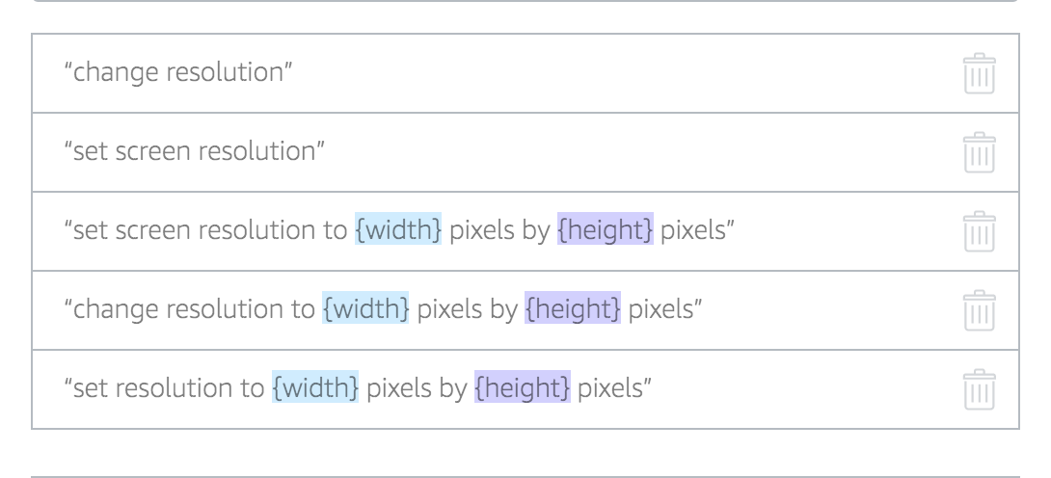

**ResetScreenResolutionIntent**:

This is called when the user says:

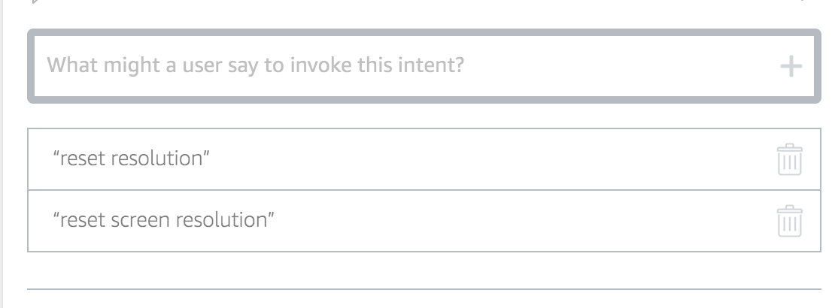

**Alexa App Config:**

// Configuration

const APP_ID = null;

const HELP_MESSAGE = 'To change the screen resolution you can say, change screen resolution.';

const HELP_REPROMPT = 'Try saying change screen resolution to 800 by 700.';

const STOP_MESSAGE = 'Goodbye!';

const UNHANDLED_MESSAGE = 'Oooooops, I don\'t understand that one.'

const AWS_SECRET_ACCESS_KEY = 'REMOVED';

const AWS_ACCESS_KEY_ID = 'REMOVED';

const AWS_IOT_ENDPOINT = 'REMOVED';

const AWS_IOT_REGION = 'REMOVED';

These are the variables in the application which can be changed in lambda.js.