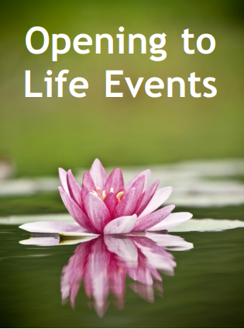
Gainesville Vipassana Society
I

nsight (Vipassana) meditation is the art of noninterfering observation. It reveals that Awareness is not an object of experience, but rather an untraceable essence that is appearing in and through each and every experience that is occurring. Through guided meditation instructions, dharma talks, inquiry and small group meetings, these residentials support “opening to life as it truly is.”
The resulting unfettered simplicity is reminiscent of childlike wonder, yet now it is somehow more fully capable of recognizing itself through all that is happening. Together in this, the nature of openness, the beauty of love and the unfolding mystery of existence all come forth as gifts to be realized and lived.
December 3-8, 2021 Franciscan Center, Tampa FL

Check-in at 10:00am Friday, ending just after lunch the following Wednesday.
Complete directions will be sent with confirmation of registration.

Registration and cost: $675 for a shared room or $725 for a private room. Please register with a check or money order made out to GVS, Inc and send to 51 Kenilworth Rd, Asheville, NC 28803. Please indicate the residential(s) for which you are registering. The cost includes lodging and meals for the duration of the retreat. All rooms have private bathrooms and include linens, blankets and towels. Donations for the teachings may be given at the end of the residential. Confirmation and directions will be sent via email. Full refund if cancelling three weeks in advance, no refund if less than a week.

Facilitators:

Paul Linn is co-founder of GVS and has been involved with insight meditation and dharma teachings for 40 years. A psychotherapist and teacher, he offers seminars and residentials throughout the US mainland and Hawaiian Islands. His teaching style facilitates the immediacy of Awakening as ordinary, direct and inherent. Realization emerges as notions of path, practice and acquisition dissolve into clearly seeing that nothing is missing and nothing need be removed from ongoing completeness.

Steve Bean is a co-founder of GVS, and he has been co-facilitating residentials at GVS for the past 20 years. In addition to his years of meditation experience he brings the integration of meditative movement from various traditions including yoga, tai chi, and qi gong.
To sign up for GVS email go to www.floridavipassana.org

