Team Swaggerz
Combat Refactoring Project

Group 3
Thomas Moore
Jonathon Shippling
Andrew Filipski
Akshay Karnawat

Submission Date – May 17, 2012

Introduction
Combat is a multi-directional shooter game that has the basis of tanks controlled by players moving around the playing field. The objective of this game is to shoot the other player and the player with a higher score wins. The Software engineering undergraduate class for May 2000 class of Concurrent SW System implemented the combat game to demonstrate their understanding of concurrent principles. Although they did not have enough time to implement all of their idea, they were still able to come up with a working game. Some features that they never got time to implement were: A GUI for level creator and save user created levels, dynamically loading the saved levels, and finally allowing the users to change the keyboard keys.
Our job as Software Engineers for SE-362 (Engineering of Software Sub-systems) is to refactor their implementation and their design to implement new feature(s) such as the GUI for the level creation, dynamically loading the saved levels, and also allowing the users to change the key bindings for controlling the tanks. As a team, we decided to implement the keyboard feature allowing users/player to select the keyboard inputs they want to use during game play. This document covers our implementation of the feature as well as our refactored design showcasing features that were not originally implemented.

Combat Refactored Design

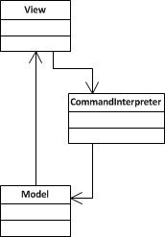
Figure 1 - High Level Architecture(MVC)

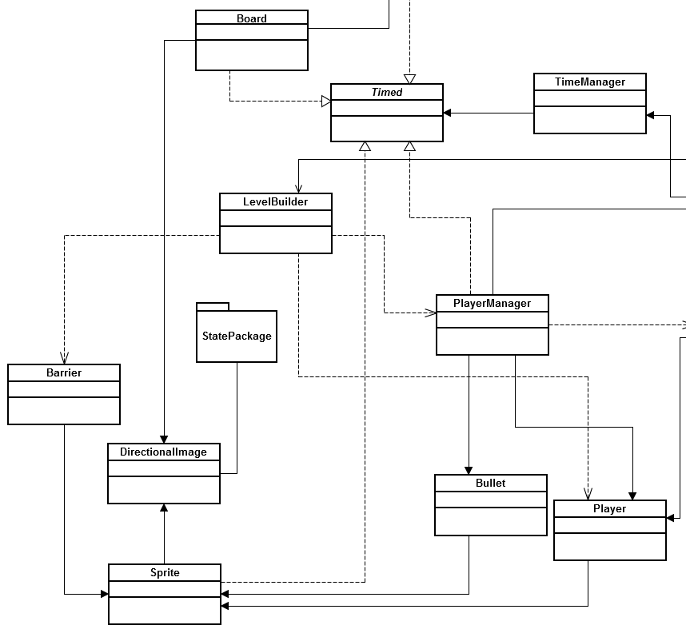
Figure 1a - Model

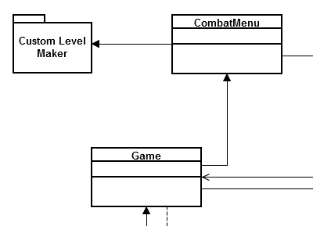
Figure 1b -View

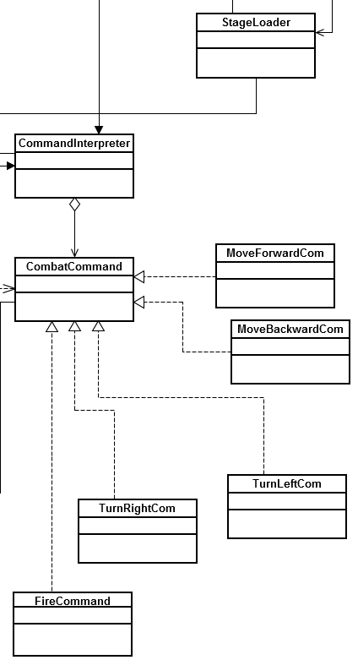
Figure 1c - Controller

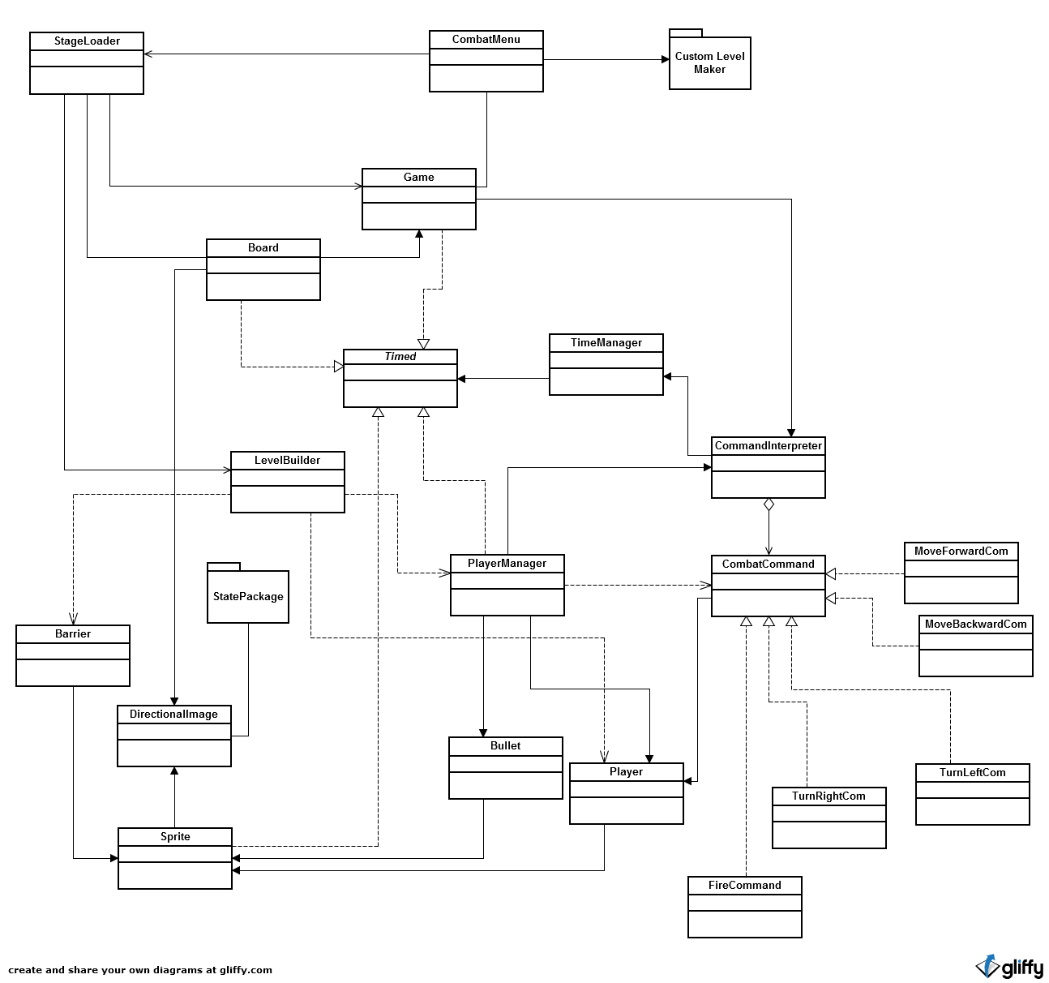
Figure 2 - Refactored Combat Design

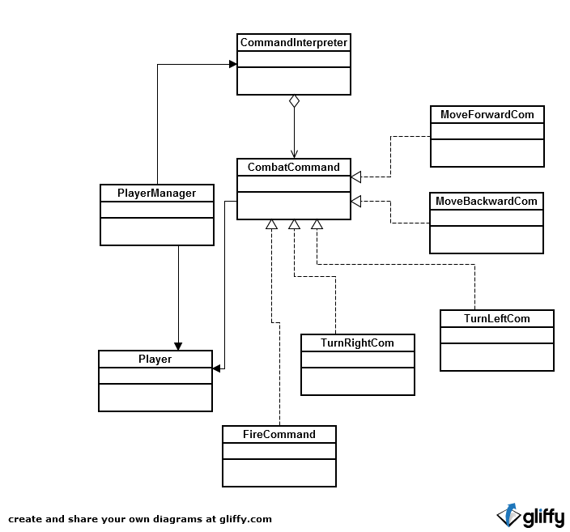

Figure 3 - Command Pattern Usage

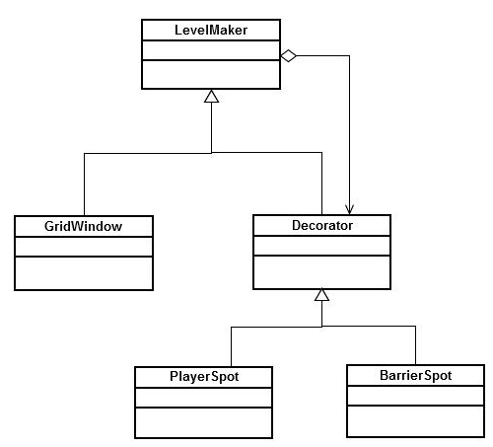

Figure 4 - Decorator Pattern Usage - “Custom Level Maker”

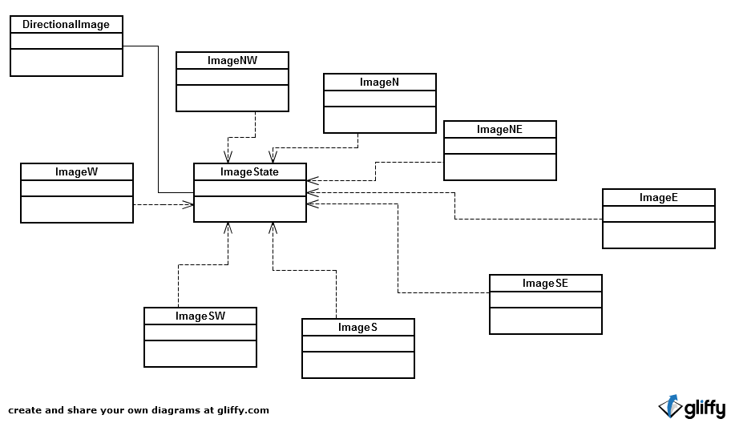
Figure 5 - State Pattern Usage
Sequence Diagrams

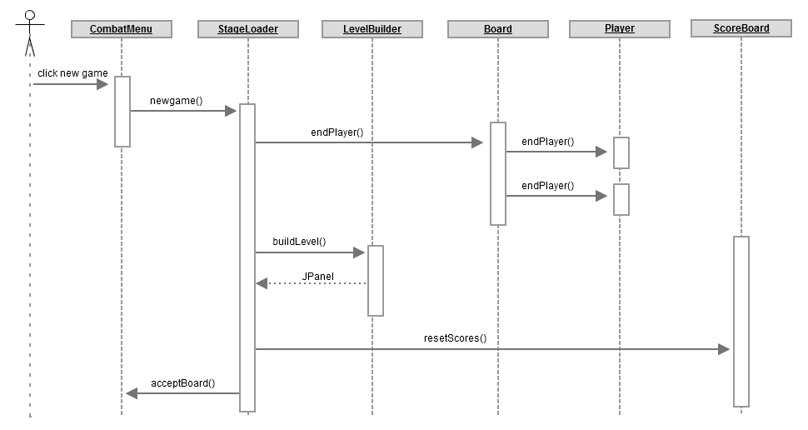
Figure 6 - Creating a new Game

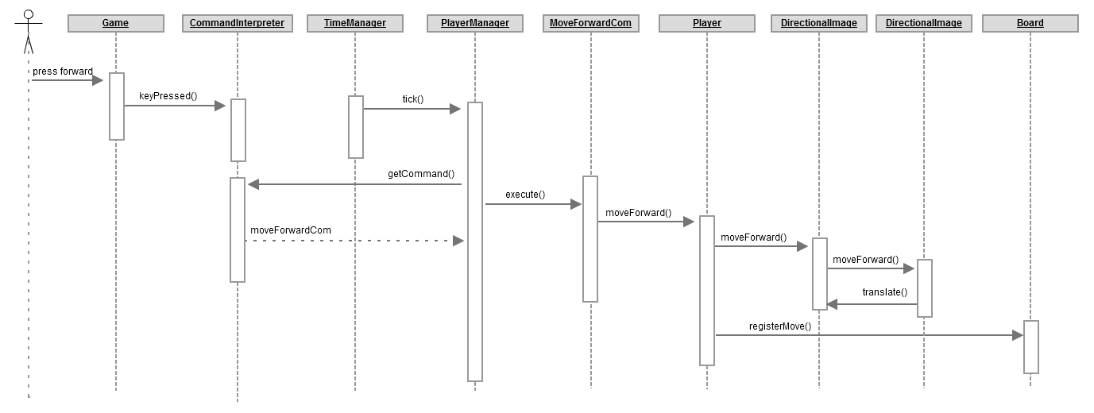
Figure 7 - Player Moving Forward

Original Design Narrative
The original Design to Combat was lacking many key design concepts and features, but due to the short nature of the project and the main focus being on Concurrency, the original team did a great job in providing us with a working game. However, there are some key design concepts that were missing in the original design. For instance, we found that the system was highly coupled; many classes had connections to other classes that could have been easily avoided if given more time. We found that the system had low cohesion and the functionality between classes were not strongly related.

After looking over the code and the comments provided in the project, we were able to determine some of the design patterns that the original team might have used. For instance, the original team decided to use Proxy for the Directional Image of the system. They used or at-least tried to use the command pattern and the iterator pattern. The use of design patterns in the original design was very limited to its functionality, and were not fully implemented. Additionally, we found some missing links between class that the global design did not mention; from LevelBuilder to CommandInterpreter and from Game to the LevelBuilder.

Since, the system overall had so many problems and design flaws, the extensibility of the system was not very great to begin with. Changing things of adding functionality could easily result in a violence of the underlying structure. Additionally, with the help of Metrics, we were able to determine the complexity of the system and the key areas where the system needed refactoring.

Refactored Design Narrative
Our refactored design was not a great fix to the original design, but we did try to fix many of the design concepts that were missing in the original system. For instance, we fixed the Command design pattern by actually implementing its correct structure (as shown above in the class diagram and as mentioned in the CRC cards below). We added the State design pattern to the original design. By doing so, we were able to define and encapsulate the different movement behavior associated with the tank and also get rid of the long switch statement in DirectionalImage. We also decided to add the decorator pattern to the design for the GUI level Buider because with that we were able to dynamically add objects to the board and to the game. With the addition of these design patterns the system was able to produce better results considering low coupling and high cohesion from before.

Some other areas where we refactored our design was in the Game class, where we broke down the game class to separate out the responsibility associated within it. The responsibility for checking for the game to end now lies within Board and GameLoader handles newGame and newRound functionality, allowing Game to focus more specifically on its role as a view. We deleted several classes such as KeyBox, KeyDialog, Test and Thing which served no purpose. We also deleted Combat.java because its role in the system was essentially only to create instances of classes and that doesn’t require a new class to do.

Refactoring Process

Metric Discussion
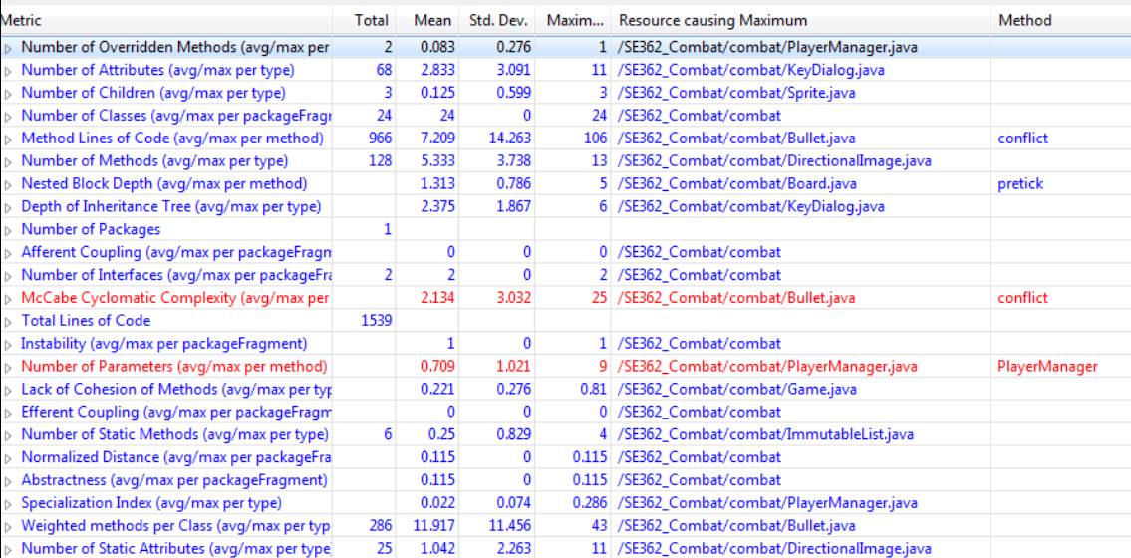
Figure 6 - Original metrics

For this section, we will be covering the four most important metrics we feel helped justify our refactoring:
- McCabe Cyclomatic Complexity
- Number of Parameters
- Number of Static Attributes
- Lack of Cohesion of Methods
These four metrics showed us that the original design of the system was convoluted and had many opportunities for refactoring, to make the design cleaner and easier to read.

The first metric of interest, the McCabe Cyclomatic Complexity, explains how many possible choices there are in a given function. While the average MCC of the system was 2.134(good), one function, conflict() in Bullet, had a MCC of 25. The high value of MCC for this function means it is very complex with many potential paths to take. The fact that the metric software used highlighted the MCC in red showed it was in great need of refactoring. The complexity of the function created a tough situation for refactoring, but with proper refactoring, the MCC could drop by as much as 16. In addition, the Method Lines of Code could drop by well over 50.

The second metric of interest, the Number of Parameters, is exactly that: the number of parameters a method or function takes in. The average was .709, but the maximum was 9, as found in the constructor of the PlayerManager class. This metric was the only other one highlighted in red, so we took it as the second most important for refactoring. Refactoring of this metric was quick, as all we did was change the five integer commands to one integer array, dropping the Number of Parameters to 5.

The third metric of interest, the Number of Static Attributes, describes how many static attributes a class has. A high number of static attributes leads to low cohesion and an overall poor design. The total for the system was 25, with the max being found in DirectionalImage class at 11, nearly half. During the course of implementing other parts of our refactored design we made these attributes final variables to at least reflect a little better their constant nature. In order to properly refactor this, we would need to different create a way of representing directions besides integers. This would eliminate the need to use an integer for all eight cardinal directions and would drastically reduce the number of static attributes required.

The final metric of interest, the Lack of Cohesion of Methods, describes the amount of cohesion a class has(or lack there of) through the amount of fields any pair of methods share. The average for the system is 22%, meaning that 22% of the methods in classes are unrelated to one another. However, the maximum, found in Game, is 81%. To lower that value, we combined the classes Game and Combat into one.

Design Pattern Usage

Name: Command |  |  | GoF pattern: Command
Participants
Class | Role in pattern | Participant's contribution in the context of the application
CombatCommand | Command | declares an interface for executing an operation
CommandInterpreter | Invoker | asks the command to carry out the request
PlayerManager | Client | creates a ConcreteCommand object and sets its receiver
Player | Receiver | preforms the operation with carrying out the request
FireCommand | Concrete CommandA | preform the corresponding operation in the receiver
TurnRightCom | Concrete CommandB | preform the corresponding operation in the receiver
TurnLeftCom | Concrete CommandC | preform the corresponding operation in the receiver
MoveForwardCom | Concrete CommandD | preform the corresponding operation in the receiver
MoveBackwardCom | Concrete CommandE | preform the corresponding operation in the receiver
Deviations from the standard pattern: Client talks to the invoker

Name: Directional Image |  |  | GoF pattern: State
Participants
Class | Role in pattern | Participant's contribution in the context of the application
DirectionalImage | Context | defines an interface to clients and also maintains instances of the concreteState subclasses that are defined in the current state
ImageState | State | defines an interface for encapsulating the behavior associated with a particular state
ImageN | Concrete StateA | implements the movement behavior of the directionalImage
ImageS | Concrete StateB | implements the movement behavior of the directionalImage
ImageE | Concrete StateC | implements the movement behavior of the directionalImage
ImageW | Concrete StateD | implements the movement behavior of the directionalImage
ImageNW | Concrete StateE | implements the movement behavior of the directionalImage
ImageNE | Concrete StateF | implements the movement behavior of the directionalImage
ImageSE | Concrete StateG | implements the movement behavior of the directionalImage
ImageSW | Concrete StateH | implements the movement behavior of the directionalImage
Deviations from the standard pattern: None

Name: GUI Level Creator |  |  | GoF pattern: Decorator
Participants
Class | Role in pattern | Participant's contribution in the context of the application
LevelMaker | Component | defines an interface for the objects that can have responsibilities added to it dynamically
Grid | ConcreteComponent | defines an object to which additional functionality can be attached
Decorator | Decorator | defines an interface for PlayerSpot and BarrierSpot
PlayerSpot | ConcreteDecoratorA | adds responsibility to the LevelMaker
BarrierSpot | ConcreteDecoratorB | adds responsibility to the LevelMaker
Deviations from the standard pattern: None

CRC Cards

Class: Game
Responsibilities: Displays the gamestate to the user, such as positions of tanks and bullets
Collaborators
Uses: CombatMenu, CommandInterpreter, Timed | Used by: StageLoader, Board

Class: CombatMenu
Responsibilities: Contains buttons for user options such as setting new keys, starting a new game and selecting a level
Collaborators
Uses: Level Maker, Stage Loader, Game | Used by: Game

Class: LevelMaker
Responsibilities: Abstract class that components used to design custom levels extend
Collaborators
Uses: None | Used by: CombatMenu, GridWindow, Decorator

Class: GridWindow
Responsibilities: The basic grid that players can drag components onto to build a custom level
Collaborators
Uses: LevelMaker | Used by: None

Class: Decorator
Responsibilities: Abstract class for decorating components that will be dragged onto the GridWindow to extend
Collaborators
Uses: LevelMaker | Used by: PlayerSpot, BarrierSpot

Class: PlayerSpot
Responsibilities: Represents a spot on the map where a player would go when playing the actual level
Collaborators
Uses: Decorator | Used by: None

Class: BarrierSpot
Responsibilities: Represents a place on the grid where a barrier would go when playing the actual level
Collaborators
Uses: Decorator | Used by: None

Class: StageLoader
Responsibilities: When New Game is clicked or a player dies, StageLoader refreshes the game, gets the newly built level from LevelBuilder and gives it to Game to be rendered.
Collaborators
Uses: LevelBuilder, Game, Board | Used by: CombatMenu, Board

Class: Board
Responsibilities: Models Sprites on the playing field and checks at each tick to see if any are conflicting with each other. Handles conflicts that the sprites cannot handle alone, such as a bullet colliding with a player (game needs to end).
Collaborators
Uses: Game, DirectionalImage, Timed, StageLoader | Used by: TimeManager

Class: LevelBuilder
Responsibilities: Reads information from a text file on how to construct a level and places the components accordingly
Collaborators
Uses: Barrier, Player, PlayerManager | Used by: StageLoader

Class: TimeManager
Responsibilities: Sends pretick and tick signals to Timed classes at regular intervals
Collaborators
Uses: LevelBuilder, Timed | Used by: CommandInterpreter

Class: CommandInterpreter
Responsibilities: Interprets commands received from the keyboard and stores the appropriate command object based on the key pressed
Collaborators
Uses: CombatCommand, TimeManager | Used by: Game, PlayerManager

Class: CombatCommand
Responsibilities: Interface to Command objects used to execute player commands such as move, turn and fire
Collaborators
Uses: Player | Used by: CommandInterpreter, PlayerManager

Class: PlayerManager
Responsibilities: Receives Command objects from CommandInterpreter to execute on Player, instructs that player’s bullets to move if any exist
Collaborators
Uses: CommandInterpreter, Player, Bullet, CombatCommand | Used by: LevelBuilder

Class: Player
Responsibilities: Represents a player’s tank on the board, contains methods for turning it and moving it as well as a conflict() method for collisions with other Sprites
Collaborators
Uses: Sprite | Used by: PlayerManager, CombatCommand, LevelBuilder

Class: Bullet
Responsibilities: Represents a bullet on the board. Contains a method for moving forward as well as a conflict() method for collisions with other Sprites
Collaborators
Uses: Sprite | Used by: PlayerManager

Class: Barrier
Responsibilities: Represents a barrier on the board. Barriers do not move or react so the class does not have any real functionality.
Collaborators
Uses: Sprite | Used by: LevelBuilder

Class: Sprite
Responsibilities: The abstract class that defines behavior for bullets, players and barriers.
Collaborators
Uses: Timed, DirectionalImage | Used by: Bullet, Player, Barrier,

Class: DirectionalImage
Responsibilities: Keeps track of the direction a Sprite is facing and the image that corresponds to that direction. Also tracks position on the board.
Collaborators
Uses: ImageState, Board | Used by: Sprite

Class: ImageState

Responsibilities: Represents the direction of a DirectionalImage. Implementing classes know which classes are on their left and right, allowing them to change the state of DirectionalImage, and which direction they should move in to go forwards/backwards.

Collaborators
Uses: DirectionalImage | Used by: DirectionalImage

Refactoring Implementation

The following classes were adjusted as part of the implementation phase of our refactoring.
Modified:
CombatMenu
DirectionalImage
LevelBuilder
Game
Player
TimeManager
Deleted:
Thing, KeyBox, KeyDialog, Test, ImmutableList
Added:
ImageState and its concrete instances

The refactoring of the design focused on two primary aspects. The first was adding the ability for a user to set their own keys to control the tanks in the game. This change was mostly made inside CombatMenu with a small modification to Game to make sending the commands to CommandInterpreter easier. The second was the implementation of a State Pattern for DirectionalImage. Player originally needed to perform an 8-step switch statement in order to move Forward or Backward because it never knew its direction. The movement operation is now encapsulated inside each concrete State class that DirectionalImage uses so no conditional statements are necessary. Changing directions is also simple because the States know who their neighbors are. Unfortunately in the time we had the benefits of the State Pattern could not be extended to Bullet because of its unusual behavior compared to a tank.

Another refactoring change made which was much simpler to implement was deleting ImmutableList and using LinkedList in its place inside TimeManager. ImmutableList provided no benefits that couldn’t be covered by LinkedList but it did incur some drawbacks like unnecessary static access to its methods.

Finally, the classes Thing, Keybox, KeyDialog and Test were deleted as they had no purpose inside the system.

Reflection - discovering the design in an existing software system

It took our team a little while to realize that the design in the document didn’t actually match the design in the code which slowed us down a little bit in the beginning. Not immediately trusting a design someone else hands you is probably a good lesson to take away from that. Beyond that though engineering a design out of written code seems easier than the other way around because all of the connections have been established and you just have to find them. Figuring out the intended architecture or pattern usage is extremely difficult though, especially since your final product may not exactly match what the developers came up with. Even if you have all the right classes and connections, placing them in different spots could obscure the original intentions of the designers. Patterns are also very hard to identify when they aren’t made explicit in the code.

