**PRACTICAL :- 02**

**AIM:-** Installation of Hadoop in Oracle Virtual Box on single node

**THEORY:**

**Virtualization:** Virtualization is a key technology in cloud computing that allows multiple Virtual Machines (VMs) to run on a single physical machine. It abstracts and isolates hardware resources, enabling better resource utilization, flexibility, and scalability.

**Step 1: Download of Virtual box 7.1.10**

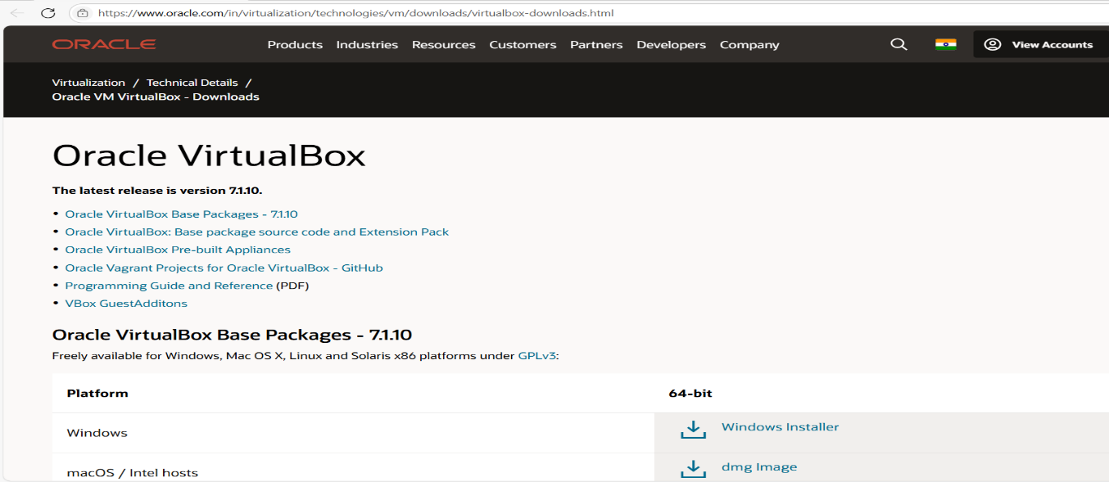

**Step 2: Setup**

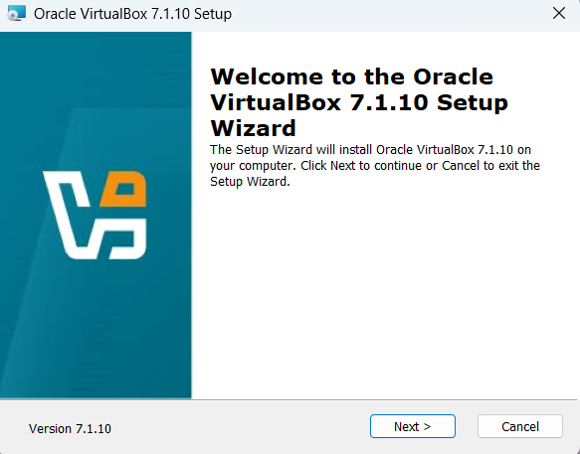

**Step 3: License Agreements** 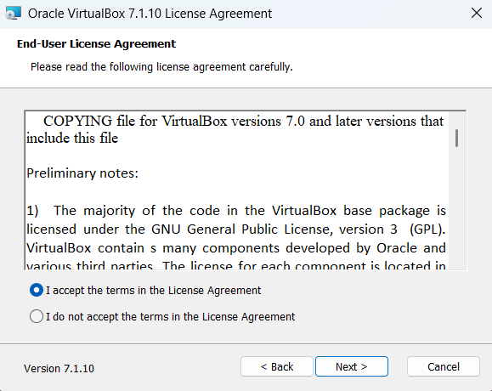

**Step 4: Custom Setup**

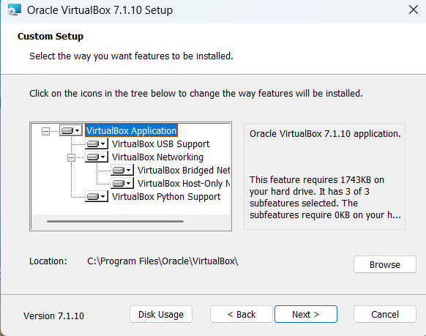

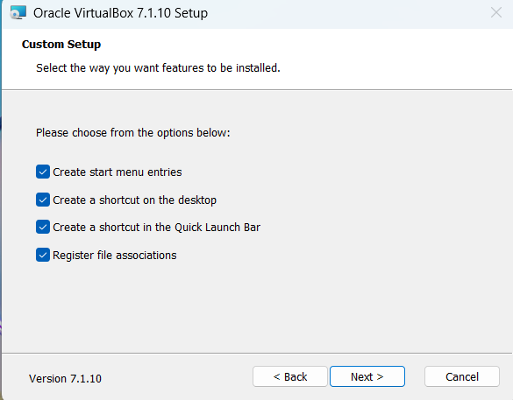

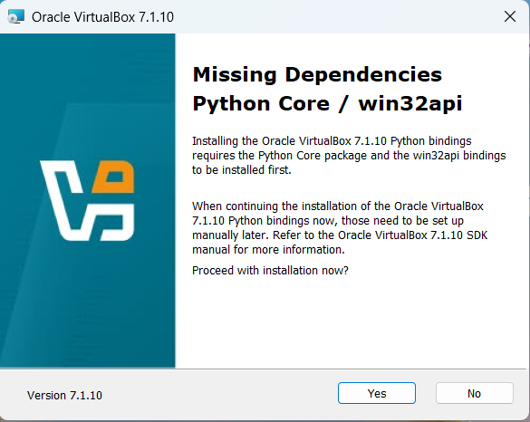

**Step 5: Installation**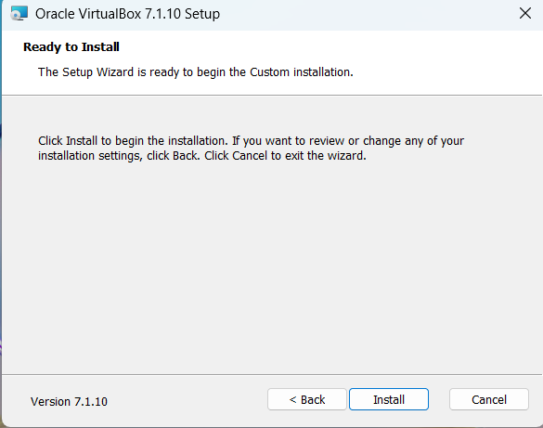

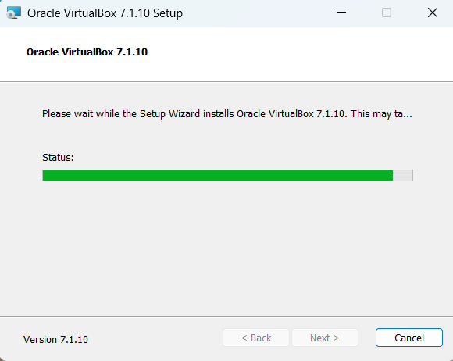

**Step 6: Successfully Installed**

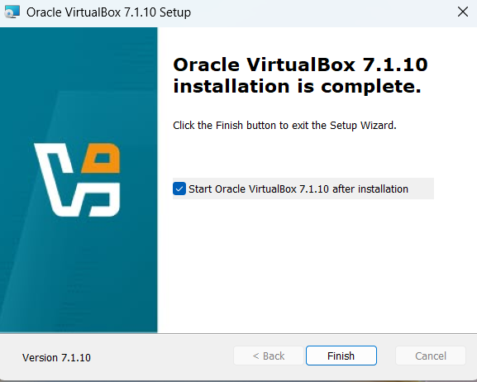

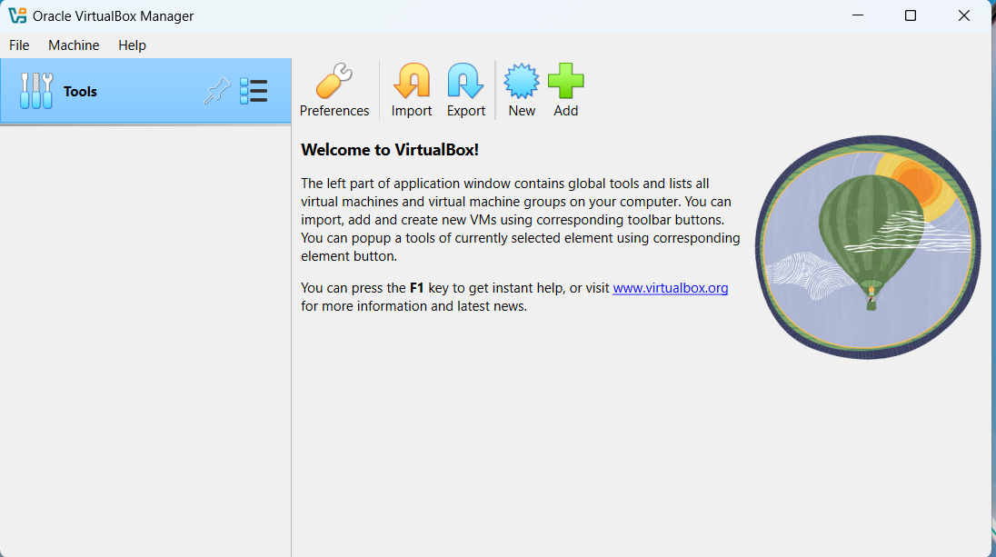

**Step 7: Again download the latest version of cloudera-quickstart.**

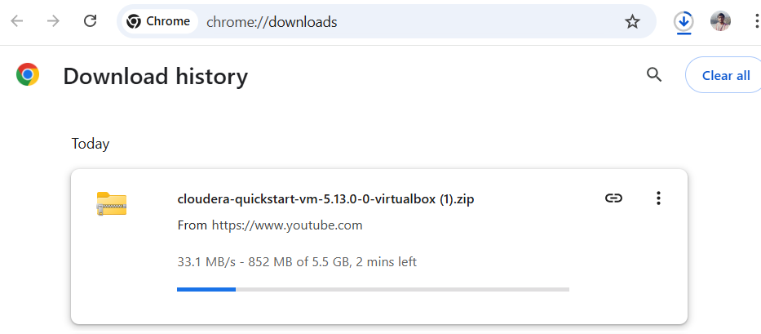

**Step 8: After the download extract with 7-zip.**

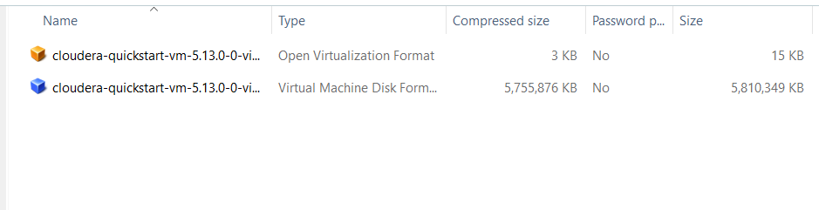

**Step 9: Import the cloudera after extracting.**

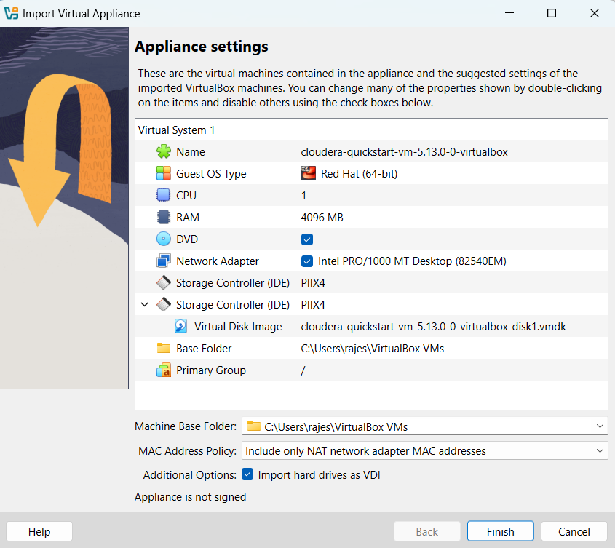

**Step 10: Cloudera is installed successfully.**

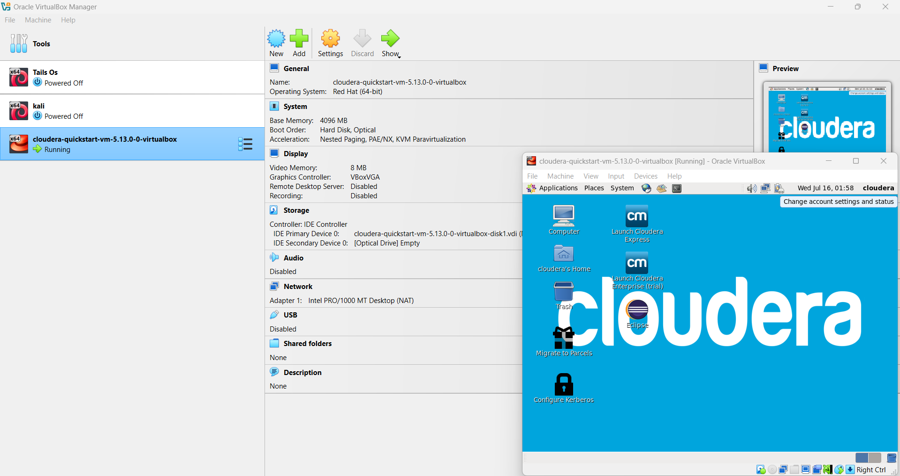

**Results:** Installation of Hadoop in Oracle Virtual Box on single node has been Installed Successfully.