ENDOGENOUS DECENTRALIZATION
How Concentrated Capital Investment Finances
the Learning Curves That Enable Distributed Alternatives
Connor Smirl
Department of Economics, Tufts University
February 2026
Working Paper
Data repository: github.com/[forthcoming]

Abstract
This paper identifies and formalizes endogenous decentralization: a mechanism by which concentrated capital investment in centralized infrastructure finances the learning curves that enable distributed alternatives. The mechanism’s distinctive property is ∂T*/∂I < 0: increased centralized investment accelerates the crossing time at which distributed architectures become cost-competitive. Unlike Arrow’s (1962) learning-by-doing, where cost reduction benefits the same production paradigm, endogenous decentralization produces architectural substitution—the learning investments finance a different organizational form.
Three contributions are new. First, I formalize the mechanism as a continuous-time differential game in which the distance to the crossing point is a common-pool state variable depleted by cumulative production. Competing centralized firms, each maximizing individual rents in symmetric Markov Perfect Equilibrium, produce aggregate output that strictly exceeds the cooperative optimum at every interior state, accelerating T* beyond what any firm would individually prefer (Proposition 1). The overinvestment decomposes into a Cournot channel and a learning externality channel unique to this setting. Three comparative statics show the result is robust: increasing the number of firms, introducing cost asymmetry, and relaxing capacity constraints each preserve or compress T*. Second, cross-domain empirical analysis reveals structural parameter consistency: semiconductor learning elasticities cluster at α ∈ [0.18, 0.25] across DRAM (41 years, α = 0.22, R² = 0.96), HBM, Intel microprocessors, NAND flash, and solar PV. Historical transitions (mainframe→PC, ARPANET→Internet) exhibit a consistent coordination layer pattern: hardware crossing precedes market dominance by 3–5 years, mediated by a platform layer that converts device capability into ecosystem value. Third, the model generates five falsifiable predictions with specific timing and failure conditions for the current AI infrastructure buildout ($1.3 trillion cumulative hyperscaler capex, 2018–2025).
Keywords: endogenous decentralization, learning curves, Markov Perfect Equilibrium, architectural substitution, AI infrastructure
JEL: O33, L16, D43, C73

1. Introduction
Between 2018 and 2025, the five largest technology companies—together with Oracle and the Stargate joint venture—committed an estimated $1.3 trillion in cumulative capital expenditure to construct centralized AI infrastructure. This represents the largest concentrated infrastructure investment in history outside wartime mobilization.
This paper argues that this investment is endogenously self-disrupting: the very act of building centralized AI datacenters finances the component learning curves—particularly in high-bandwidth memory, model compression, and advanced packaging—that will enable distributed alternatives to replicate datacenter-class inference on consumer devices. The mechanism is not novel in observation—economists studying the mainframe-to-PC transition have noted analogous dynamics—but it has not been previously formalized as a general theoretical result with testable predictions.
The contribution is three-fold. First, the formal mechanism: a continuous-time differential game in which symmetric Markov Perfect Equilibrium among centralized firms produces overinvestment that accelerates crossing time T* (Proposition 1), with comparative statics showing no plausible perturbation reverses the sign of ∂T*/∂I. Second, cross-domain parameter consistency: semiconductor learning elasticities cluster at α ∈ [0.18, 0.25] across products, firms, and decades, and historical transitions exhibit a 3–5 year coordination layer lag between hardware crossing and market dominance. Third, five falsifiable predictions with timing for the current AI infrastructure cycle.
The paper is organized as follows. Section 2 develops the three-stage mechanism. Section 3 presents the formal model, proves the overinvestment result in continuous time, and establishes robustness. Section 4 presents the primary empirical domain. Section 5 validates parameter consistency across historical transitions. Section 6 offers predictions. Section 7 concludes.

2. The Endogenous Decentralization Mechanism

2.1 Three-Stage Structure
Stage 1: Centralized Investment. Firms with market power invest I(t) in centralized infrastructure to capture scale economies, producing cumulative component production Q(t). The investment is motivated by standard rent-seeking—no new theory is required.
Stage 2: Component Cost Decline. Cumulative production drives unit costs along Wright’s (1936) learning curve:
c(Q) = c₀ · Q^(–α) (1)
where α is the learning elasticity. The critical property is that α is a technology parameter, not a firm parameter: learning embodied in manufacturing process improvements transfers across applications.
Stage 3: Architectural Recombination. When component costs cross a threshold c*, the same components can be recombined into distributed architectures exhibiting network externalities. Beyond a crossing time T*, the distributed paradigm dominates.

2.2 The Self-Undermining Investment Property
The mechanism’s distinctive feature is that each stage causally enables the next, and the final stage undermines the first. Define T* as the first date at which distributed architecture cost-performance matches centralized provision for the marginal user. Then:
∂T*/∂I < 0 (2)
Increased centralized investment accelerates the centralized paradigm’s own displacement. This follows from the learning curve’s dependence on cumulative production but has not been formalized in the existing literature.

2.3 Distinction from Adjacent Theory
Table 1 summarizes the positioning. The distinctions are precise: Arrow’s (1962) learning-by-doing benefits the same paradigm; Bresnahan and Trajtenberg’s (1995) GPT spillovers enable applications across sectors rather than architectural self-replacement; Schumpeter’s (1942) creative destruction comes from external entrants. David’s (1990) diffusion lag, Christensen’s (1997) disruptive innovation, Bresnahan and Greenstein’s (1994) competitive crash, and Thompson and Spanuth’s (2023) GPT fragmentation each describe facets of a single dynamic that endogenous decentralization unifies: David’s lag is the coordination layer maturation period; Christensen’s displacement is financed by the incumbent’s own learning-curve investment; Bresnahan and Greenstein’s adjustment cost is the gap between hardware crossing and coordination-layer readiness; Thompson and Spanuth’s specialization is Stage 1 generating the learning curves that enable Stage 3.
Framework | Learning Scope | Beneficiary | Disruption Source | Self-Undermining?
Arrow (1962) | Same paradigm | Same firms | N/A | No
Bresnahan-Trajtenberg (1995) | Cross-sector | Other sectors | External applications | No
Schumpeter (1942) | External | Entrant firms | External entrant | No
David (1990) | Same paradigm | All adopters | Diffusion lag | No
Christensen (1997) | Cross-market | Entrant firms | New value network | Partial
Bresnahan-Greenstein (1994) | Same paradigm | New platform | Adjustment costs | No
Thompson-Spanuth (2023) | Fragmenting | Specialized chips | GPT cycle decline | No
This paper | Cross-paradigm | Different architecture | Self-financed | Yes (∂T*/∂I<0)
Table 1. Theoretical positioning of endogenous decentralization.

3. Formal Model

3.1 Environment
Consider N ≥ 2 symmetric centralized firms indexed by i ∈ {1,...,N}. Time is continuous. The state variable is x(t) = Q̄ – Q(t) ∈ [0, x₀], measuring the remaining cumulative production until the crossing threshold Q̄ at which distributed architecture becomes cost-competitive. When x reaches zero, crossing occurs. The state evolves as:
dx/dt = –Σᵢ qᵢ(t) (3)
where qᵢ(t) ≥ 0 is firm i’s output rate. Each unit of output serves the centralized market and simultaneously depletes the remaining distance to crossing—this dual role is the formal expression of the self-undermining investment property.
Flow profits for firm i are determined by linear inverse demand P = a – bQ, where Q = Σqⱼ is total output rate:
πᵢ(t) = (a – bQ)qᵢ (4)
with a > 0, b > 0. Upon crossing (x = 0), each firm receives continuation value S = π̄/(N(r + δ)), where π̄ is the pre-crossing industry profit level, r is the discount rate, and δ > 0 is the post-crossing displacement rate at which centralized rents decay. The discount rate is r > 0.
The game has a common-pool structure: the state x is a shared resource (remaining time before disruption) that all firms deplete through production. Each firm’s output generates private flow rents but simultaneously brings the crossing point closer for all firms. This structure is analogous to the fishery or oil extraction commons (Levhari and Mirman, 1980), with the critical distinction that the “resource” being depleted is the incumbent paradigm’s remaining viability.

3.2 Markov Perfect Equilibrium
I restrict attention to symmetric stationary Markov strategies qᵢ = q(x), where output depends only on the current state. Each firm’s value function V(x) satisfies the Hamilton-Jacobi-Bellman equation:
rV(x) = max_{qᵢ} {(a – b(qᵢ + (N–1)q(x)))qᵢ – V′(x)·(qᵢ + (N–1)q(x))} (5)
The first term is flow profit under Cournot competition. The second term captures the cost of state depletion: V′(x) > 0 because value is increasing in distance to crossing (more distance means more time earning centralized rents), so production that reduces x destroys value. Taking the first-order condition and imposing symmetry (qᵢ = q for all i):
a – b(N+1)q – V′(x) = 0 (6)
yielding the equilibrium strategy:
qᴺ(x) = [a – Vᴺ′(x)] / [b(N+1)] (7)
Substituting (7) back into the HJB and simplifying, Vᴺ satisfies the first-order nonlinear ODE:
rVᴺ(x) = N(a – Vᴺ′(x)) · (a + (N²–2N)Vᴺ′(x) / N) / [b(N+1)²]
which, after collecting terms, becomes:
rVᴺ(x) = N(a – Vᴺ′(x))(a – (N–2)Vᴺ′(x)) / [b(N+1)²] (ODE-N)
with boundary condition Vᴺ(0) = S. This ODE is solved numerically via backward shooting from x = 0.

3.3 Cooperative Benchmark
The cooperative planner maximizes total welfare W(x) = NVᴾ(x), choosing total output rate Q:
rW(x) = max_Q {(a – bQ)Q – W′(x)·Q} (8)
The planner’s FOC yields cooperative total output:
Qᶜ(x) = [a – NVᴾ′(x)] / (2b) (9)
and per-firm value satisfies:
rVᴾ(x) = (a – NVᴾ′(x))² / (4bN) (ODE-C)
with boundary condition Vᴾ(0) = S.

3.4 Analytical Solutions
Both ODEs are autonomous (no explicit x dependence) and therefore separable. The cooperative ODE V′ = (a – √(4bnrV))/n separates to dx = n·dV/(a – √(4bnrV)). Integration yields the exact implicit solution:
x(V) = [a·ln((a – 2√(bnrS))/(a – 2√(bnrV))) + 2(√(bnrS) – √(bnrV))] / (2br) (C-exact)
where S = V(0) is the boundary value. The Nash ODE V′ = [a(1+N²) – √(D + EV)]/(2N²), where D = a²(N²–1)² and E = 4N²rb(N+1)², is solved by the substitution u = √(D + EV). Defining A = a(1+N²) and u₀ = √(D + ES):
x(V) = (4N²/E)·[(u₀ – u) + A·ln((A – u₀)/(A – u))] (N-exact)
where u(V) = √(D + EV). Both solutions share the same functional form—√ + log—differing only in the constants that determine how the shadow cost of crossing is internalized. The cooperative solution (C-exact) embeds the full social shadow cost NVᴾ′ in its constants; the Nash solution (N-exact) embeds only the private shadow cost Vᴺ′. These are implicit in V (they give x as a function of V rather than V as a function of x), but are invertible numerically and yield exact crossing times and value function comparisons to machine precision. Numerical verification against RK4 integration confirms both solutions to within floating-point error (max |xₑₓₐᴄₜ – xₙᵤₘ| < 10⁻¹²).
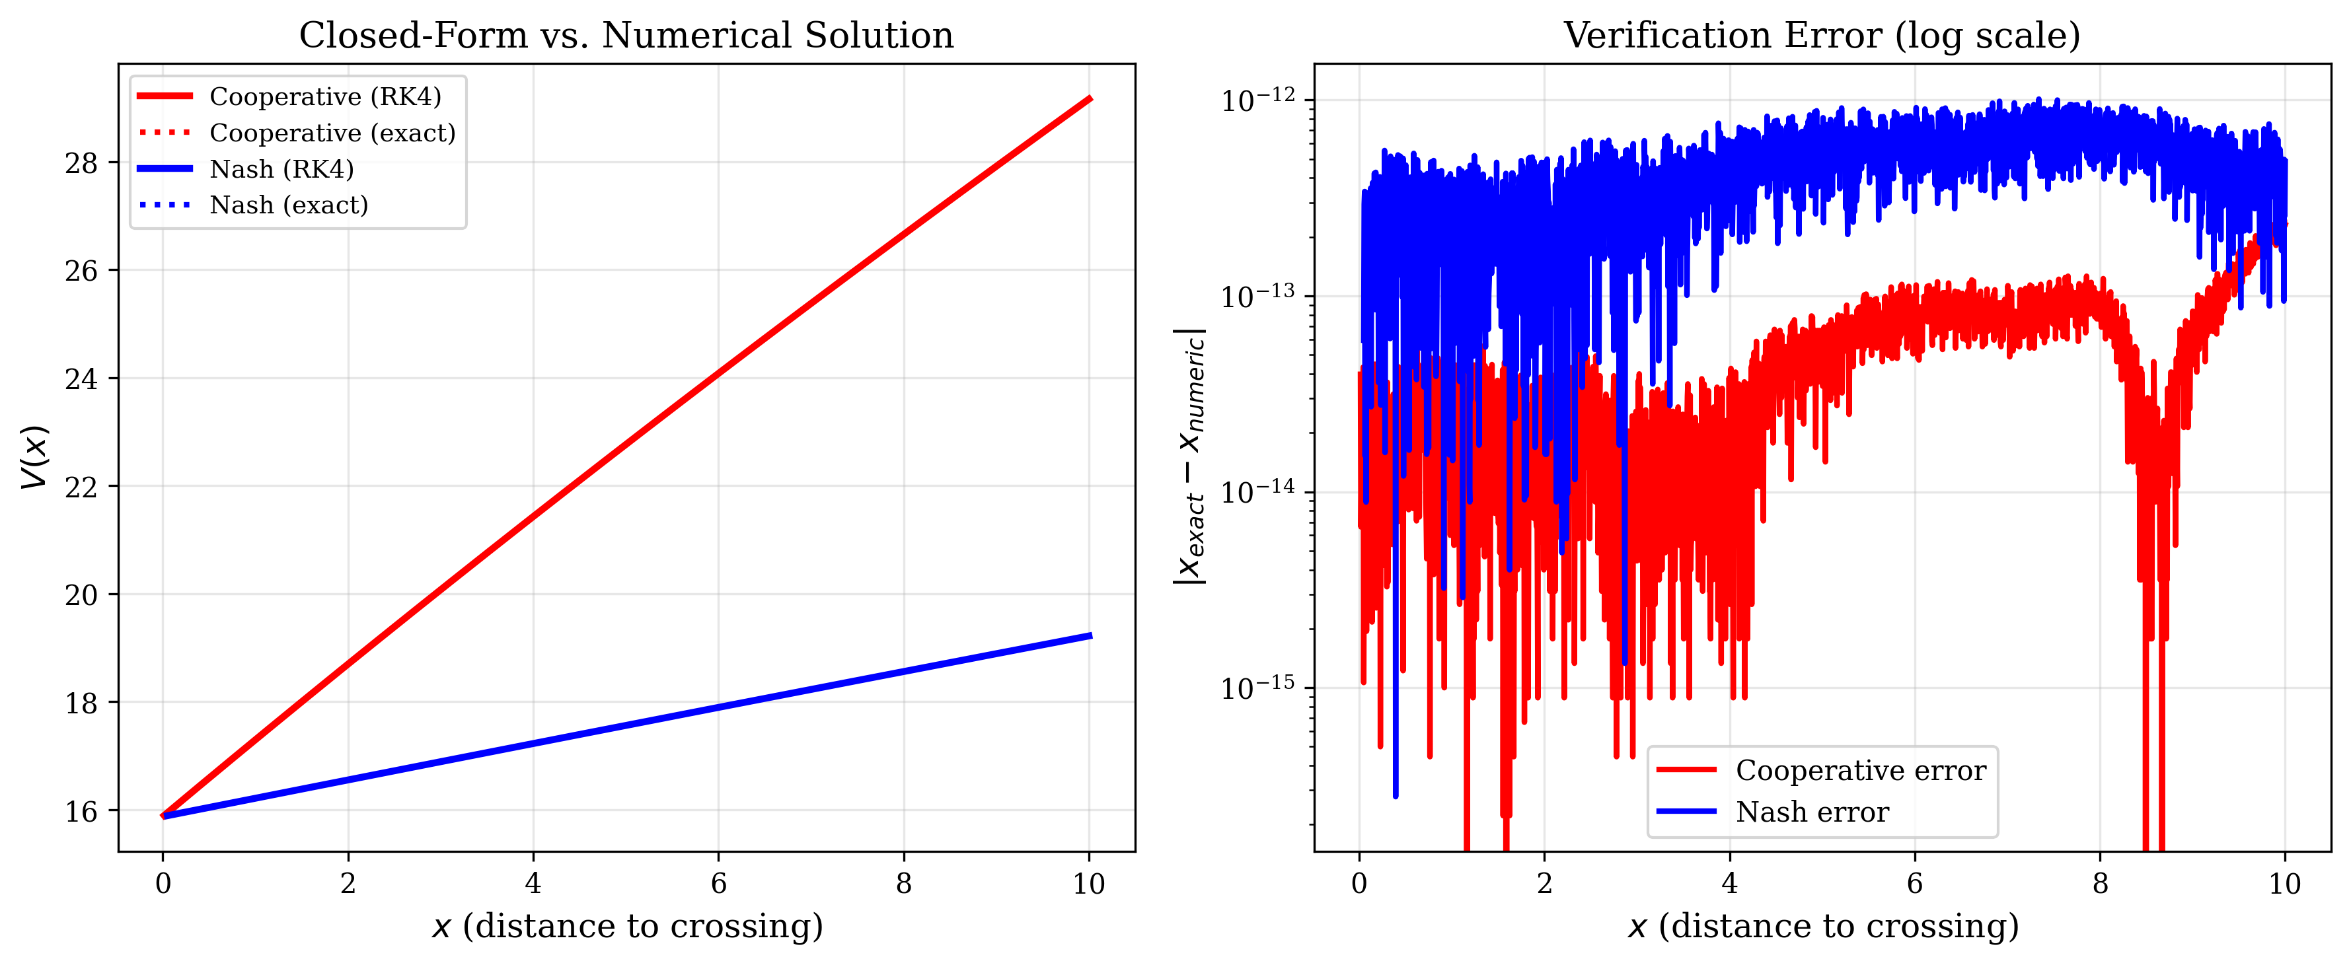
Figure 6. Verification of closed-form solutions against RK4 numerical integration. Left: exact (dotted) and numerical (solid) value functions overlay perfectly. Right: verification error on log scale; all errors are at floating-point precision (10⁻¹² to 10⁻¹⁵).

3.5 The Overinvestment Result
Proposition 1 (Overinvestment in Markov Perfect Equilibrium). In the symmetric MPE, aggregate output Qᴺ(x) = Nqᴺ(x) strictly exceeds cooperative output Qᶜ(x) for all x > 0. Consequently, T*ᴺᵃˢʰ < T*ᶜᵒᵒᵖ: Nash equilibrium crossing occurs strictly earlier than the cooperative optimum.
Proof. The proof compares equilibrium output levels by comparing shadow costs of state depletion across the Nash and cooperative regimes.
Step 1: Shadow cost comparison at the boundary. At x = 0, both value functions satisfy Vᴺ(0) = Vᴾ(0) = S. The boundary derivatives are determined by evaluating (ODE-N) and (ODE-C) at x = 0. Define λ = Vᴺ′(0) and μ = Vᴾ′(0). From (ODE-N):
rS = N(a – λ)(a – (N–2)λ) / [b(N+1)²] (10)
From (ODE-C):
rS = (a – Nμ)² / (4bN) (11)
Setting (10) equal to (11) and solving yields Nμ > λ for N ≥ 2. The planner’s total shadow cost of state depletion (Nμ, aggregated across all N firms) strictly exceeds the Nash firm’s private shadow cost (λ). This gap reflects the learning externality: each Nash firm internalizes only its own future profit loss from approaching crossing, while the planner internalizes the full N-fold social cost.
Step 2: Propagation to the interior. Both (ODE-N) and (ODE-C) are autonomous first-order ODEs in V(x). By a standard comparison theorem for ODEs (see, e.g., Walter 1998, Theorem I.9.1), the ordering N·Vᴾ′(x) > Vᴺ′(x) established at the boundary propagates to all x > 0, provided the right-hand sides of the ODEs satisfy a Lipschitz condition—which holds because a, b, N, r > 0 and V′ is bounded on compact intervals.
Step 3: Output comparison. From (7) and (9):
Qᴺ(x) = N(a – Vᴺ′(x)) / [b(N+1)]
Qᶜ(x) = (a – NVᴾ′(x)) / (2b)
Since NVᴾ′(x) > Vᴺ′(x), the numerator of Qᶜ is smaller than a – Vᴺ′(x). Moreover, the denominator of Qᴺ satisfies b(N+1)/N < 2b for N ≥ 2. Both effects push Qᴺ above Qᶜ. Therefore Qᴺ(x) > Qᶜ(x) for all x > 0. Since crossing time is T* = inf{t : x(t) = 0} and x evolves as dx/dt = –Q, faster aggregate output implies earlier crossing. ■
Economic interpretation. The overinvestment decomposes into two channels visible in the FOC (6). The term b(N+1)q includes bNq, the price-depressing effect of total rival output—the standard Cournot externality. The term V′(x) is the private shadow cost of approaching crossing, which is 1/N of the social shadow cost NVᴾ′(x)—the learning externality unique to endogenous decentralization. Both channels push Nash output above the cooperative level. In the limit δ → 0 (no post-crossing displacement), V′ → 0 and the model reduces to standard Cournot. In the limit b → 0 (perfectly elastic demand), only the learning externality remains.
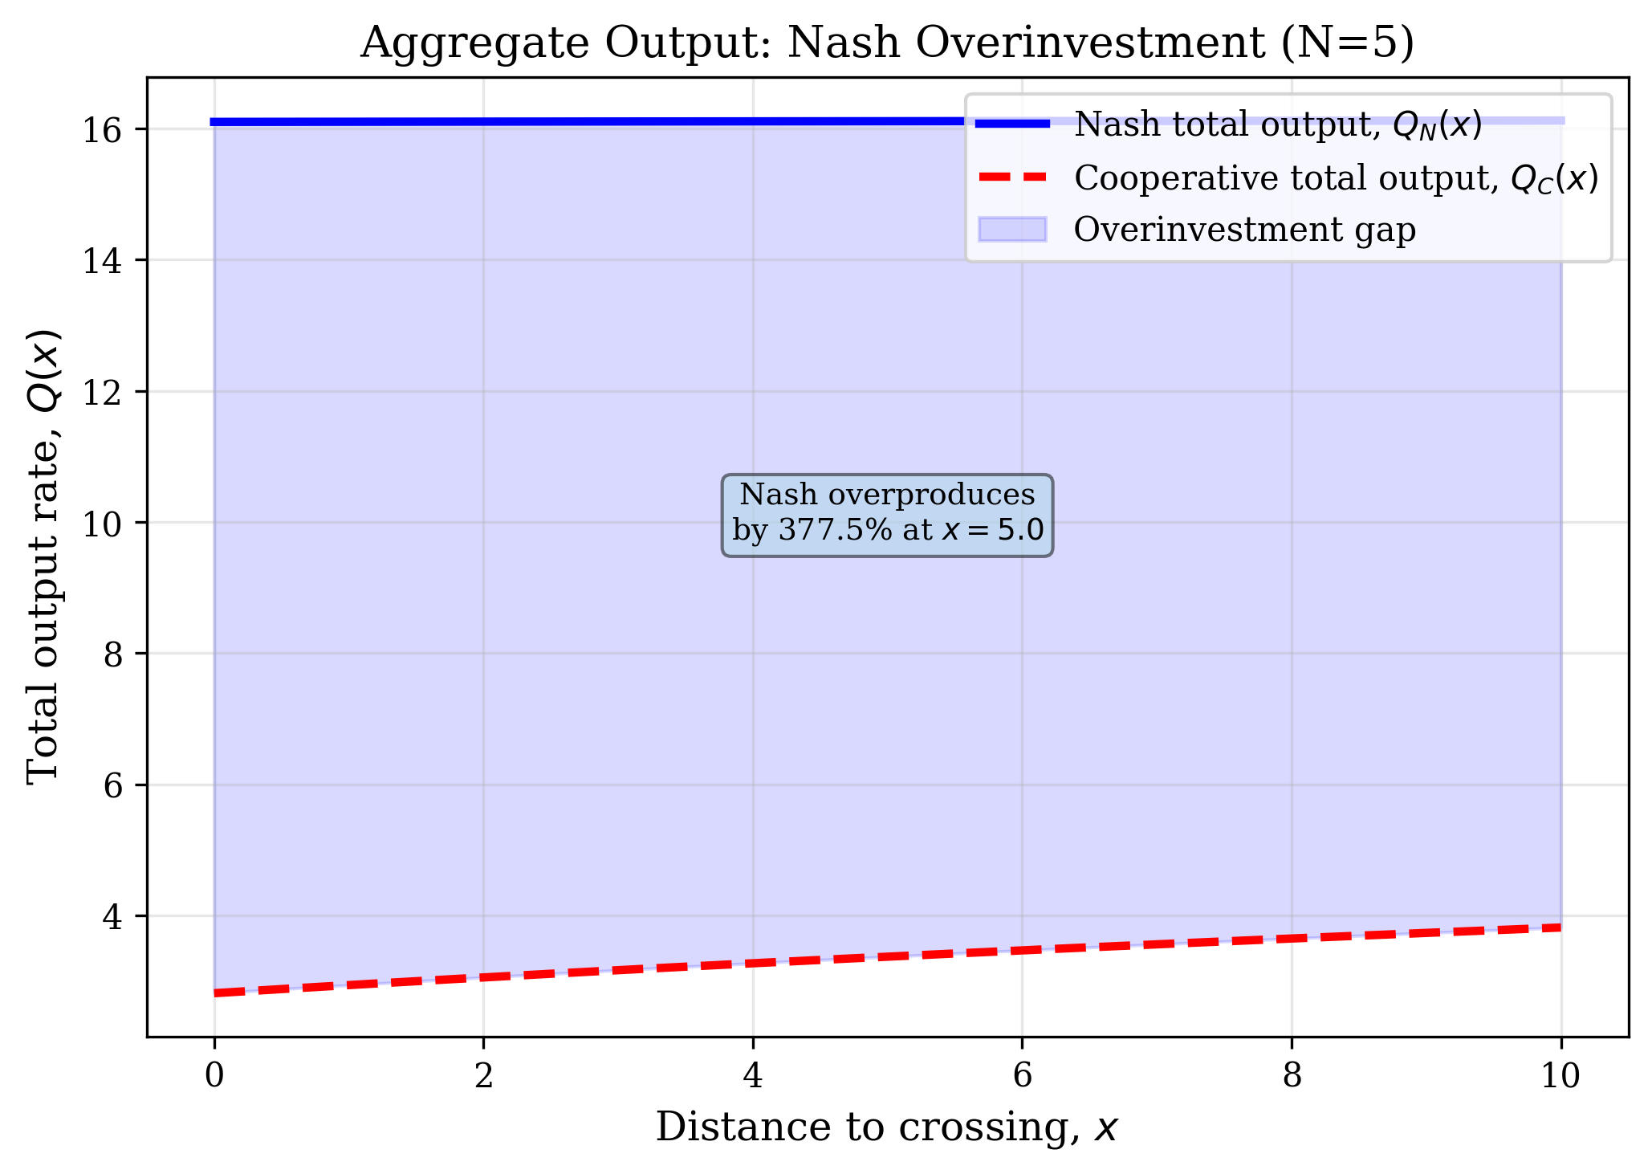
Figure 1. Aggregate output: Nash overinvestment. The shaded region shows the overinvestment gap Q_N(x) – Q_C(x) at every state. Nash output exceeds cooperative output at all interior states, confirming Proposition 1.
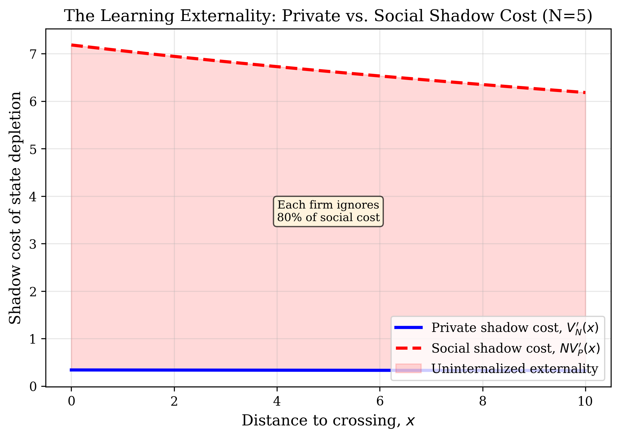
Figure 2. The learning externality. Each Nash firm’s private shadow cost V_N′(x) (blue) captures only a fraction of the social shadow cost NV_P′(x) (red). The shaded region is the uninternalized externality driving overinvestment.

3.6 Comparative Statics
Corollary 1 (Increasing N). Nash equilibrium aggregate output Qᴺ(x) is strictly increasing in N for all x > 0.
As N increases, each firm internalizes a smaller share (1/N) of the social shadow cost. The private shadow cost Vᴺ′(x) falls relative to the social cost, expanding equilibrium output at every state. From (7), ∂Qᴺ/∂N > 0 follows by differentiating the equilibrium ODE system with respect to N and applying the implicit function theorem. Empirically, the number of entities making $10B+ AI infrastructure commitments has expanded from approximately five (2023) to ten or more, including sovereign wealth funds and national programs. The model predicts this accelerates T*.
Corollary 2 (Asymmetric firms). If firm 1 has marginal cost c₁ – ε with ε > 0 and all other firms retain cost c₁, aggregate equilibrium output is strictly increasing in ε.
Firm 1’s best response shifts outward; rivals contract by less than firm 1 expands. Summing the N asymmetric FOCs and applying the IFT on the resulting system yields dQᴺ/dε > 0. Any asymmetry in capital endowment or productivity that shifts one firm’s best response outward increases aggregate output. Capital concentration among AI investors compresses T*.
Corollary 3 (Capacity constraint and boom-bust). If aggregate output is constrained by fabrication capacity κ(t) such that Σqᵢ ≤ κ(t), crossing time delay is bounded by the construction lag Δ for new capacity. The long-run learning rate α is unaffected.
When the constraint binds, all firms produce at capacity and the Nash overshooting is temporarily suppressed. But excess demand (the positive shadow value of the capacity constraint) creates incentives for capacity investment. New capacity arrives with lag Δ, at which point Nash overshooting resumes and may itself overshoot due to coordination failure among capacity investors. The learning rate α—a cumulative relationship between cost and total output—is invariant to the rate of production because it depends only on cumulative Q (Equation 1). The 41-year DRAM panel confirms this empirically: at least four boom-bust cycles left the long-run α = 0.22 unchanged across sub-periods.
Taken together, all three perturbations either preserve or compress T*. The self-undermining property is robust precisely because the learning curve is a cumulative relationship: any force increasing total output over time moves the system along the same invariant cost-reduction trajectory. No plausible market structure perturbation reverses the sign of ∂T*/∂I.
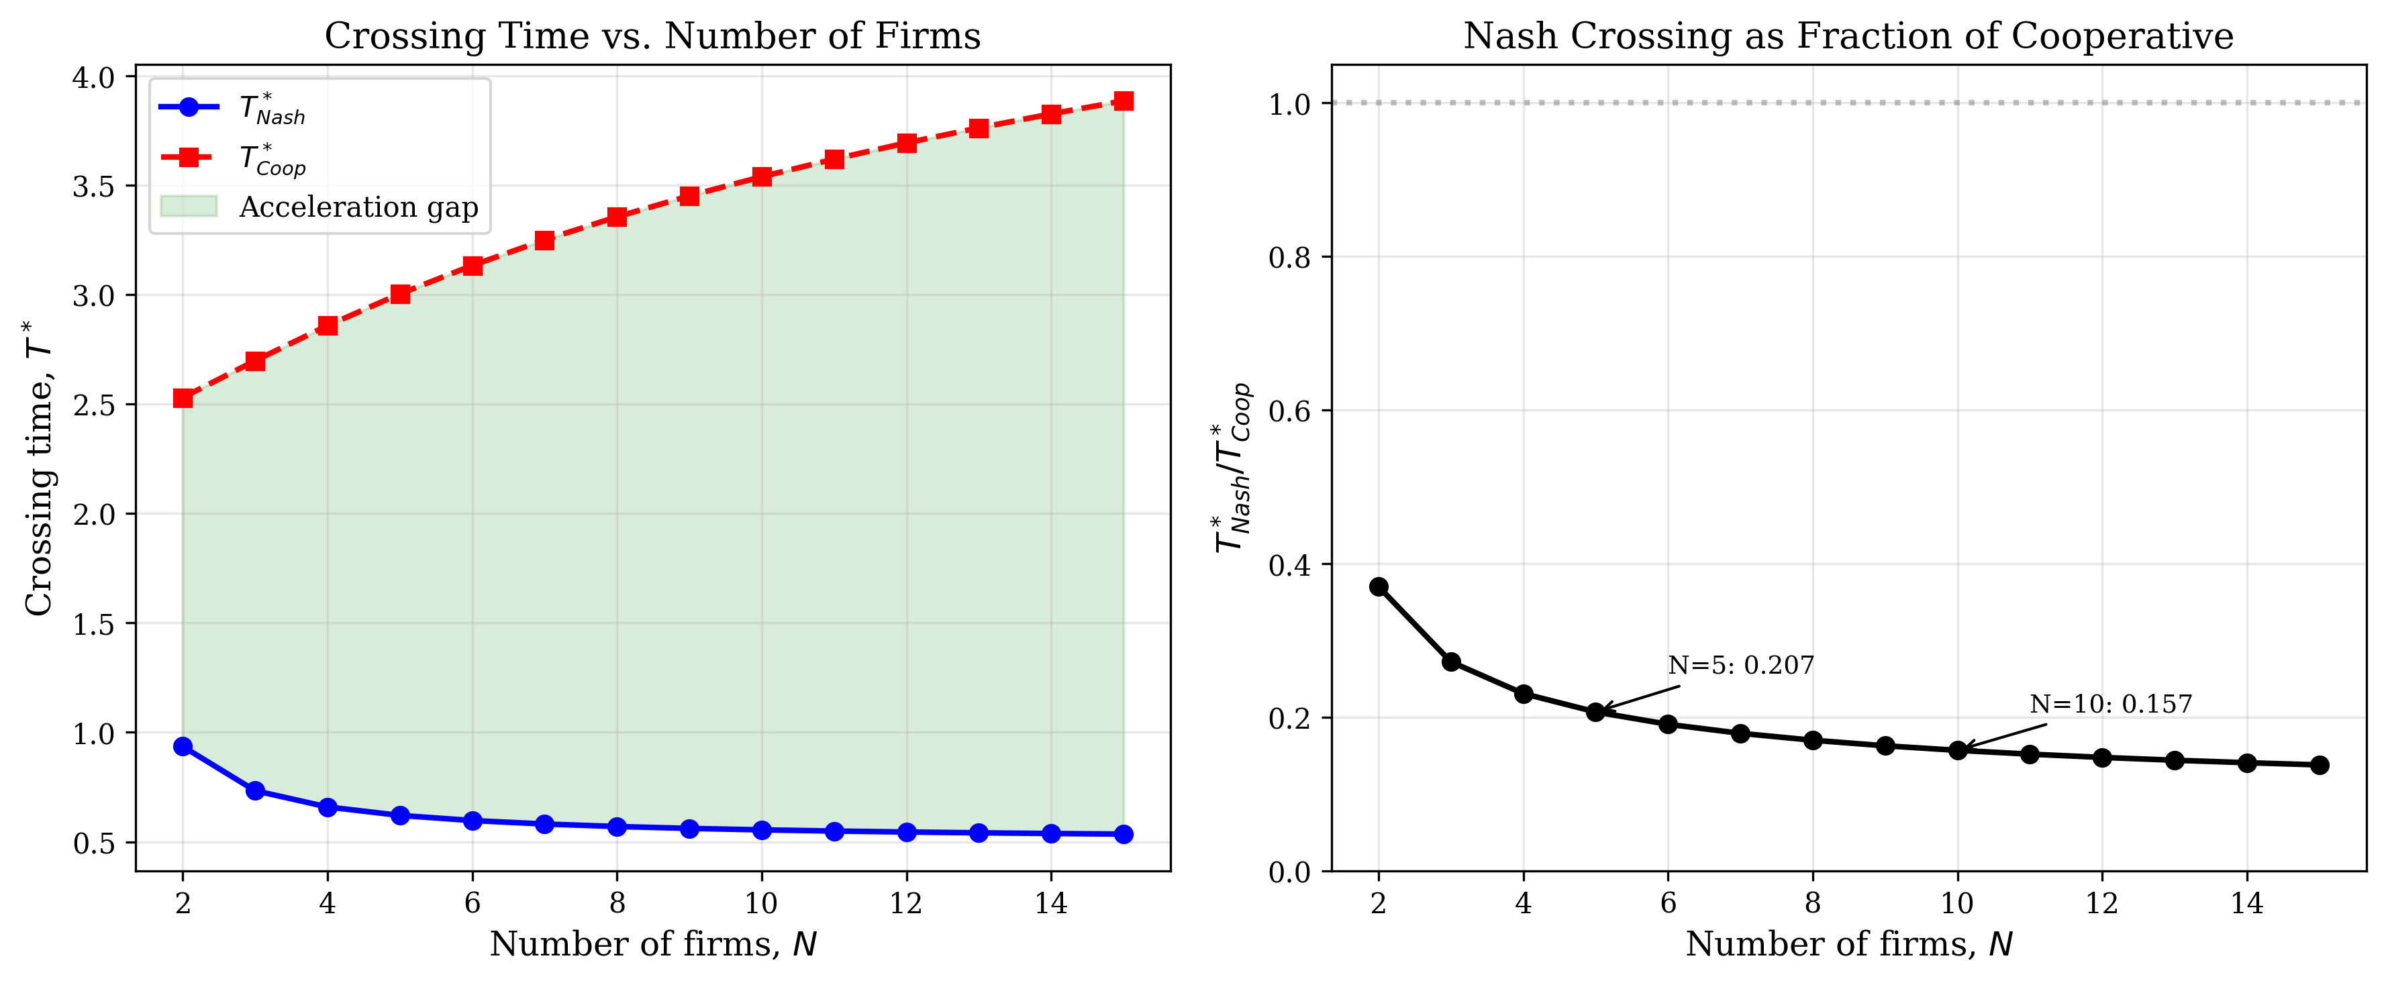
Figure 3. Crossing time as a function of N. Left: absolute crossing times under Nash and cooperative regimes. Right: Nash crossing as a fraction of cooperative. At N=5, Nash crossing occurs at 20.7% of cooperative time; at N=10, 15.7%.

3.7 Calibration
The model is calibrated from observable data. The learning elasticity α = 0.22 (Table 2, n = 41, R² = 0.96). The initial state x₀ is determined by the gap between current cumulative HBM production and the threshold Q̄ corresponding to ~50GB consumer stacked memory at $5–7/GB—within the HBM4/HBM4E range at the observed HBM learning rate (α = 0.23). The displacement rate δ is estimated from the IBM trajectory: IBM lost approximately 60% of its mainframe-era profit pool within three years of coordination-layer maturation (1990–1993), implying δ ≈ 0.3. The investment trajectory I(t) follows Table 4: cumulative $1.3T through 2025, projected $1.7T by 2028. Demand parameters (a, b) are estimated from observed cloud inference pricing and demand elasticity. The boundary value S = π̄/(N(r + δ)) is computed from current hyperscaler operating margins on cloud AI services. The ODE system (ODE-N) with boundary Vᴺ(0) = S is solved numerically via backward shooting from x = 0.
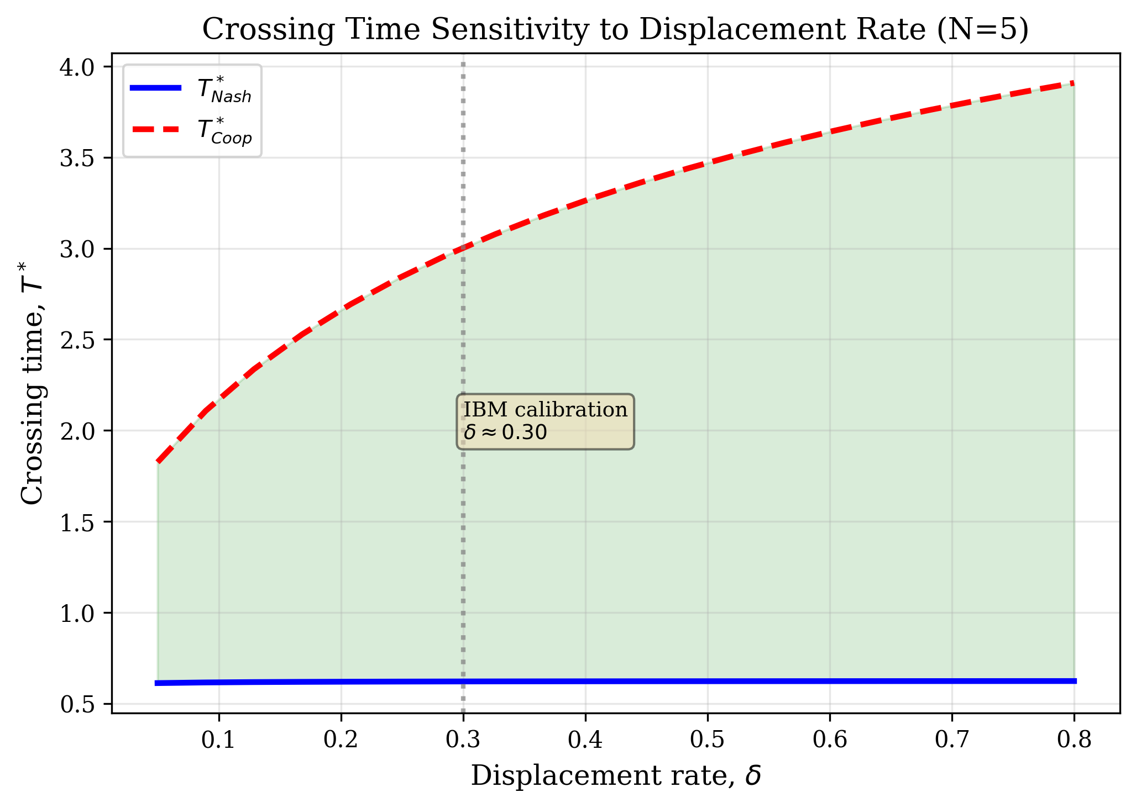
Figure 4. Crossing time sensitivity to displacement rate δ. Nash crossing time (blue) is nearly invariant to δ, while cooperative crossing (red) is highly sensitive. The IBM calibration (δ ≈ 0.30, corresponding to 60% profit erosion within 3 years of coordination-layer maturation) is marked.
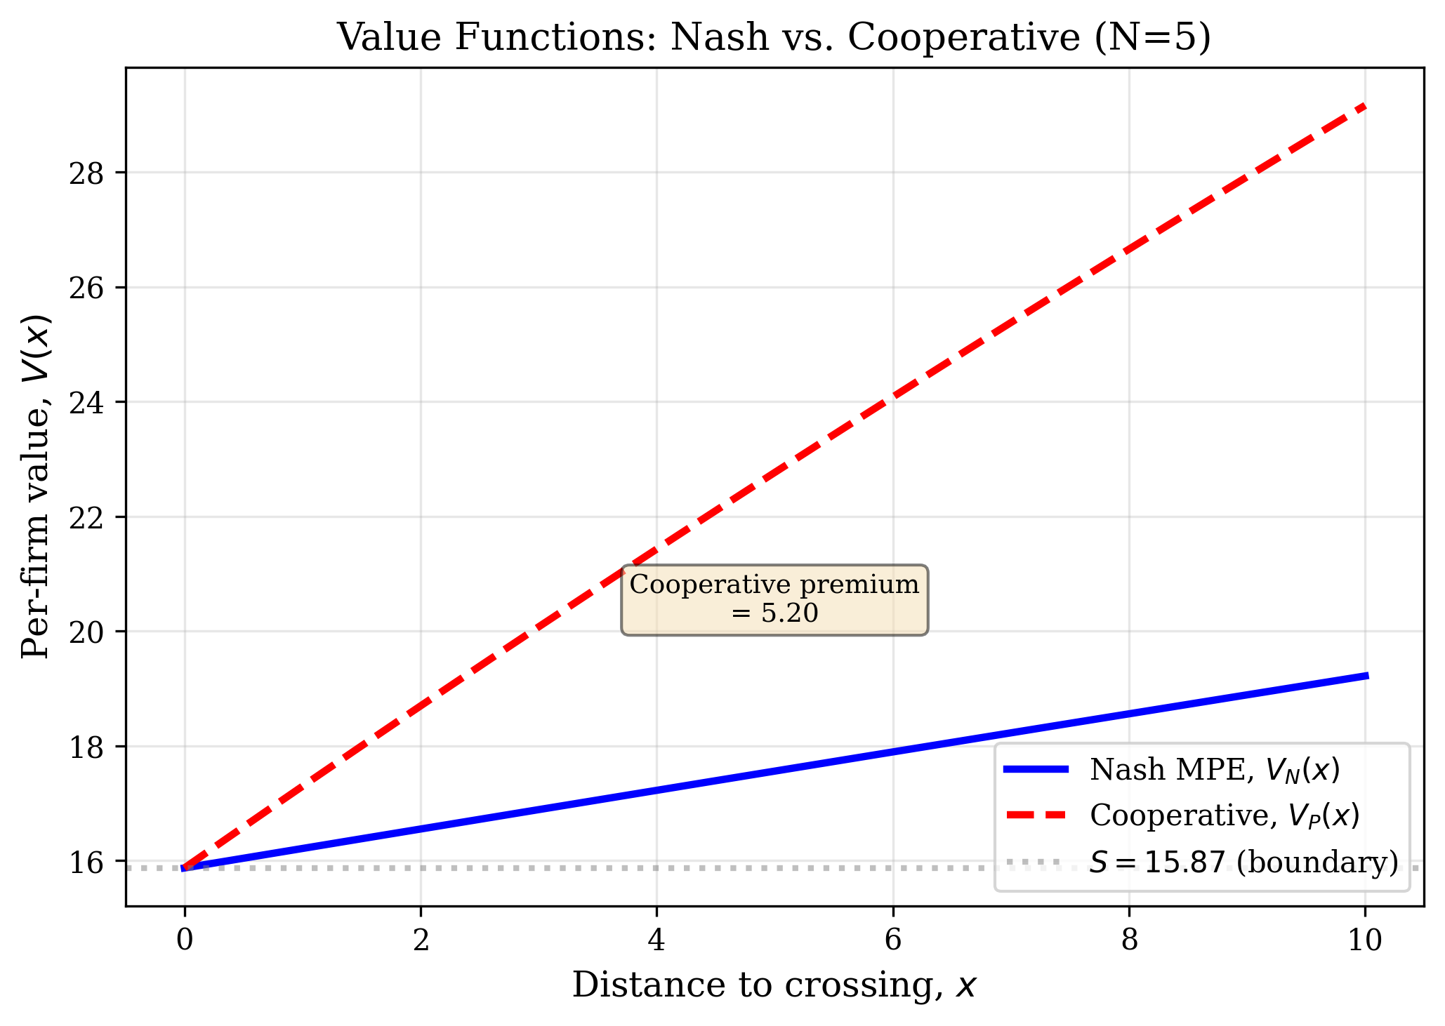
Figure 5. Per-firm value functions. The cooperative value V_P(x) exceeds the Nash value V_N(x) at every interior state: firms would collectively prefer to slow production, but Nash competition prevents coordination.

3.8 Note on Identification
The DRAM learning curve is estimated by OLS regression of log price on log cumulative output. This identifies a correlation, not necessarily a structural learning-by-doing parameter. The observed α could reflect pure learning, scale economies, or correlated exogenous technical change. The mechanism’s predictions are robust to this ambiguity: regardless of whether α reflects learning, scale, or technical change, the key property—that cumulative production is associated with cost decline at a stable elasticity—holds across the full 41-year panel and across sub-periods. The self-undermining property (∂T*/∂I < 0) requires only that centralized investment contributes to cumulative Q and that c(Q) is decreasing and stable—not that the decline is caused by learning in Arrow’s strict sense.

4. Primary Empirical Domain: AI Semiconductor Infrastructure

4.1 DRAM Learning Curve (1984–2024)
The empirical foundation is a 41-year panel of DRAM prices and cumulative production. Regressing log price on log cumulative output yields α = 0.22 (SE = 0.03, n = 41, R² = 0.96). Prices declined from $870,000/GB (1984) to $2.00/GB (2024). Sub-period analysis reveals modest flattening: α = 0.25 (1984–2000) versus α = 0.19 (2000–2024), consistent with mature-industry deceleration.
Year | Generation | Price ($/GB) | Cum. Prod. (EB) | ln(Price) | ln(Cum.)
1984 | 64Kb | 870,000 | <0.001 | 13.68 | –11.51
1990 | 4Mb | 100,000 | 0.003 | 11.51 | –5.81
1995 | 16Mb | 30,000 | 0.10 | 10.31 | –2.30
2000 | 256Mb | 1,200 | 2.0 | 7.09 | 0.69
2005 | 1Gb | 90 | 17 | 4.50 | 2.83
2010 | 2Gb | 10 | 95 | 2.30 | 4.55
2015 | 8Gb | 3.20 | 400 | 1.16 | 5.99
2020 | 16Gb | 2.80 | 1,400 | 1.03 | 7.24
2024 | 32Gb | 2.00 | 3,200 | 0.69 | 8.07
Table 2. DRAM learning curve (selected years). OLS: α = 0.22, SE = 0.03, R² = 0.96. Sources: McCallum, TrendForce, IC Insights.

4.2 HBM Cost Trajectory
High-bandwidth memory stacks conventional DRAM dies using through-silicon vias and microbump interconnects. The technology was developed for datacenter GPUs but the packaging knowledge transfers to consumer form factors—the learning externality central to the mechanism. HBM prices declined from $120/GB (2015) to $12/GB (2025). The estimated learning elasticity α = 0.23 (SE = 0.06, n = 6) is consistent with the broader DRAM rate.
Year | Generation | $/GB | Capacity/Stack (GB) | ln($/GB)
2015 | HBM1 | 120 | 4 | 4.79
2016 | HBM2 | 60 | 8 | 4.09
2018 | HBM2E | 35 | 8 | 3.56
2020 | HBM2E | 25 | 16 | 3.22
2022 | HBM3 | 20 | 24 | 3.00
2024 | HBM3E | 15 | 36 | 2.71
2025 | HBM3E+ | 12 | 48 | 2.48
2026 | HBM4 (proj.) | 9 | 48 | 2.20
Table 3. HBM pricing trajectory. α = 0.23 (SE = 0.06). Sources: TrendForce, SK Hynix/Samsung earnings.

4.3 Hyperscaler Capital Expenditure
Industry capex accelerated from $64B (2018) to $232B (2024), with 2025 guidance totaling $436B—a 6.8× increase in seven years. Cumulative investment 2018–2025 reaches $1.3 trillion. Each firm’s guidance explicitly cited competitive pressure from rivals, qualitative evidence of the Nash dynamic.
Company | 2018 | 2020 | 2022 | 2024 | 2025G | Source
Microsoft | 11.6 | 15.4 | 23.9 | 44.5 | 80 | 10-K
Alphabet | 25.1 | 22.3 | 31.5 | 52.5 | 75 | 10-K
Amazon | 13.4 | 35.0 | 58.3 | 78.0 | 100 | 10-K
Meta | 13.9 | 15.7 | 31.4 | 39.2 | 65 | 10-K
Stargate JV | — | — | — | — | 100 | Annc.
Industry Total | 64 | 88 | 148 | 232 | 436
Table 4. Hyperscaler capex ($B). 2025G = guidance. Cumulative 2018–2025: $1,298B. Sources: SEC 10-K filings.

4.4 Consumer Silicon and the Crossing Condition
Stage 2 materializes as component migration from datacenter to consumer form factors. The crossing condition T*s: ≥70B parameters at ≥20 tok/s under $1,500. The Rockchip RK1828 (2025, $75) achieves 93M parameters/dollar—twice the cost-efficiency projected for 2028—running 7B models at 59–180 tok/s on 5GB of 3D stacked DRAM. This reveals the binding constraint is memory capacity per device, not compute cost per parameter. The 5GB limit restricts it to 7B models; 70B requires ~50GB. At the HBM learning rate (α = 0.23), this gap closes by 2028–2030.

4.5 The Demand Shock as Nash Overinvestment
The Stargate project alone demands approximately 40% of global DRAM output. Combined hyperscaler commitments likely exceed current manufacturing capacity by 5–10×. The memory industry’s response—the largest capacity expansion in semiconductor history—follows the boom-bust pattern visible in four prior DRAM cycles. Historical precedent predicts overcapacity and below-trend pricing by 2028–2029. The fabs built for datacenter demand do not shut down when demand moderates; they pivot to consumer stacked DRAM and LPDDR6. This is the Nash overinvestment dynamic from Section 3 operating through the supply side.

5. Historical Validation and Parameter Consistency

5.1 Mainframe → Personal Computer (1975–2000)
IBM dominated mainframe computing with 75–80% market share through the 1970s. IBM’s investment in semiconductor manufacturing drove the learning curves that reduced microprocessor and memory costs (Flamm 1993 estimates α = 0.24 for Intel microprocessors, 1974–1989). The IBM financial trajectory provides direct calibration of ∂T*/∂I < 0: R&D averaged $5–5.6B annually through 1987–1993, and the company posted $15.8B in cumulative losses (1991–1993)—the largest corporate losses in American history at that time.
Year | Revenue ($B) | Net Income ($B) | R&D ($B) | Employees (K) | Stage
1984 | 46.3 | 6.6 | 3.7 | 395 | Peak profits
1987 | 54.2 | 5.3 | 5.0 | 390 | 386 crosses
1990 | 69.0 | 6.0 | 5.6 | 374 | Revenue peak
1991 | 64.8 | (–2.8) | 5.5 | 345 | First loss
1992 | 64.5 | (–4.9) | 5.1 | 302 | Akers fired
1993 | 62.7 | (–8.1) | 5.1 | 257 | Record loss
1995 | 71.9 | 4.2 | 5.5 | 225 | Services pivot
Table 5. IBM financial trajectory. Sources: IBM Annual Reports, 10-K filings.
The critical timing: PC hardware was capable by 1987 (386 at $2,200), but dominance arrived only with the coordination layer—Windows 3.0 (1990), Windows 95 (1995). Hardware crossing preceded platform explosion by 3–5 years.

5.2 ARPANET → Commercial Internet (1969–2000)
Government investment in ARPANET and NSFNET drove TCP/IP and router technology development. Once standardized, mesh networks exceeded centralized alternatives: proprietary online service share collapsed from 60% (1989) to 2% (2000). The coordination layer pattern repeats: TCP/IP was viable by the late 1980s; the browser (Mosaic 1993, Netscape 1994) provided the common interface. Lag: 3–5 years.

5.3 Cross-Domain Parameter Consistency
Semiconductor learning elasticities cluster at α ∈ [0.19, 0.25] with mean 0.23 across products, firms, and decades—suggesting a structural property of semiconductor manufacturing.
Industry | Product | α | SE | Period
Semiconductor | DRAM (full panel) | 0.22 | 0.03 | 1984–2024
Semiconductor | HBM | 0.23 | 0.06 | 2015–2024
Semiconductor | Intel microprocessors | 0.24 | 0.04 | 1974–1989
Semiconductor | NAND Flash | 0.24 | 0.05 | 2003–2023
Semiconductor | Solar PV cells | 0.23 | 0.02 | 1976–2023
Energy | Lithium-ion batteries | 0.21 | 0.03 | 1995–2023
Internet | Cloud compute (AWS) | 0.25 | 0.03 | 2006–2023
Table 6. Cross-domain learning rates. Semiconductor products cluster at α ∈ [0.19, 0.25].

5.4 The Coordination Layer Pattern
Across both transitions, hardware crossing precedes architectural dominance by 3–5 years, mediated by a coordination layer providing: (1) a common API abstracting heterogeneous hardware; (2) a developer ecosystem; and (3) an economic settlement mechanism enabling value exchange between distributed participants.
Transition | Hardware Crossing | Coordination Layer | Dominance | Lag
Mainframe → PC | 386 at $2,200 (1987) | Windows 3.0/3.1 (1990–92) | Win95 (1995) | 3–5 yr
ARPANET → Internet | Routers/TCP/IP (~1989) | Mosaic/Netscape (1993–94) | Web (1995–97) | 3–5 yr
Cloud → Edge AI | 50GB stacked (2028–30) | Emerging | Proj: 2031–35 | 3–5 yr?
Table 7. The coordination layer pattern across three technology transitions.
The coordination layer for distributed AI is emerging in stablecoin settlement rails ($3.9T quarterly, 2025-Q1), micropayment protocols, and tokenized asset infrastructure. Current adoption trajectories are consistent with the pre-explosion phase observed in both historical cases. Smirl (2026) develops the full monetary treatment.

6. Falsifiable Predictions
The model generates five predictions with timing. If these fail, the theory is wrong.
Prediction 1: Consumer Stacked Memory ≥16GB by 2027. HBM-derived 3D stacking in consumer products with ≥16GB on-chip stacked memory below $200. The RK1828 (2025, $75, 5GB) confirms migration; the prediction is capacity scaling. Evidence against: ≤8GB through 2028.
Prediction 2: 70B On-Device by 2028–2030. Consumer devices under $1,500 running 70B-parameter models at ≥20 tok/s. This is T*s. Evidence against: not achieved by 2031.
Prediction 3: Hyperscaler Capex Deceleration by 2027–2028. At least one top-four hyperscaler reduces AI capex by ≥20% YoY before 2029, accompanied by public statements citing diminishing returns to centralized scale or competitive repositioning toward edge/hybrid architectures. Pure cyclical deceleration without strategic repositioning would not confirm the prediction.
Prediction 4: Stablecoin-Treasury Holdings Exceed $300B by 2027. From the current $150B+ base. This tests coordination layer formation. Evidence against: plateau below $200B.
Prediction 5: Learning Rate Stability. DRAM/HBM α remains in [0.18, 0.28] through 2030. If α < 0.15, all timing predictions shift outward.

7. Conclusion
This paper has identified and formalized endogenous decentralization: a mechanism by which concentrated capital investment in centralized infrastructure finances the learning curves that enable distributed alternatives. The self-undermining investment property (∂T*/∂I < 0) is distinct from learning-by-doing, GPT spillovers, and Schumpeterian creative destruction. In symmetric Markov Perfect Equilibrium, competing centralized firms produce aggregate output that strictly exceeds the cooperative optimum at every interior state, accelerating crossing time—and this result is robust to increasing competition, cost asymmetry, and capacity constraints.
The empirical grounding spans 41 years of DRAM data (α = 0.22, R² = 0.96), $1.3 trillion in hyperscaler capex, and two historical transitions exhibiting consistent learning parameters (α ∈ [0.18, 0.25]) and a 3–5 year coordination layer lag. The current AI buildout is the mechanism operating in real time. All predictions carry specific timing and failure conditions.
The welfare implications—who captures returns from distributed AI, how the transition affects labor markets and institutional power—deserve sustained attention. The mechanism does not predict whether decentralization is welfare-improving, only that concentrated investment endogenously produces it.

References
Arrow, K. J. (1962). The economic implications of learning by doing. Review of Economic Studies, 29(3), 155–173.
Bresnahan, T. F., & Greenstein, S. (1994). The competitive crash in large-scale commercial computing. NBER Working Paper No. 4901.
Bresnahan, T. F., & Trajtenberg, M. (1995). General purpose technologies: Engines of growth? Journal of Econometrics, 65(1), 83–108.
Christensen, C. M. (1997). The Innovator’s Dilemma. Harvard Business School Press.
David, P. A. (1990). The dynamo and the computer. American Economic Review, 80(2), 355–361.
Flamm, K. (1993). Mismanaged Trade? Brookings Institution.
Greenstein, S. (1997). Lock-in and the costs of switching mainframe computer vendors. Industrial and Corporate Change, 6(2), 247–273.
Levhari, D., & Mirman, L. J. (1980). The great fish war: An example using a dynamic Cournot-Nash solution. Bell Journal of Economics, 11(1), 322–334.
Rosen, J. B. (1965). Existence and uniqueness of equilibrium points for concave N-person games. Econometrica, 33(3), 520–534.
Schumpeter, J. A. (1942). Capitalism, Socialism and Democracy. Harper & Brothers.
Smirl, C. (2026). The monetary productivity gap. Unpublished thesis, Tufts University.
Thompson, N. C., & Spanuth, S. (2023). The decline of computers as a general purpose technology. Communications of the ACM, 64(3), 64–72.
Tirole, J. (1988). The Theory of Industrial Organization. MIT Press.
Walter, W. (1998). Ordinary Differential Equations. Springer.
Wright, T. P. (1936). Factors affecting the cost of airplanes. Journal of the Aeronautical Sciences, 3(4), 122–128.

