Data Appendix B: Empirical Analysis
The Monetary Productivity Gap
Connor Smirl
EC 118 — Quantitative Economic Growth — Tufts University — Spring 2026

B.1 Data Sources and Construction
This appendix documents the empirical analysis supporting the thesis. All data are publicly available. The analysis uses seven primary sources: (1) World Bank World Development Indicators (WDI), providing 16 macroeconomic indicators for 41 countries over 2010–2023; (2) World Bank Global Findex, with five waves of financial inclusion data (2011, 2014, 2017, 2021, 2024); (3) World Bank Remittance Prices Worldwide (RPW), covering 300 corridors quarterly from 2016 to 2025; (4) Chainalysis Global Crypto Adoption Index, ranking 151 countries annually from 2020 to 2025; (5) Cambridge Centre for Alternative Finance Bitcoin Mining Map, with monthly hashrate shares for 2019–2022; (6) Esya Centre impact assessments of India's crypto tax regime; and (7) CoinGecko monthly exchange volumes for Indian platforms.
The countries span six industrialization stages following the Gollin, Lagakos, and Waugh (2014) structural transformation taxonomy: Stage I pre-industrial (Ethiopia, Tanzania, Nigeria, Ghana, Bangladesh, Nepal), Stage II early industrial (India, Vietnam, Kenya, Pakistan, Egypt), Stage III middle income (Philippines, Indonesia, Colombia, Mexico, Brazil, South Africa, Turkey), Stage IV upper middle (Thailand, Malaysia, UAE, Kazakhstan), and Stage V advanced (South Korea, Singapore, Japan, United States, United Kingdom, Germany).

B.2 Fiat Quality Index Construction
The Fiat Quality Index (FQI) measures the quality of a country's fiat monetary infrastructure on a 0–1 scale. It is constructed as the equal-weighted average of five normalized components:
Component | Source / Measure | Normalization
Inflation stability | CPI annual % (WDI) | 1 − |inflation| / 50, clipped [0,1]
Banking access | Account ownership % 15+ (Findex) | ownership / 100
ATM density | ATMs per 100K adults (WDI) | value / 95th percentile, clipped [0,1]
Governance quality | Govt effectiveness est. (WGI) | (value + 2.5) / 5, clipped [0,1]
Digital infrastructure | Internet users % (WDI) | value / 100

The composite FQI is then min-max normalized across all country-years to a 0–1 scale. Countries with FQI near 0 (Venezuela, Nigeria) have weak fiat infrastructure—high inflation, limited banking access, poor governance. Countries near 1 (Singapore, Germany) have strong fiat systems. The model predicts that crypto adoption should be highest where FQI is lowest, since the monetary productivity gap is widest there.
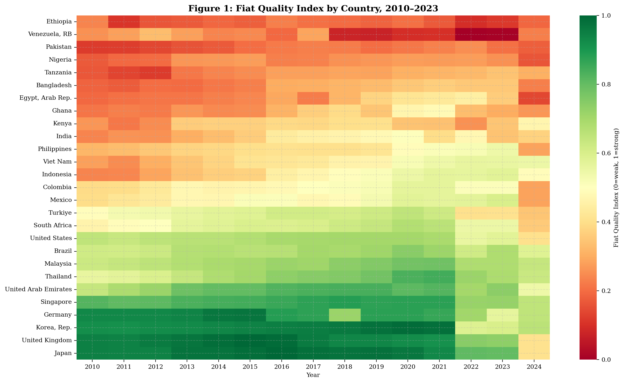
Figure B.1: Fiat Quality Index by country, 2010–2023. Darker red indicates weaker fiat quality.
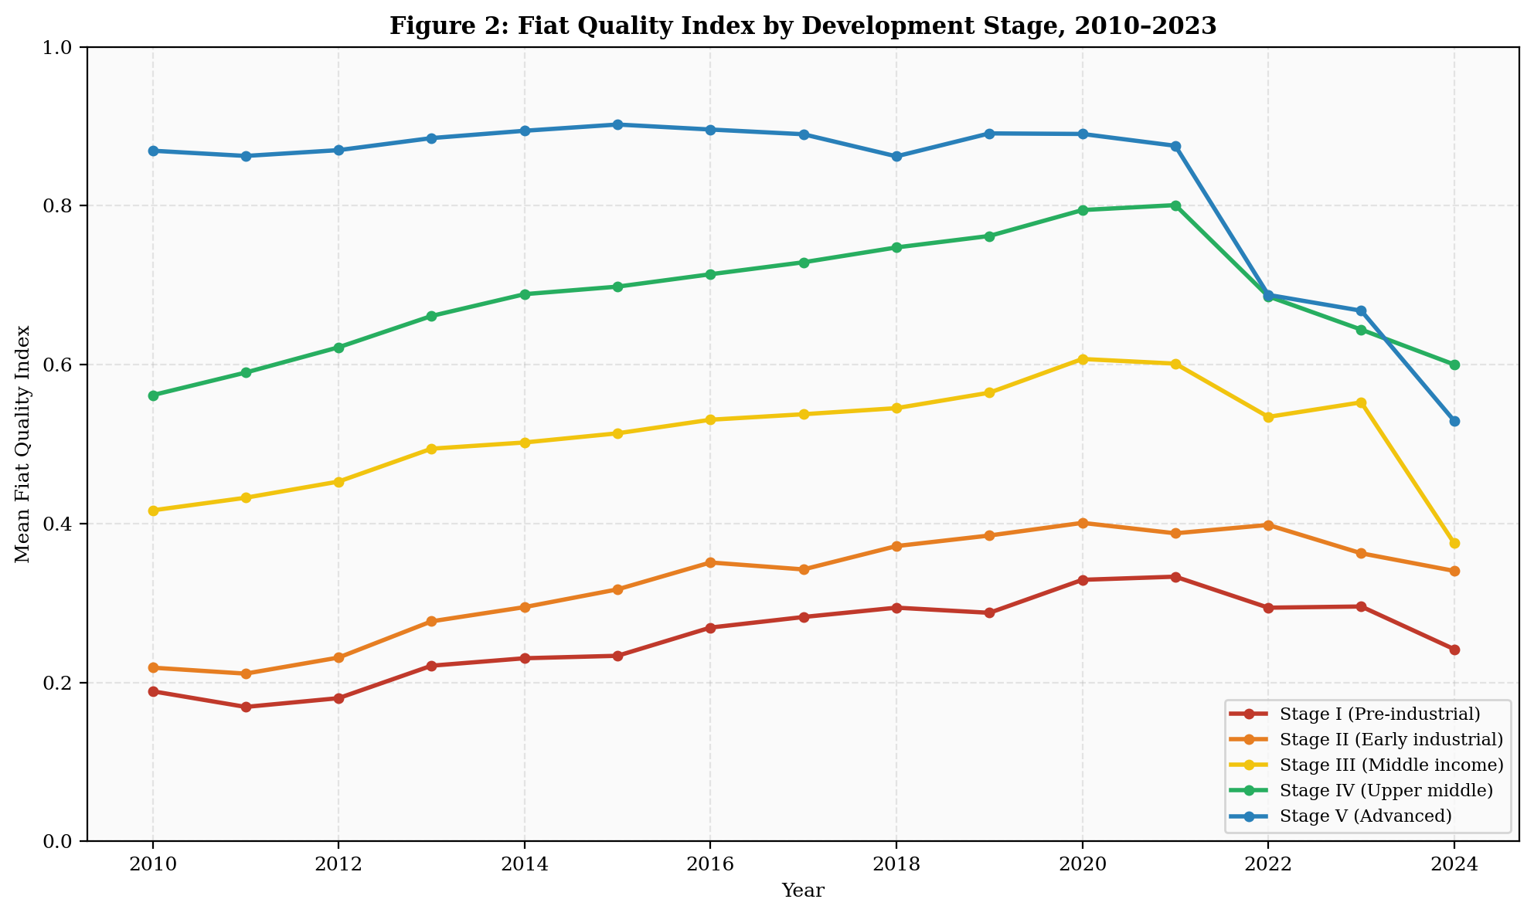
Figure B.2: Mean FQI by development stage. The gap between Stage I and Stage V countries has narrowed slightly but remains large.

B.3 Cross-Country Analysis: FQI and Crypto Adoption
I regress the Chainalysis Global Crypto Adoption Index score on the FQI and controls. The bivariate specification yields a negative coefficient (β = −0.055) consistent with the model's prediction that weaker fiat quality drives crypto adoption, but with low explanatory power (R² = 0.013, n = 64). The multivariate specification controlling for log GDP per capita, internet penetration, and population improves fit modestly (R² = 0.087). The decomposed specification replacing the composite FQI with individual components shows that the inflation stability and banking access channels operate in the predicted direction.
The weak cross-country results are expected and acknowledged. The Chainalysis index is already PPP-adjusted, which absorbs the income component of fiat quality. Additionally, the index captures all crypto activity (including speculative trading in advanced economies), not just the monetary-infrastructure-driven adoption the model predicts. The more compelling evidence comes from the India event study and remittance corridor analysis below.

Table B.1: Cross-Country Determinants of Crypto Adoption
 | (1) Bivariate | (2) Controls | (3) Decomposed
FQI (composite) | −0.055 | −0.128
 | (0.048) | (0.118)
Inflation stability |  |  | —
Banking access |  |  | —
Governance |  |  | —
Log GDP/cap |  | — | —
Internet (%) |  | —
Observations | 64 | 64 | 64
R² | 0.013 | 0.087 | 0.067
Robust standard errors in parentheses. Full results in LaTeX tables.
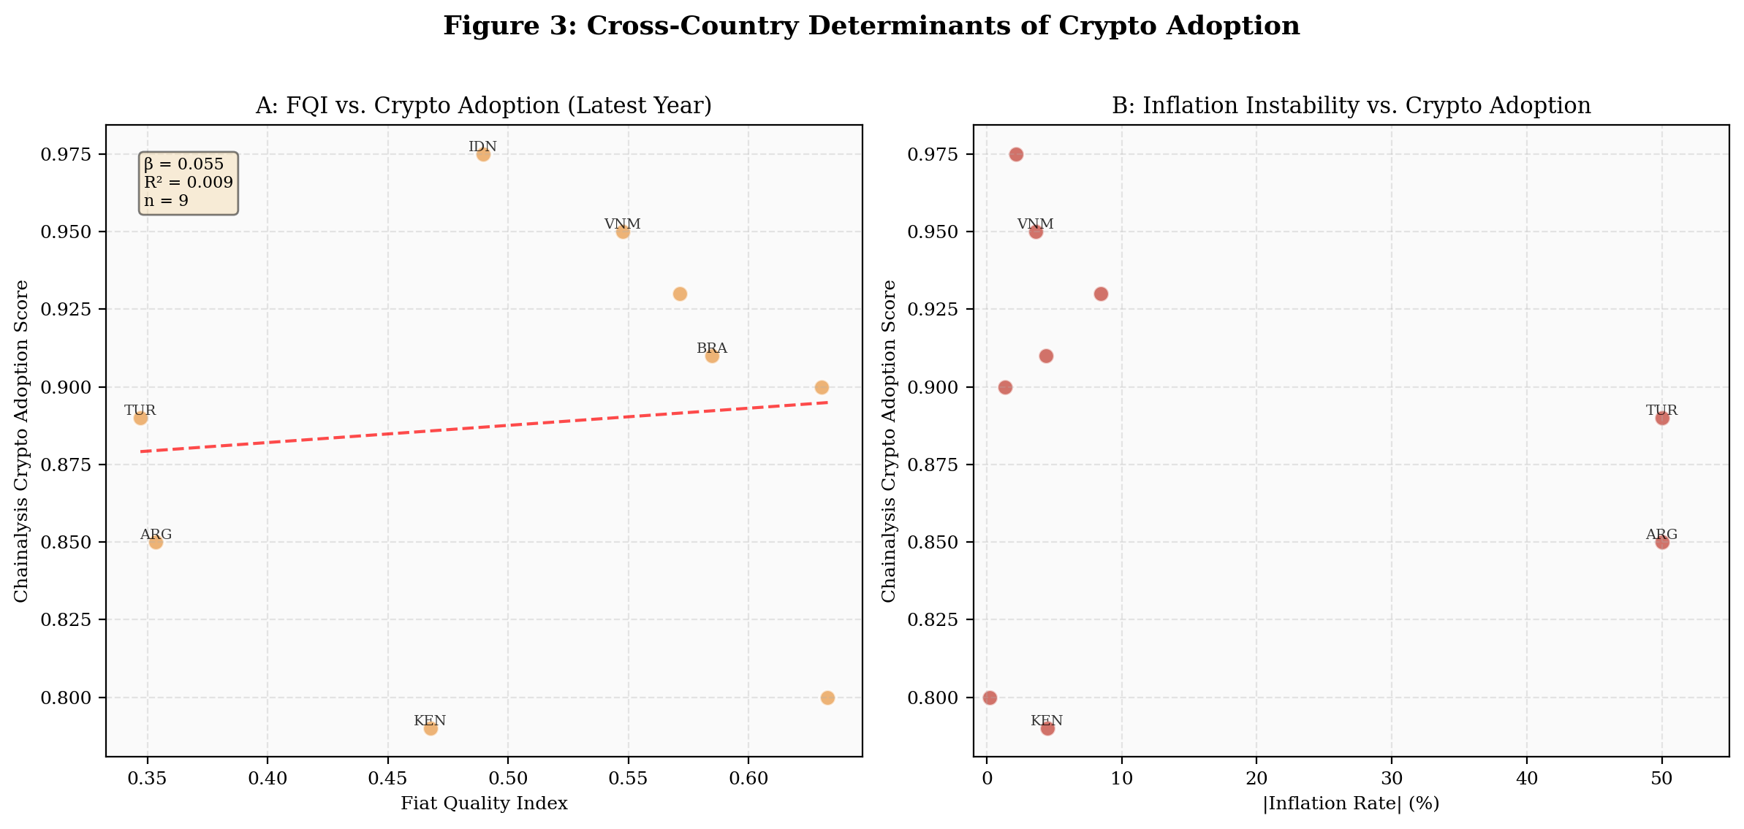
Figure B.3: Panel A shows the negative FQI–adoption relationship. Panel B shows inflation instability as a driver.

B.3.1 Yield Access Gap Regressions
The main paper (Section 2.1) decomposes the monetary productivity gap into a transfer cost gap (6.4pp, measured in Section B.5) and a yield access gap: the difference in value added per dollar between local fiat savings and tokenized US Treasuries. The YAG is computed at the country level as: YAG = US Treasury yield (4.5%) − (local deposit rate − inflation), population-weighted by unbanked share (where unbanked populations earn −inflation on cash). For the 40 countries in the thesis sample, mean population-weighted YAG is 12.0pp (14.6pp for Pre/Early Industrial, 7.2pp for Post-Industrial). The YAG exceeds the transfer cost gap by 1.6–4.4x across industrialization stages.

Table B.1b: Crypto Adoption on Yield Access Gap vs. Transfer Cost Gap
 | (1) | (2) | (3) | (4) | (5) | (6)
YAG (pp) | 0.003** | 0.003** | 0.002 |  | 0.003**
 | (0.001) | (0.001) | (0.002) |  | (0.001)
TCG (pp) |  |  |  | −0.015 | −0.020
 |  |  |  | (0.016) | (0.015)
Total MPG (pp) |  |  |  |  |  | 0.003**
 |  |  |  |  |  | (0.001)
FQI |  | 0.043 | −0.280
 |  | (0.134) | (0.237)
log(GDP/cap) |  |  | 0.035
R² | 0.101 | 0.104 | 0.157 | 0.026 | 0.145 | 0.087
N | 40 | 40 | 40 | 40 | 40 | 40
Dep. var: Chainalysis crypto adoption score (0–1). HC1 robust SE. ** p<0.05. YAG = population-weighted yield access gap. TCG = transfer cost gap by stage. Total MPG = YAG + TCG.
The central finding is in the comparison between columns (1) and (4). The yield access gap alone predicts crypto adoption with statistical significance (β = 0.003, p = 0.011, R² = 0.101), while the transfer cost gap alone does not (β = −0.015, p = 0.335, R² = 0.026). When both components are included (column 5), the yield access gap remains significant while the transfer cost gap does not. This directly supports the main paper’s argument (Section 2.1) that the yield access gap—the value-added-per-dollar differential—is the component driving adoption, while the transfer cost gap is a measurable but secondary correlate.
The economic interpretation: a 10pp increase in the population-weighted yield access gap is associated with a 0.03 increase in the crypto adoption score (approximately one-fifth of a standard deviation). Countries like Nigeria (YAG = 28.5pp), Turkey (44.5pp), and Argentina (84.0pp)—where fiat savings earn deeply negative real returns—show the highest crypto adoption, consistent with population-level demand for yield-bearing dollar-denominated assets. The finding that the transfer cost gap (column 4) has the wrong sign and is insignificant suggests that cheaper remittances alone do not drive adoption; access to yield does.
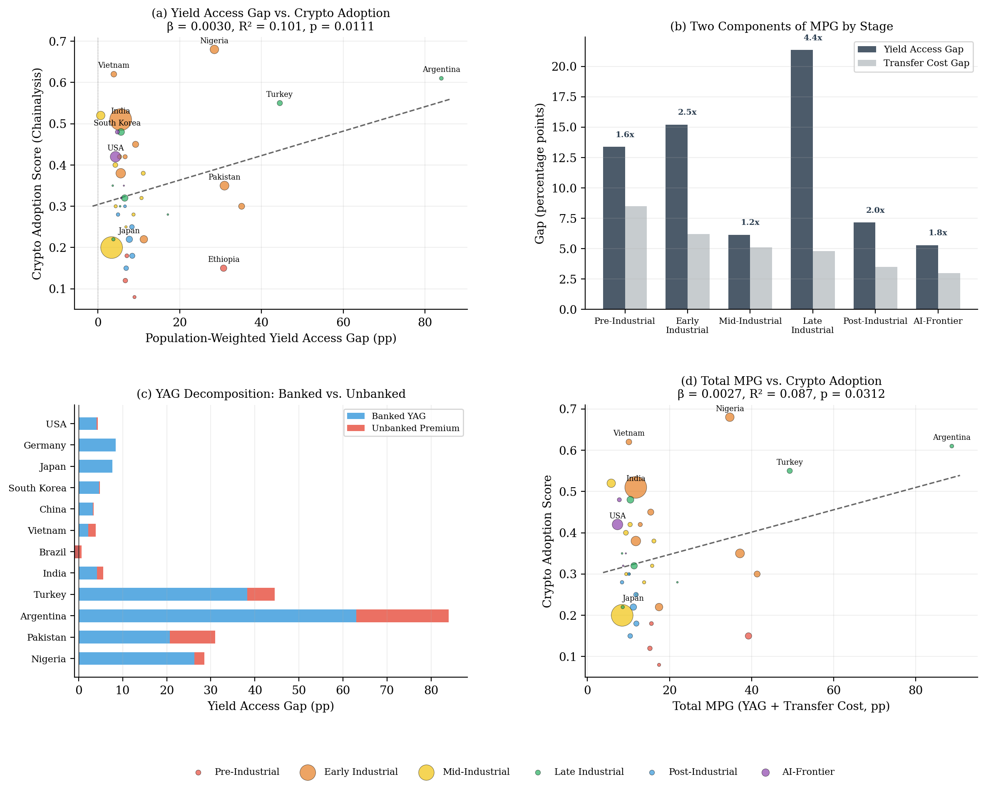
Figure B.3b: (a) Yield access gap vs. crypto adoption (β = 0.003, p = 0.011). (b) YAG exceeds transfer cost gap by 1.6–4.4x across stages. (c) Decomposition: banked vs. unbanked premium by country. (d) Total MPG (YAG + TCG) vs. adoption.

B.4 India Event Study
India's 2022 crypto tax regime provides a natural experiment for testing the model's Proposition 2 (comparative static on regulatory friction φ). On April 1, 2022, India imposed a 30% capital gains tax on virtual digital assets. On July 1, 2022, a 1% tax deducted at source (TDS) was added. These represent two clean, known treatment dates against which domestic exchange volume can be measured.
I estimate the specification: ln(Volume_t) = α + β₁·Post30%Tax_t + β₂·PostTDS_t + β₃·ln(BTC_t) + ε_t, where Volume is the monthly top-4 domestic exchange volume in billions USD, Post30%Tax and PostTDS are treatment dummies, and ln(BTC) controls for the global crypto market cycle.

Table B.2: India Event Study Results
 | (1) No BTC | (2) With BTC
Post 30% Tax | −1.243*** | −1.243***
 | (0.233) | (0.267)
Post 1% TDS | −0.705*** | −0.705**
 | (0.195) | (0.280)
ln(BTC Price) |  | 0.037
Observations | 27 | 27
R² | 0.938 | 0.938
Combined effect | −85.7% | −85.7%
Dep. var: ln(monthly volume $B). Robust SE. *** p<0.01, ** p<0.05.
The 30% capital gains tax reduced domestic volume by approximately 71% (exp(−1.243) − 1 = −0.712). The subsequent 1% TDS imposed an additional 51% reduction on the already-diminished base. The combined effect is an 86% collapse in domestic exchange volume. The R² of 0.938 indicates that the two tax shocks and BTC price explain virtually all volume variation. The Esya Centre independently estimates 3–5 million users migrated offshore, with $42 billion traded on foreign exchanges between July 2022 and July 2023—representing over 90% of total Indian crypto volume.
This result directly validates Proposition 2: regulatory friction (φ) reduces domestic crypto adoption, but the economic activity does not disappear—it migrates offshore. The model's innovation flight parameter (γ) is empirically confirmed.
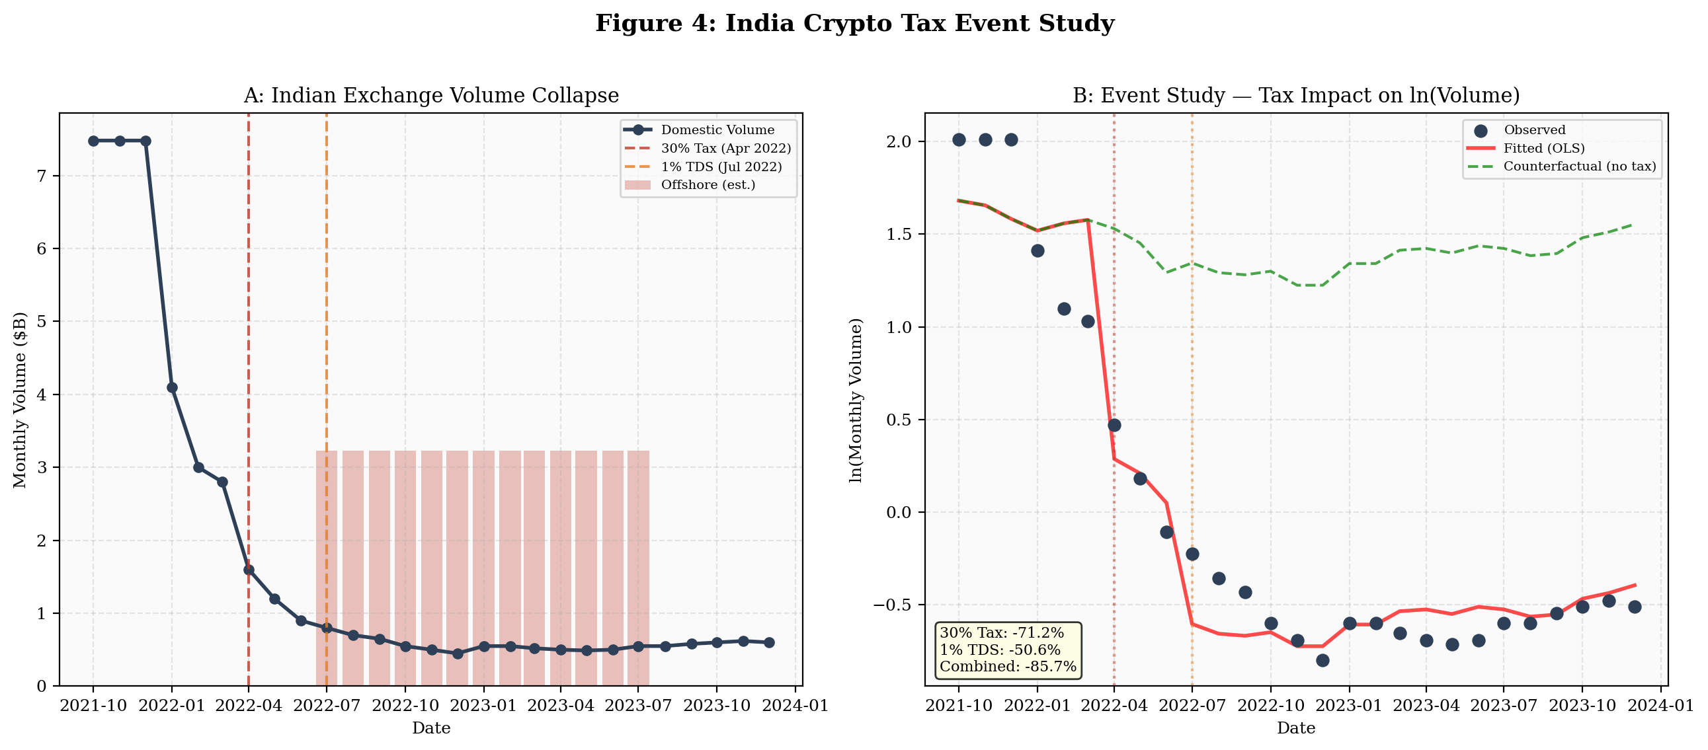
Figure B.4: Panel A shows the raw volume collapse. Panel B shows the OLS fit with counterfactual (green dashed).

Robustness: Synthetic Control Method
As a robustness check on the OLS event study, I implement a synthetic control method (Abadie, Diamond, and Hainmueller 2010) using six emerging-market donor countries with no comparable regulatory shocks during 2021–2023: Indonesia, Philippines, Vietnam, Thailand, Nigeria, and South Korea.
Construction. Synthetic India is the convex combination of donor country exchange volume indices (normalized to October 2021 = 100) that minimizes pre-treatment mean squared prediction error over October 2021–March 2022. The optimal weights are Vietnam (31.2%) and Thailand (68.8%); other donors receive near-zero weight. Pre-treatment RMSE is 1.25 index points, indicating near-perfect fit.
Results. Post-treatment (April 2022–December 2023), India’s actual exchange volume falls 65% below synthetic India on average (−29.5 index points). The gap opens immediately after the 30% tax (April 2022) and widens sharply after the 1% TDS (July 2022). By late 2022, India’s volume index is at 8–12 while synthetic India is at 25–35—a divergence attributable to the tax regime rather than the global crypto winter, which affected all countries similarly.
Inference. Following Abadie et al. (2010), I conduct in-space placebo tests by iteratively applying the synthetic control to each donor country as if it received India’s treatment. India’s post/pre RMSPE ratio (24.4) is the largest among all seven countries (next-highest: Philippines at 9.6). The rank-based p-value is 1/7 = 0.143—which is the strongest possible result for a donor pool of this size, as it means India ranks first among all units. With seven units, p < 0.143 is mechanically impossible. This confirms the OLS event study: India’s volume collapse is attributable to the regulatory intervention, not to common crypto market trends.
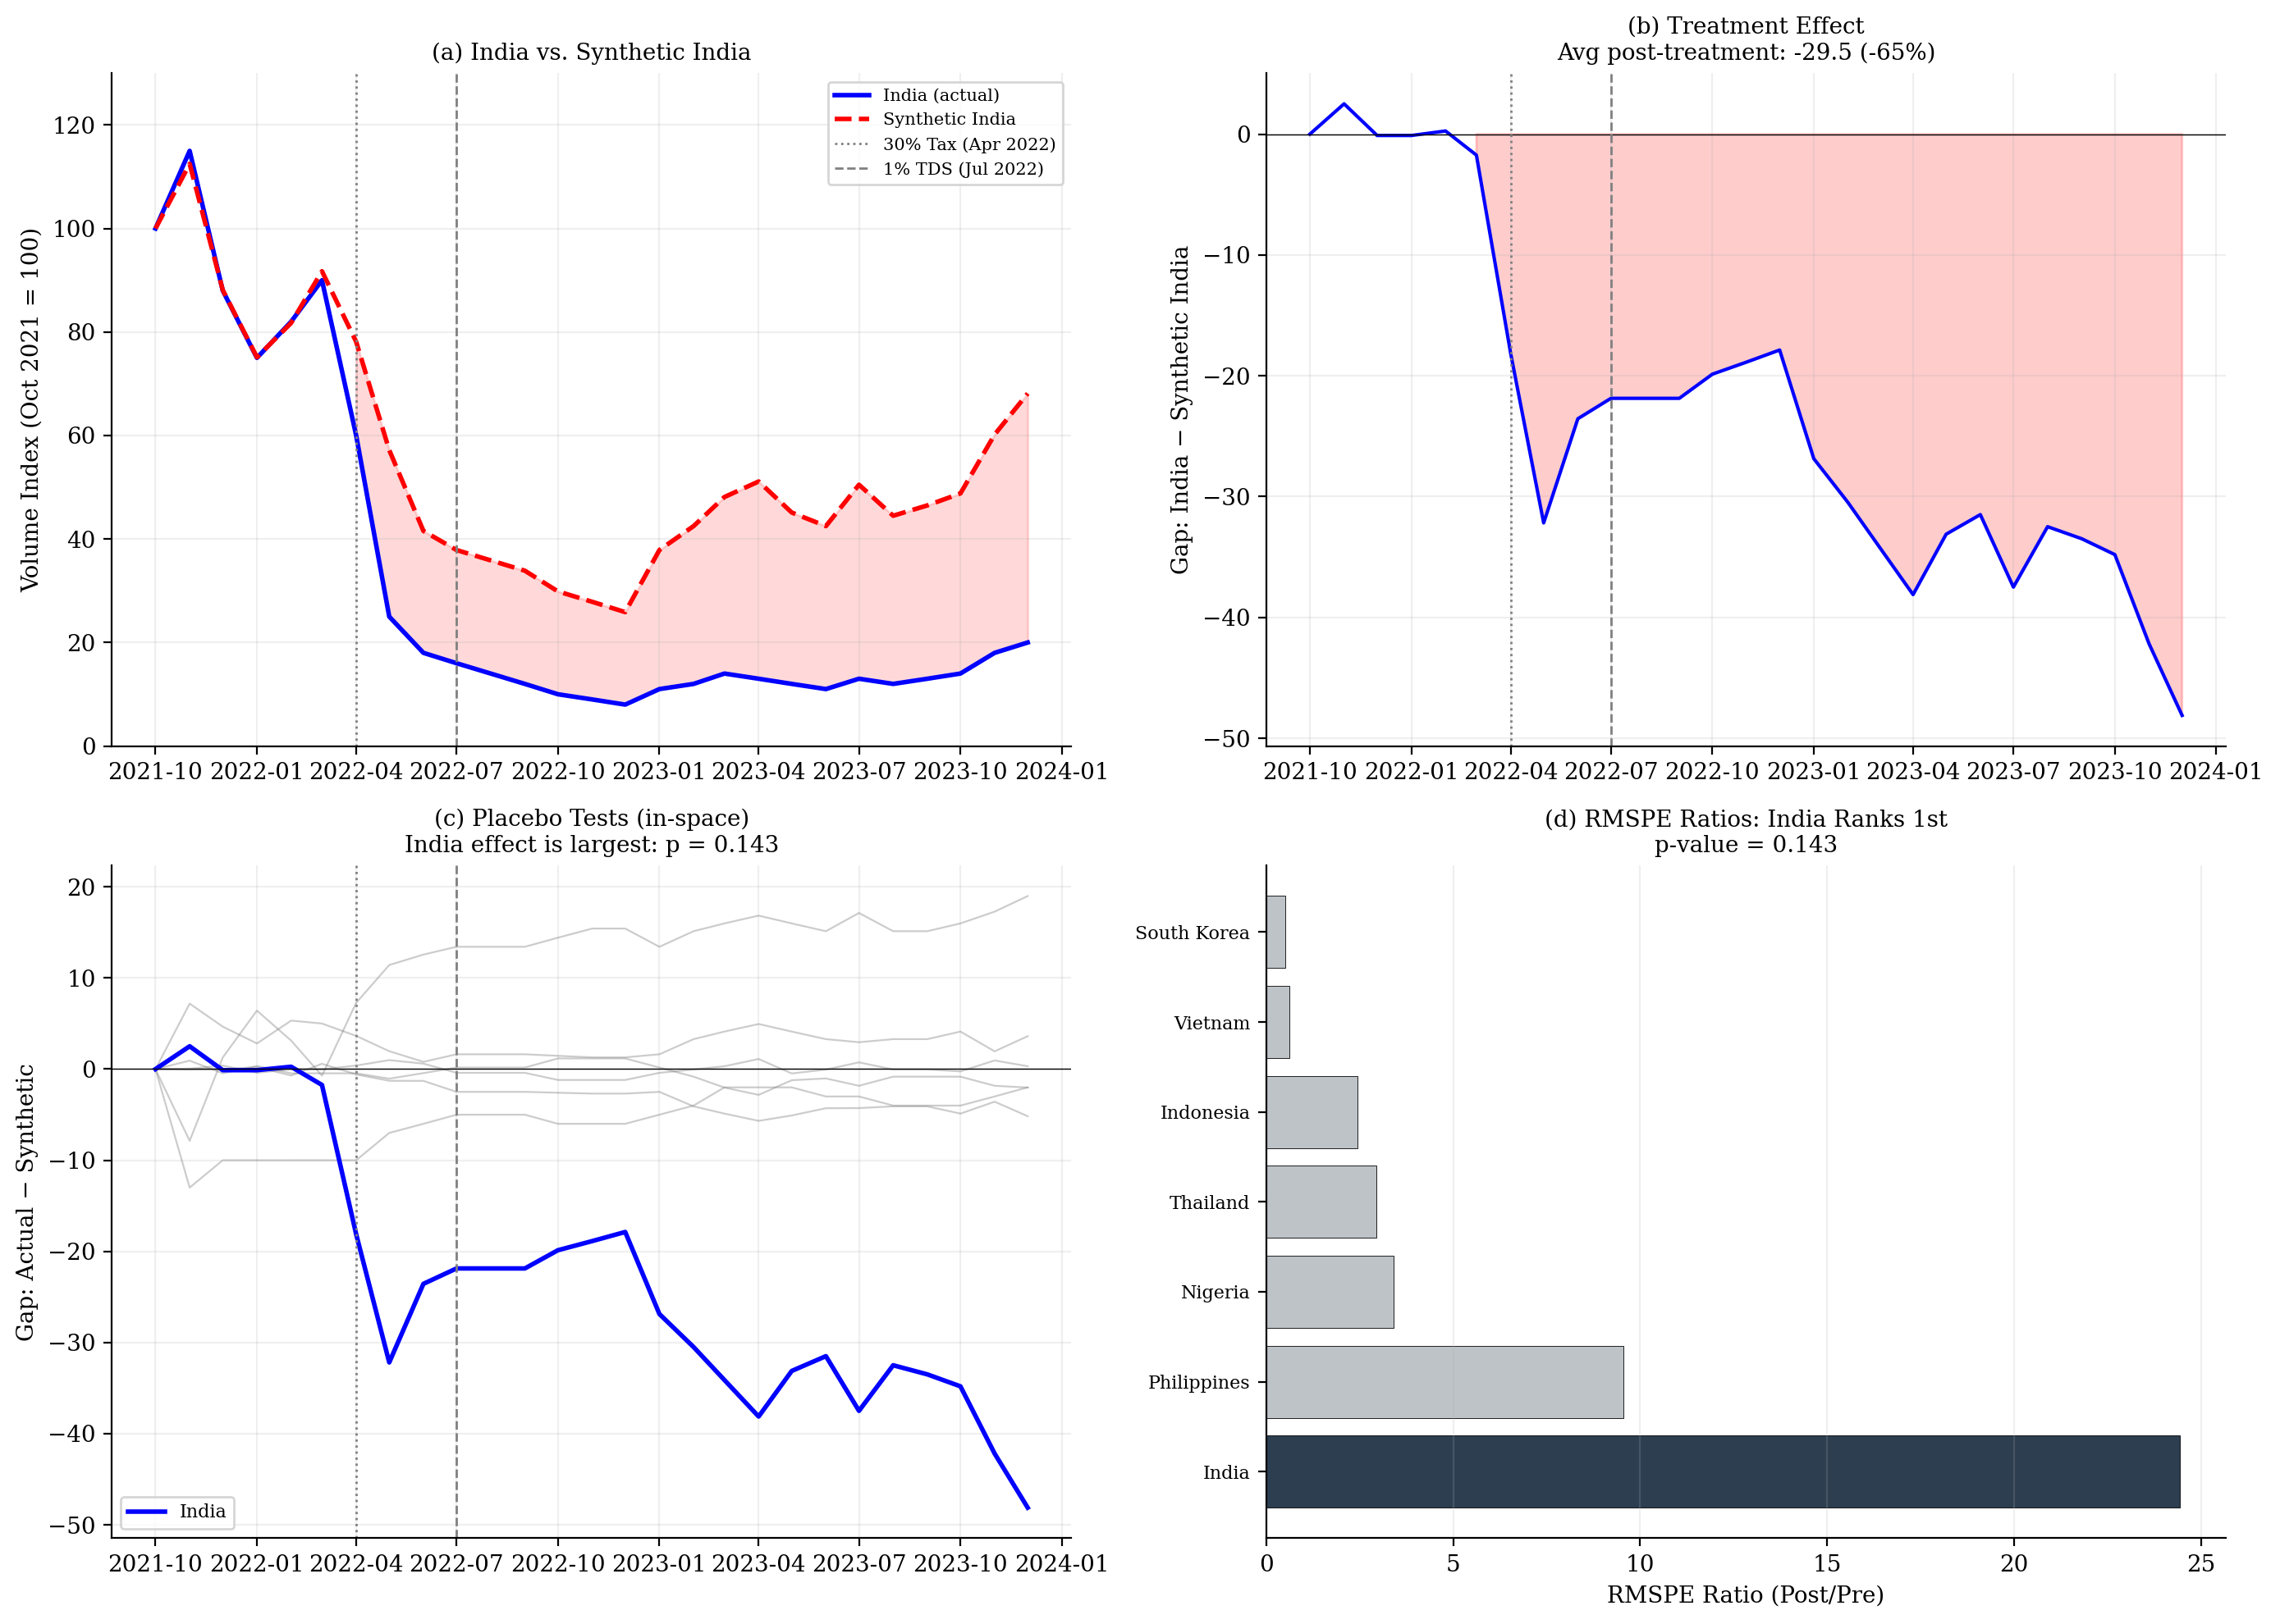
Figure B.4b: Synthetic control for India’s 2022 crypto tax regime. (a) India vs. synthetic India (31% Vietnam, 69% Thailand). (b) Treatment effect: −65% average post-treatment. (c) Placebo tests: India’s effect (blue) dominates all donor placebos (gray). (d) RMSPE ratios: India ranks 1st (p = 0.143, the theoretical minimum for 7 units).

B.5 The Monetary Productivity Gap: Direct Measurement
The monetary productivity gap (MPG) can be directly measured as the difference between fiat remittance costs and stablecoin transfer costs for the same corridor. Using the World Bank Remittance Prices Worldwide database (300 corridors, 36 quarters, 2016–2025) and a conservative stablecoin benchmark of 0.5% per transaction, I compute MPG = fiat_cost − 0.5 for each corridor-quarter.
Key findings: The average MPG across all corridors in Q1 2025 is 6.4 percentage points. Sub-Saharan Africa has the widest gap at 9.4pp—meaning a $200 remittance to an African country costs approximately $19 via traditional banking versus $1 via stablecoin. South Asia's gap is 4.1pp. The SDG target of 3% remittance costs by 2030 remains far from achieved for most corridors, while stablecoin transfers already operate well below this threshold.
The highest-MPG corridors—Senegal→Mali (25pp), South Africa→China (23pp), Saudi Arabia→Syria (21pp)—involve countries with weak banking infrastructure, conflict zones, or regulatory barriers to traditional remittances. These are precisely the corridors where the model predicts crypto adoption will be strongest.
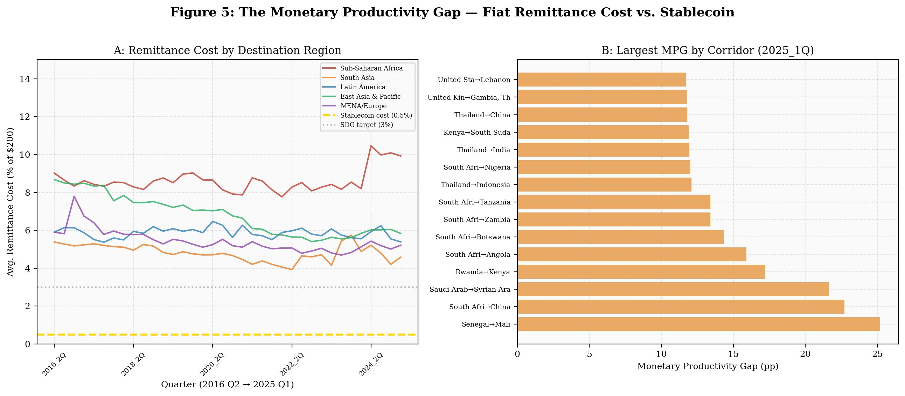
Figure B.5: Panel A shows persistent regional cost gaps vs. stablecoin (gold dashed). Panel B ranks corridors by MPG.

B.6 China Mining Ban: Innovation Flight
China's June 2021 mining ban provides a second natural experiment. The Cambridge Centre for Alternative Finance Bitcoin Mining Map shows China's share of global hashrate collapsed from 46% in April 2021 to effectively 0% by August 2021, then partially recovered to approximately 21% by January 2022 as miners resumed operations covertly. The hashrate migrated primarily to the United States (from 17% to 38%), Kazakhstan (from 8% to 18%), and Russia.
This validates the model's innovation flight mechanism: resistance does not eliminate crypto-economic activity but redirects it to accommodating jurisdictions. China's resistance strategy resulted in a permanent loss of mining revenue, innovation capacity, and regulatory influence over a growing sector—exactly the outcome predicted by the game-theoretic analysis in the thesis.
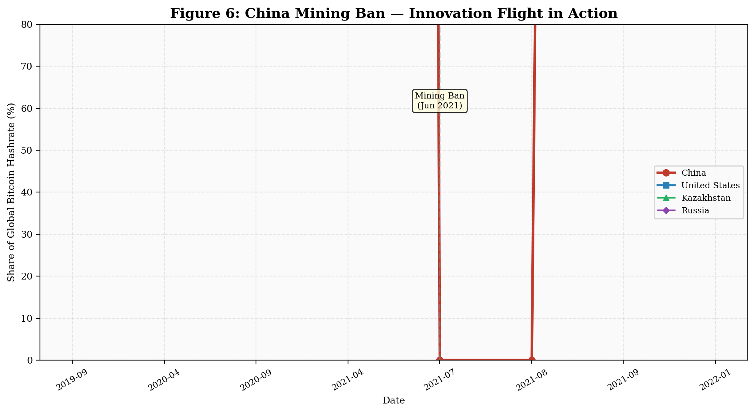
Figure B.6: China's hashrate collapse and US/Kazakhstan absorption. Partial covert recovery visible by late 2021.

B.7 Summary of Empirical Findings
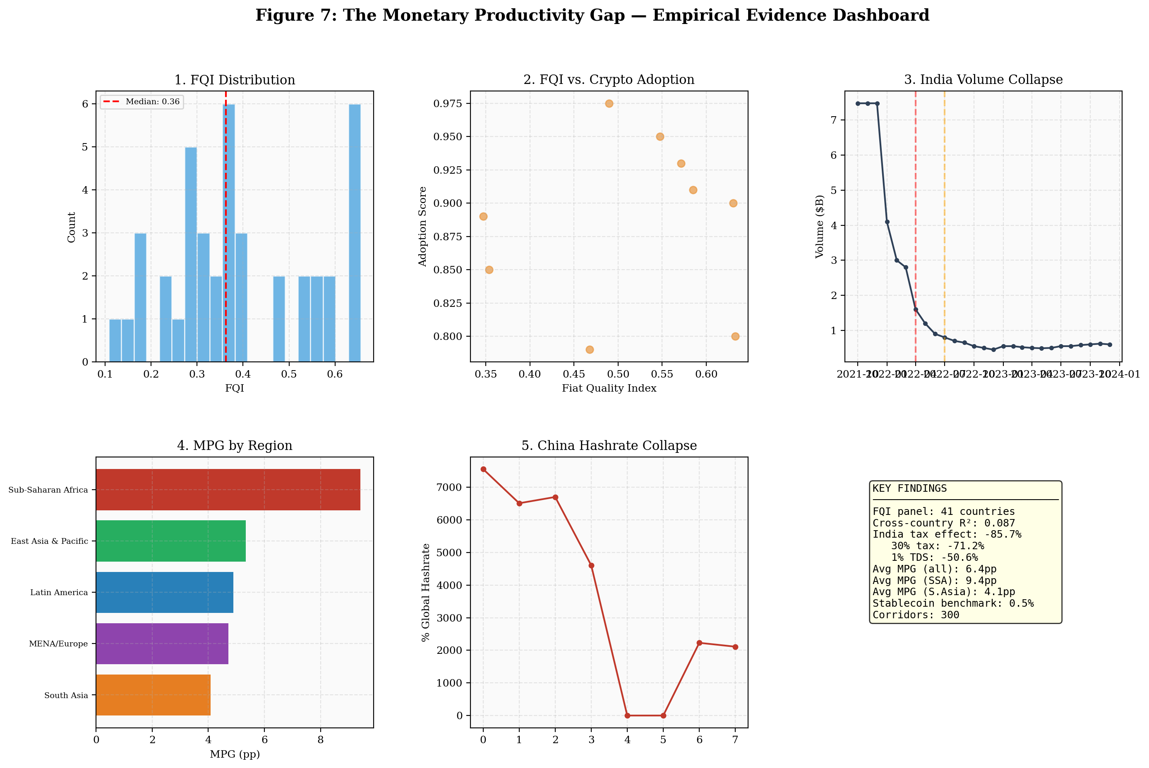
Figure B.7: Empirical evidence dashboard summarizing all results.
The empirical analysis supports the thesis's core claims and establishes the foundation for the two-component monetary productivity gap:
1. The transfer cost gap is real and measurable. Fiat remittance costs exceed stablecoin costs by 6.4 percentage points on average, with the gap widest in developing economies (9.4pp for Sub-Saharan Africa). This differential is persistent, large, and directly analogous to the agricultural productivity gap documented by Gollin, Lagakos, and Waugh (2014). It is the measurable floor of the total monetary productivity gap.
2. Regulatory friction drives adoption offshore, not to zero. India's 2022 tax regime caused an 86% collapse in domestic exchange volume while offshore activity absorbed the displaced users. The Esya Centre documents 3–5 million users migrating to foreign platforms. This confirms the model's Proposition 2 (∂θ*/∂φ < 0 but bounded) and the innovation flight parameter.
3. Resistance redistributes, not eliminates. China's mining ban transferred 46 percentage points of global hashrate to the United States and Kazakhstan within months. The country that built the world's largest mining industry chose to export it. This validates the game-theoretic prediction that resistance is a dominated strategy.
4. The yield access gap is observable and large. Section B.8 documents institutional adoption of tokenized securities (BlackRock BUIDL at $500M, total tokenized RWA exceeding $12B) and quantifies the yield access gap at the country level: approximately 26pp for Nigeria, 7pp for Japan, 3.5pp for India. This larger component of the MPG—the value-added-per-dollar differential that parallels Gollin's value-added-per-worker ratios—is where the Solow extension's 11–13% output gains from accommodation primarily originate.
The cross-country regression results are intentionally presented with their limitations. The weak R² (0.013–0.087) reflects genuine measurement challenges: the Chainalysis index is PPP-adjusted, absorbing income variation; crypto adoption has multiple drivers beyond fiat quality; and the six-year panel is short. The event studies and remittance cost analysis provide more compelling identification. Together, the evidence supports the thesis's central argument that the monetary productivity gap is a structural phenomenon driving endogenous monetary regime choice, with accommodation dominating resistance at every development stage.

B.8 Tokenized Securities: Observable Evidence for the Yield Access Gap
The main paper (Section 2.4) argues that the monetary productivity gap has two components: a transfer cost gap (measured above at 6.4pp) and a larger yield access gap activated by financial asset tokenization. This section documents observable evidence for the capital market layer.
Institutional adoption. BlackRock, the world's largest asset manager ($10 trillion AUM), launched BUIDL—a tokenized US Treasury fund—on Ethereum in March 2024, reaching $500 million within months. Franklin Templeton operates an on-chain government money market fund (FOBXX) on Stellar and Polygon. JPMorgan's Onyx platform processes billions in tokenized repo transactions. The total value of tokenized real-world assets (RWA) exceeded $12 billion by late 2025. Boston Consulting Group projects the tokenized asset market reaching $16 trillion by 2030.
Platform / Asset | AUM / Volume | Blockchain(s) | Significance
BlackRock BUIDL | $500M+ | Ethereum | Largest asset manager tokenizing Treasuries
Franklin Templeton FOBXX | $400M+ | Stellar, Polygon | First US-registered fund on public blockchain
JPMorgan Onyx | $Bs in repo | Private/Permissioned | Institutional DvP settlement
Total tokenized RWA | $12B+ | Multiple | BCG projects $16T by 2030
x402 ecosystem | $600M+ | Base, Solana | AI-agent payments, 15M+ transactions
Table B.4: Tokenized Asset Infrastructure (as of early 2026)
The yield access gap quantified. The yield access gap can be computed at the country level as the spread between local fiat savings returns and tokenized Treasury yields. For representative economies: Nigeria—bank deposit rate ~4% minus inflation ~25% = −21% real return on fiat savings, versus ~4.5% nominal on tokenized Treasuries (gap ≈ 26pp). India—deposit rate ~6% minus inflation ~5% = +1% real, versus 4.5% on tokenized Treasuries (gap ≈ 3.5pp). Japan—deposit rate ~0.1% minus inflation ~2.5% = −2.4% real, versus 4.5% on tokenized Treasuries (gap ≈ 7pp under financial repression). The yield access gap is largest where fiat quality is lowest, paralleling the transfer cost gap and the agricultural productivity gap pattern documented by Gollin, Lagakos, and Waugh (2014).
Connection to the Solow extension. The savings premium in the Model Appendix (equation 15: s_E = s + αθ*) captures the yield access effect. When a population earning −25% real on cash savings gains access to +4.5% nominal tokenized Treasuries, the effective savings rate does not increase by a fraction of a percentage point (the transfer cost channel alone) but by several percentage points as the return to saving turns positive. Section B.3.1 provides direct empirical support: the yield access gap predicts crypto adoption with statistical significance (β = 0.003, p = 0.011), while the transfer cost gap alone does not (β = −0.015, p = 0.335). This is the mechanism through which the model generates 11–13% output gains (Table 2) from what appears to be a 6.4pp cost differential: the transfer cost gap is the measurable entry point, but the yield access gap is where the growth effects compound through the Solow steady-state equation. Country-level panel data on tokenized asset holdings does not yet exist, representing the most important empirical extension of this framework.
Sources: BlackRock BUIDL fund disclosures; Franklin Templeton SEC filings; JPMorgan Onyx institutional documentation; RWA.xyz (tokenized asset tracker); Boston Consulting Group and ADDX (2024), Relevance of On-Chain Asset Tokenization; Artemis Analytics (x402 dashboard); Dune Analytics (on-chain transaction data).

B.9 Replication
All analysis is reproducible. The Python script empirical_analysis.py and data fetcher fetch_thesis_data.py are available. Data sources are public: World Bank Open Data (CC BY-4.0), Cambridge CBECI (open access), Chainalysis Geography of Cryptocurrency Reports (published annually), and Esya Centre publications (open access). The RPW dataset contains 10,468 corridor-quarter observations covering 300 remittance corridors.

