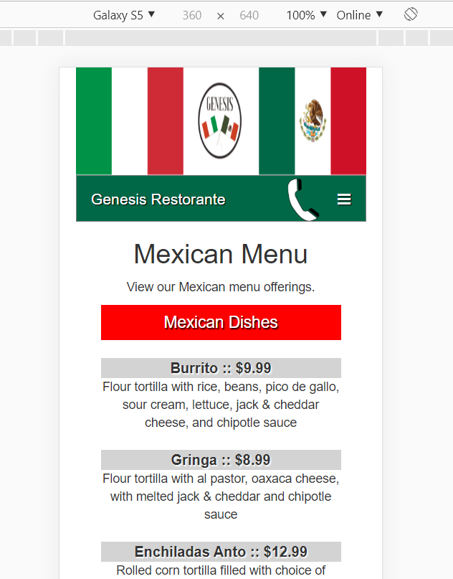 Phone link was not clearly identified as a full size button. Alter the border to ensure it stands out

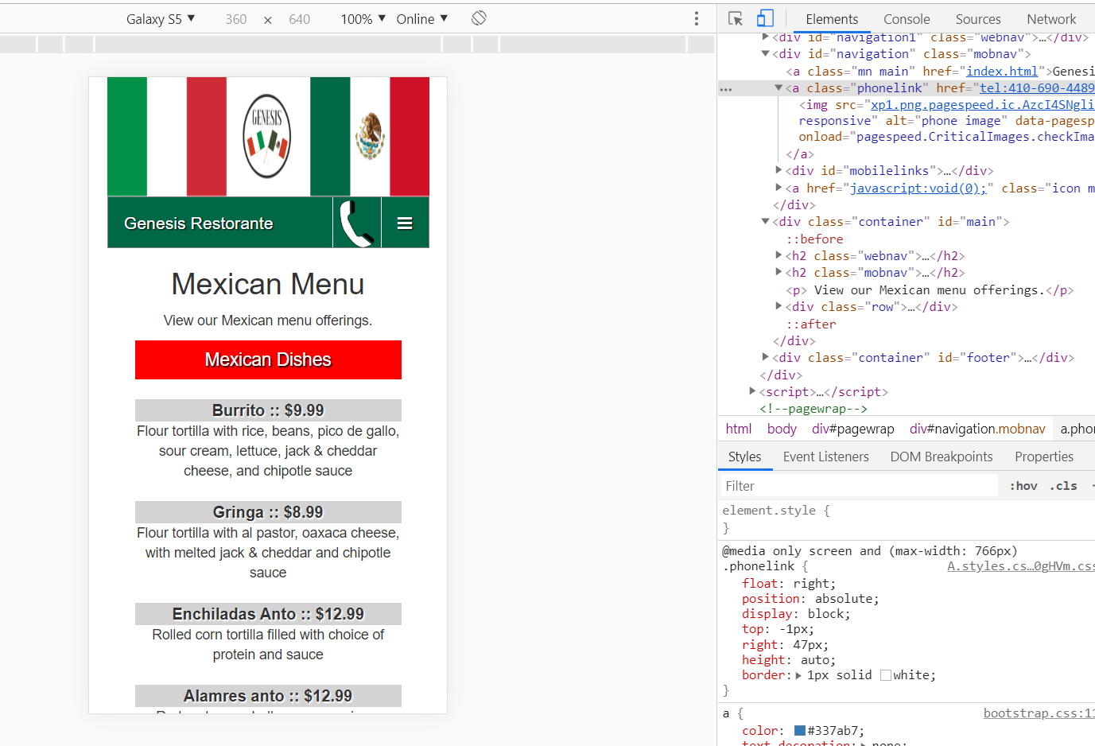

I will keep this change in the final design because it adds clarity to the nav bar.

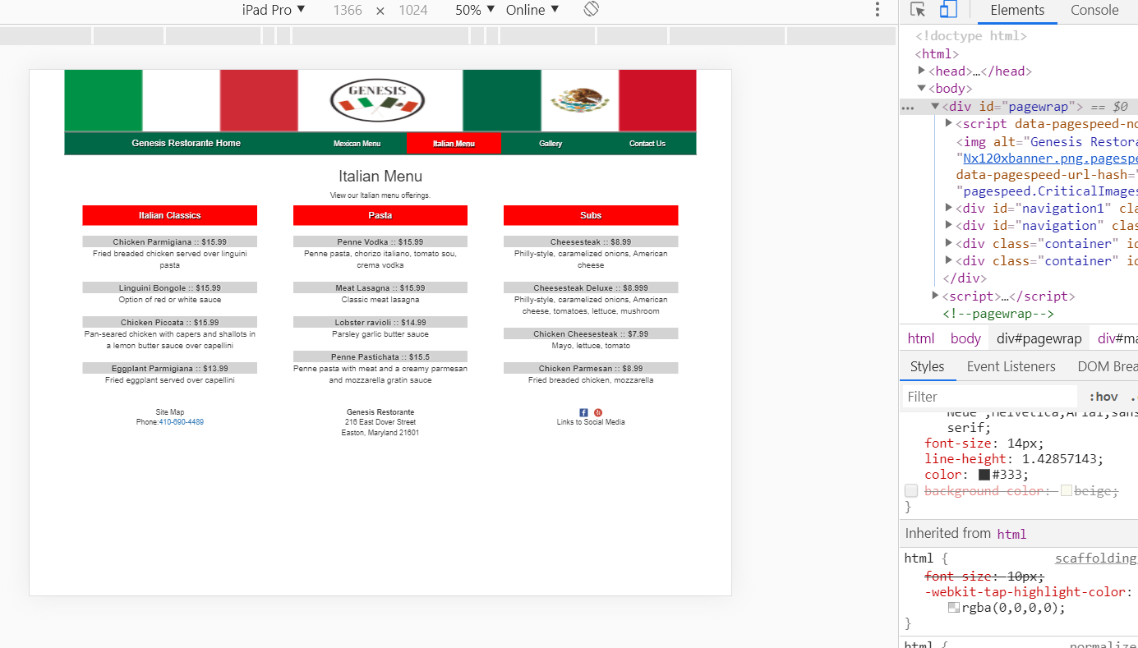

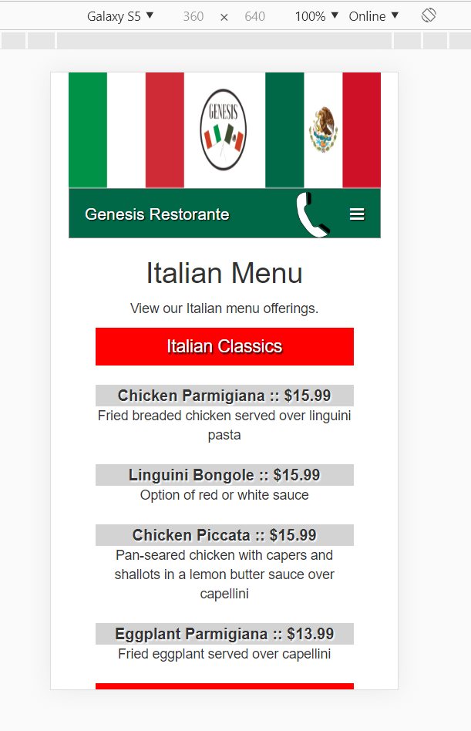Adding a background color to remove some of the whitespace and make it easier to focus on the content.

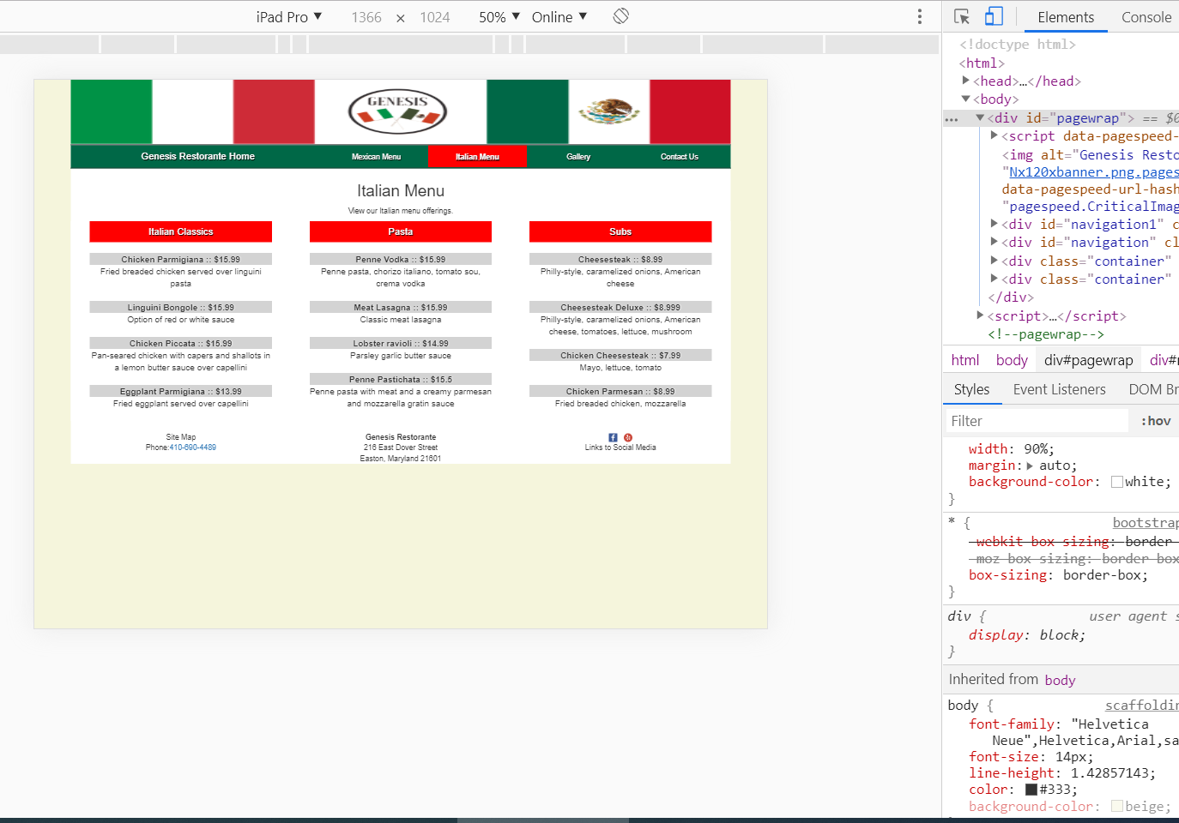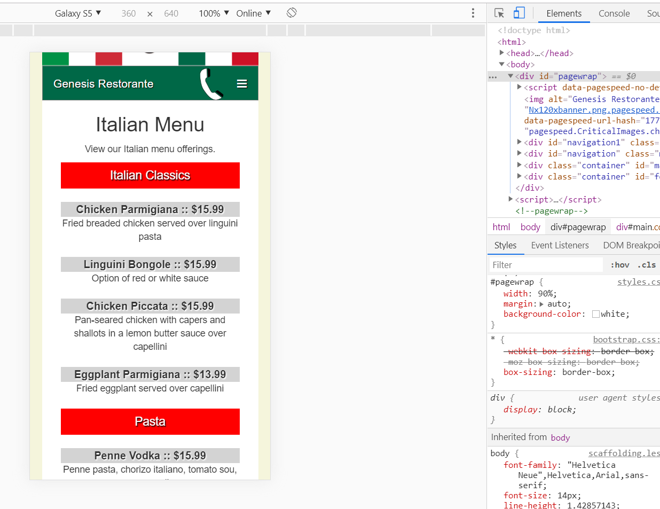

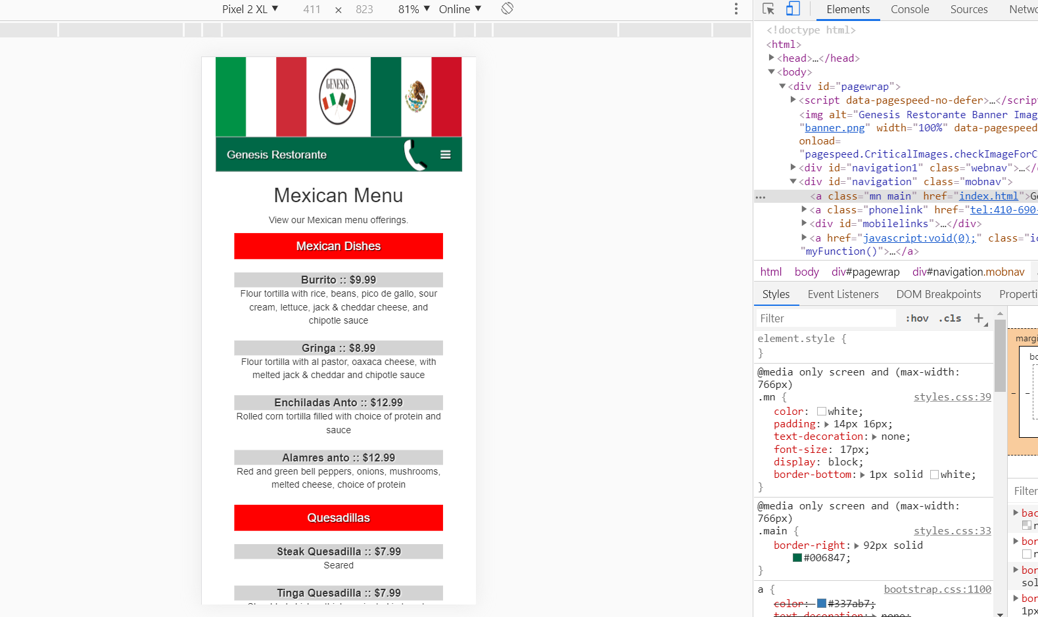

Alter the nav menu and menu items with underline text decoration. This makes the headers and menu items stand out just a bit more and would be worth keeping in the final design.

