l = 1/2; %längd på pendelns snöre
g = 9.82; %gravitation
h = 0.01;
T = 0:h:2;
n = length(T)-1;
Y = zeros(2, n+1);
Y(:,1) = [25*(pi/180); 0];
F = @(Y) [Y(2); -(g/l)*sin(Y(1))];
for j = 1:n
Y(:, j+1) = Y(:,j) + h.*F(Y(:, j));
end
hold on;
xlabel('Tid (s)');
ylabel('Utslagsvinkel (rad)');
for i = 1:n
scatter(T(i),Y(1,i), 'r');
end
Y = zeros(2, n+1);
Y(:,1) = [50*(pi/180); 0];
for j = 1:n
Y(:, j+1) = Y(:,j) + h.*F(Y(:, j));
end
for i = 1:n
scatter(T(i),Y(1,i), 'b');
end
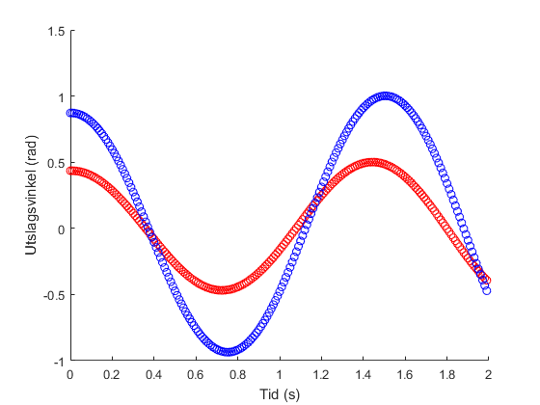
Published with MATLAB® R2016b

