ARMADA 610 Android Platform Full System Software release
Release Notes
Alpha3

Document Conventions
 | Note: Provides related information or information of special importance.
 | Caution: Indicates potential damage to hardware or software, or loss of data.
 | Warning: Indicates a risk of personal injury.
Document Status
Doc Status: Doc Status |  | Technical Publication: Int. Rev. No. x.xx

For more information, visit our website at: www.marvell.com
Disclaimer
No part of this document may be reproduced or transmitted in any form or by any means, electronic or mechanical, including photocopying and recording, for any purpose, without the express written permission of Marvell. Marvell retains the right to make changes to this document at any time, without notice. Marvell makes no warranty of any kind, expressed or implied, with regard to any information contained in this document, including, but not limited to, the implied warranties of merchantability or fitness for any particular purpose. Further, Marvell does not warrant the accuracy or completeness of the information, text, graphics, or other items contained within this document.
Marvell products are not designed for use in life-support equipment or applications that would cause a life-threatening situation if any such products failed. Do not use Marvell products in these types of equipment or applications.
With respect to the products described herein, the user or recipient, in the absence of appropriate U.S. government authorization, agrees:
1) Not to re-export or release any such information consisting of technology, software or source code controlled for national security reasons by the U.S. Export Control Regulations ("EAR"), to a national of EAR Country Groups D:1 or E:2;
2) Not to export the direct product of such technology or such software, to EAR Country Groups D:1 or E:2, if such technology or software and direct products thereof are controlled for national security reasons by the EAR; and,
3) In the case of technology controlled for national security reasons under the EAR where the direct product of the technology is a complete plant or component of a plant, not to export to EAR Country Groups D:1 or E:2 the direct product of the plant or major component thereof, if such direct product is controlled for national security reasons by the EAR, or is subject to controls under the U.S. Munitions List ("USML").
At all times hereunder, the recipient of any such information agrees that they shall be deemed to have manually signed this document in connection with their receipt of any such information.
Copyright © 2026. Marvell International Ltd. All rights reserved. Marvell, the Marvell logo, Moving Forward Faster, Alaska, Fastwriter, Datacom Systems on Silicon, Libertas, Link Street, NetGX, PHYAdvantage, Prestera, Raising The Technology Bar, The Technology Within, Virtual Cable Tester, and Yukon are registered trademarks of Marvell. Ants, AnyVoltage, Discovery, DSP Switcher, Feroceon, GalNet, GalTis, Horizon, Marvell Makes It All Possible, UniMAC, and VCT are trademarks of Marvell. Intel XScale is a trademark or registered trademark of Intel Corporation or its subsidiaries in the United States and other countries. All other trademarks are the property of their respective owners.

Table of Contents
1 About This Document 5
1.1 Purpose 5
1.2 Product/Sub-Product Overview 5
1.3 Document Structure 5
A Revision History 6
2 System Requirements 7
Hardware Requirements 7
Software Requirements 7
3 Release Differences 8
3.1 Differences between Alpha3 and Alpha2.5 8
3.1.1 BSP Differences 8
3.1.2 Android Differences 8
3.1.3 Others 8
3.2 Differences between Alpha2.5 and Alpha2 8
3.2.1 BSP Differences 8
3.2.2 Android Differences 8
3.2.3 Others 9
3.3 Differences between Alpha2 and Alpha1.1 9
3.3.1 BSP Differences 9
3.3.2 Android Differences 9
3.3.3 Others 9
3.4 Differences between Alpha1.1 and Alpha1 10
3.4.1 BSP Differences 10
3.4.2 Android Differences 10
3.4.3 Others 10
3.5 Differences between Alpha1 and PreAlpha2 10
3.5.1 BSP Differences 10
3.5.2 Android Differences 10
3.5.3 Others 11
4 Platform Features 12
4.1 Android Features 12
4.2 BSP Features 14
4.2.1 U-Boot 14
4.2.2 Linux-2.6.32 Kernel 14
5 Release Package Contents 16
6 Bonnell Setup and Configuration 17
7 Using the Prebuilt Binaries 18
7.1.1 How to know chip is booting up in armv6 mode or armv7 mode 18
7.1.2 Flashing OBM and U-Boot to NAND Using JTAG 19
7.1.3 Flashing OBM and U-Boot to eMMC Using JTAG 19
7.1.4 Flashing Android on eMMC Using U-Boot 20
8 Using the Patch Based Source Code 21
8.1.1 Setup Android working directory 21
8.1.2 Building the source code 21
8.1.3 Optimized OpenSSL for Marvell Platforms 22
9 Marvell Code Performance Analyzer 23
9.1.1 What's New 23
9.1.2 Features 23
9.1.3 System Requirements 23
9.1.4 Build, Install and Configuration 23
9.1.5 Known Issues or Limitations 24
10 Known Issues 25

List of Tables
Table 1: Document Structure 5
Table 2: Revision History 6

List of Figures
Error! No table of figures entries found.

About This Document

Purpose
This document contains the release notes for ARMADA 610 Android Platform Full System Software Alpha3 Release.

Product/Sub-Product Overview
This Software Release package provides a full Android system for the ARMADA 610 Bonnell reference board. The software includes both the prebuilt binaries, which users can flash to the board and start using immediately, as well as the source code, which users can customize and build to create new binaries.

Document Structure
This document contains the following chapters:
Table 1: Document Structure
Section | Description
About This Document | This section describes purpose, scope and structure of the document and lists document conventions and used acronyms.
System Requirement | Hardware and Software requirement for building, running the release
Platform Features | This section lists the features that are supported.
Release Package Contents | Contents description of the release package
Bonnell Setup and Configuration | Instructions of how to set up and configure Bonnell reference board
Using the Prebuilt Binaries | Instructions of how to use the prebuilt binaries in the release package
Using the Patch Based Source Code | Instructions of how to use the patch based source code to build out binaries.
Known Issues and Workarounds | Know issues and workarounds.

- Revision History
Table 2: Revision History
Document No and Revision | Int Rev | Description | Date
 | 0.1 | Initial version | 2010-3-23
 | 0.2 | Add difference from previous release (pre-alpha2 to alpha1) | 2010-3-24
 | 0.5 | Add Bonnell Setup and Configuration chapter and merge feedbacks | 2010-3-25
 | 0.6 | Add obm build description | 2010-3-31
 | 0.7 | Add known issues | 2010-4-2
 | 1.0 | Update to alpha1.1 release | 2010-4-26
 | 1.1 | Update to alpha2 release | 2010-5-28
 | 1.2 | Update to alpha2.5 release | 2010-6-30
 | 1.3 | Update to alpha3 release | 2010-7-28

System Requirements

Hardware Requirements
Bonnell reference board with the Armada 610 revision Z1 processor and 512MB of LPDDR2

Software Requirements
- Host PC with operating system Ubuntu 8.04 or 9.04.
We routinely test the Android build on these 2 versions.
We have received reports that there are build errors using Ubuntu 9.10 which requires patches for android code to enable a successful build. So using 8.04 or 9.04 is highly recommended.

Release Differences

Differences between Alpha3 and Alpha2.5

BSP Differences
- Print MMP2 stepping in uboot booting up
- Use DDR calibration hardware method to reduce latency
- Enlarge PMEM from 16MB to 32MB
- External SD slot clock was set to max 24MHz.

Android Differences
- Upgrade android version from Éclair(2.1) to Froyo(2.2)
- Build android image with vfp and armv7 support.
- Enabled audio record.
- Cmu is not integrated
- IPPCodec/vmeta is not integrated in OpenCore. So .3gpp and .mp4 High resolution(720p and above) video is not supported.
- Add suspend/resume support. Need echo disable_suspend > /sys/power/wake_unlock to remove the disable_suspend wakelock to let device to enter suspend.

Others
- Gc800 upgrade to version 0.8.0.1739
- Marvell performance analyzer tool update to version 2.3.54
- Use arm-marvell-linux-gnueabi-vfp-4.2.0 to build obm/uboot
- Use google arm-eabi-4.4.0 tool chain to build kernel/android.

Differences between Alpha2.5 and Alpha2

BSP Differences
- Switch core to v7 mode NTIM
- Support Micron 16GB eMMC
- Add audio record support
- Support ON-KEY
- Support poweroff command

Android Differences
- Power button integrated.
- Change mp3 and aac playback engine from gstreamer to opencore.

Others
- Gc800 update to version 0.8.0.1620
- Marvell performance analyzer tool update to version 2.3.38
- WTM firmware image needs to be separately downloaded from Marvell Extranet at My Products/ Cellular & Handheld Solutions/ Applications Processors/ ARMADA 610 (MMP2)/ Software/ WTM/ Version 1.2.1. Contact your Marvell representative if you have any issues on this.

Differences between Alpha2 and Alpha1.1

BSP Differences
- Kernel was upgrade to 2.6.32
- Enable CMU
- Enable ON-KEY and Reset
- Enable multi touch
- Enable DVFM and chip sleep
- Enable SD8787
- Enable Light and Proximity sensor
- Enable HDMI EDID
- Enable compass sensor
- Enable Vmeta multi instance support

Android Differences
- Integrated G-Sensor, Light Sensor and Proximity Sensor
- Integrated CMU function and add CmuSettings.apk to do color settings.
- Integrated IRE to overlay-hal, video rotate supported.
- Add internal storage (7G) support.
- Add Gallery3D, Bluetooth, CertInstaller, DeskClock, LiveWallpapers, FileManager, CmdLine and CmuSettings application.
- Integrated Wifi and Bluetooth.
- Enable LCD backlight change and auto change based on light sensor.
- Add optimized OpenSSL support.

Others
- Enabled Marvell Wireless Trusted Module (WTM) and provide crypto accelerator and trusted computing support.
- Added Marvell performance analyzer support.
- Added Ipplib add vmeta multi-instance support.

Differences between Alpha1.1 and Alpha1

BSP Differences
- None

Android Differences
- Vmeta hal upgraded to version 2010-4-7
- GC800 upgraded to version 1843
- Integrated GC800 optimization for Android surface flinger.
- Added IRE user space library source code
- Added vMeta user IO library source code
- Fixed the bug that HDMI video playback will not fit to screen

Others
- Marvell Extreme Debugger 5.0 alpha2 is need to flash obm and U-Boot.
- Added emmc auto boot support in obm
- Provided both eMMC and NAND auto boot prebuilt binaries.

Differences between Alpha1 and PreAlpha2

BSP Differences
- Added support for ARMADA610 Z1 stepping
- Added support for Elpida 512MB LPDDR2
- Added support for Synaptics TM1414 touch
- Added UBIFS support
- Enabled IRE
- Enabled VDMA in LCD pipeline
- Enabled WM8994 audio playback
- Enabled USB Host and USB OTG
- Enabled SDIO
- Enabled MDMA
- Enabled BMA150 G sensor

Android Differences
- Android framework upgraded to Éclair 2.1 r2
- Enabled H264 MP and AAC OMX with VMETA for OpenCore.
- Enabled ADB tools
- Integrated volume up/down key
- Enabled audio path and integrated Speaker
- Enabled SD-Card as massive storage to pc
- Integrated USB 3G dongle support. Details refer to wireless table in Section 4.1
- Dual display support with Video application: HDMI for video playback, LCD for graphics; Dynamic switching of audio/video playback on HDMI and LCD.

Others
- Released U-Boot and obm source code
- Marvell Extreme Debugger 5.0 with flash patch rather than EMU2.1 is needed for burning OBM and U-Boot.
- Kernel burning address changed from NAND 0x980000 to eMMC 0x4c00.

Platform Features

Android Features
Features | Sub-Features | Details
General
 | Android Version | Froyo
PM
 | Android Power Integration | Y
 | Battery information | Y
 | Suspend/Resume | Y
Video Playback
 | Video output to HDMI | Y
 | Video output optimized by overlay | Y
 | Simultaneously video output to HDMI and UI operation on LCD | Y
 | Video rotation | Y
Audio Playback
 | Headset Switch Detection | N
 | Audio Driver integration | Y
 | Audio to Headset | N
 | Audio to Speaker | Y
 | Audio to HDMI | Y
Audio Recording
 | AMR-NB Encoding | Y
 | AAC Encoding | Y
 | Sound Recorder Integration | Y
Video Recording
 | Camera Stack Integration | N
 | Camera Sensor Tuning | N
Touch
 | Single Touch | Y
 | Multi Touch | Y
Bluetooth
 | Bluetooth Base Stack | Y
 | A2DP profile | Y
Sensors
 | Gravity sensor | Y
 | Light sensor | Y
 | Proximity sensor | Y
Light
 | LCD Backlight | Y
Input
 | USB Keyboard | N
 | On board buttons | Y
 | Power Button | Y
Alarm
 | Trigger Alarm from Standby | N
Wireless
 | WiFi Access with no password | Y
 | WiFi Access with WPA/WPA2 | Y
 | WiFi Connection Stress test | Y
 | 3G USB Dongle | N
Multimedia
Containers | Extensions | AV Combinations |  | Playback Engine | GST Demuxer Plugins | Status
Containers | Extensions | Audio | Video | Playback Engine | GST Demuxer Plugins | Status
ASF | .asf | WMA | MPEG-4 | GStreamer | asfdemux/gst-plugins-ugly | Ready
ASF | .wmv | WMA | WMV | GStreamer | asfdemux/gst-plugins-ugly | Ready
ASF | .wma | WMA | No video | GStreamer | asfdemux/gst-plugins-ugly | Ready
AVI | .avi | MP3 | H.264 | GStreamer | avidemux/gst-plugins-good | Ready
AVI | .avi | MP3 | MPEG-4 | GStreamer | avidemux/gst-plugins-good | Ready
AVI | .avi | MP3 | H.263 | GStreamer | avidemux/gst-plugins-good | Ready
AVI | .avi | AAC | H.264 | GStreamer | avidemux/gst-plugins-good | Ready
AVI | .avi | AAC | MPEG-4 | GStreamer | avidemux/gst-plugins-good | Ready
AVI | .avi | AAC | H.263 | GStreamer | avidemux/gst-plugins-good | Ready
AVI | .avi | AMR-NB | H.264 | GStreamer | avidemux/gst-plugins-good | Ready
AVI | .avi | AMR-NB | MPEG-4 | GStreamer | avidemux/gst-plugins-good | Ready
AVI | .avi | AMR-NB | H.263 | GStreamer | avidemux/gst-plugins-good | Ready
MOV | .mov | AAC | H.264 | GStreamer | qtdemux/gst-plugins-good | Ready
MOV | .mov | AAC | MPEG-4 | GStreamer | qtdemux/gst-plugins-good | Ready
MPEG4 | .mp4 | AAC | H.264 | OpenCore |  | HighResolution not ready
MPEG4 | .mp4 | MP3 | MPEG-4 | OpenCore |  | HighResolution not ready
MPEG4 | .mp4 | AMR-NB | MPEG-4 | OpenCore |  | HighResolution not ready
MPEG4 | .mp4 | AMR-NB | H.263 | OpenCore |  | HighResolution not ready
MPEG4 | .mp4 | AMR-NB | H.264 | OpenCore |  | HighResolution not ready
MPEG4 | .mp4 | MP3 | H.263 | OpenCore |  | HighResolution not ready
MPEG4 | .mp4 | MP3 | H.264 | OpenCore |  | HighResolution not ready
MPEG4 | .mp4 | AAC | H.263 | OpenCore |  | HighResolution not ready
MPEG4 | .mp4 | AAC | MPEG-4 | OpenCore |  | HighResolution not ready
MPEG-2 PS | .mpg | MP3 | MPEG-2 | GStreamer |  | Ready
3GPP | .3gp/.3gpp | MP3 | H.264 | OpenCore |  | HighResolution not ready
3GPP | .3gp/.3gpp | AAC | MPEG-4 | OpenCore |  | HighResolution not ready
3GPP | .3gp/.3gpp | MP3 | H.264 | OpenCore |  | HighResolution not ready
3GPP | .3gp/.3gpp | MP3 | H.263 | OpenCore |  | HighResolution not ready
3GPP | .3gp/.3gpp | MP3 | H.263 | OpenCore |  | HighResolution not ready
MKV | .mkv | MP3 | H.264 | GStreamer |  | Not Ready
MKV | .mkv | AAC | H.264 | GStreamer |  | Not Ready
AAC | .aac/.adts | AAC | No Video | OpenCore |  | Ready
MP3 | .mp3 | MP3 | No Video | OpenCore |  | Ready

Video Output
 | Output through GC | N
 | Output through overlay | Y
Graphics
 | GC800 | Y
Tools
 | adb integration | Y
 | pixiu integration | Y
User Storage
 | SD Card | Y
 | Internal storage partition | Y
Boot Storage
 | eMMC | Y
 | SD | Y
System update
 | Fastboot Protocol | N
 | SD upgrade | N
Security | Wireless Trusted Platform Service Package (WTPSP) | Y
 | Wireless Trusted Module (WTM) Adapter for Linux Kernel Crypto Framework | Y
 | Optimized OpenSSL | Y

BSP Features

U-Boot
- NAND, Non-trusted boot
- USB Ethernet download
- zImage support
- Burn Yaffs Image
- Burn eMMC Image

Linux-2.6.32 Kernel
- L1 cache
- L2 cache
- Interrupt controller
- PDMA controller
- Memory controller
- Real-Time Clock (RTC)
- Operating System Timer (OST)
- Context switch
- Intel Wireless MMX
- GPIO IRQ
- Clock management
- SLC NAND
- OneNAND
- JFSS2 support
- UBIfs support
- Yet Another Flash File System (YAFFS)
- MultiMediaCard (MMC3.2 and MMC4.0)
- Secure Digital (SD)/SDIO (SD1.1 and SD2.0)
- UART
- HDMI Audio
- SSPA drivers
- ALSA framework
- Keypad
- I2C - Normal I2C
- DSI LCD panel (base frame, overlay)
- HDMI LCD TV path
- Image rotation
- ADMA controller
- Marvell Wireless Memory Management technology
- PMU (Oprofile)
- Vmeta
- USB client
- Max8925 PMIC and Max8649 regulator
- Battery driver
- USB charger
- USB HOST and USB OTG
- VDMA
- WM8994 codec
- BMA150 G sensor
- HMC 5843 Compass
- DVFM
- Multi touch
- On-key and Reset
- WIFI, BT on SD8787
- CM3623 Light and Proximity sensor
- HDMI EDID
- Vmeta multi instances
- ARMv7 mode
- Audio record
- Power off command

Release Package Contents
Prebuilt Binary Files | Description
ARMADA610_ANDROID_PLATFORM_ALPHA3_PREBUILT_BIN.zip | Pre-built bin binaries
- mbr | Mbr table for emmc
- system_ext3.img | Android system image
- userdata_ext3.img | Android user data image
- zImage.android | kernel image
- ramdisk_ext3.img | Ramdisk image
- u-boot.bin | Uboot
- /nand/ntim_mmp2_nand_bbu_ddr.bin | Nand version NTIM header
- /nand/ntim_mmp2_nand_bbu_ddr_elipda_512m.txt | Nand version NTIM description file
- /nand/MMP2_JASPER_Loader_3_2_15.bin | Nand version OBM image
- /emmc/ntim_mmp2_nand_bbu_ddr.bin | Emmc version NTIM header
- /emmc/ntim_mmp2_emmc_ddr_elipda512m.txt | Emmc version NTIM description file
- /emmc/MMP2_JASPER_Loader_3_2_15.bin | Emmc version OBM image
- /emmc/partition.bin | Emmc partition image
- /emmc/partition.txt | Emmc partition description file

Source Files | Description
ARMADA610_ANDROID_PLATFORM_ALPHA3_SRC | Source code tarball (patch based source code)
- setup_android.sh | Script help to setup Android code base from the xxx_src.tgz and xxx_patches.tgz
- android_patches.tgz | Marvell patches to Android Projects
- android_src.tgz | Source code for projects added by Marvell
- marvell_manifest.xml | Manifest xml file to download android source code from Google as a base
- kernel_patches.tgz | Marvell patches to kernel_src.tgz
- kernel_src.tgz | Kernel base source code
- uboot_src.tgz | Uboot base source code
- uboot_patches.tgz | Marvell patches to uboot_src.tgz
- obm_src.tgz | Obm source code

Bonnell Setup and Configuration
The diagram and instructions below illustrate how to connect the Bonnell device and debug board together and connect the power, JTAG and USB cables to the device.
To use a board programmed with the prebuilt Android binaries, the only external connection required is the micro USB power adapter (connected to the micro USB port on the debug board).
Note: the board cannot be powered from a PC USB port – please use the supplied power adapter!
The debug board provides a USB serial port connection which is used to implement the device console terminal interface. To interact with the device using the serial console port, connect a USB cable between the debug board and a host PC. The virtual serial port driver for this device is available at: http://www.ftdichip.com/Products/FT232R.htm The terminal application on the host PC should be configured to 38.4k/8/N/1 on this USB serial port.
For flash programming the boot code into NAND on a board which doesn’t boot Android (or has been programmed with another image such as the Marvell BBU), these connections are required:
- Connect the micro USB power adapter to the micro USB connector on the debug board
- Connect the JTAG interface box cable to the 20-pin connector on the debug board
Once the boot images are programmed into NAND flash (using JTAG and the procedure given in the next section), the device will boot and run UBoot. UBoot is used to flash program the kernel and file system images from an external TFTP server. For this, these connections are required:
- Connect the micro USB power adapter to the micro USB connector on the debug board
- Connect a USB cable between the debug board USB client connector and the host PC (for the serial console used to enter UBoot commands)
- Connect the a USB cable between the micro USB connector on the Bonnell device and the host PC (for the TFTP server used to download images)
Power on the board using this sequence:
- Slide the Debug Board power switch to the left or NO DOT position (so the dot is no longer visible and the power is ON).
- Press the Bonnell Device ON/OFF Button for at least 3 seconds.
- Press <SPACEBAR> after the UBoot Welcome screen is displayed to stop autoboot and get to the UBoot command prompt (‘MMP2>’)
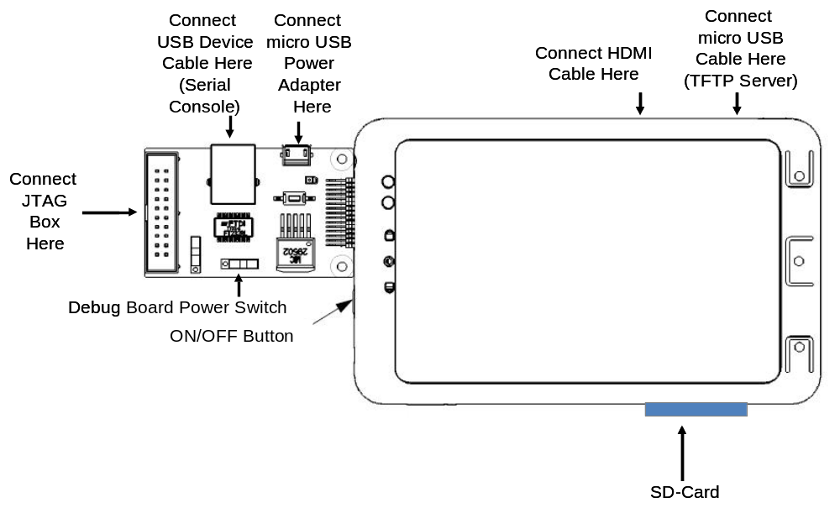
Back
Menu
Home
Volume up/down

Using the Prebuilt Binaries

How to know chip is booting up in armv6 mode or armv7 mode
- The NTIM was updated to switch core from armv6 mode to armv7 mode. If the new NTIM image is burned into flash correctly, BootROM will switch core from armv6 mode to armv7 mode during boot-up. Without new NTIM, the chip still will boot up in armv6 mode.
- The below scan chain means chip is already in armv7 mode, please use configuration file pxa688_armv7.xsf for Debugger. Otherwise please use configuration file pxa688_armv6.xsf for Debugger.
  - Press JTAG Scan
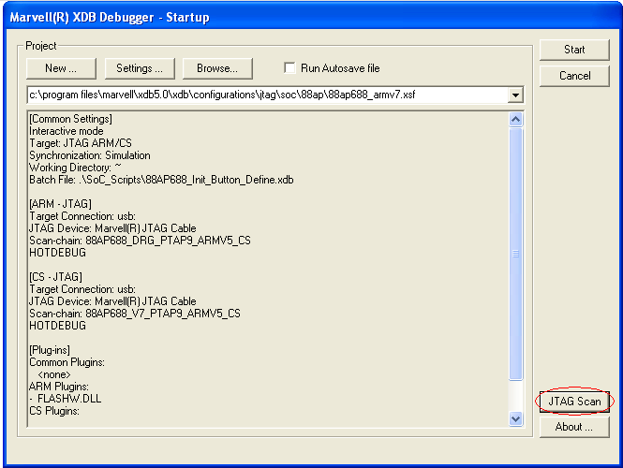
  - Press Start Scan
    - The below scan chain means core is in armv7 mode
    - Otherwise, there are 4 TAPs (not 3). The core is in armv6 mode.

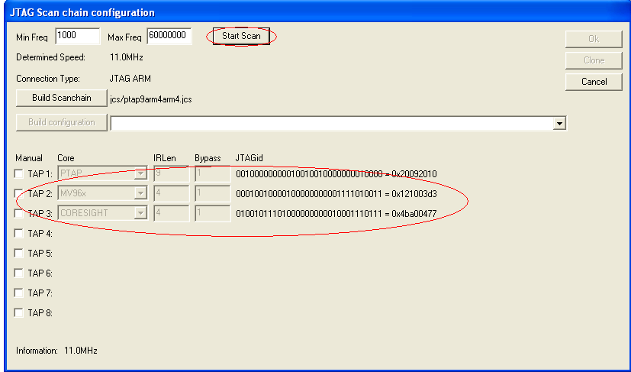

Flashing OBM and U-Boot to NAND Using JTAG

1. You need the Marvell Extreme Debugger 5.0 Gold, using configuration file pxa688_armv6.xsf. Leave all settings at their defaults. If the chip is booting up with armv7 mode, please use configuration file pxa688_armv7.xsf.

2. Flashing OBM and U-boot into NAND using XDB
- Use flash burn tool: flash --> burn flash
- Initialize a new flash and Erase all blocks
- burn file "ntim_mmp2_nand_bbu_ddr.bin" address --> 0x0
- burn file "MMP2_JASPER_Loader_3_2_15.bin" address --> 0x80000
- burn file "WtmUnresetPJ4.bin" address --> 0xc0000
- burn file "u-boot.bin" address --> 0x100000

Note: Unselect "erase affected blocks" when burning MMP2_JASPER_Loader_3_2_15.bin, WtmUnresetPJ4.bin and u-boot.bin.

Flashing OBM and U-Boot to eMMC Using JTAG
1. You need the Marvell Extreme Debugger 5.0 Gold, using configuration file pxa688_armv6.xsf. Leave all settings at their defaults. If the chip is booting up with armv7 mode, please use configuration file pxa688_armv7.xsf.

2. Change both ARM-JTAG and CS-JTAG TCK rate to 2.0 MHZ
- Click Settings button in XDB startup
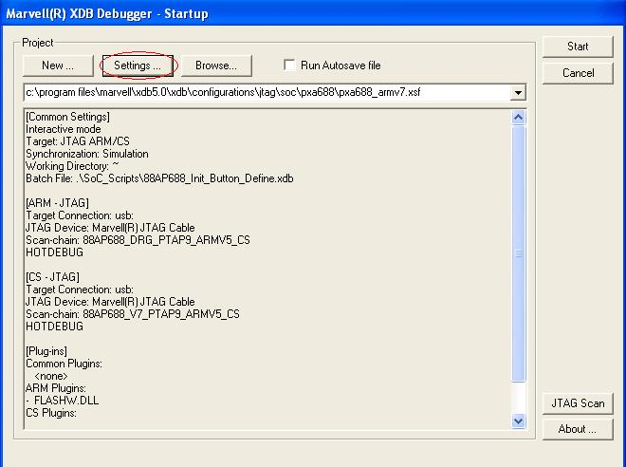
- For both ARM-JTAG and CS-JTAG Click Edit Connection to set TCK rate to 2.0 MHZ
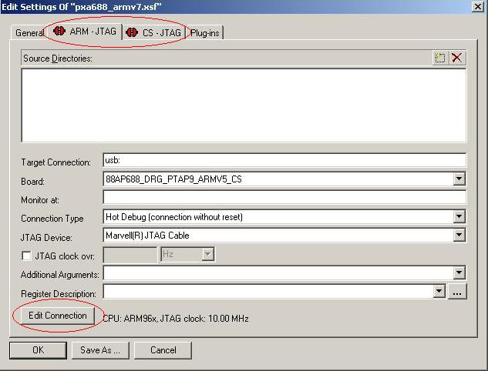
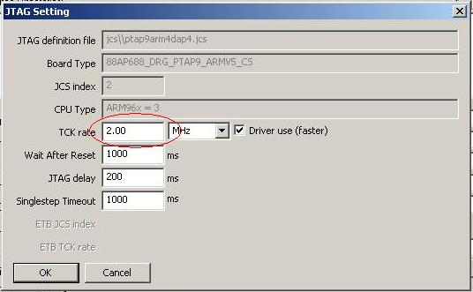

3. Flashing OBM and U-boot into EMMC using XDB
- Use flash burn tool: flash --> burn flash
- Change target ram address for burning algorithm to 0xd1000000
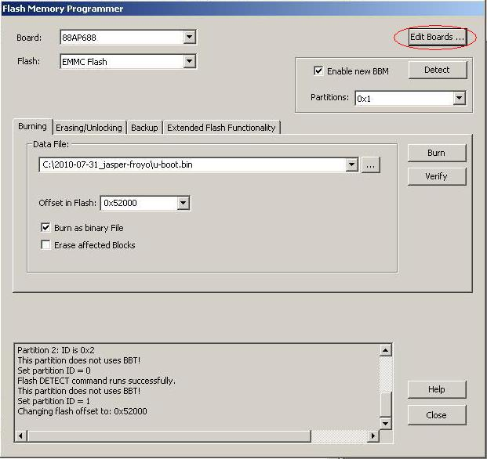
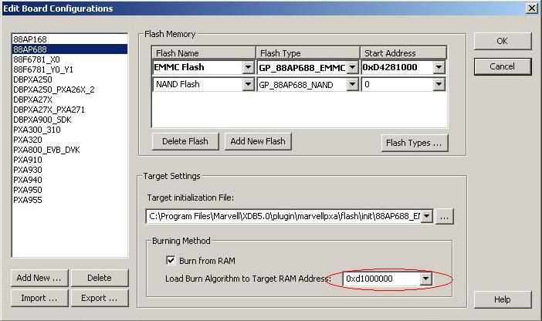
- Choose flash: NAND Flash
- Erase All Blocks to erase the NAND autoboot obm
- Choose flash: EMMC flash and click Detect button to detect emmc partition
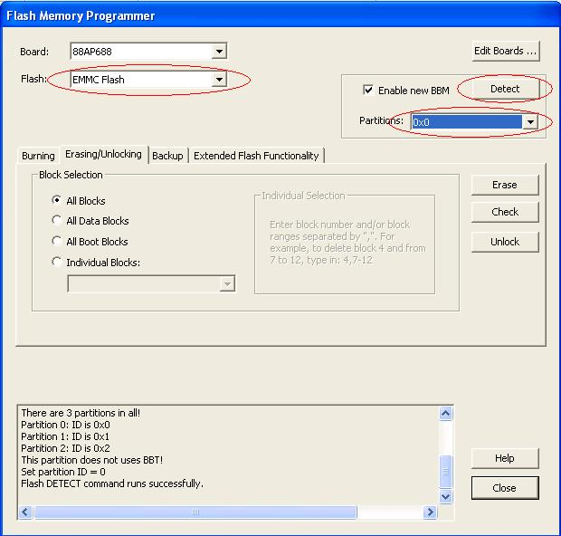
- Choose partition 0x1
  - Burn file “ntim_mmp2_nand_bbu_ddr.bin” address --> 0x0
  - Burn file “partition.bin” address --> 0x600
  - burn file "WtmUnresetPJ4.bin" address --> 0x1000
  - burn file "MMP2_NTLOADER_3_2_15.bin" address --> 0x32000
  - burn file "u-boot.bin" address --> 0x52000
Note: Select these files from the eMMC sub-directory rather than the NAND sub-directory since there are differences between the NAND and eMMC versions.

Flashing Android on eMMC Using U-Boot
The UBoot commands below will flash program zImage, mbr, ramdisk_ext2, system_ext2 and userdata_ext2 to eMMC.

First burn zImage

MMP2>> mmc sw_part 0
MMP2>> sw
MMP2>> t zImage.android
MMP2>> mmc write 0x4c00 0x2000 0x1100000

Sencond, burn mbr, ramdisk, system and userdata img
MMP2>> t mbr
MMP2>> mmc write 0x4800 0x1 0x1100000
MMP2>> t ramdisk_ext3.img
MMP2>> mmc write 0x8C00 0x4000 0x1100000
MMP2>> t system_ext3.img
MMP2>> mmc write 0xCC00 0x3C000 0x1100000
MMP2>> t userdata_ext3.img
MMP2>> mmc write 0x48C00 0x4B000 0x1100000

Notes: When you are done, power off Bonnell, and power it again to boot from eMMC. Rebooting by pressing the reset button will not work.

Using the Patch Based Source Code
The source code package includes the code for the kernel, U-Boot, android, and everything needed to boot the android on a Bonnell reference board with the Armada 610 revision Z1 processor and 512MB of LPDDR2.
The android code is provided as a group of patches based on a certain version of Android source code. A manifest file is provided to download that version of android code from AOSP(http://source.android.com)
The kernel and uboot are provided as a tar ball of base code and a tar ball of patches Marvell made on it.
Please follow the steps below to setup the code base.

Setup Android working directory

First, please go to http://source.android.com to download the "repo" tool and setup the build environment for Android.

Second, create the android working directory and download the initial code base.
$ mkdir <android_working_dir>
$ cd <android_working_dir>
$ repo init -u git://android.git.kernel.org/platform/manifest -b master
$ repo sync

Third, switch the code base specified by marvell_manifest.xml
$ cp <installed_source_dir>/marvell_manifest.xml .repo/manifests/
$ repo init -m marvell_manifest.xml
$ repo sync

Last, apply Marvell patches

$ cd <installed_source_dir>
$ ./setup_android.sh <android_working_dir>

Building the source code
Build Android by:
First, edit vendor/marvell/avlite/BoardConfig.mk, set BOARD_ENABLE_HELIX to false, as Helix is not included in the package.
Second,

- Build kernel and modules
$ cd <android_working_dir>
$ cd kernel
$ make all

Notes: The zImage is located at kernel/out/

- Build android
$ cd <android_working_dir>
$ . build/envsetup.sh
$ chooseproduct jasper
$ export ANDROID_PREBUILT_MODULES=kernel/out/modules/
$ make -j4
Notes: The android mbr, ramdisk_ext3.img, system_ext3.img and userdata_ext3.img are located at out/target/product/jasper

- Build uboot and obm
Before build uboot and obm, you need to extract wtm_rel_mmp2_virtualOTP_1.2.1.bin from WTM_Firmware_ARMADA610_1.2.1.zip which can be got from Marvell extranet, then rename it as WtmUnresetPJ4.bin and copy it to boot/obm/binaries.

$ cd <android_working_dir>
$ cd boot
$ make all

Notes: The u-boot.bin is located at boot/out, nand auto boot version obm is located at boot/out/nand, emmc auto boot version obm is located at boot/out/emmc.

Optimized OpenSSL for Marvell Platforms
An OpenSSL patch is included in this platform release. This patch fixes a SHA384/512 bug in Android OpenSSL, and optimizes Android OpenSSL crypto lib for Marvell platforms. By default, SHA384/512 bug fix is enabled, the optimization is disabled.

To enable the optimization, this patch requires Marvell WTPSP package in this platform release. Please refer to the release notes of WTPSP for how to enable it. And please contact your Marvell representative if you have any issues on that.

When the optimization is enabled, the following OpenSSL crypto schemes are optimized: SHA1/224/256 message digest, AES (CBC mode), and DES (CBC, CBC3 mode).

Note that, no matter if the optimization is enabled or not, Android OpenSSL crypto API keeps unchanged. Thus, applications using OpenSSL crypto lib don’t need to be modified. But application rebuild is required when the optimization is enabled.

- How to enable Marvell optimization for OpenSSL

First, put Marvell WTPSP middleware lib and header file into <android_working_dir>/extern/openssl/crypto/, rename it as libwtpsp.a, and add the followings into extern/openssl/crypto/Android.mk.

ifeq ($(USE_MARVELL_CRYPTO), true)
$(call add-prebuilt-files, STATIC_LIBRARIES, $libwtpsp.a)
include $(CLEAR_VARS)
endif

ifeq ($(USE_MARVELL_CRYPTO), true)
LOCAL_WHOLE_STATIC_LIBRARIES := $libwtpsp
LOCAL_PRELINK_MODULE := false
endif

Second, add the followings into extern/openssl/include/openssl/opensslconf.h.

#ifndef OPENSSL_MRVL
#define OPENSSL_MRVL /* enable marvell crypto support */
#endif

Third, add the followings into vendor/marvell/jasper/BoardConfig.mk.

USE_MARVELL_CRYPTO := true

Last, build Android system image.

Marvell Code Performance Analyzer

What's New
- Remote data collection via TCP/IP
- Linux(R) kernel 2.6.32

Features
The following sections provide information about the supported and unsupported features for this release.

Supported Features
- Remote data collection via TCP/IP
- Target local data collection in a connectionless environment
- Hotspot sampling data collection and corresponding data analysis
- Counter Monitor data collection, and corresponding data analysis.
- Real-time counter monitoring and post analysis

Unsupported Features
The following list indicates the features that are not supported in this release:
Software development kit (SDK) for dynamic code is not supported

System Requirements
N/A

Build, Install and Configuration

Build
N/A

Install
Before running the data collector, please go to the folder /system/etc/mpdc and run the following command to load the kernel driver:
$ ./load.sh

Configuration
N/A

Known Issues or Limitations
- If samples/second value is set too large, the events/sample value will be adjusted after calibration to a small one, which will make the interrupt happen very frequently. Then the system becomes busy and mpdc will stop later after the expected duration is expired. Moreover, the samples will almost locate on the process "mpdc_d". In that case, what you should do is to create your activity with a decreased samples/second value and start it.
- Please don't set OS_TIMER as the event in EBS sampling.
- When using command line, multiple activities couldn't be started at the same time.

Known Issues
1. The system may hung during the boot up phase. (Failure rate about 5%)
Resolution: N/A
2. The device will hung if opening the “Gallary3D” application in Android system.
Resolution: N/A
3. The system may hung after entered the suspend mode. (Failure rate about 30%)
Resolution: N/A
4. Failed to playback the vedio clips by HDMI.
Resolution: N/A
5. Failed to start the Android application “ Sound Recorder” and “Speech Recorder”.
Resolution: N/A
6. The OI File Manager may show the contents in SD card improperly.
Resolution: N/A
7. Battery capacity information reported by system is incorrect.
Resolution: N/A.
8. Camera OV8810 is not stable, and it can’t work w/ most of supported resolution.
Resolution: N/A.
9. CMU ACE does not work.
Resolution: N/A.
10. GC800 2D color conversion from YUV420P to RGB565 is incorrect.
Resolution: N/A.
11. LCDC has very slow response to support non-isometric ratio resize on video layer.
Resolution: N/A.
12. LCDC driver un-blank does not work.
Resolution: N/A.
13. System can't resume from suspend mode when USB cable is connected.
Resolution: N/A.
14. HDMI does not support resolutions except 1080P and 720P.
Resolution: N/A.
15. System hang when unplug a card SD in writing state.
Resolution: N/A.
16. 10. SDH can't recognize Transcend 4G class 2 micro SD card.
Resolution: N/A.
17. SDIO wi-fi can't work when doing heavily R/W on SD card.
Resolution: N/A.
18. USB OTG is not stable to switch to host mode.
Resolution: N/A.
19. NFS over USB Ethernet is not stable, heavily traffic through USB may cause NFS not responding.
Resolution: N/A.
20. Vmeta OMX IL H.263/MPEG4 encoder output files are not H.263/MPEG4 format, but H.264 format
Resolution: N/A
21. vMeta based OMX IL encoder make test application hang when input buffer size is set to 1024000.
Resolution: Set input buffer size as 20480000
22. OpenGL ES 2.0 don’t support texture sampling in vertex shader.
Resolution: N/A.
23. OpenGL ES 1.1/2.0 don’t support shared context.
Resolution: N/A.
24. Do rotate and blur on an Android window surface at the same time will cause the surface disappear.
Resolution: N/A.
25. eglSwapInterval is not supported.
Resolution: N/A.
26. EGLImage extension is not supported on OpenGL ES 1.1/2.0 render buffer and cubemap texture sharing.
Resolution: N/A.
27. Showing RGBA4444 images on an Android window surface will get wrong color.
Resolution: N/A.
28. Dithering is not supported in the 3D pipeline.
Resolution: N/A.
29. Switch to non-FIPS mode only after all FIPS sessions are closed, otherwise the non-FIPS mode will hang.
Resolution: N/A.
30. Middleware state machine in “Init” state should not check whether the current status is “Final” state. This issue causes some test cases failure only in Google Android environment.
Resolution: N/A.

