ARMADA 610 G50 Reference Platform
For Android 2.3, Linux Kernel 2.6.35
Software Release Notes
Beta1

Document Conventions
 | Note: Provides related information or information of special importance.
 | Caution: Indicates potential damage to hardware or software, or loss of data.
 | Warning: Indicates a risk of personal injury.
Document Status
Doc Status: Doc Status |  | Technical Publication: Int. Rev. No. x.xx

For more information, visit our website at: www.marvell.com
Disclaimer
No part of this document may be reproduced or transmitted in any form or by any means, electronic or mechanical, including photocopying and recording, for any purpose, without the express written permission of Marvell. Marvell retains the right to make changes to this document at any time, without notice. Marvell makes no warranty of any kind, expressed or implied, with regard to any information contained in this document, including, but not limited to, the implied warranties of merchantability or fitness for any particular purpose. Further, Marvell does not warrant the accuracy or completeness of the information, text, graphics, or other items contained within this document.
Marvell products are not designed for use in life-support equipment or applications that would cause a life-threatening situation if any such products failed. Do not use Marvell products in these types of equipment or applications.
With respect to the products described herein, the user or recipient, in the absence of appropriate U.S. government authorization, agrees:
1) Not to re-export or release any such information consisting of technology, software or source code controlled for national security reasons by the U.S. Export Control Regulations ("EAR"), to a national of EAR Country Groups D:1 or E:2;
2) Not to export the direct product of such technology or such software, to EAR Country Groups D:1 or E:2, if such technology or software and direct products thereof are controlled for national security reasons by the EAR; and,
3) In the case of technology controlled for national security reasons under the EAR where the direct product of the technology is a complete plant or component of a plant, not to export to EAR Country Groups D:1 or E:2 the direct product of the plant or major component thereof, if such direct product is controlled for national security reasons by the EAR, or is subject to controls under the U.S. Munitions List ("USML").
At all times hereunder, the recipient of any such information agrees that they shall be deemed to have manually signed this document in connection with their receipt of any such information.
Copyright © 2026. Marvell International Ltd. All rights reserved. Marvell, the Marvell logo, Moving Forward Faster, Alaska, Fastwriter, Datacom Systems on Silicon, Libertas, Link Street, NetGX, PHYAdvantage, Prestera, Raising The Technology Bar, The Technology Within, Virtual Cable Tester, and Yukon are registered trademarks of Marvell. Ants, AnyVoltage, Discovery, DSP Switcher, Feroceon, GalNet, GalTis, Horizon, Marvell Makes It All Possible, UniMAC, and VCT are trademarks of Marvell. Intel XScale is a trademark or registered trademark of Intel Corporation or its subsidiaries in the United States and other countries. All other trademarks are the property of their respective owners.

Table of Contents

List of Tables

List of Figures

Overview
This Software Release package provides a full Android system for the ARMADA 610 G50 reference board. The software includes both the prebuilt binaries, which users can flash to the board and start using immediately, as well as the source code, which users can customize and build to create new binaries.

System Requirements
Hardware Requirements
The Marvell G50 reference board with the A2 stepping of the ARMADA 610 processor and 512MB of DDR3 Memory

Software Requirements
- Host PC with operating system Ubuntu 10.04 or later.
We routinely test the Android build on the Ubuntu 10.04.

Platform Features
Features | Sub-Features | Details
General
 | Android Version | 2.3
PM
 | Android Power Integration | N
 | Battery information | Y
 | Suspend/Resume | N
Video Playback
 | Video output to HDMI | Y
 | Video output optimized by overlay | Y
 | Simultaneously video output to HDMI and UI operation on LCD | Y
 | Simultaneously different video content playback on HDMI and LCD | Y
 | Video rotation | Y
Audio Playback
 | Headset Switch Detection | Y
 | Audio Driver integration | Y
 | Audio to Headset | Y
 | Audio to Speaker | Y
 | Audio to HDMI | Y
Audio Recording
 | AMR-NB Encoding | Y
 | AAC Encoding | Y
 | Sound Recorder Integration | Y
Video Recording
 | Camera Stack Integration | N
 | Camera Sensor Tuning | N
Touch
 | Single Touch | Y
 | Multi Touch | Y
Bluetooth
 | Bluetooth Base Stack | Y
 | A2DP profile | Y
Sensors
 | Gravity sensor | N
 | Light sensor | Y
 | Proximity sensor | Y
Light
 | LCD Backlight | Y
 | Keypad backlight | Y
Input
 | USB Keyboard | Y
 | On board buttons | Y
 | Power Button | Y
Alarm
 | Trigger Alarm from Standby | N
Wireless
 | WiFi Access with no password | Y
 | WiFi Access with WPA/WPA2 | Y
 | WiFi Connection Stress test | Y
 | 3G USB Dongle | N
Multimedia
Containers | Extensions | AV Combinations |  | Playback Engine | GST Demuxer Plugins | Status
Containers | Extensions | Audio | Video | Playback Engine | GST Demuxer Plugins | Status
ASF | .asf | WMA | MPEG-4 | GStreamer | asfdemux/gst-plugins-ugly | Ready
ASF | .wmv | WMA | WMV | GStreamer | asfdemux/gst-plugins-ugly | Ready
ASF | .wma | WMA | No video | GStreamer | asfdemux/gst-plugins-ugly | Ready
AVI | .avi | MP3 | H.264 | GStreamer | avidemux/gst-plugins-good | Ready
AVI | .avi | MP3 | MPEG-4 | GStreamer | avidemux/gst-plugins-good | Ready
AVI | .avi | MP3 | H.263 | GStreamer | avidemux/gst-plugins-good | Ready
MOV | .mov | AAC | H.264 | GStreamer | qtdemux/gst-plugins-good | Ready
MOV | .mov | AAC | MPEG-4 | GStreamer | qtdemux/gst-plugins-good | Ready
MP4 | .mp4 | AAC | H.264 | Stagefright |  | Ready
MP4 | .mp4 | MP3 | MPEG-4 | Stagefright |  | not ready
MPEG-2 PS | .mpg | MP3 | MPEG-2 | GStreamer |  | Ready
3GPP | .3gp/.3gpp | MP3 | H.264 | OpenCore |  | not ready
3GPP | .3gp/.3gpp | AAC | MPEG-4 | OpenCore |  | Ready
MKV | .mkv | MP3 | H.264 | GStreamer |  | Ready
MKV | .mkv | AAC | H.264 | GStreamer |  | Ready
AAC | .aac | AAC | No Video | OpenCore |  | Ready
AAC | .adts | AAC | No Video | OpenCore |  | Ready
MP3 | .mp3 | MP3 | No Video | OpenCore |  | Ready

Video Output
 | Output through GC | N
 | Output through overlay | Y
Graphics
 | GC800 | Y
Tools
 | adb integration | Y
 | pixiu integration | N
User Storage
 | SD Card | Y
 | Internal storage partition | Y
Boot Storage
 | eMMC | Y
 | SD | Y
System update
 | Fastboot Protocol | N
 | SD upgrade | N
Security | Wireless Trusted Platform Service Package (WTPSP) | N
 | Wireless Trusted Module (WTM) Adapter for Linux Kernel Crypto Framework | N
 | Optimized OpenSSL | N

BSP Features

U-Boot
- USB Ethernet download
- zImage support
- Burn eMMC Image
- Dynamic voltage and frequency change support
- CPU MIPS calculation support

Linux-2.6.35 Kernel
- L1 cache
- L2 cache
- Interrupt controller
- PDMA controller
- Memory controller
- Real-Time Clock (RTC)
- Operating System Timer (OST)
- Context switch
- Intel Wireless MMX
- GPIO IRQ
- Clock management
- MultiMediaCard (MMC3.2 and MMC4.0)
- Secure Digital (SD)/SDIO (SD1.1 and SD2.0)
- UART
- HDMI Audio
- SSPA drivers
- ALSA framework
- Keypad
- I2C - Normal I2C
- Parallel LCD panel (base frame, overlay)
- HDMI LCD TV path
- ADMA controller
- Marvell Wireless Memory Management technology
- Vmeta
- USB client
- USB HOST
- Battery and charger driver
- VDMA
- ALC5625 codec
- Multi touch
- On-key and reset
- WIFI, BT on SD8787
- BMA150 G-sensor
- HDMI EDID
- Vmeta multi instances
- ARMv7 mode
- Audio record
- Power off command
- NXP RTC

Release Package Contents
Prebuilt Binary Files | Description
ARMADA610_ANDROID_GINGERBREAD_BETA1_BIN.zip | Pre-built bin binaries
- primary_gpt_4g | Primary GUID partition table(For 4G eMMC)
- secondary_gpt_4g | Secondary GUID partition table(For 4G eMMC)
- system.img | Android system image
- userdata.img | Android user data image
- zImage.android | kernel image
- ramdisk.img | Ramdisk image
- u-boot.bin | Uboot
- /nontrusted/ntim_mmp2_nand_bbu_ddr.bin | NTIM header
- /nontrusted/ntim_mmp2_nand_ddr3_elipda_512m.txt | NTIM description file
- /nontrusted/??????? | NTIM Loader
- /nontrusted/partition.bin | partition image for non-trusted boot
- /nontrusted/partition.txt | partition description file for non-trusted boot

Source Files | Description
ARMADA610_ANDROID_GINGERBREAD_BETA1_SRC | Source code tarball (patch based source code)
- setup_android.sh | Script help to setup Android code base from the xxx_src.tgz and xxx_patches.tgz
- android_patches.tgz | Marvell patches to Android Projects
- android_src.tgz | Source code for projects added by Marvell
- marvell_manifest.xml | Manifest xml file to download android source code from Google as a base
- kernel_patches.tgz | Marvell patches to kernel_src.tgz
- kernel_src.tgz | Kernel base source code
- uboot_src.tgz | Uboot base source code
- uboot_patches.tgz | Marvell patches to uboot_src.tgz
- obm_src.tgz | Obm source code

Installation

Using the Prebuilt Binaries

How to know chip is booting up in armv6 mode or armv7 mode
- The NTIM was updated to switch core from armv6 mode to armv7 mode. If the new NTIM image is burned into flash correctly, BootROM will switch core from armv6 mode to armv7 mode during boot-up. Without new NTIM, the chip still will boot up in armv6 mode.
- The below scan chain means chip is already in armv7 mode, please use configuration file pxa688_armv7.xsf for Debugger. Otherwise please use configuration file pxa688_armv6.xsf for Debugger.
  - Press JTAG Scan
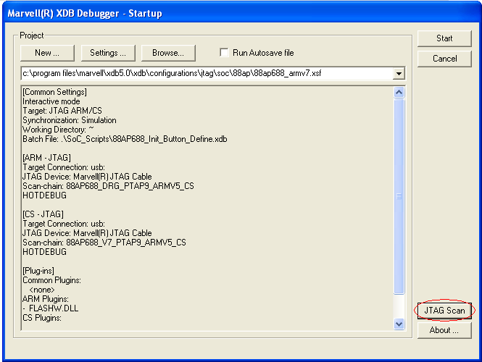
  - Press Start Scan
    - The below scan chain means core is in armv7 mode
    - Otherwise, there are 4 TAPs (not 3). The core is in armv6 mode.

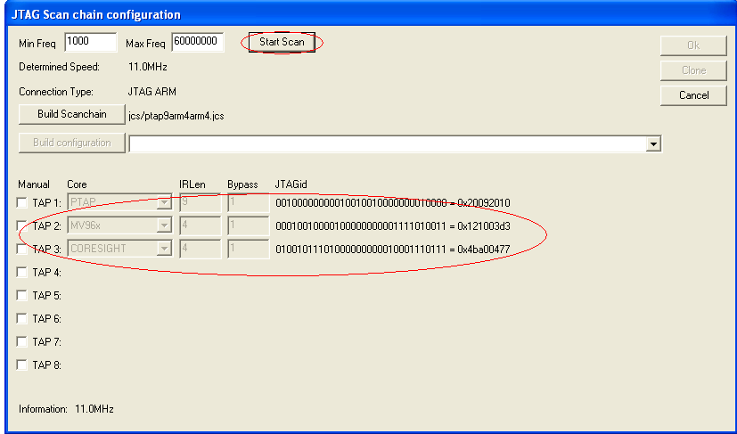

Flashing OBM and U-Boot to eMMC Using JTAG
1. You need the Marvell Extreme Debugger 5.0 Gold, using configuration file pxa688_armv6.xsf. Leave all settings at their defaults. If the chip is booting up with armv7 mode, please use configuration file pxa688_armv7.xsf.

2. Change both ARM-JTAG and CS-JTAG TCK rate to 2.0 MHZ
- Click Settings button in XDB startup
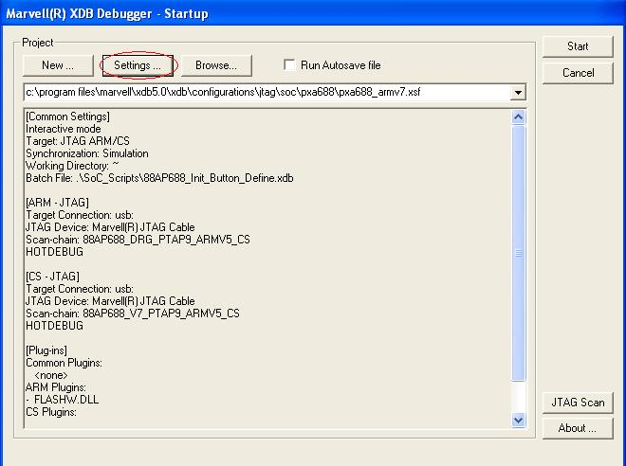
- For both ARM-JTAG and CS-JTAG Click Edit Connection to set TCK rate to 2.0 MHZ
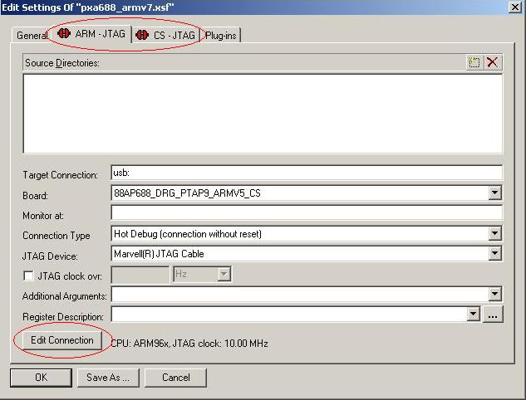
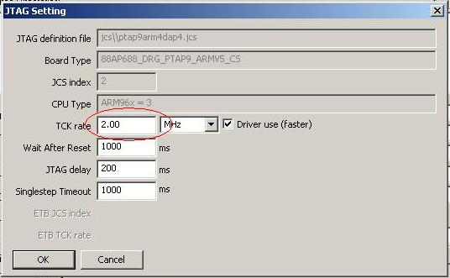

3. Flashing OBM and U-boot into EMMC using XDB
- Use flash burn tool: flash --> burn flash
- Change target ram address for burning algorithm to 0xd1000000
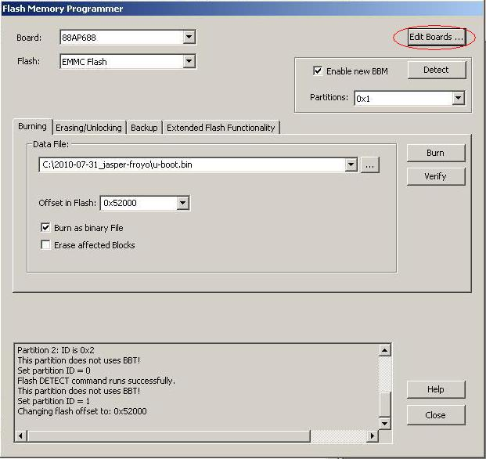
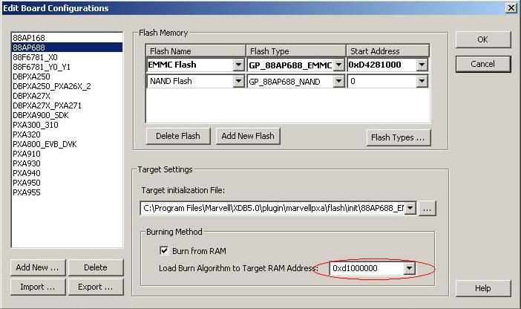
- Choose flash: NAND Flash
- Erase All Blocks to erase the NAND autoboot obm
- Choose flash: EMMC flash and click Detect button to detect emmc partition
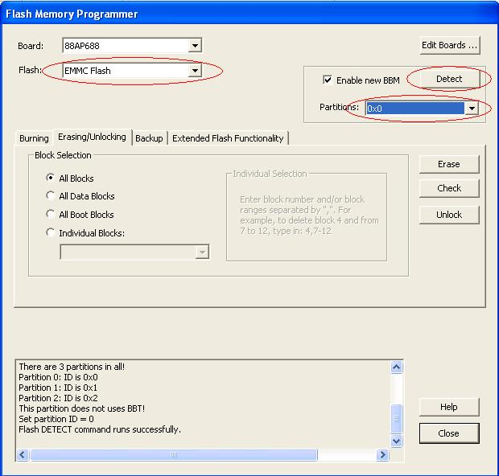
- Choose partition 0x1
  - Burn file “ntim_mmp2_nand_bbu_ddr.bin” address --> 0x0
  - Burn file “Wtm_rel_mmp2.bin” address --> 0x4000
  - Burn file "MMP2_NTLOADER_3_2_19.bin" address --> 0x20000
  - Burn file "u-boot.bin" address --> 0x60000
  - Burn file "u-boot.bin" as recovery u-boot address --> 0xB0000
Note: Select these files from the eMMC sub-directory rather than the NAND sub-directory since there are differences between the NAND and eMMC versions.

Flashing Android on eMMC Using U-Boot
The UBoot commands below will flash program GPTs, zImage, ramdisk, system and userdata to eMMC.

MMP2>> mmc sw_part 0

Burn GPTs:
MMP2>> t primary_gpt_4g
MMP2>> mmc write 0 0x22 0x1100000
MMP2>> t secondary_gpt_4g
MMP2>> mmc write 0x75efdd 0x21 0x1100000

Burn kernel:
MMP2>> t zImage.android
MMP2>> mmc write 0x4c00 0x2000 0x1100000

Burn Ramdisk:
MMP2>> t ramdisk.img
MMP2>> mmc write 0x8c00 0x800 0x1100000

Burn System:
MMP2>> t system.img
MMP2>> mmc write 0xcc00 0x4b000 0x1100000

Burn Userdata:
(Clean up data if userdata.img is unavailable)
MMP2>> mw.b 0x1100000 0 0x80000
MMP2>> mmc write 0x57c00 0x400 0x1100000

(You can flash user partition if it's available.)
MMP2>> t userdata.img
MMP2>> mmc write 0x57c00 0x4b000 0x1100000

Notes: When you are done, power off G50, and power it again to boot from eMMC. Rebooting by pressing the reset button will not work.

Using the Patch Based Source Code
The source code package includes the code for the kernel, U-Boot, android, and everything needed to boot the android on a brownstone reference board with the Armada 610 revision A0 processor and 1GB of DDR3.
The android code is provided as a group of patches based on a certain version of Android source code. A manifest file is provided to download that version of android code from AOSP(http://source.android.com)
The kernel and uboot are provided as a tar ball of base code and a tar ball of patches Marvell made on it.
Please follow the steps below to setup the code base.

Setup Android working directory

First, please go to http://source.android.com to download the "repo" tool and setup the build environment for Android.
Second, create the android working directory and download the initial code base.
$ mkdir <android_working_dir>
$ cd <android_working_dir>
$ repo init -u git://android.git.kernel.org/platform/manifest -b master
$ repo sync
Third, switch the code base specified by marvell_manifest.xml
$ cp <installed_source_dir>/marvell_manifest.xml .repo/manifests/
$ repo init -m marvell_manifest.xml
$ repo sync
Last, apply Marvell patches
$ cd <installed_source_dir>
$ ./setup_android.sh <android_working_dir>

Building the source code
Build kernel and modules
$ cd <android_working_dir>
$ cd kernel
$ make all

Notes: The zImage is located at kernel/out/

Build uboot and obm
Before build uboot and obm, you need to extract wtm_rel_mmp2_virtualOTP_1.2.1.bin from WTM_Firmware_ARMADA610_1.2.1.zip which can be got from Marvell extranet, then rename it as WtmUnresetPJ4.bin and copy it to boot/obm/binaries.

$ cd <android_working_dir>
$ cd boot
$ make all

Notes: The u-boot.bin and OBM files are located at boot/out/nontrusted, while the unified WTM files are at boot/out

Build android
$ cd <android_working_dir>
$ . build/envsetup.sh
$ chooseproduct brownstone
$ export ANDROID_PREBUILT_MODULES=kernel/out/modules/
$ make -j4
Notes: The android GPTs, ramdisk.img, system.img and userdata.img are located at out/target/product/brownstone

Known Issues
- Power management feature is not enabled
- Recovery and update feature is not enabled
- Security feature is not enabled
- Camera feature is not enabled.
- FM has no audio output
- WIFI on/off, BT on/off or FM on/off may lead to system reboot on some boards

