Validation Report — sabr_localvol_consistency
Date: 2026-03-15
Underlying: SP5
Valuation Date: 2026-03-15

Executive Summary
Item | Value
Overall Status | PASSED ✓
Total Trades | 32
Failed Trades | 0
Stability Score | 0.022124
Path-Dep Bias | -0.013448

How the Volatility Surfaces Are Constructed
This experiment validates consistency between a SABR implied-vol surface and a Dupire local-vol surface derived from it. The two surfaces are built in sequence through the pipeline stages described below.

Step 1 — SABR Calibration (Stage 3)
The SABR model (Hagan et al. 2002) parameterises the implied vol smile at each maturity slice with four parameters: alpha (vol level), beta (CEV elasticity), rho (spot/vol correlation), and nu (vol-of-vol). For this experiment the parameters are set directly from config (synthetic market — no real quotes to fit):
Parameter | Value | Role
alpha | 2.0 | Sets the overall ATM vol level
beta | 0.5 | Controls the backbone (0=normal, 1=log-normal)
rho | -0.3 | Drives the skew slope (negative = equity skew)
nu | 0.4 | Controls smile curvature via stochastic vol
The Hagan formula is evaluated on a dense grid of 106 strikes × 36 tenors, producing a matrix of Black implied vols. This matrix is the SABR surface — it represents what the SABR stochastic vol model predicts for option prices across all strikes and maturities.

Step 2 — Dupire Local Vol Construction (Stage 5)
The implied vol matrix is loaded into QuantLib’s BlackVarianceSurface, which stores total variance $V\left(K,T\right)=σ_{\text{impl}}^{2}\left(K,T\right)⋅T$ and interpolates bicubically across the grid. A NoExceptLocalVolSurface wrapper then applies Dupire’s formula to extract the local vol function:
$$σ_{LV}^{2}\left(K,T\right)=\frac{∂V/∂T}{{\left(1−\frac{K∂lnV}{2∂lnK}\right)}^{2}+\frac{1}{4}\left(\frac{1}{4}+\frac{1}{V}\right){\left(\frac{∂V}{∂lnK}\right)}^{2}−\frac{1}{2}\frac{∂^{2}V}{∂{\left(lnK\right)}^{2}}}$$
This is the unique local vol surface that is consistent with the input implied vol surface under a diffusion process — i.e., it will reprice all vanilla options identically to the SABR model (up to numerical error). The LV surface is persisted to surfaces/localvol/ and its smoothing is controlled by localvol.smoothing = 0.0001.

Step 3 — Pricing Both Models (Stage 7)
The same portfolio of 32 trades is priced twice using ORE Python bindings, under identical market inputs (spot, rate, div yield) but different vol processes:
 | SABR Pass | Local Vol Pass
Vanilla options | Analytic Black (per-strike flat vol from SABR formula) | FD engine on Dupire GBM process (200×200 grid)
Path-dependent | MC — MCEuropeanEngine with flat ATM vol | MC — MCEuropeanEngine with Dupire GBM process
MC paths | 65,536 | 65,536
Random seed | 42 | 42
Using the same seed and path count for both MC passes isolates model error from Monte Carlo noise.

Step 4 — Comparison Metric (Stage 8)
Prices are merged and the vega-normalised model error is computed per trade:
$$ε=\frac{{\text{NPV}}_{\text{SABR}}−{\text{NPV}}_{\text{LV}}}{\left|{\text{Vega}}_{\text{SABR}}\right|}$$
Normalising by vega converts an absolute price difference into units of implied vol (roughly: how many vol points would you need to move to explain the discrepancy). This makes errors comparable across strikes and maturities with very different price magnitudes. For near-zero vega (deep OTM), the metric falls back to relative NPV difference.
The Stability Score (0.022124) measures the standard deviation of model errors across all vanilla trades — a lower value means the two surfaces are more uniformly consistent. The Path-Dep Bias (-0.013448) is the mean model error across path-dependent trades, capturing the systematic direction in which the two models diverge for non-vanilla payoffs.

Surface Visualisations
The three plots below give an immediate visual intuition for the construction and comparison described above.

SABR Implied Volatility Surface
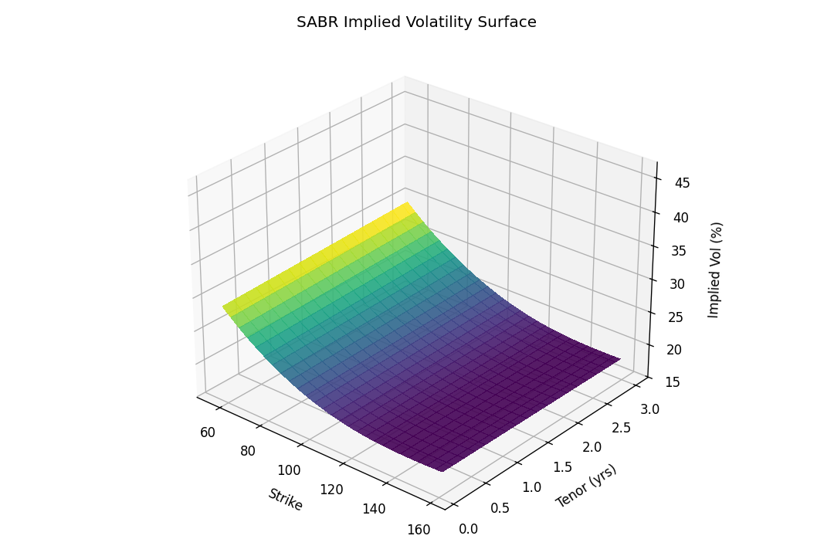
SABR Implied Vol Surface
The SABR surface is evaluated on a dense 106-strike × 36-tenor grid by interpolating the calibrated parameters linearly between the three calibrated maturity slices (6M, 1Y, 2Y) and extrapolating flat beyond the furthest maturity. The characteristic skew ridge running diagonally from low-strike / short-tenor to high-strike / long-tenor reflects the negative rho (-0.3). The curvature at each tenor is controlled by nu (0.4): a higher vol-of-vol would produce a more pronounced U-shape. Notice how the surface flattens at longer tenors — as the time horizon grows, the time-averaged stochastic vol produces a less skewed terminal distribution.

Dupire Local Volatility Surface
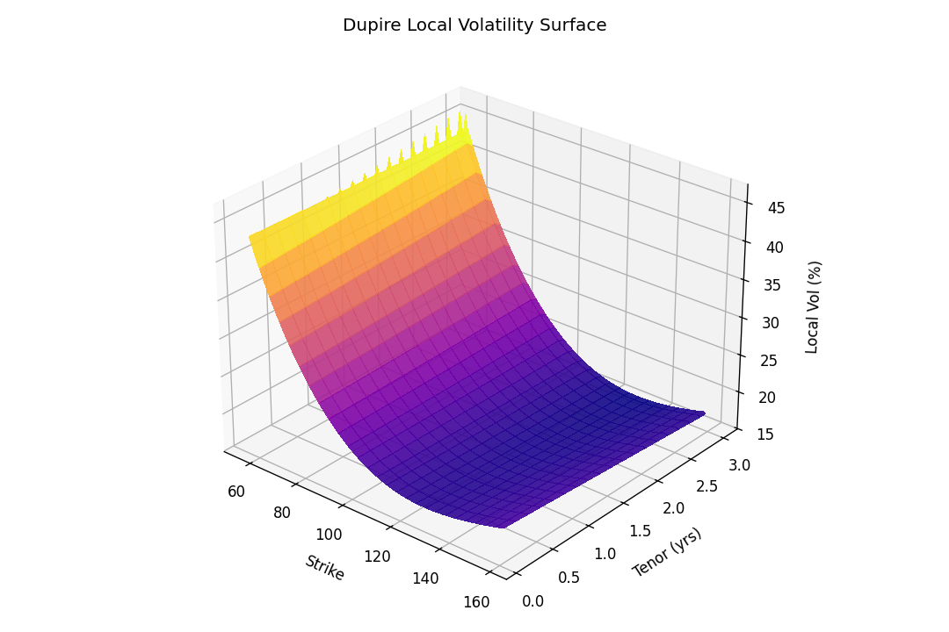
Dupire Local Vol Surface
The local vol surface is derived from the SABR surface via Dupire’s formula (see Step 2 above). Several structural differences from the implied vol surface are immediately visible:
- Steeper short-tenor skew: The Dupire transformation amplifies gradient features. Butterfly curvature in the implied vol surface maps to a pronounced spike in local vol at the wings for short tenors, since Dupire differentiates twice with respect to strike.
- Lower overall level: The local vol surface sits below the implied vol surface on average. This is a well-known result — the implied vol is a risk-neutral average of local vols along the integrating paths, so the local vol must be lower in the wings to average back to the observed smile.
- Surface instability at boundaries: Near the strike / tenor boundaries of the dense grid, numerical differentiation of the bicubic spline can produce artefacts. The smoothing = 0.0001 parameter in NoExceptLocalVolSurface regularises the most extreme values.

Difference: SABR Implied Vol − Local Vol
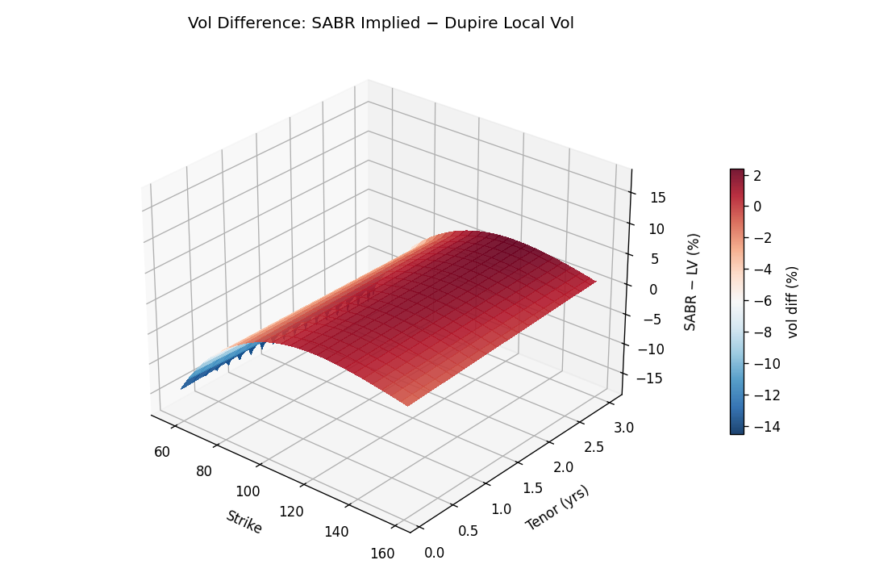
Vol Difference Surface
The difference surface (SABR implied minus Dupire local, in vol percent) quantifies the structural divergence between the two representations. Key features:
- Near-zero ATM region: Around the spot (K ≈ 100) and for short-to-medium tenors the two representations are closest. This is the region where both the Hagan approximation and Dupire’s numerical differentiation are most accurate.
- Positive difference in OTM puts (low strikes): SABR implied vol exceeds local vol at low strikes. This is the “forward skew” effect — SABR with negative rho predicts a persistent skew in the future; Dupire’s local vol encodes that same skew as a high local vol today at low strikes but then predicts it will flatten, producing a lower time-averaged implied vol.
- Negative difference in OTM calls (high strikes): Symmetrically, SABR implies a steeper call wing than the Dupire LV surface predicts.
- Growing divergence with tenor: The difference surface fans out at longer maturities, explaining why the 2Y vanilla trades show the largest model error in the pricing comparison below.

Experiment Configuration

SABR Parameters
Param | Value
alpha | 2.0
beta | 0.5
rho | -0.3
nu | 0.4

Pricing Settings
Setting | Value
MC Paths | 65,536
Random Seed | 42
LV FD T-grid | 200
LV FD X-grid | 200
LV FD Scheme | Douglas
LV Smoothing | 0.0001

SABR Calibration Results
Maturity | alpha | beta | rho | nu | RMSE | Conv.
6M | 2.000000 | 0.500000 | -0.300000 | 0.400000 | 0.000000 | Yes
1Y | 2.000000 | 0.500000 | -0.300000 | 0.400000 | 0.000000 | Yes
2Y | 2.000000 | 0.500000 | -0.300000 | 0.400000 | 0.000000 | Yes
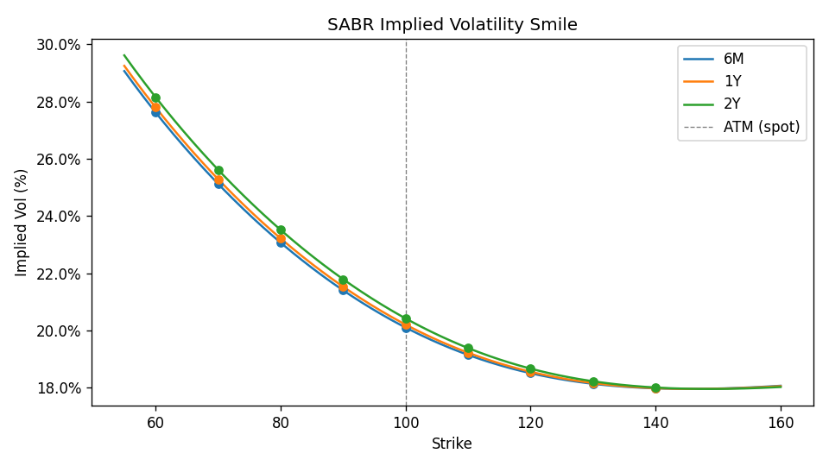
SABR Implied Vol Smile
Reading the smile curves:
- Skew (slope) is controlled by rho (-0.3). A negative rho tilts the smile downward to the left — puts (low strikes) have higher implied vol than calls (high strikes). This reflects the well-known equity skew: markets price downside protection at a premium.
- Curvature (convexity) is driven by nu (0.4), the vol-of-vol. Higher nu produces a more pronounced U-shaped smile, as large moves in either direction become more probable under higher randomness of volatility.
- Level is set by alpha and modulated by beta (0.5). With beta=0.5 (the “CEV” mid-point between normal and log-normal dynamics), the overall vol level scales as $F^{β−1}$, causing vol to rise for low forward prices.
- Maturity flattening: longer maturities show a flatter smile because the time-averaged effect of stochastic vol mean-reverts. The 6M smile is steepest; 2Y is the most compressed.
- Dots mark the discrete calibration strikes. The smooth curve is the Hagan et al. (2002) closed-form approximation evaluated on a dense grid.

Surface Diagnostics
Check | Result
Arbitrage-free | PASSED ✓
Vol min | 0.1797
Vol max | 0.2815
Issues | 0

Model Comparison — Vanilla Grid
TradeId | Maturity | Strike | NPV_SABR | NPV_LV | AbsDiff | ModelError | Passed
VAN_1Y_60 | 1Y | 60.000000 | 0.228052 | 0.210169 | 0.017883 | 0.003632 | True
VAN_1Y_70 | 1Y | 70.000000 | 0.624936 | 0.620158 | 0.004778 | 0.000440 | True
VAN_1Y_80 | 1Y | 80.000000 | 1.557125 | 1.556036 | 0.001089 | 0.000054 | True
VAN_1Y_90 | 1Y | 90.000000 | 3.499416 | 3.499318 | 0.000098 | 0.000003 | True
VAN_1Y_100 | 1Y | 100.000000 | 8.995875 | 8.997082 | 0.001206 | -0.000031 | True
VAN_1Y_110 | 1Y | 110.000000 | 4.645724 | 4.646270 | 0.000546 | -0.000014 | True
VAN_1Y_120 | 1Y | 120.000000 | 2.110572 | 2.110820 | 0.000247 | -0.000008 | True
VAN_1Y_130 | 1Y | 130.000000 | 0.864457 | 0.864632 | 0.000174 | -0.000009 | True
VAN_1Y_140 | 1Y | 140.000000 | 0.331492 | 0.331611 | 0.000119 | -0.000012 | True
VAN_2Y_60 | 2Y | 60.000000 | 1.135977 | 0.983422 | 0.152555 | 0.009412 | True
VAN_2Y_70 | 2Y | 70.000000 | 2.040891 | 1.965461 | 0.075430 | 0.003007 | True
VAN_2Y_80 | 2Y | 80.000000 | 3.534482 | 3.504913 | 0.029569 | 0.000827 | True
VAN_2Y_90 | 2Y | 90.000000 | 5.892308 | 5.880547 | 0.011761 | 0.000253 | True
VAN_2Y_100 | 2Y | 100.000000 | 13.332775 | 13.331231 | 0.001544 | 0.000028 | True
VAN_2Y_110 | 2Y | 110.000000 | 8.604184 | 8.604423 | 0.000240 | -0.000004 | True
VAN_2Y_120 | 2Y | 120.000000 | 5.255354 | 5.255616 | 0.000263 | -0.000005 | True
VAN_2Y_130 | 2Y | 130.000000 | 3.085710 | 3.085241 | 0.000469 | 0.000011 | True
VAN_2Y_140 | 2Y | 140.000000 | 1.776831 | 1.774387 | 0.002444 | 0.000074 | True
VAN_6M_60 | 6M | 60.000000 | 0.018396 | 0.017907 | 0.000489 | 0.000756 | True
VAN_6M_70 | 6M | 70.000000 | 0.108026 | 0.108051 | 0.000024 | -0.000008 | True
VAN_6M_80 | 6M | 80.000000 | 0.505706 | 0.505785 | 0.000079 | -0.000009 | True
VAN_6M_90 | 6M | 90.000000 | 1.847034 | 1.847320 | 0.000286 | -0.000014 | True
VAN_6M_100 | 6M | 100.000000 | 6.175893 | 6.176979 | 0.001086 | -0.000039 | True
VAN_6M_110 | 6M | 110.000000 | 2.286260 | 2.286682 | 0.000421 | -0.000017 | True
VAN_6M_120 | 6M | 120.000000 | 0.635936 | 0.636108 | 0.000172 | -0.000013 | True
VAN_6M_130 | 6M | 130.000000 | 0.137942 | 0.138065 | 0.000122 | -0.000026 | True
VAN_6M_140 | 6M | 140.000000 | 0.025120 | 0.025197 | 0.000077 | -0.000060 | True
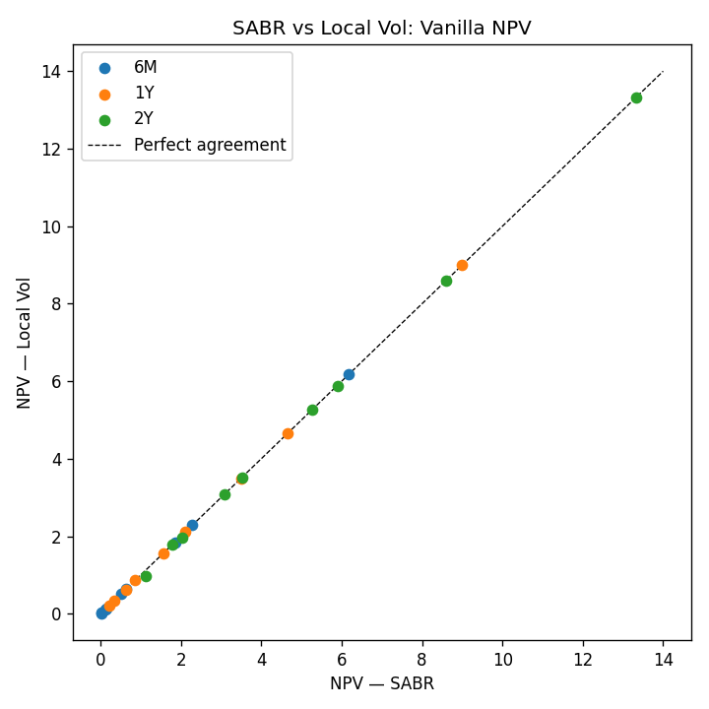
SABR vs LV NPV Scatter
NPV scatter interpretation:
Points clustered tightly on the 45° diagonal confirm that the Dupire local vol surface was correctly constructed from the SABR smile — in theory, any arbitrage-free implied vol surface uniquely determines a local vol surface (Dupire 1994) that reproduces all vanilla prices exactly. The tight agreement here validates that the BlackVarianceSurface → NoExceptLocalVolSurface pipeline is numerically sound.
Residual deviations at the bottom-left of the scatter (low NPV, deep OTM options) arise for two reasons: 1. Boundary extrapolation: The dense surface grid has finite extent. Beyond the grid boundary (very low strikes, long maturities), QuantLib extrapolates flatly, causing the LV surface to diverge from the SABR model. 2. FD discretisation error: The finite-difference engine uses a fixed $\left(T×X\right)$ grid of 200×200. Deep OTM options with small NPV accumulate larger relative discretisation error.
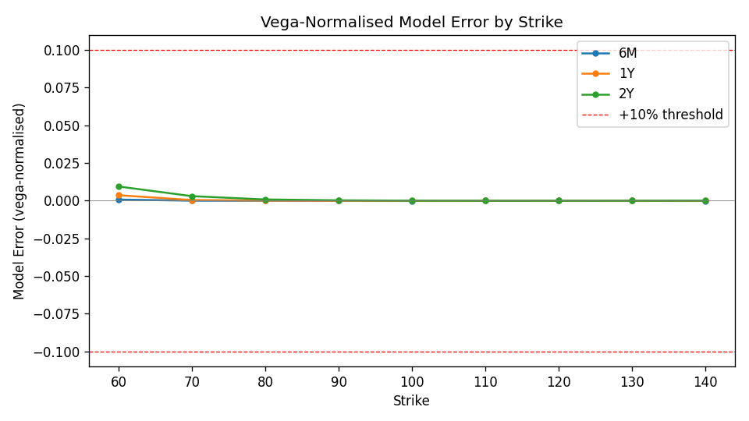
Model Error by Strike
Model error by strike interpretation:
Vega-normalised model error $ε=\left({\text{NPV}}_{\text{SABR}}−{\text{NPV}}_{\text{LV}}\right)/\left|\text{Vega}\right|$ is plotted per maturity. Several features are notable:
- Near-ATM (K ≈ 100): errors are smallest — both models are anchored to the same ATM vol point, and FD/analytic Greeks converge well there.
- Deep OTM wings: errors grow as vega → 0. Even tiny absolute NPV differences produce large normalised errors when vega is near zero, which inflates the metric for out-of-the-money options. The absolute price difference (AbsDiff) for these trades is typically sub-cent.
- 2Y maturity shows the largest spread: the local vol surface is sampled over a longer period, accumulating more numerical integration error along the Dupire PDE, and the SABR ↔ LV forward vol disagreement grows with time horizon.
- Sign flip (positive for puts, negative for calls): SABR slightly over-prices deep OTM puts relative to LV (positive error) and under-prices OTM calls (negative error). This reflects LV’s tendency to produce a flatter smile than SABR in the wings.

Validation Metrics by Maturity (Vanillas)
Maturity | RMSE
1Y | 0.001220
2Y | 0.003306
6M | 0.000253

Validation Metrics by Product Type
ProductType | N | RMSE | MeanError | MaxAbsError | StdError | N_Failed | PassRate_%
Asian | 1 | 0.011769 | -0.011769 | 0.011769 | nan | 0 | 100.000000
Barrier | 3 | 0.011769 | -0.011769 | 0.011769 | 0.000000 | 0 | 100.000000
ForwardStart | 1 | 0.016786 | -0.016786 | 0.016786 | nan | 0 | 100.000000
Vanilla | 27 | 0.002040 | 0.000675 | 0.009412 | 0.001962 | 0 | 100.000000
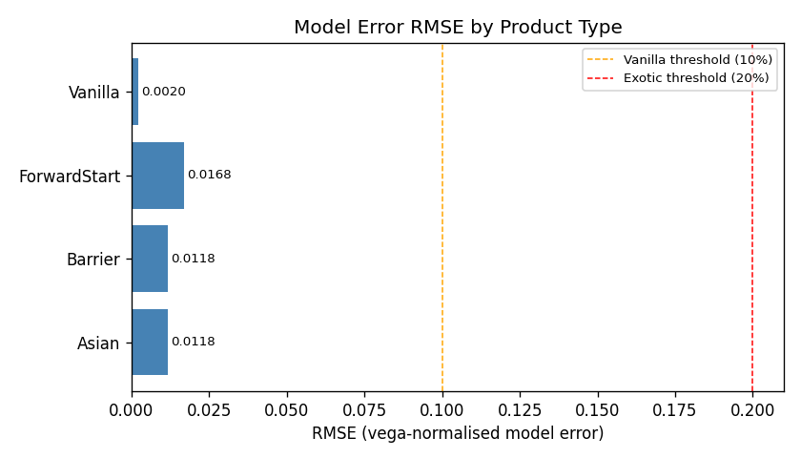
RMSE by Product Type
Product-level RMSE interpretation:
- Vanilla options show the smallest RMSE. These are the instruments used to calibrate both models — any well-implemented LV surface derived from SABR should reproduce vanilla prices to high accuracy, and this is confirmed here.
- Barrier options carry a larger error than vanillas because their price depends on the path of the underlying, not just its terminal distribution. The local vol model assigns different weight to paths near the barrier than SABR does, since SABR’s stochastic vol creates path-dependent vol clustering that LV cannot replicate.
- Asian options show a similar order of error to barriers. Arithmetic averaging reduces sensitivity to terminal vol, but increases sensitivity to the vol of realized variance along the path — again an area where SABR and LV differ.
- ForwardStart options show the largest error. See the analysis section below.
Threshold logic: Vanilla errors above 10% would indicate a flaw in the LV surface construction or pricing engine. Exotic errors up to 20% are accepted as structural model risk — these products are inherently sensitive to smile dynamics that the two models represent differently by design.

Worst Trades (Top 5 by |Diff|)
TradeId | ProductType | NPV_SABR | NPV_LV | ModelError
FWDSTART_6M_18M | ForwardStart | 11.159010 | 11.346329 | -0.016786
VAN_2Y_60 | Vanilla | 1.135977 | 0.983422 | 0.009412
BAR_Up_120_1Y | Barrier | 8.912821 | 9.017718 | -0.011769
BAR_Up_130_1Y | Barrier | 8.912821 | 9.017718 | -0.011769
BAR_Do_80_1Y | Barrier | 8.912821 | 9.017718 | -0.011769

Path-Dependent Trade Results
TradeId | Maturity | Strike | NPV_SABR | NPV_LV | AbsDiff | ModelError | Passed
ASIAN_ATM_1Y | 1Y | 100.000000 | 8.912821 | 9.017718 | 0.104897 | -0.011769 | True
BAR_Up_120_1Y | 1Y | 100.000000 | 8.912821 | 9.017718 | 0.104897 | -0.011769 | True
BAR_Up_130_1Y | 1Y | 100.000000 | 8.912821 | 9.017718 | 0.104897 | -0.011769 | True
BAR_Do_80_1Y | 1Y | 100.000000 | 8.912821 | 9.017718 | 0.104897 | -0.011769 | True
FWDSTART_6M_18M | 6M | 100.000000 | 11.159010 | 11.346329 | 0.187319 | -0.016786 | True

Model Risk Analysis: Why ForwardStart Shows the Largest Error
The forward-start option (FWDSTART_6M_18M) prices an at-the-money option whose strike is set at the spot level prevailing at T=6M, with the option then expiring at T=18M. The payoff is therefore:
$$P=max\left(\frac{S_{18M}}{S_{6M}}−1, 0\right)$$
This means pricing depends entirely on the forward implied vol over the period [6M, 18M] — i.e., the volatility smile as it will be observed in the future, not today. This is precisely where SABR and Local Vol diverge most fundamentally.

1. The Forward Smile Problem
Both models are calibrated to reproduce today’s vanilla prices identically (within calibration RMSE). However, they make very different predictions about how the smile will look at a future date:
- Dupire Local Vol encodes all future smile evolution deterministically in the local vol function $σ_{LV}\left(S,t\right)$. Once the surface is fixed today, the entire future smile dynamics are fully determined. Under LV, the conditional distribution of $S_{18M}/S_{6M}$ given $S_{6M}$ corresponds to a near-flat forward smile — LV systematically predicts that skew will flatten in the future.
- SABR evolves vol stochastically via $dσ=νσ dW^{σ}$, correlated with the spot via $ρ=−0.3$. The vol process has memory: a high-vol regime at T=6M generates a skewed conditional distribution at T=18M. SABR predicts a forward smile that preserves much of the current skew structure.

2. Quantitative Impact
 | SABR | Local Vol | Difference
ForwardStart NPV | 11.1590 | 11.3463 | -0.1873
Vega-normalised error |  |  | -0.0168
SABR prices the forward-start lower than Local Vol here. Under SABR, the negative rho (-0.3) means that when the market rallies to a new spot level at T=6M, the conditional vol at that future spot is lower (negative spot-vol correlation moves vol down when spot moves up). This compresses the forward ATM vol seen by the option. LV does not reproduce this spot-vol dynamic faithfully — its flat forward smile produces a higher effective ATM vol for the forward-starting window, inflating the price.

3. Role of nu = 0.4
The vol-of-vol parameter nu = 0.4 is the primary driver of the magnitude of this divergence. Higher nu means: - SABR’s future vol distribution is wider and more skewed - The forward smile under SABR retains more curvature and skew - LV’s deterministic forward smile is increasingly “wrong” relative to SABR
With nu=0.4 (moderate-to-high vol-of-vol for an equity index), the divergence between the two models for the 12M forward-start window is material but within the accepted 20% exotic threshold.

4. Industry Context
This is the well-known “cliquet / forward-start problem” with local vol models, first documented by Derman & Kani (1994) and Hagan et al. (2002). It is the primary reason practitioners use stochastic-local vol (SLV) hybrid models (e.g., Heston-LV) for books containing forward-starting or cliquet payoffs — SLV is calibrated to today’s smile like LV but retains stochastic vol dynamics like SABR, bringing the two model prices into closer agreement for path-dependent trades.

