## Apache Kafka Producer Windows Setup

**Step 1:** Kafka should be installed and setup in the windows machine.

Download kafka_2.11-0.10.1.1.zip and unzip.

**STEP 2:** Open a command prompt in administrator mode and run the zookeeper server.

Launch a command prompt from inside **kafka_2.11-0.10.1.1\bin\windows** folder.

Run: **zookeeper-server-start.bat ../../config/zookeeper.properties**

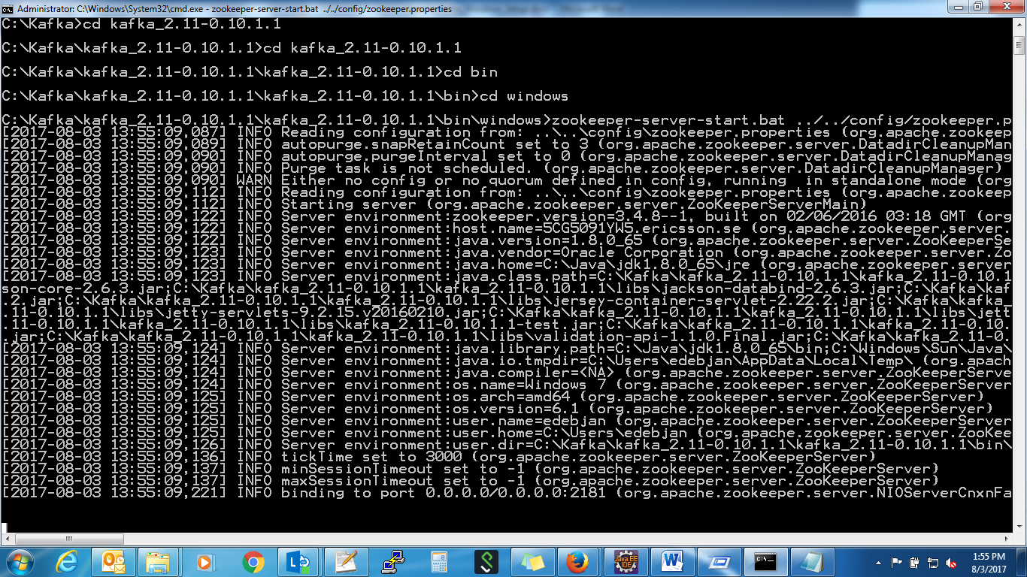

**STEP 3:** Open a command prompt in administrator mode and run the kafka server

Launch a command prompt from inside **kafka_2.11-0.10.1.1\bin\windows** folder.

Run: **kafka-server-start.bat ../../config/server.properties**

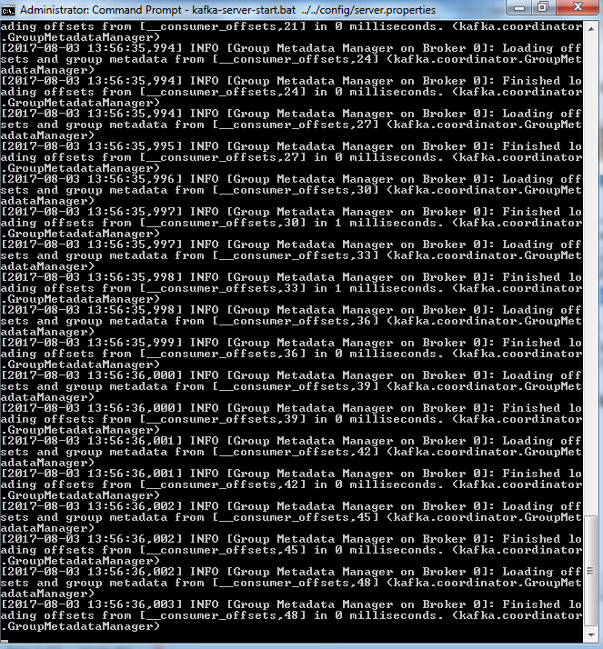

**Step 4:** Create a topic

Launch a command prompt from inside **kafka_2.11-0.10.1.1\bin\windows** folder.

Run**: kafka-topics.bat --create --zookeeper localhost:2181 --replication-factor 1 --partitions 1 --topic <TopicName>**

Here I’ve named the topic as sparkInjestor.

**STEP 5:** Run a producer .

Launch a command prompt from inside **kafka_2.11-0.10.1.1\bin\windows** folder.

Run**: kafka-console-producer.bat --broker-list localhost:9092 --topic sparkInjestor**