

IT342-G4 SYSTEMS INTEGRATION AND

ARCHITECTURE 1

FUNCTIONAL REQUIREMENTS SPECIFICATION (FRS)

Project Title: Mini App – User Registration & Authentication Prepared By: Jon Vic T. Barcenas
Date of Submission: February 3, 2026
Version: 1.0

Table of Contents
- Introduction 3
  - Purpose 3
  - Scope 3
  - Definitions, Acronyms, and Abbreviations 3
- Overall Description 3
  - System Perspective 3
  - User Classes and Characteristics 3
  - Operating Environment 3
  - Assumptions and Dependencies 4
- System Features and Functional Requirements 4
  - Feature 1: 4
  - Feature 2: 4
- Non-Functional Requirements 4
- System Models (Diagrams) 5
  - ERD 5
  - Use Case Diagram 5
  - Activity Diagram 6
  - Class Diagram 7
  - Sequence Diagram 8
- Appendices 8

Introduction

Purpose
The purpose of this document is to define the functional and non-functional requirements of a simple user authentication system.

Scope
The system allows users to register an account, log in, view their profile or dashboard, and log out. Access to protected pages is restricted to authenticated users only. This system focuses only on basic authentication features and does not include advanced functionalities such as roles, permissions, or account management.

Definitions, Acronyms, and Abbreviations
Term | Definition
DB | Database
UI | User Interface
ERD | Entity Relationship Diagram
API | Application Programming Interface
JWT | JSON Web Token

Overall Description

System Perspective
The system is a standalone web-based application composed of a frontend user interface and a backend server connected to a database. It handles user authentication and session management.

User Classes and Characteristics
User Type | Description
Guest User | A user who has not logged in and can only register or log in
Authenticated User | A logged-in user who can view their profile/dashboard  and log out

Operating Environment
    - Frontend: Web browser (Chrome, Edge, Firefox)
    - Backend: Spring Boot REST API
    - Database: Relational database (MySQL / PostgreSQL)
    - Tools: draw.io / diagrams.net, GitHub, IDE

Assumptions and Dependencies
    - Users have internet access
    - Users provide valid email addresses
    - The system depends on a database for storing user data
    - Authentication is handled using session or token-based logic

System Features and Functional Requirements
  - Feature 1: User Registration
Description: Allows a new user to create an account by providing personal and login details.
Functional Requirements:
- The system shall allow users to enter first name, last name, email, and password
- The system shall store user information securely in the database
- The system shall prevent duplicate email registration
  - Feature 2: User Login and Logout
Description: Allows registered users to log in, access protected pages, and log out. Functional Requirements:
- The system shall authenticate users using email and password
- The system shall allow logged-in users to view their profile/dashboard
- The system shall prevent access to protected pages when the user is logged out
- The system shall allow users to log out and terminate their session

Non-Functional Requirements
Security: Passwords shall be stored in encrypted/hashed form Usability: The system shall be easy to use and understand
Performance: Login and registration responses shall occur within reasonable time Reliability: The system shall handle invalid inputs gracefully

System Models (Diagrams)

ERD
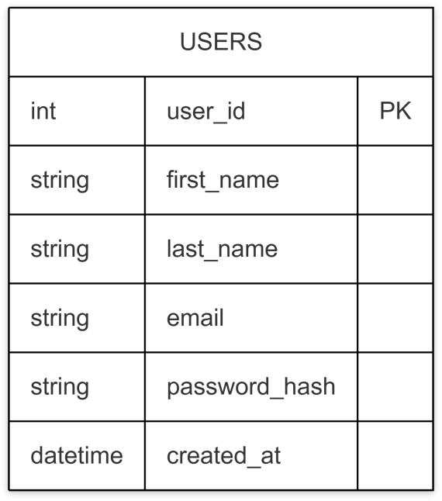

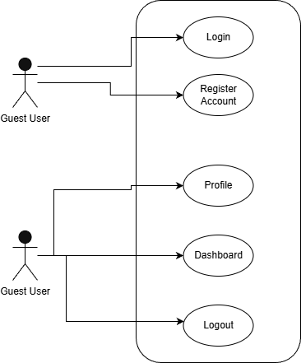
Use Case Diagram
Authenticated
User

Activity Diagram
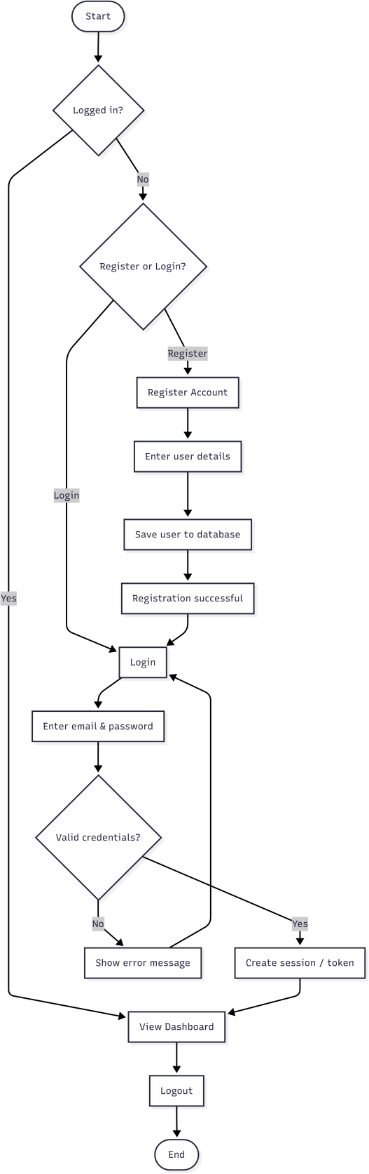

Class Diagram
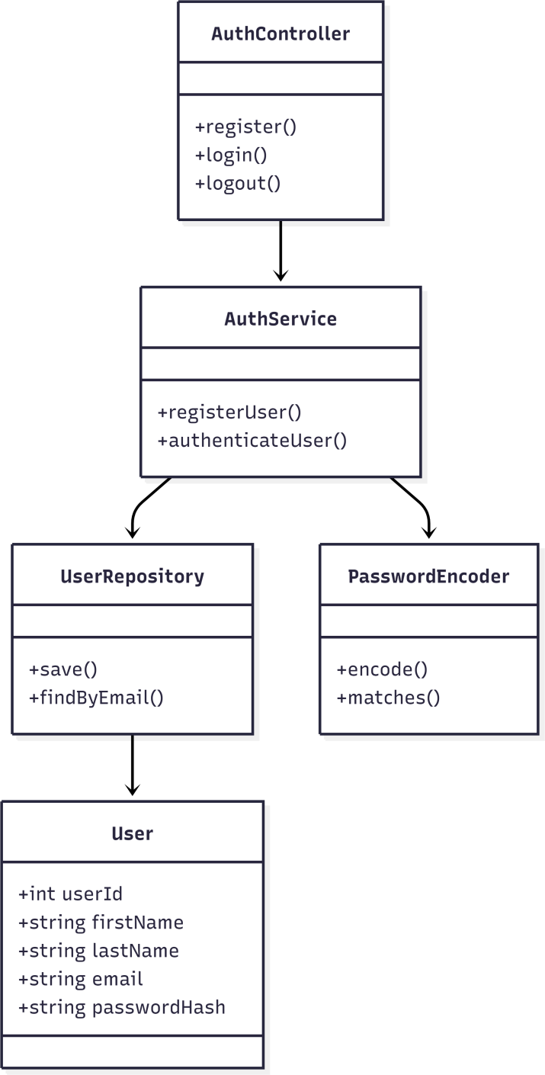

Sequence Diagram
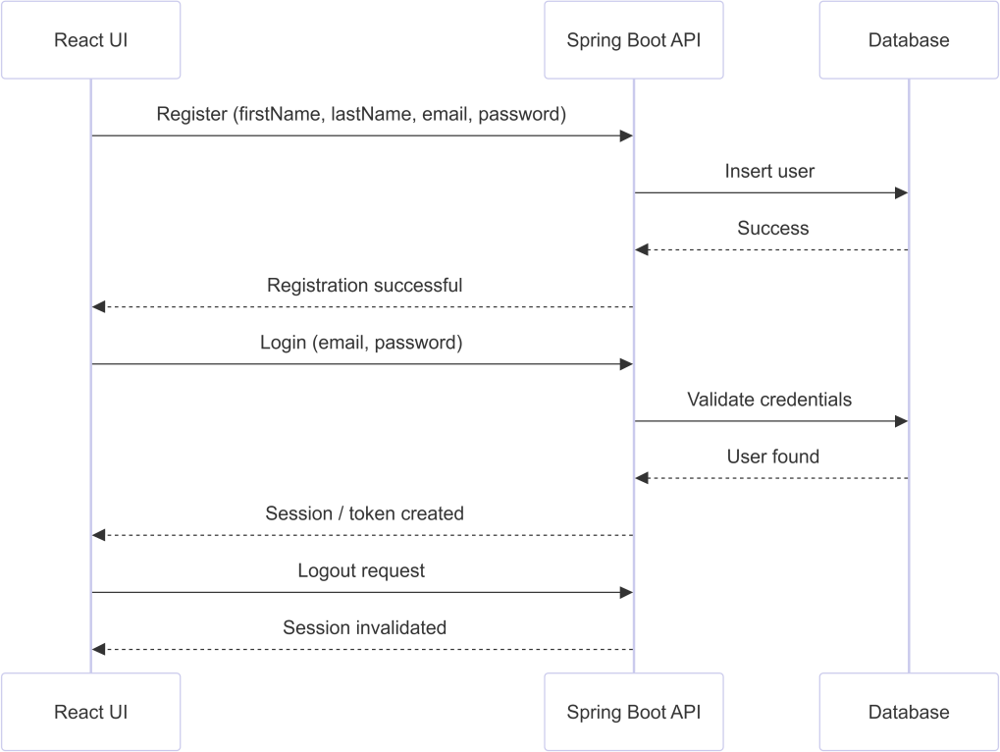

Appendices
All system diagrams were created using draw.io / diagrams.net and Mermaid syntax.

Web Screenshots

Register

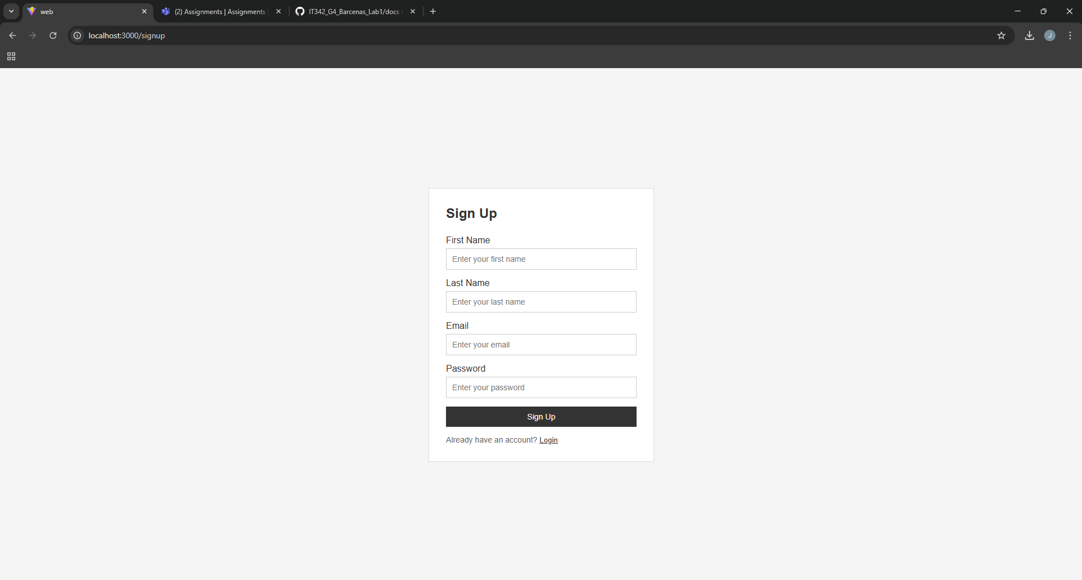

-Login

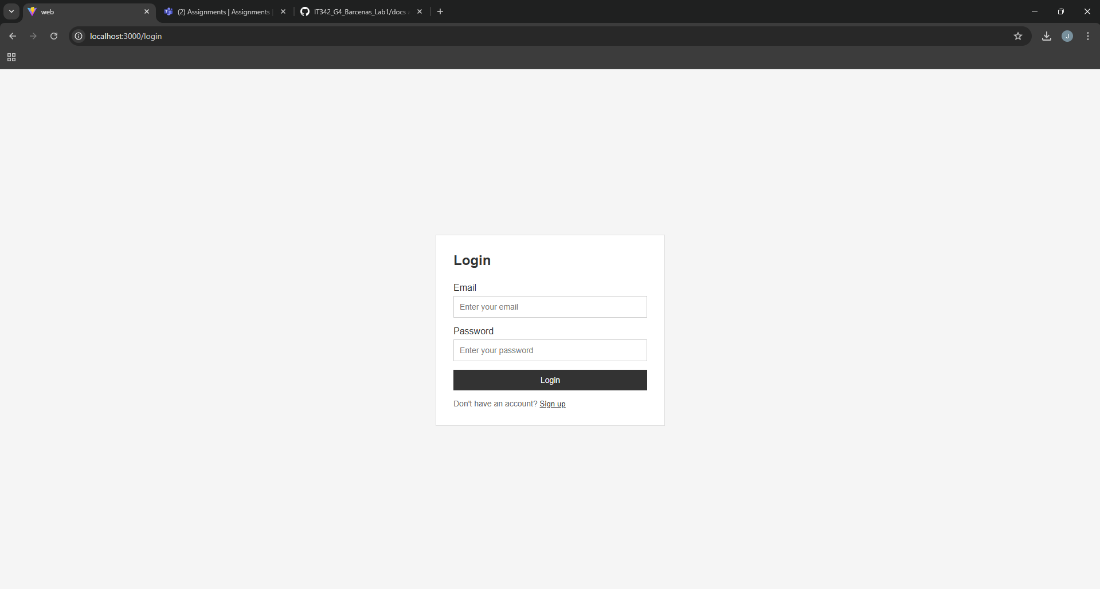

-Dashboard/Profile

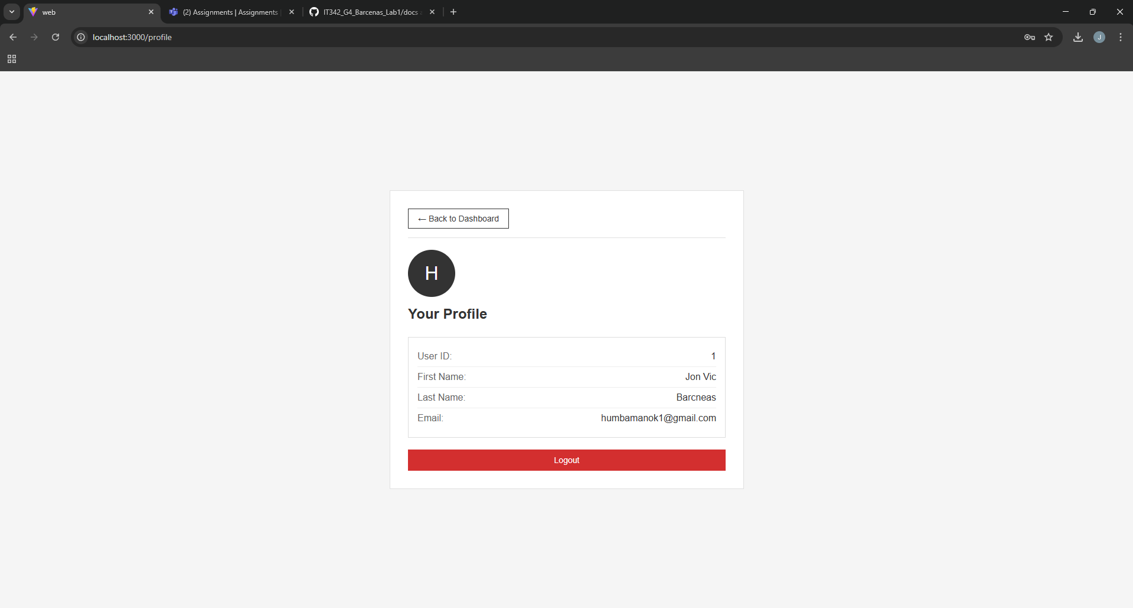

-Logout result

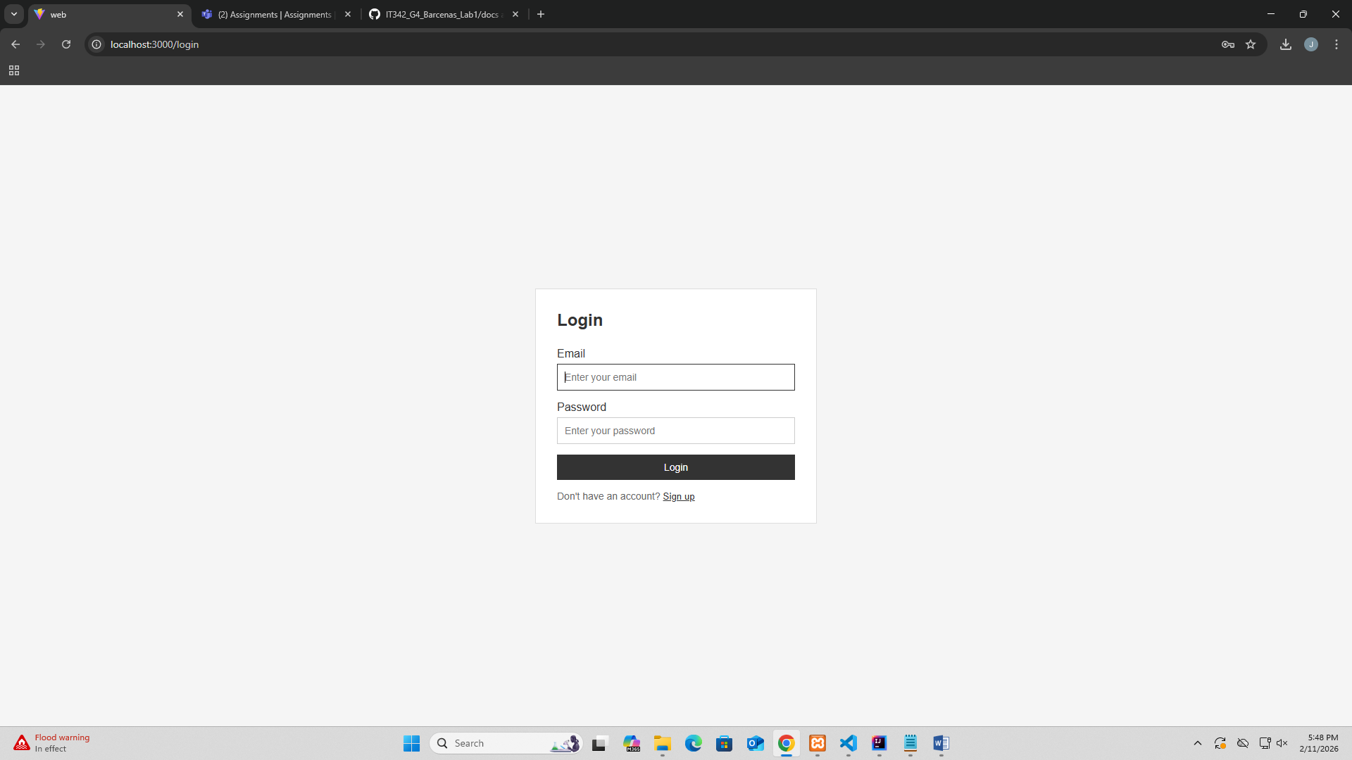

Proof of Integration
