

IT342-G4
System Integration and Architecture

System Design Document (SDD)

Project Title: QueueMS: Smart Queue Management System
Prepared By: Barcenas, Jon Vic T.

Version: 2.0
Date: March 3, 2026
Status: Draft

REVISION HISTORY TABLE
Version | Date | Author | Changes Made | Status
1.0 | 02/18/2026 | Barcenas, Jon Vic T. | Initial draft | Draft
2.0 | 03/03/2026 | Barcenas, Jon Vic T. | Major change | Draft

TABLE OF CONTENTS
Contents
EXECUTIVE SUMMARY 4
1.0 INTRODUCTION 5
2.0 FUNCTIONAL REQUIREMENTS SPECIFICATION 5
3.0 NON-FUNCTIONAL REQUIREMENTS 9
4.0 SYSTEM ARCHITECTURE 11
5.0 API CONTRACT & COMMUNICATION 12
6.0 DATABASE DESIGN 17
7.0 UI/UX DESIGN 18
8.0 PLAN 21

EXECUTIVE SUMMARY
1.1 Project Overview
QueueMS is a Smart Queue Management System that digitizes service queues for campus offices. It allows users to register, log in securely, obtain queue numbers, receive notifications, and monitor queue status in real time.
The system integrates authentication, role-based access control, external APIs, Google OAuth, SMTP email notifications, in-app push notifications via Firebase Cloud Messaging (FCM), and real-time updates using WebSocket.
The system is split across two client platforms: a Web application (React) used by Superadmins and Tellers to manage queues and system settings, and a Mobile application (Android/Kotlin) used by Users (Students) to create and monitor service requests.
1.2 Objectives
- Implement secure authentication using Firebase Authentication with backend-generated JWT and BCrypt password hashing
- Enforce Role-Based Access Control (RBAC)
- Provide full CRUD operations
- Integrate external APIs meaningfully
- Implement Google OAuth login (via Firebase Authentication)
- Send email notifications via SMTP and push notifications via Firebase Cloud (FCM)
- Provide real-time queue updates
- Deploy system to production-ready environment
- Implement file upload for supporting documents attached to service requests
1.3 Scope
Included Features:
- User registration and authentication via Firebase Authentication with backend JWT generation and BCrypt password hashing
- Role-based access control (SUPERADMIN / TELLER / USER)
- ServiceRequest CRUD operations
- Google OAuth login (Firebase Authentication — backend generates own JWT after OAuth login)
- SMTP email notifications (registration confirmation, queue confirmation)
- In-app push notifications via Firebase Cloud Messaging (FCM)
- External public holiday API integration
- File upload support (supporting documents attached to service requests)
- Real-time updates via WebSocket
Excluded Features:
- AI-based queue prediction
- Biometric authentication
- Multi-campus distributed system
- Advanced analytics dashboard

1.0 INTRODUCTION
1.1 Purpose
This document serves as the comprehensive design specification for QueueMS. It provides detailed requirements, architecture decisions, API contracts, database schema, integrations, and development roadmap to ensure system components integrate seamlessly.

2.0 FUNCTIONAL REQUIREMENTS SPECIFICATION
2.1 Project Overview
Project Name: QueueMS
Domain: Campus Services / Queue Systems
Primary Users: Students (Users) and Administrators
Problem Statement: Manual queue systems cause long waiting times and poor service efficiency.
Solution: A digital queue management system with secure authentication, real-time updates, and automated notifications.
2.2 Core User Journeys
Journey 1: User Creates Service Request
- User registers or logs in via the Mobile App
- User creates new ServiceRequest on their phone
- Receives confirmation email and/or in-app push notification (FCM)
- Monitors queue status in real time on the Mobile App
Journey 2: Admin Manages Queue
- Admin logs in via the Web App
- Views all service requests on the Admin Dashboard
- Serves next request from the Web interface
- Updates request status via the Web App
- System broadcasts real-time update to all connected Mobile users
2.3 Feature List (MoSCoW)
MUST HAVE
- User authentication (register, login, logout, /me)
- Firebase Authentication + backend-generated JWT (BCrypt password hashing)
- Role-based access control
- Full CRUD for ServiceRequest
- SMTP email notifications
- In-app push notifications via Firebase Cloud Messaging (FCM)
- External API integration
- File upload (supporting documents for service requests)
- Real-time queue updates
SHOULD HAVE
- Estimated waiting time
- Public holiday blocking
COULD HAVE
- Queue history tracking
- Basic admin statistics
WON'T HAVE
- Real payment processing
- Any payment processing (Real or Sandbox)
- Multi-language support
- AI-based automation
- Biometric login
2.4 Detailed Feature Specifications
Feature: User Authentication
- Platforms:
  - Superadmin: Web App (React)
  - Teller: Web App (React)
  - User/Student: Mobile App (Android/Kotlin)
- Screens:
  - Web (Superadmin): Login only — Superadmin accounts are pre-registered; full system access
  - Web (Teller): Login only — Teller accounts are created by Superadmin; counter-scoped access
  - Mobile (User): Registration, Login
- Fields: Email, Password, Confirm Password (Mobile User registration only)
- Validation: Email format, password strength, uniqueness
- API Endpoints:
  - GET /auth/me — Verify Firebase ID token; return user profile and role (SUPERADMIN / TELLER / USER) from Firestore
- Client-Side (Firebase SDK): Registration, login, and logout are initiated via Firebase Authentication on the client.
- Sign-In Providers: Email/Password and Google OAuth (both built into Firebase Authentication)
- Security: Firebase Authentication + backend-generated JWT; BCrypt password hashing (salt rounds = 12)
Feature: ServiceRequest (Core Module)
User-Facing (Mobile App):
- Screens: User Dashboard, Create Request Page, Request Detail Page
- Display: List layout showing request number, status, service type, date created
- Functions: Create request, cancel request, view request status, monitor queue position
Teller-Facing (Web App):
- Screens: Teller Dashboard, Queue Management Page, Request Detail Page
- Display: List of active/pending requests assigned to their counter
- Functions: View assigned requests, serve next request, update request status, open/close their counter
Superadmin-Facing (Web App):
- Screens: Admin Dashboard, User Management Page, Counter Management Page, System Settings
- Display: Full list of all requests across all counters; all user accounts and roles
- Functions: View all requests, manage all users and roles, manage service counters, view analytics, full system control
- Validation: Required fields, valid service counter selection, status enum validation
- Data Storage: Records stored as Firestore documents (NoSQL)
- User API Endpoints (Mobile):
  - GET /requests — Get all requests for authenticated user
  - GET /requests/{id} — Get specific request
  - POST /requests — Create new request
  - DELETE /requests/{id} — Cancel request
- Teller API Endpoints (Web):
  - GET /teller/requests — View requests for teller's assigned counter (TELLER only)
  - PUT /requests/{id}/serve — Mark request as being served (TELLER only)
  - PUT /requests/{id} — Update request status (TELLER only)
  - PUT /teller/counter/status — Open or close teller's counter (TELLER only)
- Superadmin API Endpoints (Web):
  - GET /admin/requests — View all requests across all counters (SUPERADMIN only)
  - GET /admin/users — View all user accounts (SUPERADMIN only)
  - POST /admin/users — Create Teller or Superadmin account (SUPERADMIN only)
  - PUT /admin/users/{id} — Update user role or details (SUPERADMIN only)
  - DELETE /admin/users/{id} — Delete user account (SUPERADMIN only)
  - GET /admin/counters — View all service counters (SUPERADMIN only)
  - POST /admin/counters — Create new service counter (SUPERADMIN only)
  - PUT /admin/counters/{id} — Update counter details (SUPERADMIN only)
  - DELETE /admin/counters/{id} — Remove service counter (SUPERADMIN only)
Feature: External Public Holiday API Integration
- Screens: Mobile App — Dashboard Holiday Banner (shown to Users before creating a request)
- Display: Holiday name and date
- Purpose: Prevent users from booking on public holidays
- API Integration:
  - GET https://date.nager.at/api/v3/PublicHolidays/{year}/PH
Feature: Email Notification (SMTP)
- Trigger Events: User registration, service request confirmation, status updates
- Email Types:
  - Welcome Email (on successful registration)
  - Queue Confirmation Email (on service request creation)
  - Status Update Email (when request status changes)
- Integration: SMTP via JavaMailSender (Gmail or other provider)
Feature: In-App Push Notifications (FCM)
- Trigger Events: Queue status updates, request confirmation, "Your turn is next" alerts, admin actions
- Notification Types:
  - Push notification via Firebase Cloud Messaging (FCM)
  - In-app notification bell / notification feed
- Integration:
  - Backend: Firebase Admin SDK (triggers and sends notifications)
  - Mobile (User): Firebase Android SDK (receives FCM push notifications — primary recipient)
- Platforms: Android Mobile App only (FCM push notifications are for Users on mobile; Admins manage via Web and do not receive FCM push)
Feature: Real-Time Queue Updates
- Technology: WebSocket (Spring Boot)
- Purpose: Live status updates broadcast to Mobile Users when Admin serves next request
- Trigger: When Admin updates request status via Web App
- Receivers: Mobile App (Users) — see live queue position updates
- Sender: Web App (Admin) — triggers status change that initiates the broadcast

2.5 Acceptance Criteria
AC-1: Successful User Registration (Mobile App)
Given I am a new user on the Mobile App
When I enter a valid email and strong password
And confirm the password correctly
And click "Register"
Then my account should be created
And my password should be stored securely by Firebase Authentication
And I should receive a welcome email and/or an in-app push notification
And I should be able to log in via the Mobile App
AC-2: Successful Login with Firebase Authentication
Given I am a User with a registered account on the Mobile App
When I enter valid credentials and click "Login"
Then Firebase Authentication should issue a valid ID token (JWT)
And allow access to protected Mobile App pages

Given I am a Teller logging in via the Web App
When I enter valid credentials and click "Login"
Then Firebase Authentication should issue a valid ID token (JWT)
And allow access to the Teller Dashboard on the Web App
And the GET /auth/me endpoint should return my details and TELLER role

Given I am a Superadmin logging in via the Web App
When I enter valid credentials and click "Login"
Then Firebase Authentication should issue a valid ID token (JWT)
And allow access to the full Admin Dashboard on the Web App
And the GET /auth/me endpoint should return my details and SUPERADMIN role
AC-3: Role-Based Access Control
Given I am logged in as a USER (via Mobile App)
When I attempt to access a Teller or Superadmin-only endpoint
Then I should receive 403 Forbidden

Given I am logged in as a TELLER (via Web App)
When I access teller endpoints
Then I should be allowed to view and serve requests at my assigned counter
And I should receive 403 Forbidden when accessing Superadmin-only endpoints

Given I am logged in as a SUPERADMIN (via Web App)
When I access admin endpoints
Then I should be allowed to manage all requests, users, roles, and counters
And Users should not be able to access the Web App dashboard
AC-4: Create Service Request (Mobile App)
Given I am authenticated as a User on the Mobile App
When I submit a valid service request
Then a new ServiceRequest document should be created in Firestore
And it should be linked to my user account
And the system should return 201 Created
AC-5: Update Service Request Status (Web App — Teller)
Given I am a Teller on the Web App
When I update the status of a service request at my counter
Then the system should update the request
And return 200 OK
And all connected Mobile App users should receive the real-time update
AC-6: Cancel Service Request (Mobile App — User)
Given I am a User and the owner of a service request on the Mobile App
When I choose to cancel it
Then the request status should be updated to "Cancelled"
And it should no longer appear in the active queue
AC-7: External Public Holiday Restriction (Mobile App — User)
Given today is a public holiday retrieved from the external API
When I attempt to create a service request on the Mobile App
Then the system should prevent the request
And display a holiday notification message on the Mobile App
AC-8: Real-Time Queue Update
Given multiple Users are viewing the queue on the Mobile App
When an ADMIN serves the next request via the Web App
Then all connected Mobile App users should see the updated queue status in real time

AC-9: Email Notification
Given I successfully register
When my account is created
Then the system should send a welcome email via SMTP

Given I create a service request
When the request is successfully submitted
Then I should receive a confirmation email via SMTP
AC-10: In-App Push Notification (Mobile App — Users only)
Given I am a registered User with notifications enabled on the Mobile App
When an Admin updates my service request status via the Web App
Then I should receive a push notification via FCM on my mobile device
And the notification should also appear inside the Mobile App as an in-app notification

Given I create a service request on the Mobile App
When the request is successfully submitted
Then I should receive an in-app push notification confirming my request on my mobile device

3.0 NON-FUNCTIONAL REQUIREMENTS
3.1 Performance Requirements
- API response time: ≤ 2 seconds for 95% of requests
- Web page load time: ≤ 3 seconds on broadband connection
- Mobile app cold start: ≤ 3 seconds
- Real-time queue updates reflected within 3 seconds
- Support at least 100 concurrent users
- Firestore queries complete within 500ms under normal load

3.2 Security Requirements
    - HTTPS for all communications
    - Firebase Authentication JWT ID token verification for protected endpoints
    - Password hashing using BCrypt (salt rounds = 12) before storage in Firestore
    - Backend generates and signs its own JWT after Firebase token verification
    - Google OAuth login flow: Firebase token → backend verification → backend JWT issued
    - Role-based access control enforcement at API level
    - Firestore security rules to prevent unauthorized data access
    - NoSQL data validation handled via Firestore rules and server-side validation
    - XSS protection through input validation and output encoding
    - Rate limiting: 100 requests per minute per IP
    - Teller endpoints require TELLER or SUPERADMIN role verification
    - Superadmin endpoints require SUPERADMIN role verification only
    - DTO usage to prevent exposure of sensitive user data (e.g., roles, tokens) in API responses
3.3 Compatibility Requirements
Web App (Admin only):
- Web Browsers: Chrome, Firefox, Safari, Edge (latest 2 versions)
- Screen Sizes:
  - Tablet (768px and above)
  - Desktop (1024px and above)
- Operating Systems: Windows 10+, macOS 10.15+, Linux Ubuntu 20.04+
Mobile App (Users only):
- Android: API Level 34+ (Android 7.0 and above)
- Screen Sizes:
  - Mobile (360px and above)

3.4 Usability Requirements
Mobile App (Users):
- Users should be able to create a service request within 3 minutes
- Clear queue position visibility on the mobile dashboard
- Consistent navigation across all mobile screens
- Clear validation and error messages with recovery options
- Touch targets minimum 44x44px on mobile
- Responsive and mobile-friendly interface
Web App (Teller):
- Tellers should be able to view and serve the next request within 2 clicks
- Clear overview of pending, active, and completed requests at their counter
- Keyboard navigation support
- Consistent and intuitive teller dashboard layout
Web App (Superadmin):
- Superadmin should be able to manage users and counters within 3 clicks
- Clear overview of all requests across all counters
- Full user management interface (create, edit, delete accounts)
- Consistent and intuitive admin dashboard layout

4.0 SYSTEM ARCHITECTURE
4.1 Component Diagram
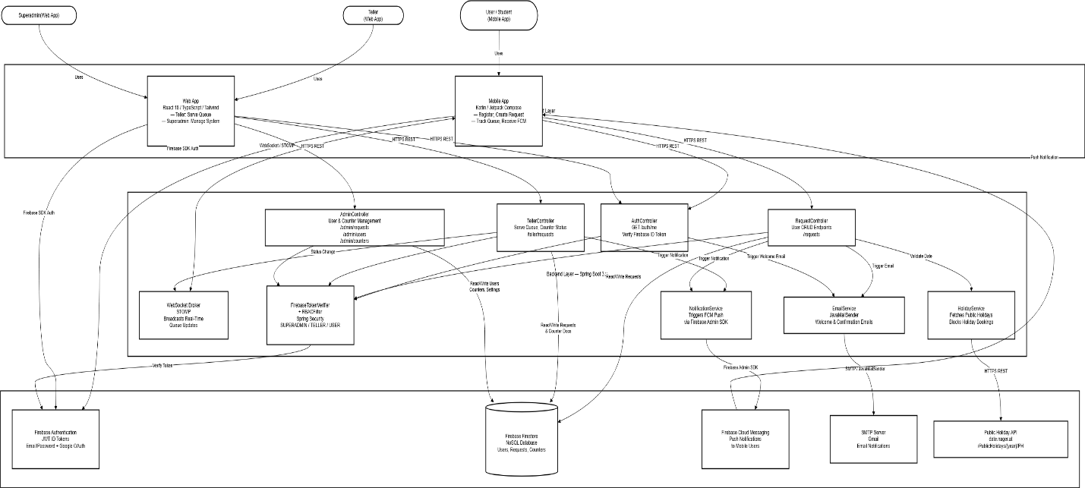

Technology Stack:
- Backend: Java 17, Spring Boot 3.x, Spring Security (JWT + RBAC), Firebase Admin SDK (Firestore), JavaMailSender (SMTP), Firebase Admin SDK (FCM)
- Database: Firebase Cloud Firestore (NoSQL)
- Authentication: Firebase Authentication (Email/Password + Google OAuth) + Backend-generated JWT (BCrypt)
- Web Frontend: React 18, TypeScript, Tailwind CSS, Firebase Web SDK (Auth), Axios
- Mobile: Kotlin, XML-Based UI Layouts, Android API Level 34, Firebase Android SDK (Auth
+ FCM), Retrofit
- Build Tools: Maven (Backend), npm/yarn (Web), Gradle (Android)
- Deployment: Railway/Render (Backend), Firebase Hosting/Vercel (Web — Admin), APK (Mobile — Users)

5.0 API CONTRACT & COMMUNICATION
5.1 API Standards
Base URL | https://[server_hostname]:[port]/api/v1
Format | JSON for all requests/responses
Authentication | Bearer token (Firebase JWT ID Token) in Authorization header
Response Structure | { "success": boolean, "data": object or null, "error": { "code": string, "message": string, "details": object or null }, "timestamp": string }

5.2 Endpoint Specifications
Authentication

GET /auth/me — Get Current Authenticated User

Description | Verifies Firebase ID Token and returns the user's profile and role from Firestore
API URL | /auth/me
HTTP Method | GET
Authentication | Bearer token (Firebase JWT ID Token)
Request Payload | None
Response Structure | { "success": true, "data": { "uid": "<firebase_uid>", "email": "<email>", "firstname": "<firstname>", "lastname": "<lastname>", "role": "<USER or TELLER or SUPERADMIN>" }, "error": null, "timestamp": "<ISO 8601 datetime>" }

Service Request — User (Mobile App)

POST /requests — Create Service Request

Description | Creates a new service request for the authenticated user. Blocked on public holidays.
API URL | /requests
HTTP Method | POST
Authentication | Bearer token (USER role)
Request Payload | { "serviceType": "<service_type>", "counterId": "<counter_id>", "notes": "<optional notes>" }
Response Structure | { "success": true, "data": { "id": "<request_id>", "queueNumber": "<number>", "serviceType": "<service_type>", "status": "PENDING", "counterName": "<counter_name>", "createdAt": "<ISO 8601 datetime>" }, "error": null, "timestamp": "<ISO 8601 datetime>" }

GET /requests — Get My Requests

Description | Returns all service requests belonging to the authenticated user
API URL | /requests
HTTP Method | GET
Authentication | Bearer token (USER role)
Request Payload | None
Response Structure | { "success": true, "data": [ { "id": "<request_id>", "queueNumber": "<number>", "serviceType": "<service_type>", "status": "<PENDING or SERVING or COMPLETED or CANCELLED>", "counterName": "<counter_name>", "createdAt": "<ISO 8601 datetime>" } ], "error": null, "timestamp": "<ISO 8601 datetime>" }

DELETE /requests/{id} — Cancel Service Request

Description | Cancels a service request owned by the authenticated user
API URL | /requests/{id}
HTTP Method | DELETE
Authentication | Bearer token (USER role)
Request Payload | None
Response Structure | { "success": true, "data": { "id": "<request_id>", "status": "CANCELLED" }, "error": null, "timestamp": "<ISO 8601 datetime>" }

Queue Management — Teller (Web App)

GET /teller/requests — Get Counter Requests

Description | Returns all active/pending service requests assigned to the teller's counter
API URL | /teller/requests
HTTP Method | GET
Authentication | Bearer token (TELLER role)
Request Payload | None
Response Structure | { "success": true, "data": [ { "id": "<request_id>", "queueNumber": "<number>", "userFullName": "<firstname lastname>", "serviceType": "<service_type>", "status": "<PENDING or SERVING>", "createdAt": "<ISO 8601 datetime>" } ], "error": null, "timestamp": "<ISO 8601 datetime>" }

PUT /requests/{id}/serve — Serve Next Request

Description | Marks a request as being served. Triggers real-time WebSocket broadcast and FCM push notification to the user.
API URL | /requests/{id}/serve
HTTP Method | PUT
Authentication | Bearer token (TELLER role)
Request Payload | None
Response Structure | { "success": true, "data": { "id": "<request_id>", "status": "SERVING", "updatedAt": "<ISO 8601 datetime>" }, "error": null, "timestamp": "<ISO 8601 datetime>" }

PUT /teller/counter/status — Open or Close Counter

Description | Allows the teller to open or close their assigned service counter
API URL | /teller/counter/status
HTTP Method | PUT
Authentication | Bearer token (TELLER role)
Request Payload | { "status": "<OPEN or CLOSED>" }
Response Structure | { "success": true, "data": { "counterId": "<counter_id>", "counterName": "<counter_name>", "status": "<OPEN or CLOSED>", "updatedAt": "<ISO 8601 datetime>" }, "error": null, "timestamp": "<ISO 8601 datetime>" }

System Management — Superadmin (Web App)

POST /admin/users — Create Staff Account

Description | Creates a new Teller or Superadmin account. Users self-register via Mobile App.
API URL | /admin/users
HTTP Method | POST
Authentication | Bearer token (SUPERADMIN role)
Request Payload | { "email": "<email>", "firstname": "<firstname>", "lastname": "<lastname>", "role": "<TELLER or SUPERADMIN>", "counterId": "<counter_id (required if TELLER)>" }
Response Structure | { "success": true, "data": { "uid": "<firebase_uid>", "email": "<email>", "firstname": "<firstname>", "lastname": "<lastname>", "role": "<TELLER or SUPERADMIN>", "createdAt": "<ISO 8601 datetime>" }, "error": null, "timestamp": "<ISO 8601 datetime>" }

GET /admin/requests — Get All Requests

Description | Returns all service requests across all counters
API URL | /admin/requests
HTTP Method | GET
Authentication | Bearer token (SUPERADMIN role)
Request Payload | None
Response Structure | { "success": true, "data": [ { "id": "<request_id>", "queueNumber": "<number>", "userFullName": "<firstname lastname>", "serviceType": "<service_type>", "status": "<PENDING or SERVING or COMPLETED or CANCELLED>", "counterName": "<counter_name>", "createdAt": "<ISO 8601 datetime>" } ], "error": null, "timestamp": "<ISO 8601 datetime>" }

POST /admin/counters — Create Service Counter

Description | Creates a new service counter and optionally assigns a teller
API URL | /admin/counters
HTTP Method | POST
Authentication | Bearer token (SUPERADMIN role)
Request Payload | { "name": "<counter_name>", "serviceType": "<service_type>", "assignedTellerId": "<teller_uid or null>" }
Response Structure | { "success": true, "data": { "id": "<counter_id>", "name": "<counter_name>", "serviceType": "<service_type>", "status": "CLOSED", "createdAt": "<ISO 8601 datetime>" }, "error": null, "timestamp": "<ISO 8601 datetime>" }

5.3 Error Handling
HTTP Status Codes
Status Code | Meaning
200 OK | Successful request
201 Created | Resource successfully created
400 Bad Request | Invalid input or malformed request
401 Unauthorized | Firebase token invalid or expired
403 Forbidden | Insufficient role permissions
404 Not Found | Resource does not exist
409 Conflict | Duplicate resource (e.g., email already registered)
500 Internal Server Error | Unexpected server error

Error Code Examples
Example 1 — Invalid Token

Code | AUTH-002
Response | { "success": false, "data": null, "error": { "code": "AUTH-002", "message": "Token expired or invalid", "details": "Firebase ID token has expired. Please re-authenticate." }, "timestamp": "2024-01-28T10:30:00Z" }

Example 2 — Validation Failed

Code | VALID-001
Response | { "success": false, "data": null, "error": { "code": "VALID-001", "message": "Validation failed", "details": { "email": "Email is required", "password": "Must be at least 8 characters" } }, "timestamp": "2024-01-28T10:30:00Z" }

Common Error Codes
Error Code | Description
AUTH-001 | Invalid credentials
AUTH-002 | Firebase token expired or invalid
AUTH-003 | Insufficient role permissions
VALID-001 | Validation failed
DB-001 | Resource not found
DB-002 | Duplicate entry
HOLIDAY-001 | Booking not allowed on public holidays
SYSTEM-001 | Internal server error

6.0 DATABASE DESIGN
6.1 Entity Relationship Diagram

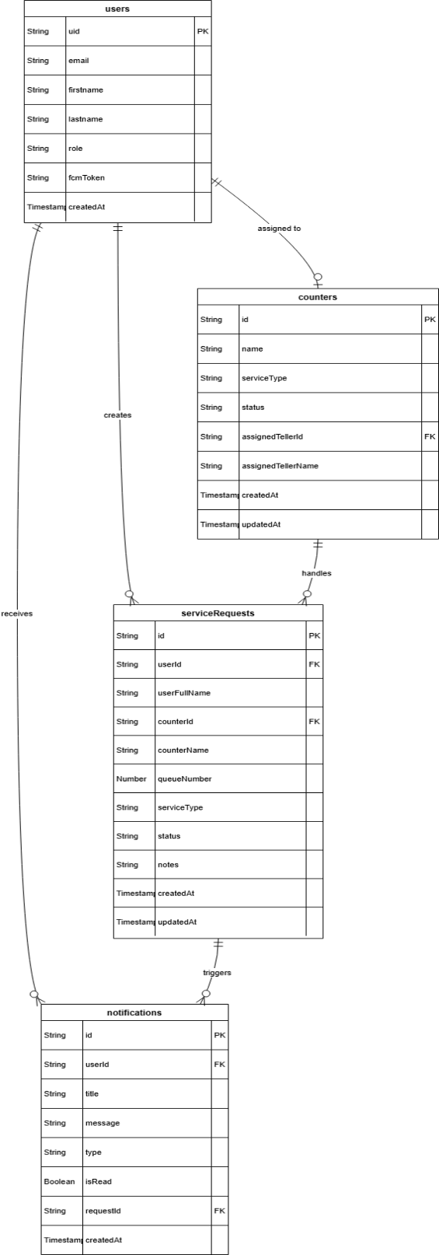

7.0 UI/UX DESIGN
7.1 Web Application Wireframes
Login Screen

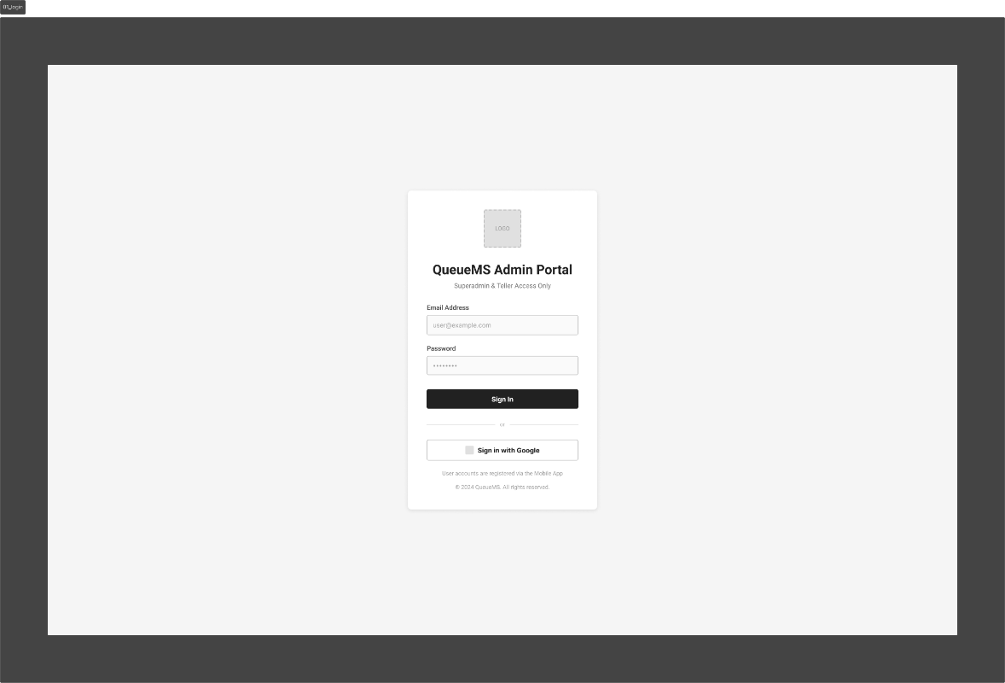

Teller Dashboard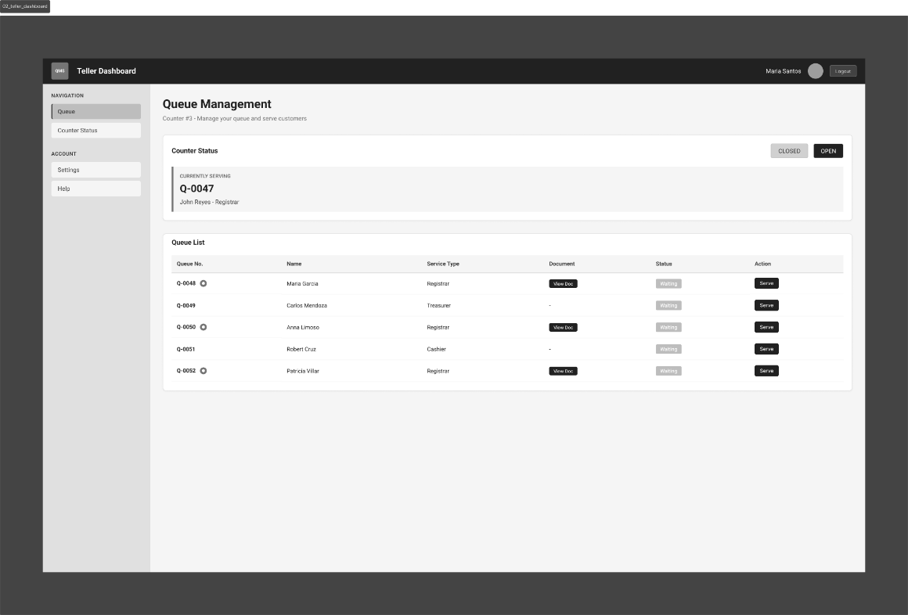

Superadmin Dashboard Screen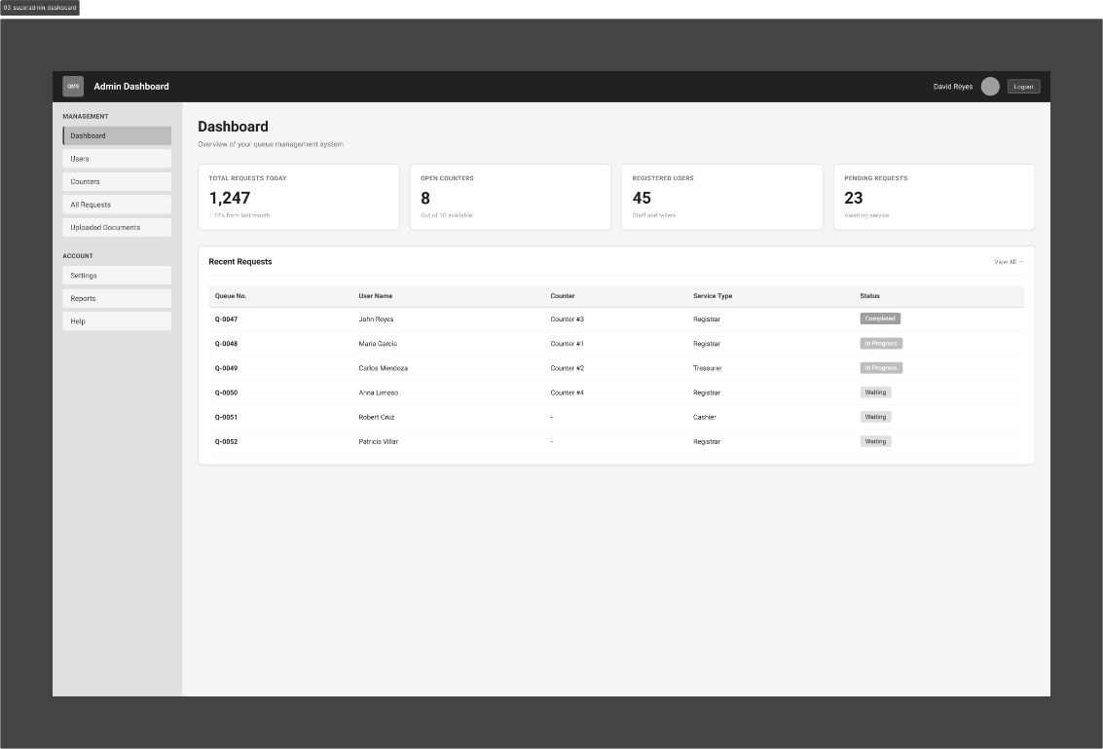

User Management Screen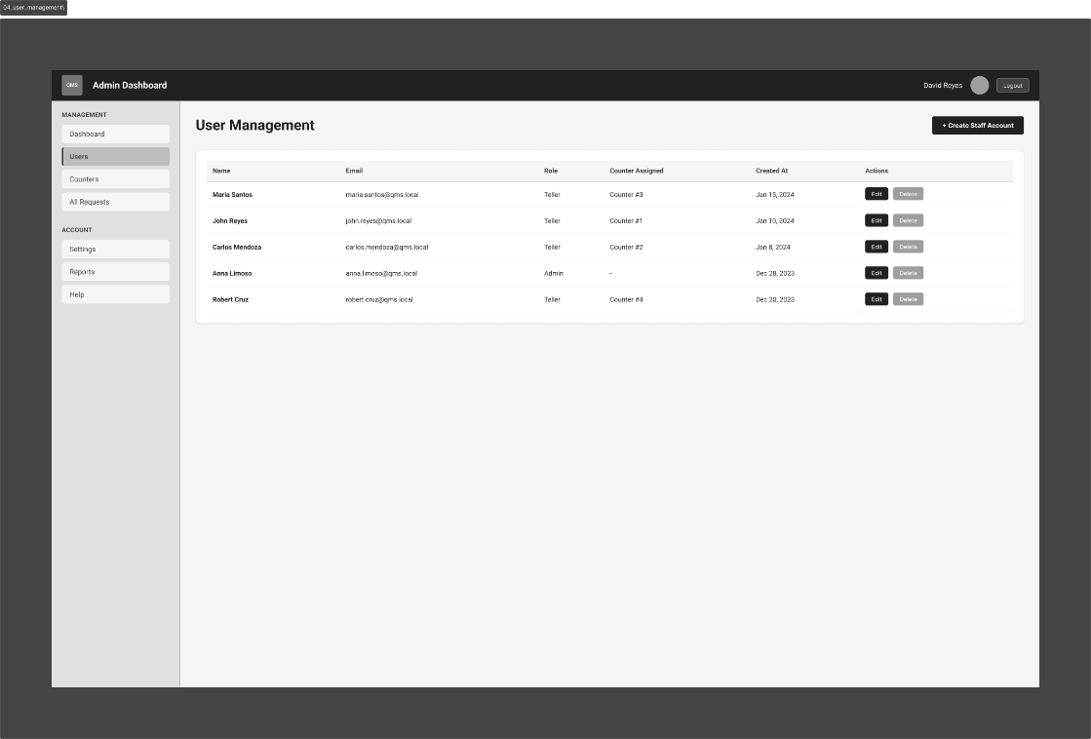

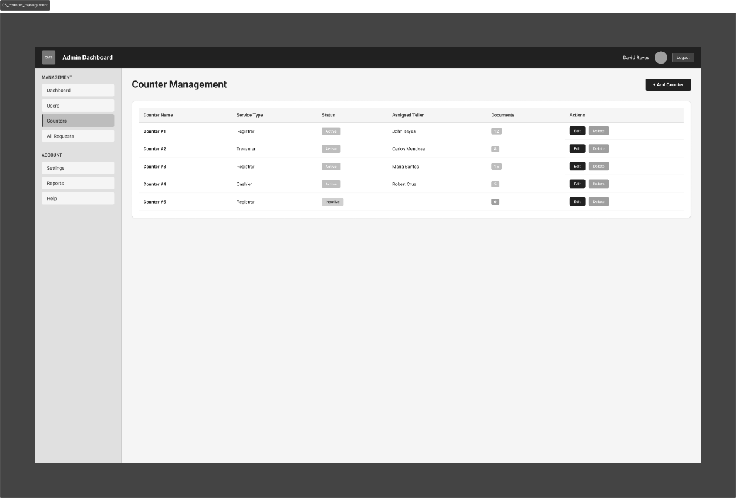
Counter Management Screen

  - Mobile Application Wireframes

Splash Screen  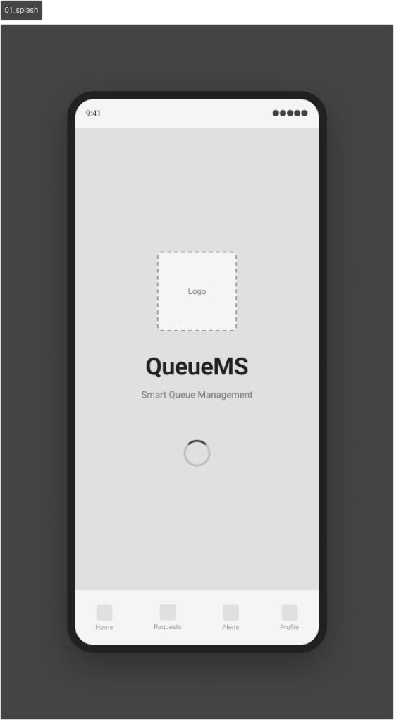 | Register Screen  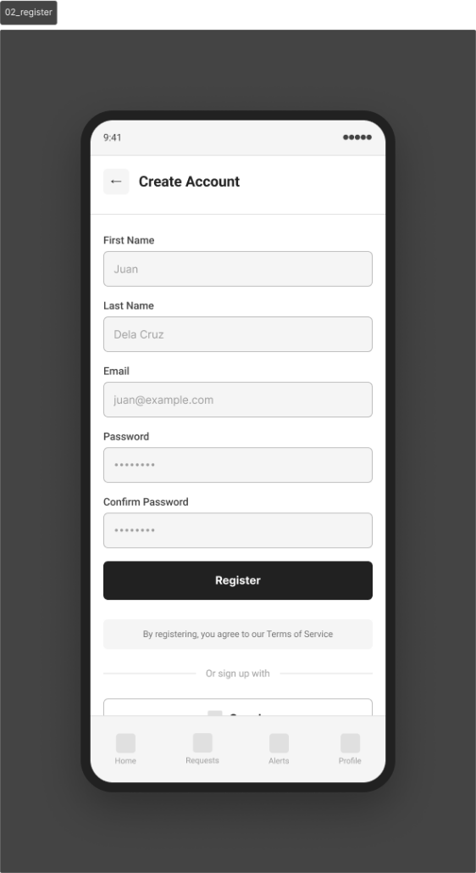

Login Screen  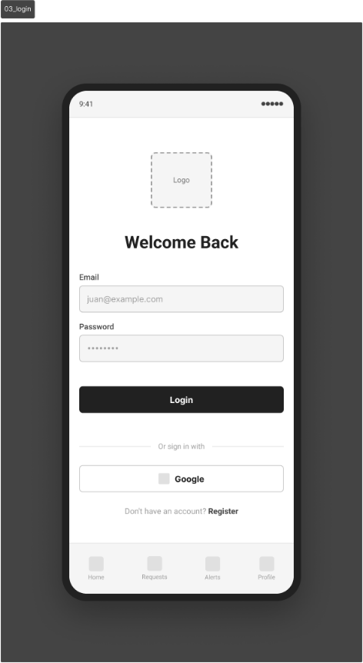 | Dashboard Screen  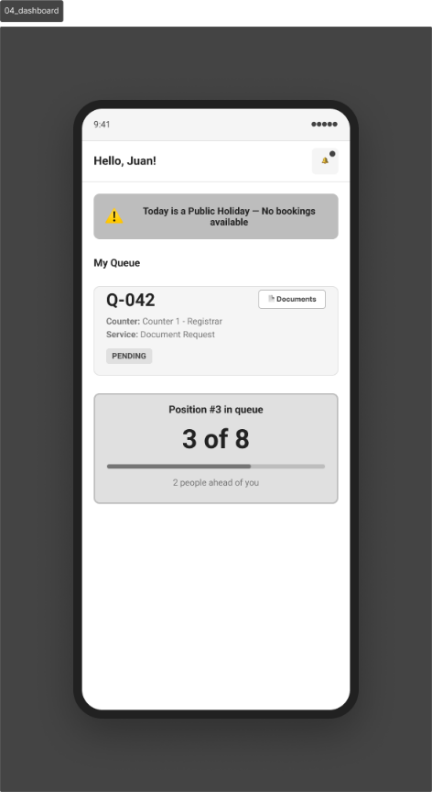
Create Request Screen  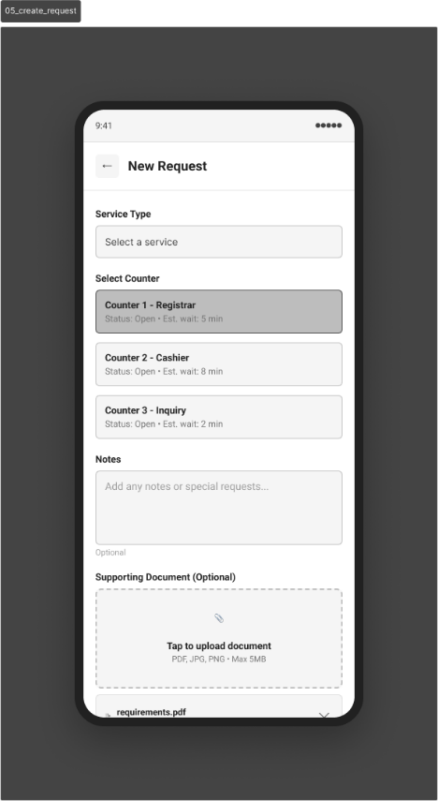 | My Request Screen  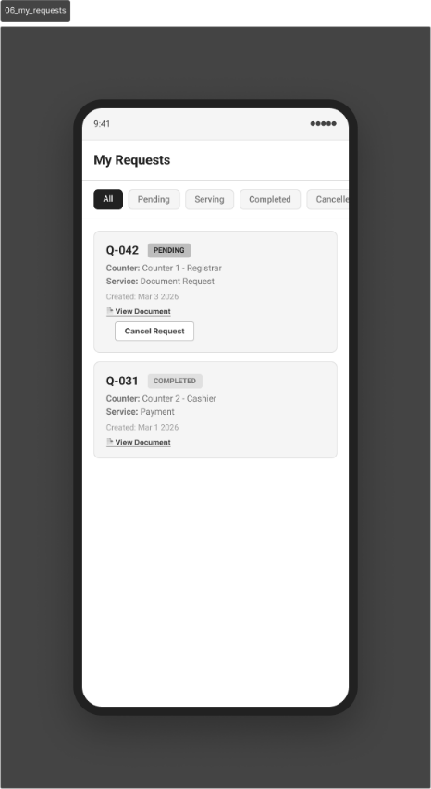

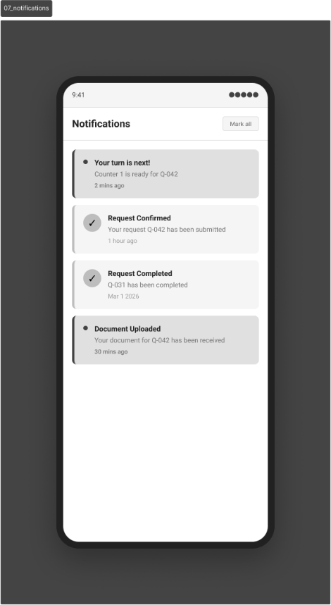
Notifications Screen
Design System:
Colors:
Role | Hex | Usage
Primary | #1D4ED8 | Main actions, buttons, links, navbar
Secondary | #475569 | Sidebar, secondary text, labels
Success | #16A34A | COMPLETED status, OPEN counter, success toast
Warning | #D97706 | PENDING status, holiday banner, alerts
Role | Hex | Usage
Error | #DC2626 | CANCELLED status, error messages, delete actions
Serving | #4F46E5 | SERVING status indicator
Background | #F8FAFC | Page background
Surface | #FFFFFF | Cards, modals, inputs
Border | #E2E8F0 | Dividers, input borders, table borders
Text Primary | #0F172A | Headings, body text
Text Secondary | #64748B | Subtext, placeholders, captions
Status Badge Colors:
Status | Background | Text
PENDING | #FEF3C7 | #D97706
SERVING | #EEF2FF | #4F46E5
COMPLETED | #DCFCE7 | #16A34A
CANCELLED | #FEE2E2 | #DC2626
OPEN | #DCFCE7 | #16A34A
CLOSED | #F1F5F9 | #64748B
Typography:
Element | Font | Size | Weight
Font Family | Inter | — | —
H1 / Page Title | Inter | 32px | 700 Bold
H2 / Section Title | Inter | 24px | 600 SemiBold
H3 / Card Title | Inter | 18px | 600 SemiBold
Body | Inter | 14px | 400 Regular
Small / Caption | Inter | 12px | 400 Regular
Button | Inter | 14px | 500 Medium
Badge / Label | Inter | 11px | 600 SemiBold
Spacing:
- Base unit: 8px grid system
- xs: 4px | sm: 8px | md: 16px | lg: 24px | xl: 32px | 2xl: 48px

Components:
- Buttons: 8px border radius — Primary (filled #1D4ED8), Secondary (outlined), Danger (filled #DC2626)
- Inputs: 8px border radius, #E2E8F0 border, focus ring #1D4ED8
- Cards: White background, #E2E8F0 border, 12px radius, 16px padding, subtle shadow
- Modals: White, centered, 16px radius, dark overlay rgba(0,0,0,0.5)
- Navbar (Web): #1D4ED8 primary blue background, white text
- Sidebar (Web): #F8FAFC light gray, active item #EFF6FF with blue left border
- Bottom Nav (Mobile): White, active icon #1D4ED8, inactive #94A3B8
- Badges: Pill-shaped, color-coded per status

Iconography:
- Icon Library: Lucide Icons or Material Icons
- Size: 16px (inline), 20px (buttons), 24px (navigation)
Responsive Breakpoints:
Platform | Breakpoints
Web App (Admin) | Tablet: 768px, Desktop: 1024px, Wide: 1280px
Mobile App (Android) | Target: 390px, Min: 360px, Android API Level 34

8.0 PLAN
8.1 Project Timeline
Phase 1: Planning & Design (Week 1-2)

Week 1: Requirements & Architecture
Day 1-2: Project setup and documentation
Day 3-4: Complete FRS, NFR, and system scope
Day 5-7: System architecture design and tech stack finalization

Week 2: Detailed Design
Day 1-2: API contract specification
Day 3-4: Firestore database schema design
Day 5-6: UI/UX wireframes (Web Admin + Mobile User)
Day 7: Implementation plan finalization

Phase 2: Backend Development (Week 3-4)

Week 3: Foundation
Day 1: Spring Boot project setup with Firebase Admin SDK dependencies
Day 2: Firebase Firestore configuration and collection structure
Day 3: Firebase Authentication token verification and Spring Security setup
Day 4: Role-based access control (SUPERADMIN / TELLER / USER)
Day 5: GET /auth/me endpoint and user profile management

Week 4: Core Features
Day 1: ServiceRequest CRUD endpoints (User — Mobile)
Day 2: Teller queue management endpoints (serve, counter status)
Day 3: Superadmin user and counter management endpoints
Day 4: Public Holiday API integration (date.nager.at)
Day 5: SMTP email notifications (welcome + confirmation emails)

Phase 3: Real-Time & Notifications (Week 5)

Week 5: Integrations
Day 1: WebSocket (STOMP) setup in Spring Boot
Day 2: Real-time queue broadcast on status change
Day 3: Firebase Cloud Messaging (FCM) push notification service
Day 4: FCM trigger on request confirmation and status update
Day 5: End-to-end backend testing and error handling

Phase 4: Web Application — Admin (Week 6-7)

Week 6: Web Foundation
Day 1: React + TypeScript + Tailwind CSS project setup
Day 2: Firebase Authentication integration (login page for Teller and Superadmin)
Day 3: Teller Dashboard — view and serve queue requests
Day 4: Teller counter open/close functionality
Day 5: Real-time queue updates via WebSocket on Web App

Week 7: Web Admin Features
Day 1: Superadmin Dashboard — view all requests across counters
Day 2: User management page (create, update, delete Teller/Superadmin accounts)
Day 3: Counter management page (create, update, delete counters)
Day 4: Responsive design polish and UI refinement
Day 5: Web App API integration testing

Phase 5: Mobile Application — Users (Week 8-9)

Week 8: Mobile Foundation
Day 1: Android Studio setup, Kotlin + Jetpack Compose project structure
Day 2: Firebase Authentication integration (registration and login screens)
Day 3: User Dashboard — view queue status and position
Day 4: Create Service Request screen with public holiday validation
Day 5: Cancel service request functionality

Week 9: Mobile Features
Day 1: Real-time queue updates via WebSocket on Mobile App
Day 2: FCM push notification integration (receive and display)
Day 3: In-app notification bell / notification feed screen
Day 4: UI polish, animations, and mobile UX refinement
Day 5: Testing on emulator and physical device

Phase 6: Integration & Deployment (Week 10)

Week 10: Final Integration & Deployment
Day 1: End-to-end testing across all platforms (Backend, Web, Mobile)
Day 2: Bug fixes, security review, and performance testing
Day 3: Backend deployment (Railway/Render)
Day 4: Web App deployment (Firebase Hosting/Vercel), APK generation
Day 5: Final testing, documentation updates, and project submission
Milestones:
- M1 (End Week 2): All design documents complete
- M2 (End Week 5): Backend API, WebSocket, FCM, and SMTP fully functional
- M3 (End Week 7): Web Admin application complete
- M4 (End Week 9): Mobile application complete
- M5 (End Week 10): Full system deployed and integrated
Critical Path:
- Firebase Authentication + Role-Based Access Control (Week 3)
- ServiceRequest CRUD API (Week 4)
- WebSocket real-time queue broadcast (Week 5)
- FCM push notification integration (Week 5)
- Web Admin queue management (Week 6-7)
- Mobile User request and queue tracking (Week 8-9)
- Cross-platform integration testing (Week 10)
Risk Mitigation:
- Start with the simplest working version of each feature before adding complexity
- Test Firebase Authentication and Firestore integration early in Week 3
- Test WebSocket real-time updates across Web and Mobile before finalizing
- Keep working backups/branches at the end of each phase
- Focus on core queue functionality (create, serve, update) before enhancements (FCM, holiday blocking)
- Validate FCM token registration on Mobile App early to avoid late-stage notification issues

