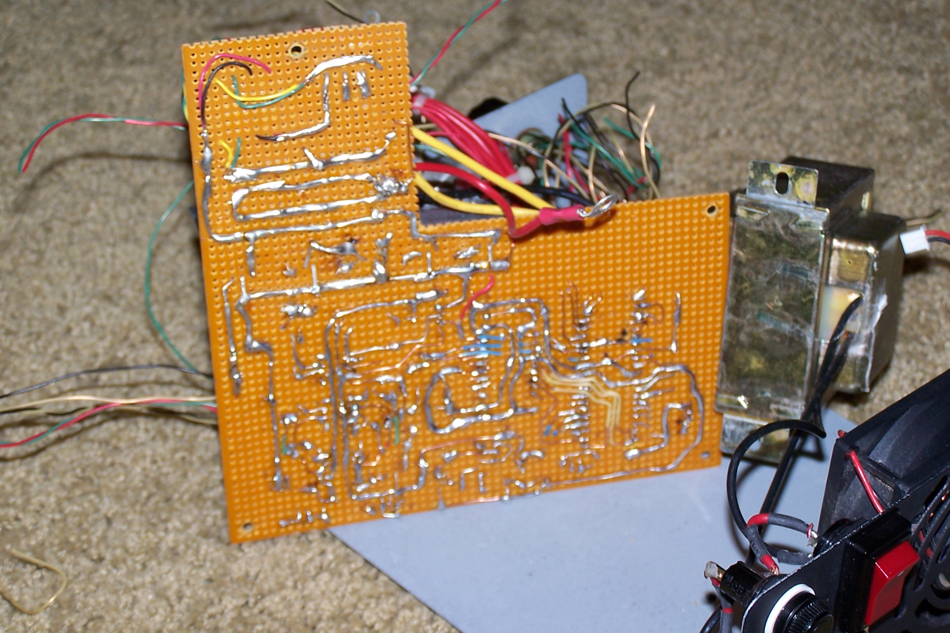
Picture taken during the construction to show the point to point wiring method.

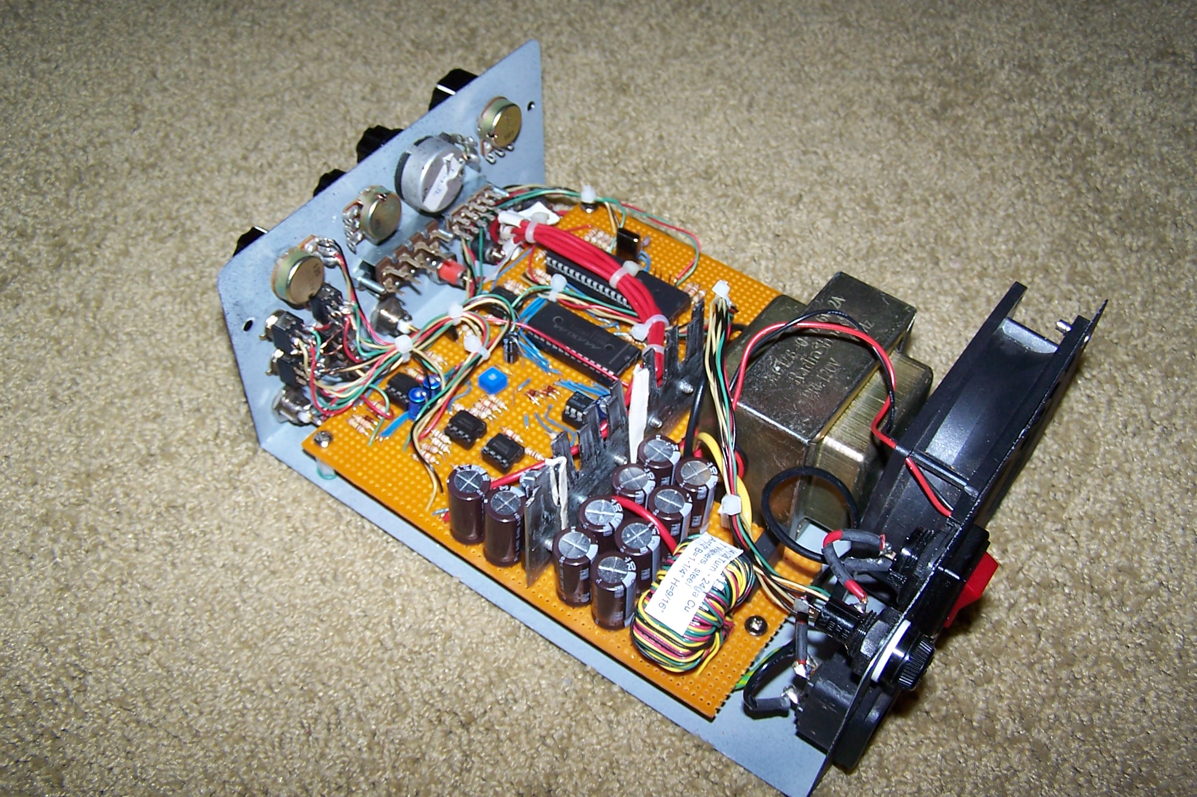
Completed oscilloscope without the cover.
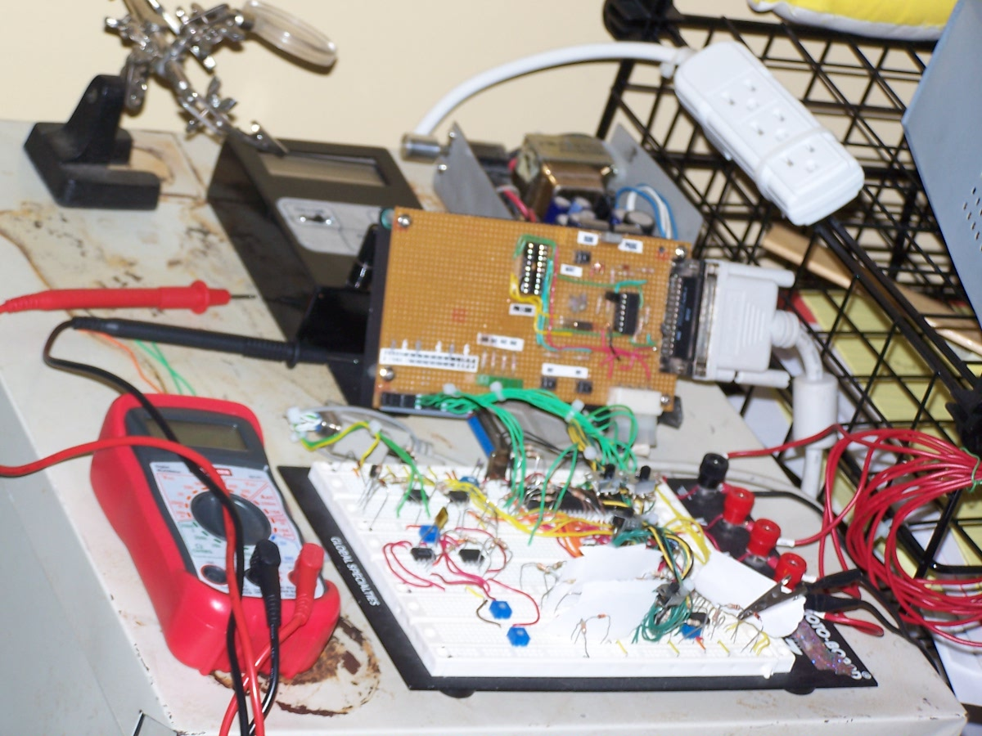
Early Prototype setup for testing.

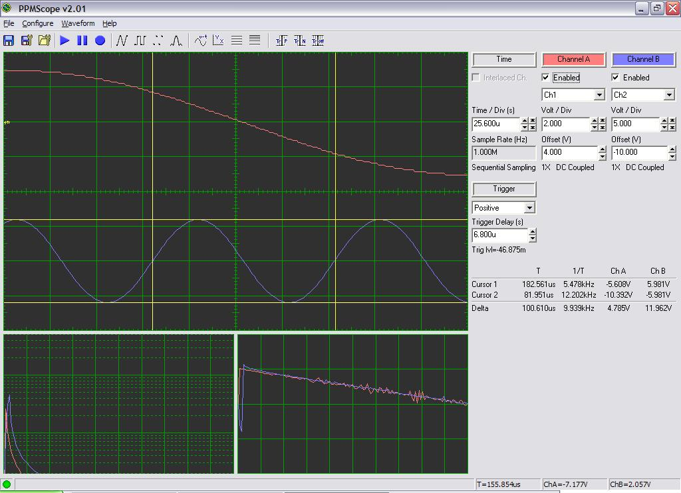
Oscilloscope computer program interface screenshot.

