**Sample KMeans clustering analysis**

**Jiong (Jon) Wang**

I prepared the codes based upon the data I used to work with in China. There are 8 image layers about the environment of a Chinese city named Wuhan. These 8 layers of images are about water index (NDWI), enhanced vegetation index (EVI), building volume density (BVD), impervious surface fraction (ISF), etc... Of course, it's quite difficult for us to work on the original image with very large sizes, thus I significantly resampled the resolution of the original images resulting very small image layers. Now they are all 71*91 pixels in size, and can be used for illustration easily. They are also covering exactly the same area in Wuhan.

I then applied Kmeans to these 8 layers, which means it's an unsupervised clustering/classification in 8-dimensional feature space, isn't it? I directly apply the ***KMeans function*** from the Python ***sklearn*** module to the data. Thus I did not write Kmeans function this time, it's not necessary! I think you can be able to achieve the same procedure by using QGIS. But you may also notice that, this piece of code can be reused easily by replacing few lines inside. That's one of the advantage of programming.

**As you can see below in the figures**, by choosing 2 clusters or 5 clusters, the results all make sense! When it is 2 clusters, it is basically showing the shape of the city of Wuhan (compared to fig.03) -- very nice data! When the clusters increase to 5, the waterbodies (lakes and rivers), downtown, city outskirt are all nicely delineated (compare to the last image). That's what KMeans brings to you. I also try to make interpretation/comments to each line of the code, so that to help you to think what is actually going on.

**With all the code and data, try to figure out how to apply the same analysis over your dataset. For the simplest start, you can just replace the image data and few lines in the code to make the program work on your data.**

fig.01

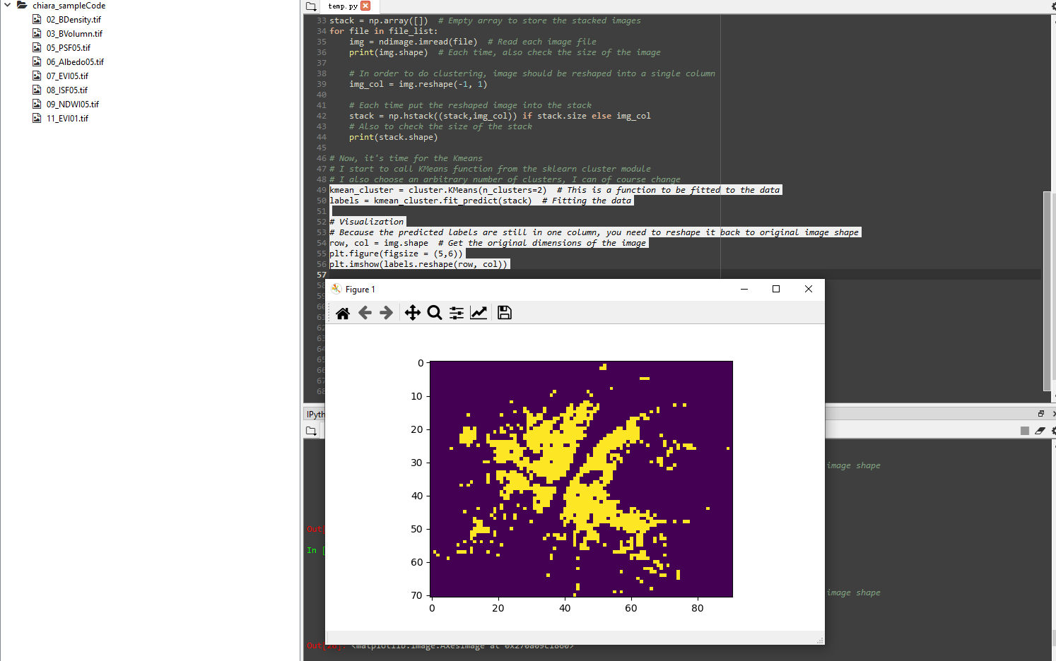

fig.02

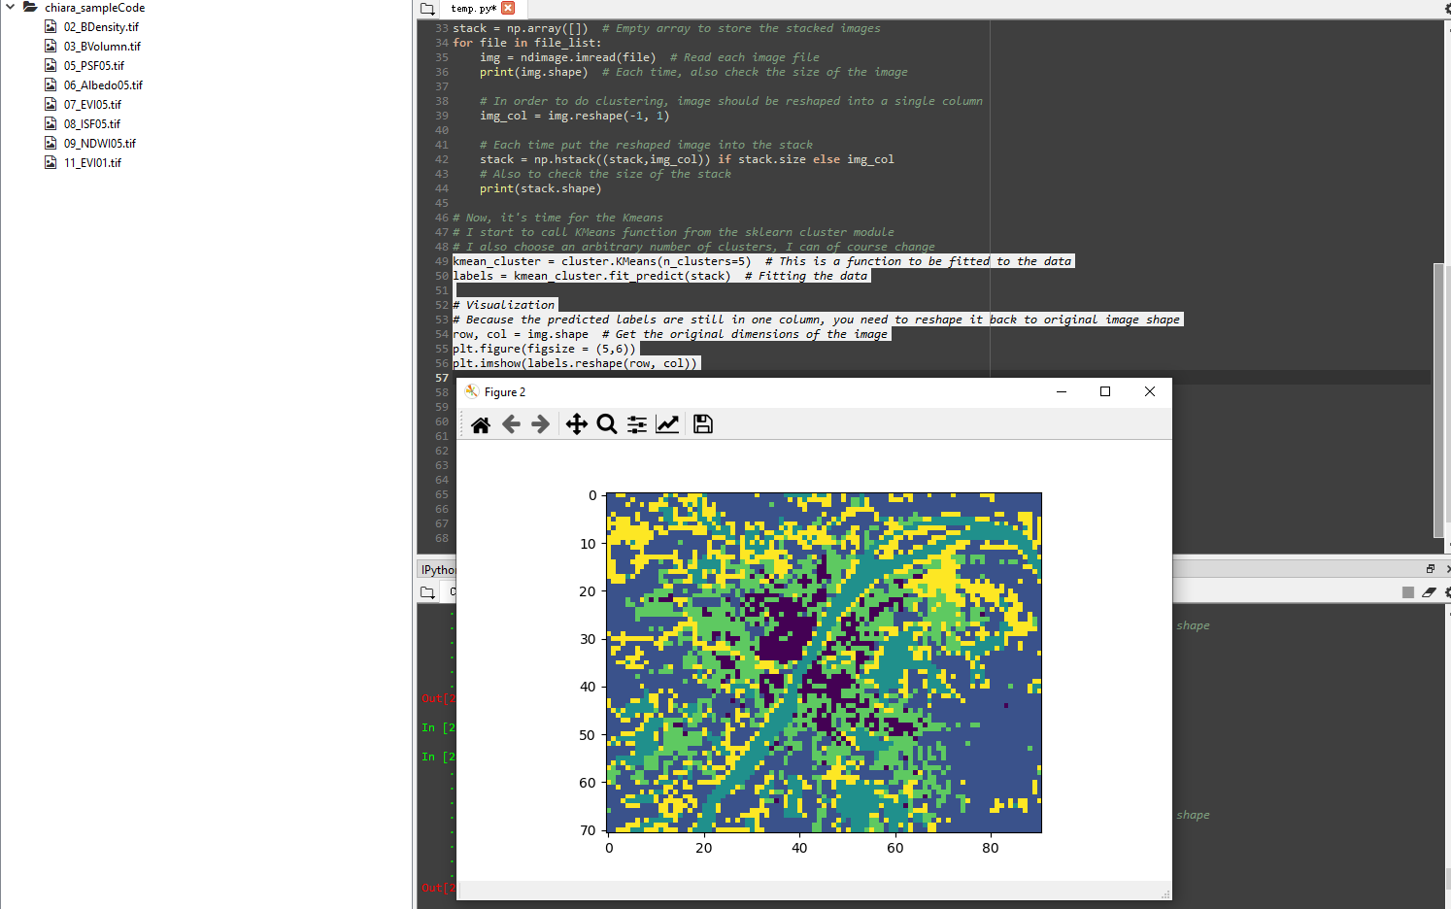

fig.03

