Analysis Variable : weight
N | Mean | Std Dev | Std Error | t Value | Pr > |t|
15 | 1.6466667 | 0.2531704 | 0.0653683 | 25.19 | <.0001

Moments
N | 15 | Sum Weights | 15
Mean | 1.64666667 | Sum Observations | 24.7
Std Deviation | 0.25317037 | Variance | 0.06409524
Skewness | 1.09630411 | Kurtosis | 2.72573796
Uncorrected SS | 41.57 | Corrected SS | 0.89733333
Coeff Variation | 15.374719 | Std Error Mean | 0.06536831

Basic Statistical Measures
Location |  | Variability
Mean | 1.646667 | Std Deviation | 0.25317
Median | 1.600000 | Variance | 0.06410
Mode | 1.600000 | Range | 1.10000
 |  | Interquartile Range | 0.20000

Tests for Location: Mu0=0
Test | Statistic |  | p Value
Student's t | t | 25.1906 | Pr > |t| | <.0001
Sign | M | 7.5 | Pr >= |M| | <.0001
Signed Rank | S | 60 | Pr >= |S| | <.0001

Tests for Normality
Test | Statistic |  | p Value
Shapiro-Wilk | W | 0.884372 | Pr < W | 0.0552
Kolmogorov-Smirnov | D | 0.239789 | Pr > D | 0.0205
Cramer-von Mises | W-Sq | 0.17198 | Pr > W-Sq | 0.0101
Anderson-Darling | A-Sq | 0.875499 | Pr > A-Sq | 0.0199

Quantiles (Definition 5)
Level | Quantile
100% Max | 2.3
99% | 2.3
95% | 2.3
90% | 2.0
75% Q3 | 1.7
50% Median | 1.6
25% Q1 | 1.5
10% | 1.4
5% | 1.2
1% | 1.2
0% Min | 1.2

Extreme Observations
Lowest |  | Highest
Value | Obs | Value | Obs
1.2 | 11 | 1.7 | 1
1.4 | 12 | 1.7 | 10
1.5 | 9 | 1.8 | 8
1.5 | 3 | 2.0 | 4
1.6 | 15 | 2.3 | 5

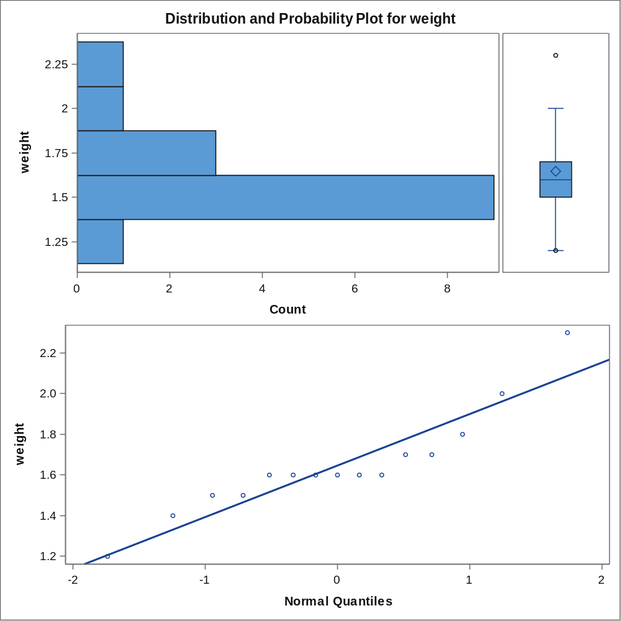

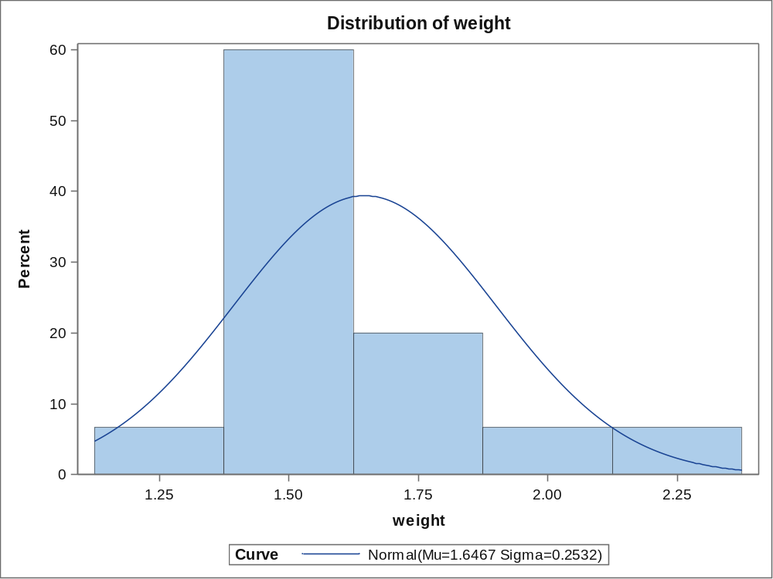
Parameters for Normal Distribution
Parameter | Symbol | Estimate
Mean | Mu | 1.646667
Std Dev | Sigma | 0.25317

Goodness-of-Fit Tests for Normal Distribution
Test | Statistic |  | p Value
Kolmogorov-Smirnov | D | 0.23978902 | Pr > D | 0.021
Cramer-von Mises | W-Sq | 0.17197960 | Pr > W-Sq | 0.010
Anderson-Darling | A-Sq | 0.87549869 | Pr > A-Sq | 0.020

Quantiles for Normal Distribution
Percent | Quantile
Percent | Observed | Estimated
1.0 | 1.20000 | 1.05770
5.0 | 1.20000 | 1.23024
10.0 | 1.40000 | 1.32222
25.0 | 1.50000 | 1.47591
50.0 | 1.60000 | 1.64667
75.0 | 1.70000 | 1.81743
90.0 | 2.00000 | 1.97112
95.0 | 2.30000 | 2.06309
99.0 | 2.30000 | 2.23563

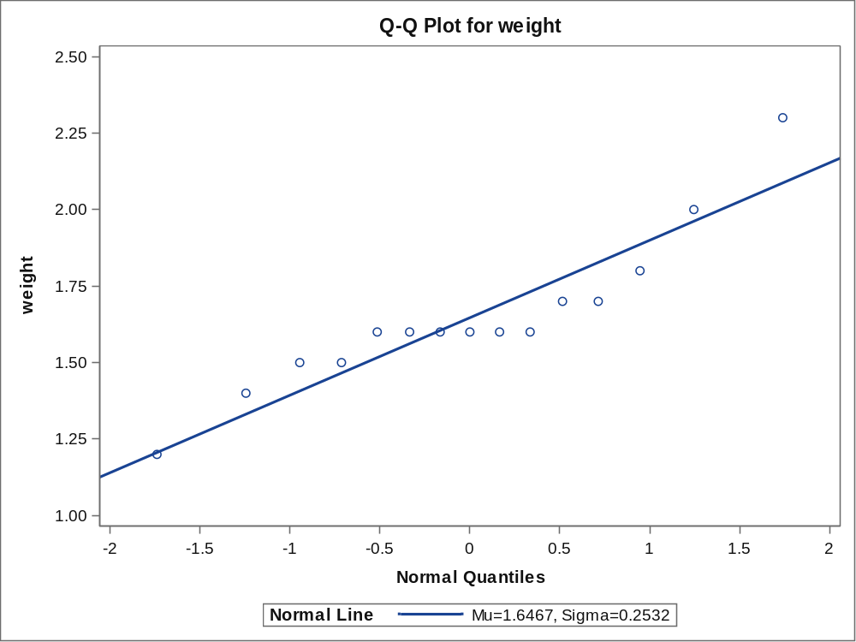
N | Mean | Std Dev | Std Err | Minimum | Maximum
15 | 1.6467 | 0.2532 | 0.0654 | 1.2000 | 2.3000

Mean | 95% CL Mean |  | Std Dev | 95% CL Std Dev
1.6467 | 1.5065 | 1.7869 | 0.2532 | 0.1854 | 0.3993

DF | t Value | Pr > |t|
14 | -2.35 | 0.0342

