Cross-Asset Sentiment Regime Detector: Automating Market Psychology Analysis Through Multi-Source NLP

Jonathan Rocha Advisor: Dr. David (King Ip) Lin
Master of Science in Data Science, Southern Methodist University, Dallas, TX 75275 USA
jrocha@smu.edu

Abstract. Market regime shifts often precede price moves through changes in investor psychology. Traditional risk indicators like the VIX lag and show stress after volatility has already emerged. This research develops an automated Cross-Asset Sentiment Regime Detector to identify market transitions before volatility spikes, using an ensemble transformer sentiment model trained on financial news and social media across Equities, Crypto, Forex, and Commodities. The two-layer architecture uses sentiment-market inputs to estimate GARCH (1,1) volatility features, then applies a Jump Model with persistence controls to classify regimes. Results support Hypothesis 2 (H2) (divergence signal) and Hypothesis 3 (H3) (network effect), but Hypothesis 1 (H1) (leading indicator) lacks global confirmation.

1. Introduction
Financial markets shift through behavioral regimes driven by changing risk appetite, and these shifts are often evident in narratives before they fully materialize in price indicators. However, most operational risk frameworks still rely on lagging signals such as realized volatility and the VIX, which makes it easier to explain regime changes after they occur than to spot them early for risk management. Major events like the COVID-19 crash, the 2021 GameStop surge, and the 2022 crypto winter highlight this pattern: narrative intensity and cross-market sentiment stress increase quickly as market structures become unstable.
Despite growth in financial NLP, most sentiment systems are limited to single assets, narrow source types, or dashboard-style workflows that do not directly produce reproducible regime labels. Traditional regime models also face stability issues; Hidden Markov frameworks are often sensitive to local noise and tend to over-switch, reducing their usefulness. Meanwhile, aligning mixed-frequency data remains a major technical challenge because text events are irregular while market bars are regular, and cross-asset spillover effects are poorly captured by isolated models.
This study proposes a practical two-layer cross-asset architecture to address these issues. The first layer develops aligned volatility and sentiment features from market and text data, while the second layer applies a Statistical Jump Model to maintain persistence and prevent frequent switches. This design aims to move beyond single-market sentiment scoring toward a regime-based system that can be audited, rerun, and interpreted consistently across Equities, Crypto, Forex, and Commodities.
The goal is to test whether cross-asset sentiment structures can offer lead or transition insights that complement traditional volatility measures. In this framework, Hypothesis 1 (H1) assesses global lead-time behavior in response to VIX-based stress; Hypothesis 2 (H2) examines divergence patterns near regime shifts; and Hypothesis 3 (H3) investigates connectedness across stable and transitioning regimes.
This research provides a reproducible end-to-end framework with established artifacts, walk-forward evaluation, and protocol-driven hypothesis testing. The results support divergence and connectedness mechanisms (H2 and H3), while the expected global lead-time advantage over VIX (H1) was not confirmed under the fixed criteria. Therefore, the study limits its conclusions to findings directly supported by the evidence base.
2. Literature Review
2.1 Transformer Models in Financial Sentiment Analysis
The evolution of financial sentiment analysis mirrors the broader transition in NLP from rule-based methods to contextual language models. Loughran and McDonald (2011) showed that generic sentiment dictionaries yield low precision for financial texts because words like "liability" carry distinct semantic valence in finance, establishing the need for domain-specific resources. Araci (2019) introduced FinBERT, a BERT model fine-tuned on financial news and reports that improved accuracy by 15% over prior methods and performed well even with as few as 500 labeled samples, demonstrating the viability of transfer learning for financial NLP. Mishev et al. (2020) systematically compared lexicons through transformers in over 100 experiments, finding that BERT and ALBERT-xxlarge achieved Matthews Correlation Coefficients of 0.895 and 0.881, respectively, while distilled models like DistilBERT retained over 95% of BERT's accuracy with 40% fewer parameters—making them suitable for production deployment.
The emergence of LLMs has expanded the toolkit for financial sentiment analysis, though with important trade-offs. Zero-shot and few-shot evaluations show that general-purpose LLMs can classify financial texts without supervised adaptation: Fatouros et al. (2023) reported approximately 35% higher sentiment classification accuracy with ChatGPT 3.5 over FinBERT for forex sentiment, while Shen and Zhang (2024) found that GPT-4o with few-shot prompting achieved competitive results, though FinBERT with domain-specific pretraining still outperformed on precision, recall, and F1-score. Fine-tuned LLMs show further gains—Konstantinidis et al. (2024) developed FinLlama using LoRA adaptation, achieving 44.7% higher cumulative returns than FinBERT-based portfolios, and Luo and Gong (2024) improved Financial PhraseBank accuracy from 0.86 to 0.90 through supervised fine-tuning of LLaMA-2.
Systematic benchmarks confirm these patterns. Nasiopoulos et al. (2025) found that fine-tuned GPT-4o and GPT-4o-mini achieved 87.79% accuracy, outperforming BERT models by approximately 9% but at substantially higher computational cost. Mahendran et al. (2025) noted that DistilBERT retains 97% of BERT's capabilities at half the parameters, making it suitable for real-time monitoring. Liu et al. (2024) emphasized that practical LLM deployment in finance requires careful attention to inference latency and domain-specific calibration. Ergun and Sefer (2025) proposed FinSentiment, a transfer-learning framework that produces finance-specific versions of BERT, RoBERTa, GPT, Llama, and T5, and found that RoBERTa pretrained on financial text achieved state-of-the-art results even with as few as 250 labeled samples—a result particularly relevant to our ensemble design.
Corpus composition and feature engineering also influence model performance. Delgadillo et al. (2024) developed FinSoSent, pretrained on 49 million words of financial news, and found through over 860 experiments that hyperparameter configuration is as important as domain-specific pretraining, with accuracy remaining in the 50–60% range even for specialized models. Cicekyurt and Bakal (2025) showed that BERT-based knowledge transfer to stock market tweets yields significant gains over training from scratch, particularly with limited labeled data. Sun et al. (2025) introduced EnhancedFinSentiBERT, a three-branch architecture combining financial pretraining, dictionary knowledge embedding, and neutral feature extraction, achieving F1 scores of 87.0–97.6% across benchmark datasets and demonstrating that architectural innovations beyond model scaling remain valuable. Recent synthesis work by Todd et al. (2024) and Ehsan et al. (2025) identifies recurring weaknesses in financial sentiment studies, including inconsistent benchmark design and under-reporting of deployment trade-offs, while findings from Moradi-Kamali et al. (2025) and Gu and Song (2026) confirm that finance-specific language modeling improves directional signal quality, though gains are sensitive to task framing and temporal validation.
2.2 Financial Sentiment and Market Prediction
The theoretical foundations of behavioral finance trace to Keynes' (1936/1973) concept of "animal spirits," which anticipated research demonstrating that markets are arenas of collective psychology, not merely information-processing mechanisms. Baker and Wurgler (2007) operationalized investor sentiment through a composite index derived from six market-based proxies (closed-end fund discount, NYSE turnover, IPO volume, first-day IPO returns, equity share in new issues, and dividend premium). Their finding that sentiment predicts cross-sectional stock returns—with effects concentrated in hard-to-arbitrage, hard-to-value stocks—established sentiment as a systematic factor, with a 0.43 correlation with contemporaneous returns and significant predictive power during sentiment extremes.
Bollen et al. (2011) conducted a foundational study using approximately 9.8 million tweets, finding that the "Calm" dimension of aggregate mood demonstrated Granger causality with DJIA movements at lags of 2–6 days, with a Self-Organizing Fuzzy Neural Network achieving 86.7% directional accuracy—establishing that social media mood contains forward-looking market information. Renault (2017) extended this to intraday timeframes using StockTwits, finding that first-half-hour sentiment predicts last-half-hour returns (74–76% accuracy), driven primarily by novice traders whose sentiment extremes often precede market turning points.
Cryptocurrency markets—characterized by 24/7 trading, high retail participation, and strong social media presence—provide a natural environment for sentiment research. Kraaijeveld and De Smedt (2020) found significant predictive relationships between Twitter sentiment and crypto returns for Bitcoin, Bitcoin Cash, and Litecoin with 1–4 day lead times, while noting that 1–14% of tweets originated from bots. Roumeliotis et al. (2024) benchmarked language models for crypto sentiment, showing that fine-tuned GPT-4 achieved 86.7% accuracy, compared with FinBERT at 84.3%, demonstrating near-parity at far lower computational cost. Raheman et al. (2022) found that interpretable models often outperformed deep learning for sentiment-based crypto prediction, with peak predictive power at a 2-day lag. Trushkovskyi (2025) confirmed bidirectional Granger causality between sentiment and crypto returns, finding that sentiment signals survive transaction costs—validating their use in regime detection.
Cross-asset sentiment spillovers have been documented across market boundaries. Caferra (2022) found bidirectional sentiment transmission between Bitcoin and S&P 500 markets using Transfer Entropy methods, with entropy-based approaches outperforming traditional VAR models—demonstrating that spillovers are fundamentally nonlinear. Cao et al. (2025) showed that firms with higher sentiment connectedness face elevated crash risk, particularly during market extremes, when network-level sentiment measures outperformed individual-firm sentiment. Nyakurukwa and Seetharam (2025) mapped sentiment networks across DJIA stocks, decomposing connectedness into short-term (1–5 days), medium-term (5–20 days), and long-term (20+ days) components, finding that negative news exhibits higher connectedness than positive sentiment and that connectedness peaks during globally significant events.
Across asset classes and methodologies, the literature consistently demonstrates that sentiment signals precede market movements. Table 2.2.1 synthesizes predictive lead times from major studies:
Table 2.2.1: Lead Time Evidence Synthesis
Study | Asset Class | Lead Time | Accuracy/Correlation
Bollen et al. (2011) | Equities (DJIA) | 2-6 days | 86.7% accuracy
Renault (2017) | Equities (S&P 500) | Intraday (hours) | 74-76%
Kraaijeveld and De Smedt (2020) | Cryptocurrency | 1-4 days | Significant Granger causality
Raheman et al. (2022) | Cryptocurrency | -2 days peak | 0.57 correlation
Trushkovskyi (2025) | Cryptocurrency | 1 day | 0.24-0.25% per unit
Baker and Wurgler (2007) | Equities (broad) | Monthly | 0.43 correlation

This convergence across independent studies strengthens the foundation for sentiment-based regime detection. The consistent 1–6 day lead times suggest an optimal window for regime-transition early-warning systems. The data layer supporting these analyses has expanded in parallel, with Fottner et al. (2022), Dong et al. (2024), and Xu et al. (2025) proposing multimodal financial datasets that highlight a shift toward reproducible, multi-source benchmarks.
Despite encouraging evidence, Kengmegni (2024) found that agreement ratios between sentiment signals and next-day price movements hover around 0.5—essentially random chance—and that market efficiency has increased, with prediction error standard deviations declining from 0.2 in 2009 to 0.065 by 2023. Critically, economy-wide sentiment measures outperformed stock-specific sentiment, supporting our research design's focus on cross-asset aggregate sentiment rather than single-security approaches. The conclusion that "next-day stock prediction remains elusive" underscores the importance of regime-level analysis over precise return prediction.
2.3 Cross-Asset Sentiment Analysis
Integrating sentiment signals across multiple markets remains a frontier with significant implications. Building on the cross-asset spillover evidence reviewed in Section 2.2, Wang et al. (2024) found asymmetric momentum transmission between China's stock and bond markets, with hybrid funds acting as intermediaries—demonstrating that institutional investment vehicles can amplify or dampen cross-asset sentiment propagation. Yang et al. (2025) introduced a cross-asset risk management framework that leverages GPT-4 and Llama-3-30b for real-time monitoring across equities, fixed income, and currencies, achieving 82.1% accuracy in predicting market shifts—substantially outperforming traditional methods (74.0–75.2%). These findings demonstrate the practical feasibility of unified cross-asset sentiment monitoring systems.
Foreign exchange markets present unique opportunities for sentiment analysis given their 24-hour trading and macroeconomic sensitivity. Olaiyapo (2024) combined lexicon-based analysis with Naive Bayes classification to achieve 85% accuracy for USD-related sentiment signals, generating over 12% profit when combined with technical indicators. Dakalbab et al. (2025) advanced forex prediction through cross-modal attention mechanisms integrating technical and sentiment analysis, achieving 82.9% accuracy across major currency pairs. Sibande et al. (2021) established that forex markets exhibit regime-specific sentiment effects: extreme bullish or bearish sentiment strengthened anti-herding behavior, while average sentiment produced weaker effects—suggesting that real-time sentiment monitoring can identify periods of heightened speculative activity.
The integration of sentiment into multi-asset portfolio management demonstrates practical applications. Sarfarazurrehman et al. (2025) showed that DRL and LSTM-based approaches for cross-asset risk analysis achieved cumulative returns of 29.52% with a Sharpe ratio of 0.98, outperforming traditional Mean-Variance Optimization. Pankwaen et al. (2025) developed an adaptive multi-asset framework that maintained effectiveness across major disruptions, including COVID-19 and the 2022 crypto crash, suggesting that dynamic, sentiment-aware approaches are essential for cross-asset regime detection.
Commodities exhibit unique sentiment dynamics. Shi (2025) developed a sentiment-based GARCH-MIDAS hybrid model to explain the 2020–2022 anomaly, where gold prices rose 40% despite a 12% increase in the US Dollar Index. Using FinBERT-scored sentiment, the model reduced out-of-sample prediction errors by 18.7% over traditional volatility models. Negative sentiment had 1.8 times the impact on volatility as positive sentiment—consistent with loss-aversion theory—and sentiment factors accounted for approximately 15% of previously unobserved heteroskedasticity in long-term volatility components. This finding directly informs our framework's GARCH-based volatility layer.
The cross-asset evidence reviewed here—from crypto-equity spillovers to commodity safe-haven dynamics—demonstrates both the feasibility and value of unified sentiment analysis frameworks, motivating our research design that synthesizes sentiment across all four asset classes detect regime regimes.
2.4 Market Regime Detection
Having established that transformer-based sentiment analysis achieves strong classification performance and that sentiment signals demonstrate predictive power across asset classes, we now address how to integrate these insights for regime detection. Identifying market regimes—distinct periods characterized by different return distributions, volatility patterns, and investor behavior—enables dynamic allocation, downside hedging, and the capture of regime-specific opportunities.
Classical regime detection relies on threshold-based indicators—volatility thresholds (VIX above 30 for Risk-Off, below 15 for complacent Risk-On), moving-average crossovers, yield-curve inversion, and Hidden Markov Models (HMMs) that infer latent state transitions. The fundamental limitation is lag: these methods identify regimes after transitions have already progressed. Baker and Wurgler (2007) suggested that behavioral signals may provide earlier indicators, though their proxies relied on indirect measures rather than direct textual sentiment extraction.
While HMMs have been the standard for regime detection, Shu et al. (2024) demonstrate critical limitations: HMMs are highly sensitive to daily noise, producing "whipsaw" signals that degrade performance through excessive transaction costs. Statistical Jump Models (JMs) address this by directly incorporating a discrete jump penalty into the objective function, thereby mathematically enforcing regime persistence and requiring substantial evidence before triggering state changes. Empirically, JMs reduce annualized portfolio turnover by approximately two-thirds versus HMMs (44% vs. 141% for S&P 500) while improving risk-adjusted returns, reducing maximum drawdown by 10–15 percentage points, and increasing compound annual growth rates by 1–4% across U.S., German, and Japanese equity indices from 1990 to 2023. This persistence-enforcing mechanism is central to our Layer 2 design.
Zhang et al. (2020) developed an explainable ML framework using hierarchical clustering for regime-based allocation, achieving 22.53% annualized returns with a Sharpe ratio of 1.06. Suárez-Cetrulo et al. (2023) reviewed 140 studies on ML for financial prediction under regime change, finding that most conventional techniques struggle with abrupt structural changes—the very characteristic that distinguishes regime transitions from normal fluctuations—and noting that the literature on concept drift and regime switching has developed largely independently despite addressing similar challenges.
Table 2.4.1: Regime Detection Performance Comparison
Approach | Method | Annual Return | Sharpe Ratio | Key Advantage | Citation
Hierarchical Clustering | Black-Litterman integration | 22.53% | 1.06 | Explainability | Zhang et al. (2020)
Statistical Jump Model | Jump-penalty regime switching | +1-4% vs. benchmark | Higher vs. HMM | Reduced turnover | Shu et al. (2024)
Relative Sentiment | Sentix + ML ensemble | +400-700 bps | Improved | Cross-regional validity | Micaletti (2022)
Mixed-Frequency | MF-EEMD-ML | - | - | 19.18% MAE reduction | Cai et al. (2024)
Intraday Sentiment | Field-specific lexicon | 4.55% (strategy) | 1.496 | Leading indicator | Renault (2017)

The application of sentiment to regime detection remains an emerging frontier. Bollen et al. (2011) established sentiment as a potentially leading indicator by showing that specific emotional dimensions (calm and anxiety) correlate with subsequent market movements, suggesting shifts in investor psychology precede price adjustments. Renault (2017) demonstrated that domain-specific lexicons are essential, as predictability disappeared when using standard dictionaries. Micaletti (2022) introduced relative sentiment—the gap between institutional and individual expectations—achieving 400–700 basis point annual outperformance across U.S., Europe, Japan, and Asia ex-Japan markets, with a 50-percentage-point return differential driven by sentiment state alone.
Mixed-frequency data present additional methodological challenges. Cai et al. (2024) addressed this with an MF-EEMD-ML system that integrates half-hourly sentiment with three-minute return prediction, achieving a 19.18% reduction in MAE over traditional approaches and showing that sentiment impact persists across seven intraday periods. Shao et al. (2024) developed the HD-SURDLM framework, integrating sentiment from 2.5 million tweets using VADER, TextBlob, and RoBERTa, but noted a critical practical trade-off: RoBERTa-based extraction increased computational costs from seconds to up to 14 hours compared with simpler methods. These temporal dynamics suggest a natural hierarchy—intraday noise signals, short-term momentum, and medium-term regime transitions—with our framework targeting the medium-term detection horizon.
2.5 Research Gaps and Hypotheses
The preceding review reveals several critical gaps. First, no framework systematically aggregates sentiment across equities, cryptocurrency, forex, and commodities to detect portfolio-level regime transitions. Second, the established 1–6 day sentiment lead time has not been exploited for regime-level early warning systems. Third, cross-asset sentiment networks remain unexplored despite evidence of effects on individual network connectedness. Fourth, the practical integration of multi-source sentiment with regime detection algorithms has not been attempted.
Despite progress in both financial NLP and econometric modeling, a critical gap persists at the intersection. Konstantinidis et al. (2024) established FinLlama as a superior sentiment classifier but limited its application to standard portfolio construction, neglecting structural regime identification. Shu et al. (2024) validated Statistical Jump Models but relied exclusively on endogenous price features, ignoring exogenous sentiment signals. Yang et al. (2025) applied LLMs to cross-asset monitoring, and Shi (2025) integrated GARCH-MIDAS with sentiment, but no existing research has incorporated transformer-based sentiment depth into the persistence-enforcing framework of Statistical Jump Models for a cross-asset universe. This research addresses this gap by constructing the first Two-Layer Sentiment Regime Detector, synthesizing generative AI sentiment with econometric jump penalties across Equities, Crypto, Forex, and Commodities.
Based on the literature review, we hypothesize:
H1 (Leading Indicator Hypothesis): Cross-asset sentiment aggregation acts as a leading indicator of market regime changes, preceding VIX-based regime detection by 1-5 trading days. This hypothesis is supported by findings from Bollen et al. (2011), showing a 2–6-day predictive lead time with 86.7% accuracy; Caferra (2022), illustrating sentiment-driven cross-market connections; and Trushkovskyi (2025), confirming Granger causality between sentiment and returns.
H2 (Divergence Signal Hypothesis): Sentiment divergence across asset classes (e.g., equities bullish while crypto bearish) signals an impending shift between Risk-On and Risk-Off regimes. Caferra (2022) found that sentiment connectedness effectively identifies market linkages, suggesting that disconnection or divergence may indicate regime instability. Wang et al. (2024) demonstrated asymmetric cross-asset momentum transmission supporting this mechanism.
H3 (Network Effect Hypothesis): Sentiment connectedness intensity will be associated with the probability of regime transition, with higher connectedness during stable regimes and rapid disconnection before transitions. Sibande et al. (2021) identified regime-specific sentiment effects in currency markets, supporting the idea of state-dependent sentiment dynamics.

3. Methods
3.1 Study Design and Data
This study uses a daily-frequency, multi-source sentiment and market-data design over a unified window (2005-01-19 to 2025-08-14). The canonical pipeline produces 4,490 market-aligned observations and 22 engineered features, and the results are written to pipeline_output/pipeline_summary.json. The design prioritizes portfolio-level regime inference over single-security next-day prediction, consistent with evidence that aggregate sentiment can be more informative than stock-level signals for market-state analysis (Kengmegni, 2024).

The empirical pipeline consumes pre-aggregated daily sentiment and aligned stress/market series. Core market inputs are SPY returns, VIX, and ECB CISS; sentiment inputs include compound polarity and cross-asset/source components scored prior to regime modeling. This paper, therefore, focuses on the implemented feature-to-regime workflow and hypothesis diagnostics rather than re-documenting raw text ingestion.

3.2 Feature Engineering and Time Alignment
Feature construction is implemented in scripts/hpc/run_analysis.py. Sentiment and market series are aligned to a common trading-day index, with controlled forward-fill handling for missing observations. This mixed-frequency harmonization is motivated by prior evidence that sentiment timing structure materially affects predictive behavior and error profiles (Cai et al., 2024), while the computational burden can vary substantially across extraction stacks (Shao et al., 2024).
Engineered features include:
1) sentiment level/polarity (compound, positive, negative),
2) dispersion/divergence (cross_asset_std, sent_dispersion, max_divergence),
3) market risk (returns, realized_vol, vix, vix_change, ciss, ciss_change), and
4) temporal dynamics (sent_momentum, sent_acceleration).
Let $s_{c,t}$ denote the daily sentiment level for asset class $c ∈\{1,…,C\}$ on day $t$. The aggregate sentiment signal and principal divergence feature are:
$$\overline{s_{t}}=\frac{1}{C}\sum_{c=1}^{C}{s_{c,t}}, D_{t}=\max_{c}{s_{c,t}}-\min_{c}{s_{c,t}}$$
Temporal dynamics are represented as first- and second-difference operators:
$$Δ\overline{s_{t}}=\overline{s_{t}}-\overline{s_{t-1}}, Δ^{2}\overline{s_{t}}=Δ\overline{s_{t}}-Δ\overline{s_{t-1}}$$
which correspond to the implemented momentum and acceleration fields.
For connectedness, two modes are evaluated: a proxy baseline and an upgraded full_granger_te mode computing rolling Granger/transfer-entropy diagnostics. This follows the nonlinear spillover literature, which shows that entropy-style connectedness features capture cross-market transmission that is missed by simpler linear formulations (Caferra, 2022).

3.3 Two-Layer Regime Modeling
The implemented model is a two-layer pipeline. Layer 1 estimates conditional volatility features using a fitted GARCH(1,1) model with the arch backend and reports the results. Layer 2 applies a Statistical Jump Model that segments the multivariate feature path into persistent regime states using dynamic programming with an explicit jump penalty.
The Layer 1 volatility recursion follows the standard form:
$$r_{t}=μ+ϵ_{t}, ϵ_{t}=σ_{t}z_{t}, z_{t}∼N\left(0,1\right)$$
$$σ_{t}^{2}=ω+αϵ_{t-1}^{2}+βσ_{t-1}^{2}, ω>0, α,β≥0, α+β<1$$
In the jump-model stage, the optimization target is:
$$\min_{Θ,s}{\sum_{t=0}^{T-1}{l\left(x_{t},θ_{s_{t}}\right)}}+λ\sum_{t=1}^{T-1}{I\left(s_{t}≠s_{t-1}\right)}$$
where $λ$ penalizes rapid switching and improves regime persistence.
This design is literature-grounded in two ways. First, the sentiment-informed volatility structure is motivated by GARCH-MIDAS evidence in commodity settings (Shi, 2025). Second, the jump-penalty mechanism addresses documented HMM over-switching and whipsaw behavior, improving persistence and risk-usable regime labeling (Shu et al., 2024). The implemented state mapping uses four stress-ordered regimes: low volatility, normal, elevated, and high volatility
3.4 Validation Protocol
Out-of-sample evaluation was performed with walk-forward validation scripts/run_canonical_validation.py using a 756-day train window, a 63-day test window, a 63-day step, and a 5-day purge gap. Each window trains to reduce temporal leakage and concept-drift effects. The canonical classifier is a balanced random forest with 300 estimators.
Primary model-quality metrics include weighted accuracy, weighted precision, recall, F1 score, Matthews Correlation Coefficient (MCC), and transition accuracy. Transition accuracy is emphasized because the research objective is transition detection, not only static state assignment.

3.5 Hypothesis Testing Framework
Hypothesis diagnostics were implemented in src/sentiment_detector/validation/hypothesis_validator.py.
H1 (leading indicator): Tested via lead-lag cross-correlation, Granger causality, and event-conditioned warning diagnostics against VIX stress behavior. This structure follows prior lead-lag and Granger evidence in equities and crypto contexts (Bollen et al., 2011; Renault, 2017; Kraaijeveld and De Smedt, 2020; Trushkovskyi, 2025). The lead-lag diagnostic was computed as:
ρSVk=CorrSt-k,Vt, k=argmaxk∈{0,…,5}ρSVkρSVk = CorrSt-k, t, k=argmaxk ∈ {0,…,5} ρSVk

where $S_{t}$ is the sentiment signal, and $V_{t}$ is the stress reference series.
H2 (divergence signal): Tested by comparing pre-transition versus stable-period divergence with t-tests and effect-size reporting, consistent with cross-asset spillover asymmetry literature (Caferra, 2022; Wang et al., 2024). Compared pre-transition with stable-period divergence and reported t-tests along with effect sizes using:
$$t=\frac{\overline{D_{\text{pre}}}-\overline{D_{\text{stable}}}}{\sqrt{\frac{s_{\text{pre}}^{2}}{n_{\text{pre}}}+\frac{s_{\text{stable}}^{2}}{n_{\text{stable}}}}}$$
where $D_{t}$ is the divergence feature from Section 3.2.
H3 (network effect): Tested connectedness separation using ANOVA-style analysis under proxy and full-network modes, aligned with connectedness/crash-risk and state-dependent sentiment evidence (Cao et al., 2025; Nyakurukwa and Seetharam, 2025; Sibande et al., 2021). Reported ANOVA-based evidence for connectedness separation across regime conditions in both proxy and full-network feature modes.
$$F=\frac{MS_{\text{between}}}{MS_{\text{within}}}$$
The locked confirmation framework for H1 was executed via scripts/run_h1_locked_confirmation.py and documented in the protocol artifacts in docs/H1_LOCKED_CONFIRMATION_PROTOCOL.md.
3.6 Reproducibility
The study uses a fixed reporting configuration and manifest-tracked artifacts for reproducibility. Core outputs are stored in results/pipeline_output/, and validation artifacts are tracked under results/validation/. Integrity and traceability are documented in docs/RESULTS_MANIFEST.json.
To preserve manuscript flow, execution commands and run-level artifact identifiers are moved to Appendix A.
3.7 Dashboard and Deployment Context
The system is exposed through a FastAPI backend and Next.js dashboard (Railway/Vercel deployment) to provide reproducible visibility into sentiment, regimes, transitions, and explainability payloads. This implementation context is included because the contribution is both methodological and operational.
3.8 Canonical Validation Execution (Locked Reporting Run)
Reported results are anchored to the canonical feature matrix and labels from results/pipeline_output/, with walk-forward retraining under fixed window rules, baseline volatility mode for top-line comparability, and upgraded connectedness diagnostics for H3 sensitivity checks.
4. System Implementation
The system is a production-grade research stack covering data processing, model execution, validation, and deployment. The backend uses FastAPI and PostgreSQL for data storage. It offers endpoints for current and historical sentiment, regime state, transition events, CISS/VIX history, GARCH diagnostics, and explainability payloads. The frontend is built with Next.js, TypeScript, and Recharts to enable cross-asset sentiment and regime monitoring, along with event drill-down views.
Modeling and evaluation are implemented in the Python pipeline and validation modules. The feature/regime pipeline is executed through scripts/hpc/run_analysis.py, while walk-forward and hypothesis protocols are executed through scripts/run_canonical_validation.py, src/sentiment_detector/validation/walk_forward_backtest.py, and src/sentiment_detector/validation/hypothesis_validator.py. Methodology A/B paths for volatility and network-feature modes are stored under results/validation/ and manifest-tracked for auditability.
Deployment is handled with Railway (backend) and Vercel (frontend), with repository-driven CI/CD hooks. This architecture was selected to ensure that manuscript claims are directly connected to executable artifacts rather than stand-alone notebook outputs. The production frontend dashboard is available at https://sentiment-regime-detector.vercel.app/.
5. Results
5.1 Primary Outcomes
The canonical run shows strong out-of-sample regime classification: Accuracy = 0.9284, weighted Precision = 0.9252, weighted Recall = 0.9284, weighted F1 = 0.9236, MCC = 0.8279, and Transition Accuracy = 0.8010.
At the hypothesis level, evidence supports H2 and H3 but does not confirm H1 under the project’s locked global rule (Table 5.1). This pattern is directionally consistent with Section 2: divergence and network structure appear robust cross-asset mechanisms (Caferra, 2022; Cao et al., 2025; Nyakurukwa and Seetharam, 2025), while broad lead-time generalization remains difficult outside specific episodes (Kengmegni, 2024).

Hypothesis-level results are summarized in Table 5.1.

Table 5.1 Primary Outcomes
Hypothesis | Result | Key Diagnostic Evidence
H1 (Leading Indicator) | Not confirmed | Strongest lead-lag alignment at lag 0; global confirmation criteria for a 1-5 day lead not met
H2 (Divergence Signal) | Supported | Pre-transition divergence > stable divergence (ratio 1.19x; (t=18.73), (p<0.001), Cohen's (d=0.58))
H3 (Network Effect) | Supported | Stable-regime connectedness > transition connectedness (TCI 0.5402 vs. 0.4569; ANOVA (F=427.44), (p<0.001))

5.2 Robustness and Sensitivity Synthesis
Robustness tests were conducted across feature engineering, walk-forward windows, leakage-control gaps, volatility-feature modes, network-feature modes, and subperiod slices. Detailed run-level identifiers are provided in Appendix A.
Table 5.2 Robustness and Sensitivity Synthesis
Robustness Dimension | Main Observation | Implication
Lagged sentiment features | Higher aggregate Accuracy/F1/MCC; lower transition accuracy | Improves static discrimination but does not establish H1 lead-time confirmation
Walk-forward windows | Shorter test/step windows improved aggregate metrics; larger train windows did not improve transitions | Model quality is window-sensitive, but hypothesis direction is stable
Purge-gap controls | Larger purge slightly reduced aggregate metrics; hypothesis outcomes unchanged | H1/H2/H3 interpretation is not driven by leakage-control choice in tested ranges
Volatility mode | GARCH_MIDAS_CISS did not outperform baseline in this configuration | Baseline volatility representation retained for manuscript reporting
Network mode | Full connectedness mode preserved top-line performance and improved transition accuracy slightly | H3 support is robust to connectedness-construction choice
Subperiod checks | Pre-2020 segment remains most informative; short post-2020 slices are low-power | Recent perfect scores are interpreted as small-sample artifacts

5.3 Locked H1 Confirmation
Global H1 remains unconfirmed across the entire locked sequence (V1-V3). Only one event window (the COVID-19 crash) satisfied the strict support criteria, while project-level confirmation required at least two event-confirmed windows. The result suggests conditional or event-specific lead behavior, with no broad portfolio-level lead confirmation under fixed rules.
This non-confirmation should be seen as boundary-setting rather than a model failure: the framework still shows strong regime discrimination and consistent support for H2/H3, but it does not justify a broad claim of 1-5-day leading behavior relative to VIX across all market conditions.

Table 5.3 Locked H1 Confirmation
Protocol | Rule Variant | Global Outcome | Event-Confirmed Windows | Project-Level Decision
V1 | Base event set, 1-5 day confirmation horizon | Inconclusive global lag pattern | 1 | Not confirmed
V2 | Expanded event universe (11 events) | Inconclusive global lag pattern | 1 | Not confirmed
V3 | Horizon extension to 1-7 days | Inconclusive global lag pattern | 1 | Not confirmed

5.4 Figures and Evidence Traceability
Five manuscript figures summarize global/event-conditioned lead behavior, regime-VIX alignment, transition classification, divergence separation, and connectedness separation. Appendix A provides command-level provenance and run registries linking each figure/table to manifest-tracked artifacts.

Figure 5.4.1. H1 lead-time summary (global and event-conditioned).
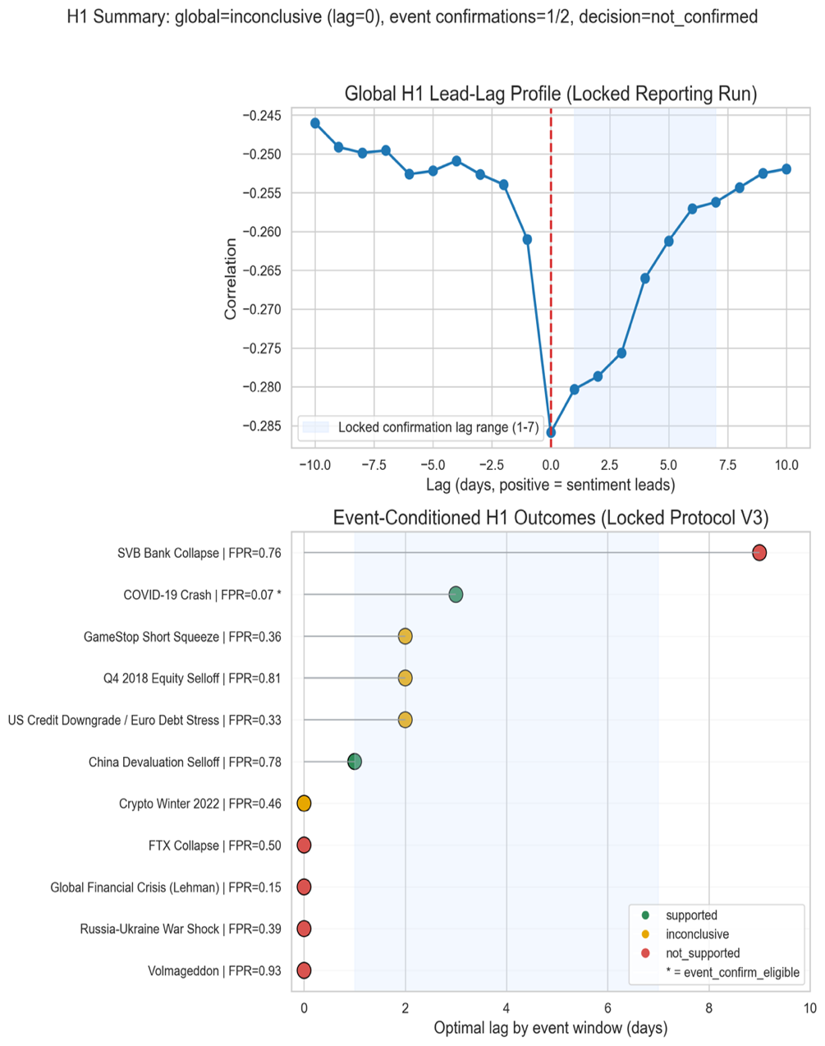
Interpretation: The global curve peaks at lag 0, while event-conditioned windows show localized positive lead behavior that is insufficient for project-level H1 confirmation.

Figure 5.4.2. Regime labels vs. VIX in the COVID stress window.
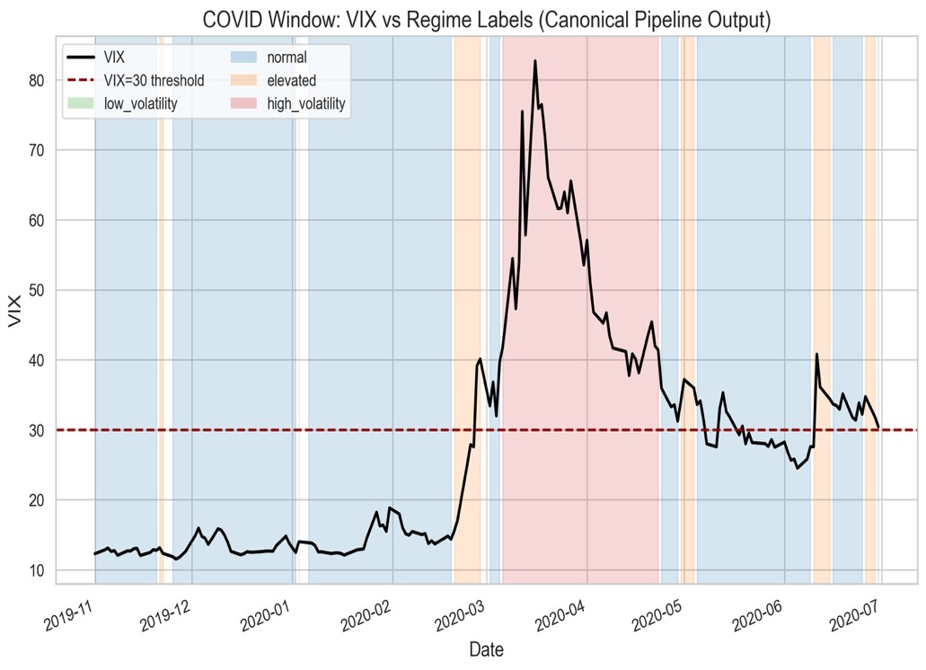

Interpretation: JM regime escalation aligns with stress buildup around the COVID period; local lead behavior appears in this window but does not generalize across all tested events.

Figure 5.4.3. Transition-performance confusion matrix.
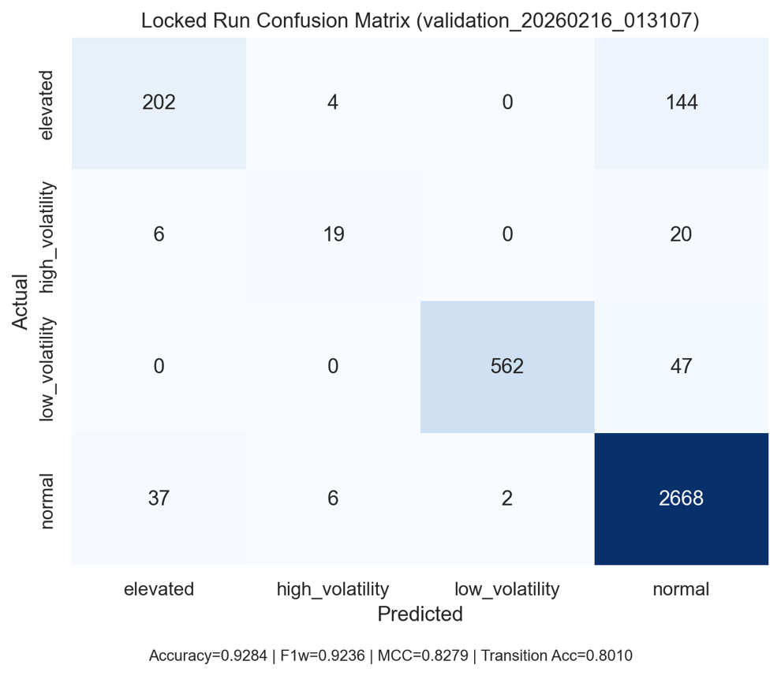

Interpretation: Confusion is concentrated near adjacent stress states, while major regime classes remain well separated, consistent with high aggregate MCC and transition accuracy.

Figure 5.4.4. H2 divergence distribution (pre-transition vs. stable periods).
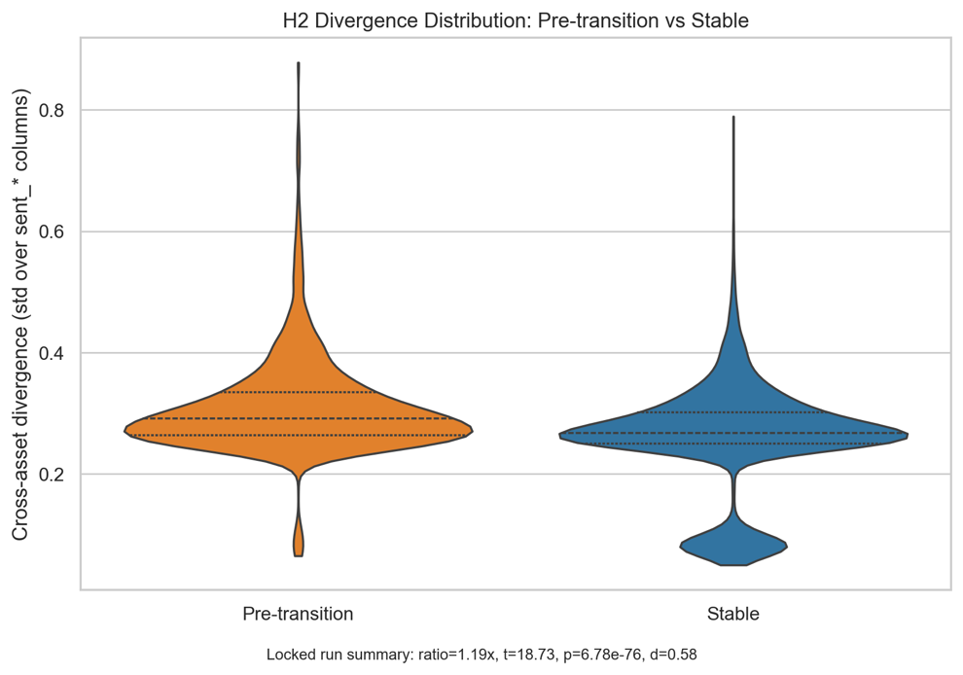
Interpretation: Pre-transition divergence mass shifts upward relative to stable periods, matching the reported positive effect size and statistically significant t-test.

Figure 5.4.5. H3 connectedness comparison (stable vs. transition regimes).
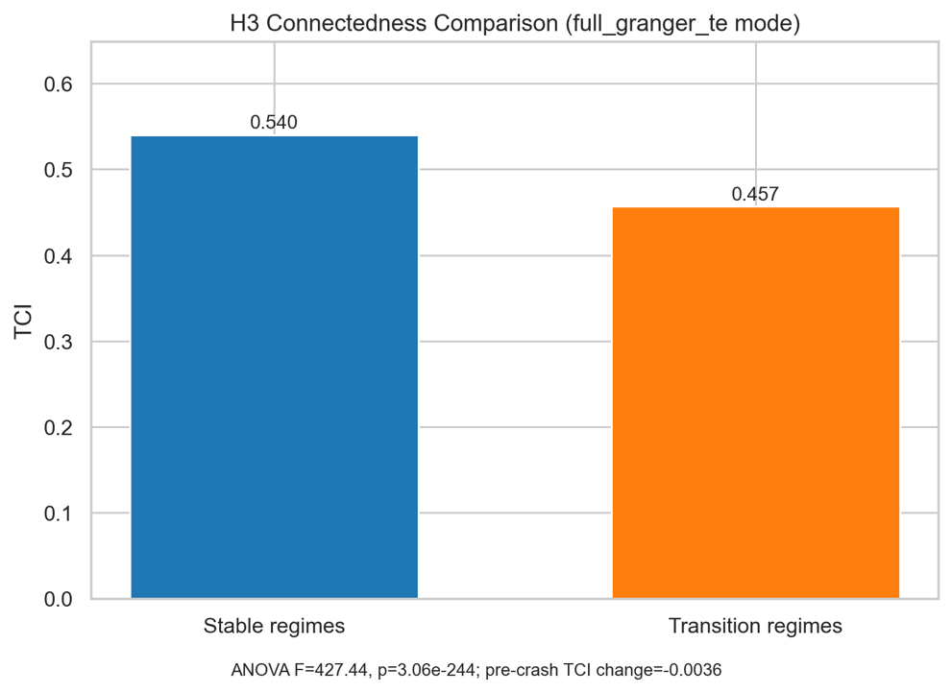
Interpretation: Stable regimes show higher connectedness than transition regimes, supporting the network-separation result under both proxy and full connectedness modes.

5.5 Results Synthesis
The empirical contribution is a reproducible cross-asset regime-detection workflow that consistently supports the divergence (H2) and connectedness (H3) mechanisms under both canonical and robustness settings. H1 remains unconfirmed at the global level under pre-registered criteria, so lead-time interpretation is intentionally bounded to directional behavior in selected stress episodes.

6. Discussion
6.1 Implemented System
The project has a working canonical pipeline that transforms source-aligned sentiment and market data into reproducible regime outputs. Canonical artifact generation for feature export and regime labeling results/pipeline_output/, fitted volatility and jump-model summaries in run metadata results/pipeline_output/pipeline_summary.json, and audit traceability in docs/RESULTS_MANIFEST.json jointly establish that the core engineering workflow is functional and reproducible.
6.2 Evidence Boundaries
The strongest support is for reproducible pipeline execution and coherent regime segmentation. At the hypothesis level, H1 remains unconfirmed across all locked global confirmation passes despite targeted remediation, while H2 and H3 remain supported in both canonical and A/B feature-mode runs. This pattern indicates that the core classifier is robust for regime discrimination, but broad lead-time confirmation relative to VIX has not been established under the pre-registered project decision rule. Interpretation, therefore, remains limited: directional event-conditioned lead behavior exists, but global H1 claims are not made.
6.3 Practical Implications (Conditional on Validation)
The framework enables earlier detection of risk states for portfolio rebalancing, monitors cross-asset instability through connectedness and divergence diagnostics, and offers a transparent, reproducible alternative to black-box sentiment dashboards. In this study, it is positioned as research-grade decision support rather than production-grade automated trading infrastructure.
6.4 Limitations and Constraints
Several limitations still exist. Tuning jump penalties and rolling validation are computationally costly for repeated time-series cross-validation, and transformer inference latency may limit near-real-time operation on large data streams. Mixed-frequency alignment between irregular text arrivals and regular market bars introduces noise, especially during periods of sparse news. Data quality and representativeness are also affected by bots, sarcasm, and selection bias in public discourse, and observed relationships may be correlational rather than causal.
6.5 Ethical Considerations
Ethical risks include potential manipulation of public sentiment, ongoing information-access disparities even with open tools, and misalignments between public posting behaviors and user expectations regarding downstream financial inference. These issues should be clear in deployment governance and within the defined boundaries of interpretation.
7. Conclusion and Future Work
7.1 Research Contributions
This research fills a vital gap in financial sentiment analysis by creating a system that combines multi-source, cross-asset sentiment to identify market regimes. It features a practical two-layer regime detector that combines GARCH(1,1)-based volatility metrics with a Statistical Jump Model for persistence-aware discrete-state classification, extending to asymmetric GARCH-MIDAS. Empirically, it shows consistent support across assets for the connectedness and divergence mechanisms, particularly for H2 and H3 in the reporting analyses. Additionally, it formalizes and operationalizes a lead-time evaluation framework to test whether sentiment structures can predict VIX-confirmed stress transitions. Using four asset classes and multiple text sources, these components establish a reproducible regime-analysis framework with limited claims: H2 and H3 are supported, but global H1 confirmation is not achieved under fixed criteria.
The real-time dashboard deployment ensures accessibility for retail investors, traders, and risk managers, potentially reducing the information advantage currently held by institutional players who rely on costly sentiment analysis tools.
7.2 Future Work
Future work should focus on adaptive model weighting, such as IMCA-style recalibration, multimodal signals, such as earnings-call audio, and high-frequency decomposition to determine whether lead-time effects persist at intraday levels. The framework could also be expanded to include additional asset classes, such as bonds and REITs, extended to multilingual financial discourse, and enhanced with more rigorous causal identification to distinguish sentiment-to-price influence from reverse causality.
Acknowledgments
Dr. David (King Ip) Lin, PhD - Capstone Advisor
Jacquelyn Cheun, PhD - Capstone Professor
SMU MANEFRAME team - HPC support
References
Araci, D. (2019). FinBERT: Financial sentiment analysis with pre-trained language models [Preprint]. arXiv. https://doi.org/10.48550/arXiv.1908.10063
Baker, M., & Wurgler, J. (2007). Investor sentiment in the stock market. Journal of Economic Perspectives, 21(2), 129–151. https://doi.org/10.1257/jep.21.2.129
Bollen, J., Mao, H., & Zeng, X. (2011). Twitter mood predicts the stock market. Journal of Computational Science, 2(1), 1–8. https://doi.org/10.1016/j.jocs.2010.12.007
Caferra, R. (2022). Sentiment spillover and price dynamics: Information flow in the cryptocurrency and stock market. Physica A: Statistical Mechanics and its Applications, 593, 126983. https://doi.org/10.1016/j.physa.2022.126983
Cai, Y., Tang, Z., & Chen, Y. (2024). Can real-time investor sentiment help predict the high-frequency stock returns? Evidence from a mixed-frequency-rolling decomposition forecasting method. North American Journal of Economics and Finance, 70, 102147. https://doi.org/10.1016/j.najef.2024.102147
Cao, J., He, G., & Jiao, Y. (2025). Too sensitive to fail: The impact of sentiment connectedness on stock price crash risk. Entropy, 27(4), 345. https://doi.org/10.3390/e27040345
Cicekyurt, E., & Bakal, G. (2025). Enhancing sentiment analysis in stock market tweets through BERT-based knowledge transfer. Computational Economics. https://doi.org/10.1007/s10614-025-10901-8
Dakalbab, F., Kumar, A., Talib, M. A., & Nasir, Q. (2025). Advancing forex prediction through multimodal text-driven models and attention mechanisms. Intelligent Systems with Applications, 25, 200518. https://doi.org/10.1016/j.iswa.2025.200518
Delgadillo, J., Kinyua, J., & Mutigwe, C. (2024). FinSoSent: Advancing financial market sentiment analysis through pretrained large language models. Big Data and Cognitive Computing, 8(8), 87. https://doi.org/10.3390/bdcc8080087
Dong, Z., Fan, X., & Peng, Z. (2024). FNSPID: A comprehensive financial news dataset in time series [Preprint]. arXiv. https://doi.org/10.48550/arXiv.2402.06698
Ehsan, A., Habib, S., & Sohail, A. (2025). Financial news sentiment analysis using NLP and machine learning for asset price prediction: A systematic review. VFAST Transactions on Software Engineering. https://doi.org/10.21015/vtse.v13i3.2165
Ergun, Z. E., & Sefer, E. (2025). FinSentiment: Predicting financial sentiment through transfer learning. Intelligent Systems in Accounting, Finance and Management, 32(1), e70015. https://doi.org/10.1002/isaf.70015
Fatouros, G., Soldatos, J., Kouroumali, K., Makridis, G., & Kyriazis, D. (2023). Transforming sentiment analysis in the financial domain with ChatGPT. Machine Learning with Applications, 14, 100508. https://doi.org/10.1016/j.mlwa.2023.100508
Fottner, A., Okhrin, Y., Pfahler, J., & Wustl, J. (2022). Reddit financial image post sentiment dataset. Data in Brief, 45, 108759. https://doi.org/10.1016/j.dib.2022.108759
Gu, G., & Song, Y. (2026). Enhancing exchange rate forecasting with contextual sentiment indices: A fine-tuned FinBERT approach. Applied Soft Computing. https://doi.org/10.1016/j.asoc.2026.114556
Kengmegni, D. L. (2024). Limitations of news sentiment analysis for next-day stock prediction [Preprint]. arXiv. https://arxiv.org/abs/2411.05791
Keynes, J. M., & Royal Economic Society (Great Britain). (1973). The general theory of employment, interest, and money. Cambridge University Press.
Konstantinidis, T., Iacovides, G., Xu, M., Constantinides, T. G., & Mandic, D. (2024). FinLlama: Financial sentiment classification for algorithmic trading applications [Preprint]. arXiv. https://arxiv.org/abs/2403.12285
Kraaijeveld, O., & De Smedt, J. (2020). The predictive power of public Twitter sentiment for forecasting cryptocurrency prices. Journal of International Financial Markets, Institutions and Money, 65, 101188. https://doi.org/10.1016/j.intfin.2020.101188
Liu, C., Arulappan, A., Naha, R., Mahanti, A., Kamruzzaman, J., & Ra, I.-H. (2024). Large language models and sentiment analysis in financial markets: A review, datasets, and case study. IEEE Access, 12, 134041–134061. https://doi.org/10.1109/ACCESS.2024.3445413
Loughran, T., & McDonald, B. (2011). When is a liability not a liability? Textual analysis, dictionaries, and 10-Ks. The Journal of Finance, 66(1), 35–65. https://doi.org/10.1111/j.1540-6261.2010.01625.x
Luo, W., & Gong, D. (2024). Pre-trained large language models for financial sentiment analysis [Preprint]. arXiv. https://arxiv.org/abs/2401.05215
Mahendran, M., Gokul, A., Lakshmi, P. S., & Preethi, S. (2025). Comparative advances in financial sentiment analysis: A review of BERT, FinBERT, and large language models. In 2025 International Conference on Devices, Circuits and IoT (IDCIoT) (pp. 1–6). IEEE. https://doi.org/10.1109/idciot64235.2025.10914764
Micaletti, R. C. (2022). Relative sentiment and machine learning for tactical asset allocation. SSRN Electronic Journal. https://doi.org/10.2139/ssrn.3475258
Mishev, K., Gjorgjevikj, A., Vodenska, I., Chitkushev, L. T., & Trajanov, D. (2020). Evaluation of sentiment analysis in finance: From lexicons to transformers. IEEE Access, 8, 131662–131682. https://doi.org/10.1109/ACCESS.2020.3009626
Moradi-Kamali, H., Rajabi-Ghozlou, M.-H., Ghazavi, M., Soltani, A., Sattarzadeh, A., & Entezari-Maleki, R. (2025). Market-derived financial sentiment analysis: Context-aware language models for crypto forecasting [Preprint]. arXiv. https://doi.org/10.48550/arXiv.2502.14897
Nasiopoulos, D. K., Roumeliotis, K. I., Sakas, D. P., & Athanasopoulou, N. I. (2025). Financial sentiment analysis and classification: A comparative study of fine-tuned deep learning models. International Journal of Financial Studies, 13(2), 75. https://doi.org/10.3390/ijfs13020075
Nyakurukwa, K., & Seetharam, Y. (2025). Investor sentiment networks: Mapping connectedness in DJIA stocks. Financial Innovation, 11(1), 4. https://doi.org/10.1186/s40854-024-00675-7
Olaiyapo, O. E. (2024). Applying news and media sentiment analysis for generating forex trading signals. Review of Business and Economics Studies, 11(4), 84–94. https://doi.org/10.26794/2308-944X-2023-11-4-84-94
Pankwaen, K., Thongkairat, S., & Saijai, W. (2025). Global cross-market trading optimization using an iterative combined algorithm: A multi-asset approach with stocks and cryptocurrencies. Mathematics, 13(8), 1317. https://doi.org/10.3390/math13081317
Raheman, A., Kolonin, A., Fridkin, I., Ansari, W., Vishwas, M., Tulabandhula, T., & Bahrami, S. (2022). Social media sentiment analysis for cryptocurrency market prediction [Preprint]. arXiv. https://arxiv.org/abs/2204.10185
Renault, T. (2017). Intraday online investor sentiment and return patterns in the U.S. stock market. Journal of Banking & Finance, 84, 25–40. https://doi.org/10.1016/j.jbankfin.2017.07.002
Roumeliotis, K. I., Nasiopoulos, D. K., & Tselikas, N. D. (2024). LLMs and NLP models in cryptocurrency sentiment analysis: A comparative classification study. Big Data and Cognitive Computing, 8(6), 63. https://doi.org/10.3390/bdcc8060063
Sarfarazurrehman, S., Mane, V., & Doshi, A. (2025). AI and machine learning models in cross-asset class investment risk analysis: A case study of real estate and equities markets. In 2025 IEEE International Conference on Smart Systems and Applications (ICSSAS) (pp. 1–6). IEEE. https://doi.org/10.1109/icssas66150.2025.11081061
Shao, Z., Yao, X., Chen, F., Wang, Z., & Gao, J. (2024). Revisiting time-varying dynamics in stock market forecasting: A multi-source sentiment analysis approach with large language models. Decision Support Systems, 187, 114362. https://doi.org/10.1016/j.dss.2024.114362
Shen, Y., & Zhang, P. K. (2024). Financial sentiment analysis on news and reports using large language models and FinBERT. In IEEE International Conference on Power, Intelligent Computing and Systems (pp. 717–721). IEEE. https://doi.org/10.1109/ICPICS62053.2024.10796670
Shi, C. (2025). Understanding gold and dollar price movements: A sentiment-based GARCH-MIDAS approach. In Proceedings of the 2025 International Conference on Economics and Business Management (p. 47). https://doi.org/10.2991/978-94-6463-835-6_47
Shu, Y., Yu, C., & Mulvey, J. M. (2024). Downside risk reduction using regime-switching signals: A statistical jump model approach. Journal of Asset Management, 25(5), 493–507. https://doi.org/10.1057/s41260-024-00376-x
Sibande, X., Gupta, R., Demirer, R., & Bouri, E. (2021). Investor sentiment and (anti) herding in the currency market: Evidence from Twitter feed data. Journal of Behavioral Finance, 24(1), 56–72. https://doi.org/10.1080/15427560.2021.1917579
Suárez-Cetrulo, A. L., Quintana, D., & Cervantes, A. (2023). Machine learning for financial prediction under regime change using technical analysis: A systematic review. International Journal of Interactive Multimedia and Artificial Intelligence, 8(2), 117–138. https://doi.org/10.9781/ijimai.2023.06.003
Sun, Y., Yuan, H., & Xu, F. (2025). Financial sentiment analysis for pre-trained language models incorporating dictionary knowledge and neutral features. Natural Language Processing Journal, 10, 100148. https://doi.org/10.1016/j.nlp.2025.100148
Todd, A., Bowden, J., & Moshfeghi, Y. (2024). Text-based sentiment analysis in finance: Synthesising the existing literature and exploring future directions. Intelligent Systems in Accounting, Finance and Management. https://doi.org/10.1002/isaf.1549
Trushkovskyi, V. (2025). Application of social media sentiment analysis for stock price prediction. SSRN Electronic Journal. https://doi.org/10.57017/jaes.v20.3(89).11
Wang, X., Wang, R., & Zhang, Y. (2024). Cross-asset momentum and the hybrid fund transmission mechanism in China’s stock and bond markets. PLOS ONE, 19(3), e0300781. https://doi.org/10.1371/journal.pone.0300781
Xu, W., Xiang, D., Liu, Y., Wang, X., Ma, Y., Zhang, L., Hu, S., Xu, C., & Zhang, J. (2025). FinMultiTime: A four-modal bilingual dataset for financial time-series analysis [Preprint]. arXiv. https://doi.org/10.48550/arXiv.2506.05019
Yang, J., Tang, Y., Li, Y., Zhang, L., & Zhang, H. (2025). Cross-asset risk management: Integrating LLMs for real-time monitoring of equity, fixed income, and currency markets [Preprint]. arXiv. https://arxiv.org/abs/2504.04292
Zhang, R., Yi, C., & Chen, Y. (2020). Explainable machine learning for regime-based asset allocation. In 2020 IEEE International Conference on Big Data (pp. 5480–5485). IEEE. https://doi.org/10.1109/BigData50022.2020.9378332
Appendix A. Reproducibility Commands and Run Registry
A.1 Canonical Run Registry
Analysis Component | Artifact ID(s)
Canonical reporting configuration | validation_20260216_013107
Baseline proxy-network comparison | validation_20260216_012920
Volatility upgrade comparison | validation_20260216_012945
Full-network parameter checks | validation_20260216_013134, validation_20260216_013203, validation_20260216_013252
Lagged-feature robustness | validation_20260215_225156, validation_20260216_002914, robustness_seed11/42/77
Subperiod checks | validation_20260216_013807, validation_20260216_013829, validation_20260216_013837
H1 transform checks | validation_20260216_014501, validation_20260216_014530, validation_20260216_014558
Event-conditioned H1 probe | h1_event_probe_20260216_015024
Locked confirmation V1/V2/V3 | h1_locked_confirmation_20260216_020514, h1_locked_confirmation_20260216_021242, h1_locked_confirmation_20260216_022558

A.2 Reproducibility Commands
A.2.1 Canonical Validation Execution
PYTHONPATH=src python scripts/run_canonical_validation.py \
--feature-matrix results/pipeline_output/feature_matrix.csv \
--regime-labels results/pipeline_output/regime_labels.csv \
--output-dir results/validation/methodology_ab_backend/network_tuning_pyinform/cfg_default \
--volatility-feature-mode baseline \
--network-feature-mode full_granger_te \
--network-window-days 126 \
--network-step-days 21 \
--network-te-history-length 3 \
--network-te-permutations 10 \
--network-granger-max-lag 3 \
--train-window-days 756 \
--test-window-days 63 \
--step-days 63 \
--purge-days 5 \
--rf-estimators 300 \
--rf-random-state 42 \
--compound-lag-days 10 \
--h1-sentiment-transform compound \
--h1-max-lag-days 10
A.2.2 Locked H1 Confirmation (Horizon Extension Protocol)
PYTHONPATH=src python scripts/run_h1_locked_confirmation.py \
--feature-matrix results/pipeline_output/feature_matrix.csv \
--regime-labels results/pipeline_output/regime_labels.csv \
--output-dir results/validation/h1_confirmation/locked_protocol \
--protocol-id H1_LOCKED_CONFIRMATION_PROTOCOL_V3_HORIZON \
--events-json docs/h1_event_universe_v2.json \
--confirm-lag-min 1 \
--confirm-lag-max 7
A.2.3 Manifest Integrity Check
PYTHONPATH=src python scripts/validate_results_manifest.py \
--manifest docs/RESULTS_MANIFEST.json
A.3 Figure Artifact Traceability
Figure files were generated with:
python scripts/generate_draft11_figures.py
On Apple Silicon systems, full_granger_te execution may require a locally built libinform binary for pyinform-backed transfer entropy. When unavailable, the fallback path should be documented explicitly in reproduction notes.
A.4 Deployment Access Points
Table A.4 Deployment Access Points
Component | URL | Notes
Frontend dashboard | https://sentiment-regime-detector.vercel.app/ | Public interface used for sentiment/regime monitoring.
GitHub Repository | https://github.com/jonx0037/sentiment-regime-detector | Source code and reproducibility artifacts for all manuscript analyses.

