Cross-Asset Sentiment Regime Detector: Automating Market Psychology Analysis Through Multi-Source NLP
Jonathan Rocha, Dr. David (King Ip) Lin
Master of Science in Data Science, Southern Methodist University, Dallas, TX 75275 USA
jrocha@smu.edu
Abstract
Market regime shifts often precede measurable price movements through changes in collective market psychology. However, traditional risk indicators such as the VIX are inherently lagging and typically register stress after volatility has already emerged. This research develops an automated Cross-Asset Sentiment Regime Detector to identify market transitions before volatility spikes by applying an ensemble transformer sentiment model to financial news and social media across Equities, Crypto, Forex, and Commodities. The implemented two-layer architecture uses aligned sentiment-market inputs to estimate GARCH(1,1)-based volatility features, then applies a statistical Jump Model (JM) with persistence controls to classify market regimes. Empirical results support H2 (divergence signal) and H3 (network effect), while H1 (leading indicator) does not achieve global confirmation under the fixed decision protocol.
1. Introduction
Financial markets shift through behavioral regimes driven by changing risk appetite, and these shifts are often visible in narratives before they fully show up in price indicators. However, most operational risk frameworks still depend on lagging signals like realized volatility and the VIX, which makes it easier to explain regime changes after they happen than to spot them early for risk management. Major events like the COVID-19 crash, the 2021 GameStop surge, and the 2022 crypto winter highlight this pattern: narrative intensity and cross-market sentiment stress increase quickly as market structures become unstable.
Despite growth in financial NLP, most sentiment systems are limited to single assets, narrow source types, or dashboard-style workflows that do not directly produce reproducible regime labels. Traditional regime models also face stability issues; Hidden Markov frameworks are often sensitive to local noise and tend to over-switch, reducing their usefulness. Meanwhile, aligning mixed-frequency data remains a major technical challenge because text events are irregular while market bars are regular, and cross-asset spillover effects are poorly captured by isolated models.
This study proposes a practical two-layer cross-asset architecture to address these issues. The first layer develops aligned volatility and sentiment features from market and text data, while the second layer applies a Statistical Jump Model to maintain persistence and prevent frequent switches. This design aims to move beyond single-market sentiment scoring toward a regime-based system that can be audited, rerun, and interpreted consistently across Equities, Crypto, Forex, and Commodities.
The goal is to test whether cross-asset sentiment structures can offer lead or transition insights that complement traditional volatility measures. In this framework, H1 assesses global lead-time behavior against VIX-based stress; H2 examines divergence patterns near regime shifts; and H3 investigates the connectedness across stable and transitioning regimes.
This research provides a reproducible end-to-end framework with established artifacts, walk-forward evaluation, and protocol-driven hypothesis testing. The results support divergence and connectedness mechanisms (H2 and H3), while the expected global lead-time advantage over VIX (H1) was not confirmed under the fixed criteria. Therefore, the study limits its conclusions to findings directly supported by the evidence base.
2. Literature Review
2.1 Transformer Models in Financial Sentiment Analysis
2.1.1 From Lexicons to BERT
The development of financial sentiment analysis reflects the shift in natural language processing from rule-based, symbolic methods to neural network-based contextual language models. Early approaches used domain-specific sentiment lexicons to identify polarity-related terms in financial texts. Loughran and McDonald (2011) demonstrated that general sentiment dictionaries have low accuracy in financial writing because words like “liability” have different meanings in finance than in everyday English. Their finance-specific lexicon fixed this problem and set a benchmark for future research in computational finance.
The advent of transformer-based models marked a major change in financial sentiment analysis. For example, Araci (2019) introduced FinBERT, a BERT model fine-tuned on financial news and reports, which improved accuracy by 15% compared to earlier methods. FinBERT also proved effective with limited labeled data, outperforming baseline models trained on as few as 500 samples. This showed that transfer learning is useful for financial NLP tasks with small datasets.
Mishev et al. (2020) conducted over 100 experiments to systematically compare sentiment analysis methods, ranging from lexicons to transformers. Their comprehensive study tested BERT variants, including RoBERTa, XLNet, ALBERT, and DistilBERT, on several financial datasets. They found that contextual embeddings are much more effective than lexicons and fixed-word encoders. BERT and ALBERT-xxlarge achieved the highest scores, with a Matthews Correlation Coefficient of 0.895 and 0.881, respectively. Importantly, distilled transformers like DistilBERT kept over 95% of BERT’s accuracy while using 40% fewer parameters, making them suitable for production environments with limited computing power.
2.1.2 Large Language Models
The rise of large language models (LLMs) has improved financial sentiment analysis, especially through zero-shot and few-shot learning frameworks. Fatouros et al. (2023) evaluated ChatGPT 3.5 for FX market sentiment assessment, noting approximately 35% higher sentiment classification accuracy and 36% greater correlation with market returns than the domain-adapted FinBERT. Their zero-shot evaluation confirmed that LLMs can interpret and categorize financial texts without supervised domain adaptation, though prompt engineering was identified as an important factor influencing output.
Konstantinidis et al. (2024) introduced FinLlama, a fine- tuned Llama 2 7B model optimized for financial sentiment analysis. They used Low-Rank Adaptation (LoRA) to reduce computational demand, lowering the number of trainable parameters to 0. 0638% of the total while maintaining model accuracy. In portfolio optimization, FinLlama yielded cumulative returns 44. 7% higher than those of FinBERT- based portfolios, with higher Sharpe ratios and lower annualized volatility. Beyond simple sentiment detection, FinLlama provides sentiment polarity scores, allowing traders to gain more detailed insights from financial news articles.
Luo and Gong (2024) showed that supervised fine- tuning of LLaMA- 2 7B achieves state- of- the- art results on the Financial PhraseBank benchmark, increasing accuracy from 0. 86 to 0. 90. Their experiments compared few- shot learning, additional pre- training, and supervised fine- tuning, finding that extra pre- training alone does not significantly improve performance beyond the baseline. The supervised fine-tuning approach was most effective, confirming that task-specific adaptation remains critical even for large pre-trained models.
Shen and Zhang (2024) compared FinBERT to GPT-3.5-turbo and GPT-4o for sentiment analysis of financial news articles and reports. Their results showed that FinBERT with domain-specific pretraining consistently outperformed general-purpose LLMs in accuracy, precision, recall, and F1-score. However, GPT-4o, with few- shot examples of financial texts, achieved competitive results, suggesting that effective prompt engineering can make general-purpose LLMs suitable for financial sentiment analysis without extensive fine-tuning.
2.1.3 Model Comparison and Selection Criteria
Systematic comparisons of different model architectures have clarified the trade-offs between accuracy, computational cost, and deployment considerations. Nasiopoulos et al. (2025) conducted a comparative study of fine-tuned deep learning models, including GPT-4 o, GPT-4 o- mini, BERT, and FinBERT, benchmarking them against traditional machine learning classifiers. Using Bayesian optimization across 100 trials for hyperparameter tuning, they found that fine-tuned GPT-4 o and GPT-4 o- mini achieved 87.79% accuracy on the combined FiQA and Financial PhraseBank datasets. Traditional approaches, such as Support Vector Machines, Random Forests, and Logistic Regression, lagged significantly behind, with accuracies ranging from 64.53. 53% to 65. 31%. Fine-tuned large language models (LLMs) outperformed fine-tuned BERT models by approximately 9% in average accuracy, though at the expense of increased computational time and inference costs.
Mahendran et al. (2025) reviewed advances in financial sentiment analysis using BERT, FinBERT, and large language models, emphasizing practical considerations for deployment. Their analysis noted that DistilBERT retains 97% of BERT's capabilities while requiring only half the number of parameters, making it suitable for low-latency applications such as algorithmic trading and real-time market monitoring. The review identified ongoing challenges, including model bias, limited interpretability, high computational demands, and ethical issues related to data privacy and market manipulation. Domain-specific adaptation remains critical because financial language contains jargon and subtle expressions that general-purpose models may misinterpret.
Liu et al. (2024) offered a comprehensive review of large language models and sentiment analysis in financial markets, synthesizing recent advances across datasets, methodologies, and application areas. Their analysis cataloged publicly available financial sentiment datasets and assessed both traditional machine learning methods and modern transformer- based approaches. The review highlighted that while LLMs demonstrate impressive zero-shot abilities, deploying them in practice in financial settings requires careful attention to inference latency, computational costs, and the importance of domain-specific calibration. Their case study on market prediction demonstrated how sentiment features derived from news and social media could be combined with technical indicators to improve forecasting accuracy.
Ergun and Sefer (2025) introduced FinSentiment, a comprehensive transfer-learning framework that creates finance-specific versions of multiple pretrained models, including Fin-BERT, Fin-XLNet, Fin-RoBERTa, Fin-GPT, Fin-Llama, and Fin-T5. Their experiments across three financial sentiment datasets showed that models pretrained on financial texts consistently outperform their general-domain equivalents. RoBERTa, pretrained on financial content, demonstrated remarkable performance and robustness, achieving state-of-the-art results even when fine-tuned on as few as 250 labeled samples. This finding indicates that transfer learning techniques provide effective solutions for financial sentiment analysis, especially in data-limited scenarios.
2.1.4 Domain-Specific Fine-Tuning Approaches
Beyond architecture choice, recent research has examined how the makeup of the pre-training corpus and feature engineering impact model performance. Delgadillo et al. (2024) created FinSoSent, a domain-specific language model pretrained on 49 million words from the Thomas Reuters Corpus of financial news articles. Through over 860 experiments with different learning rates, epochs, and batch sizes, they discovered that choosing the right hyperparameter setup is as important as domain-specific pre-training for reaching optimal performance. While FinSoSent outperformed baseline models, including Amazon Comprehend, GPT-3.5-Turbo, IBM Watson, SentiStrength, and VADER, the performance differences were small, with accuracy in the 50-60% range across the datasets tested. Ensemble methods using majority voting provided modest additional improvements, highlighting the challenge of sentiment analysis even with domain-specific strategies.
Cicekyurt and Bakal (2025) investigated BERT-based knowledge transfer to improve sentiment analysis of stock market tweets. Their method utosed pre-trained BERT representations and applied targeted fine-tuning on Twitter-specific financial language, addressing social media features such as abbreviations, hashtags, and informal speech. The study showed that transferring knowledge from general-domain BERT to finance-specific Twitter data results in significant performance gains over training from scratch, especially when labeled data is scarce. Their results underscore the value of transfer learning for sentiment analysis of noisy, informal financial text.
Sun et al. (2025) tackled ongoing issues in recognizing neutral sentiment with EnhancedFinSentiBERT, a three-branch architecture that combines financial-domain pre-training, dictionary knowledge embedding, and neutral feature extraction. The dictionary knowledge component uses dynamic weight adjustment based on word performance in financial contexts and provides a multidimensional sentiment representation that captures not only polarity but also intensity and market impact. The neutral feature extractor employs multi-head attention to identify subtle differences between neutral and sentiment-laden expressions. In tests against BERT-base, XLNet, GPT-4, Llama 2, FinBERT, and BloombergGPT, EnhancedFinSentiBERT achieved F1 scores of 87.0% on Financial PhraseBank, 88.0% on FiQA, and 97.6% on Headline datasets. On consensus-labeled subsets, F1 scores reached 98.0%, showing the model performs very well when annotator agreement is high. Ablation studies indicated that dictionary knowledge embedding and neutral feature extraction are the most significant contributors to improved performance, demonstrating that architectural innovations beyond just scaling models remain vital for financial sentiment analysis.
Recent synthesis work confirms these model-level findings while stressing the importance of thorough evaluation. Todd et al. (2024) and Ehsan et al. (2025) point out common issues in financial sentiment studies, including inconsistent benchmark design, limited comparability across datasets, and a lack of reporting on deployment trade-offs. Supporting evidence from crypto-focused modeling by Moradi-Kamali et al. (2025) and exchange-rate forecasting by Gu and Song (2026) suggests that contextualized, finance-specific language modeling continues to enhance directional signal quality, but improvements are sensitive to task framing and how the data is validated over time.
2.2 Financial Sentiment and Market Prediction
Market sentiment has long been seen as a key factor influencing asset prices, going beyond the limits of rational expectations models of price formation. This section explores the theoretical basis of investor sentiment, empirical evidence linking sentiment to market returns, and recent progress in computational sentiment analysis that allows for real-time predictions across both traditional and digital asset classes.
2.2.1 Foundational Work on Investor Sentiment
The theoretical roots of behavioral finance trace back to Keynes’ (1936/1973) idea of “animal spirits”—the spontaneous drive to action rather than inaction that motivates economic decisions beyond pure calculation. This insight anticipated decades of research showing that markets are not just information-processing systems but also spaces of collective psychology.
Baker and Wurgler (2007) operationalized investor sentiment measurement with a composite index based on six market-based indicators: the closed-end fund discount, NYSE share turnover, the number of IPOs, the average first-day IPO return, the share of equity in new issues, and the dividend premium. Their key finding was that sentiment predicts cross-sectional stock returns, especially in stocks that are hard to arbitrage and difficult to value—small, new, high-volatility, unprofitable, non-dividend-paying, extreme-growth, and distressed stocks. The sentiment index shows a correlation of 0.43 with current market returns and has significant predictive power for future returns, particularly during sentiment extremes. Baker and Wurgler’s framework shows that sentiment is not just noise but a systematic factor that professional investors cannot completely eliminate because of limits on short selling and trading costs in affected stocks securities.
2.2.2 Social Media as Predictive Signal
The rise of social media platforms created unprecedented opportunities for real-time, large-scale sentiment measurement. Bollen et al. (2011) conducted a foundational study using about 9.8 million tweets collected over ten months in 2008. Their methodology employed two sentiment tools: OpinionFinder for binary positive/negative classification and Google Profile of Mood States (GPOMS) for six-dimensional mood measurement (Calm, Alert, Sure, Vital, Kind, Happy). The key finding was that the “Calm” dimension showed Granger causality with DJIA movements at lags of 2-6 days. A Self-Organizing Fuzzy Neural Network (SOFNN) trained on historical DJIA and the Calm mood dimension achieved 86.7% directional accuracy in predicting DJIA closing values, a significant improvement over baseline models using only historical price data. This study established that aggregate social media mood contains forward-looking information about market movements.
Renault (2017) expanded social media sentiment research to intraday timeframes using StockTwits, a platform designed specifically for financial discussion. Analyzing S&P 500 stock discussions, the study found that sentiment in the first half-hour predicts last-half-hour returns on the same trading day, with accuracy ranging from 74% to 76%. Notably, traders labeled as novices drove this effect more strongly than expert-labeled traders, suggesting that StockTwits sentiment reflects retail investor psychology rather than institutional views. This finding is especially relevant for regime detection, as retail sentiment extremes often precede market turning points when institutional investors have not yet repositioned.
2.2.3 Cryptocurrency-Specific Sentiment Analysis
Cryptocurrency markets, characterized by 24/7 trading, high retail participation, and a strong social media presence, offer a natural environment for sentiment- based prediction research. The asset class's sensitivity to narratives and community dynamics makes it especially well-suited to sentiment analysis.
Kraaijeveld and De Smedt (2020) explored the predictive power of Twitter sentiment for nine major cryptocurrencies: Bitcoin, Bitcoin Cash, EOS, Ethereum, IOTA, Litecoin, NEO, Ripple, and Tron. Using a labeled dataset and machine learning classifiers, they discovered significant predictive relationships for Bitcoin, Bitcoin Cash, and Litecoin with lead times of 1-4 days. Their study also found that 1-14% of tweets in their dataset came from bot accounts, highlighting data quality issues specific to crypto sentiment analysis. Granger causality tests indicated that social media sentiment provides information not fully reflected in prices, supporting its use as a leading indicator.
Roumeliotis et al. (2024) conducted a detailed comparison of language models for cryptocurrency sentiment analysis, providing key benchmark data to help select models. Their evaluation showed: Fine-tuned GPT-4 achieved 86.7% accuracy, followed by FinBERT at 84.3%, BERT at 83.3%, and zero-shot GPT-4 at 82.9%.
These findings demonstrate that domain-specific fine-tuning (FinBERT) achieves near-parity with state-of-the-art large language models at a much lower computational cost. The slight gain from GPT-4 fine-tuning (2.2 percentage points over FinBERT) must be balanced against increased inference costs and latency, which are important factors for real-time regime detection systems.
Raheman et al. (2022) tested 21 machine learning models for social media sentiment-based cryptocurrency prediction, noting that the best model achieved a correlation of 0.57 between predicted and actual returns after fine-tuning. Their analysis showed that interpretable models (gradient boosting, random forests) often outperformed black-box deep learning methods, with peak predictive power at a 2-day lag. This supports the use of ensemble methods that combine interpretable and neural components for robust sentiment-based forecasting.
Trushkovskyi (2025) assessed the economic impact of social media sentiment on cryptocurrency returns, finding that a one-unit increase in sentiment score leads to a 24-25% increase in next-day returns. XGBoost models outperformed linear models, and Granger causality tests confirmed bidirectional relationships between sentiment and returns. The study's focus on practical trading applications—showing that sentiment signals persist after transaction costs—provides validation for sentiment-based regime detection approaches.
2.2.4 Lead Time Evidence Synthesis
Across asset classes and methodologies, the literature consistently demonstrates that sentiment signals precede market movements. Table 2.2.1 synthesizes predictive lead times from major studies:
Table 2.2.1: Lead Time Evidence Synthesis
Study | Asset Class | Lead Time | Accuracy/Correlation
Bollen et al. (2011) | Equities (DJIA) | 2-6 days | 86.7% accuracy
Renault (2017) | Equities (S&P 500) | Intraday (hours) | 74-76%
Kraaijeveld and De Smedt (2020) | Cryptocurrency | 1-4 days | Significant Granger causality
Raheman et al. (2022) | Cryptocurrency | -2 days peak | 0.57 correlation
Trushkovskyi (2025) | Cryptocurrency | 1 day | 0.24-0.25% per unit
Baker and Wurgler (2007) | Equities (broad) | Monthly | 0.43 correlation
Table 2.2.1: Lead Time Evidence Synthesis
This convergence across independent studies using various methodologies, time frames, and asset classes strengthens the theoretical base for sentiment-based regime detection. The consistent 1-6 day lead times suggest an optimal window for early-warning systems that predict regime changes.
The data supporting these analyses has also grown. Fottner et al. (2022) introduced a Reddit financial image-post sentiment dataset, while Dong et al. (2024) and Xu et al. (2025) proposed multimodal financial time-series datasets that combine textual and market signals. These developments show a broader shift toward reproducible, multi-source benchmarks for sentiment-driven forecasting and regime analysis.
2.2.5 Limitations and Short-Term Prediction Challenges
Despite promising evidence for sentiment-based prediction, recent research has highlighted significant limitations that reduce expectations for real-time applications. Kengmegni (2024) conducted a thorough analysis of news sentiment for next-day stock prediction, finding that agreement ratios between sentiment signals and subsequent price movements hover around 0.5—roughly equivalent to random chance. The study reported that market efficiency has improved over time, with prediction error standard deviations decreasing from 0.2 in 2009 to 0.065 by 2023, indicating that markets have become more effective at incorporating sentiment information.
Critically, Kengmegni discovered that economy-wide sentiment measures outperform stock-specific sentiment for prediction purposes, implying that aggregate sentiment indices may reflect systematic factors that individual stock sentiment cannot capture. This finding supports our research focus on cross-asset aggregate sentiment rather than single-security methods. The study’s conclusion that “next-day stock prediction remains elusive” emphasizes the importance of regime-level analysis—identifying broad market states—rather than precise return prediction.
2.2.6 Cross-Asset Sentiment Spillover
While single-asset sentiment analysis is well-developed, cross-asset approaches are still limited but show great potential. Caferra (2022) studied sentiment spillovers between cryptocurrency (Bitcoin) and stock markets (S&P 500) using Transfer Entropy methods. The study found that sentiment metrics mediate the link between these markets: crypto sentiment impacts stock returns, and economic sentiment influences Bitcoin behavior. Notably, entropy-based methods outperformed traditional VAR models in detecting these connections, highlighting the value of information-theoretic approaches for cross-asset analysis.
Cao et al. (2025) examined sentiment-connectedness networks among S&P 500 companies using nonlinear Granger causality and entropy-based centrality measures. Their results showed that firms with higher sentiment connectedness face significantly higher stock price crash risk. This effect was especially strong during market stress, when sentiment connectedness was a better predictor than individual firm sentiment. This research shows how network-based sentiment analysis can identify the spread of systemic risk.
Nyakurukwa and Seetharam (2025) mapped investor sentiment networks across DJIA stocks, discovering that sentiment is highly interconnected among major stocks and affects market behavior through network effects. Their network analysis provides a foundation for understanding how sentiment moves through interconnected markets. These concepts for cross-asset sentiment transmission are further explored in Section 2.3.
2.3 Cross-Asset Sentiment Analysis
While sentiment analysis has advanced for individual asset classes, combining sentiment signals across multiple markets remains a challenging area with significant theoretical and practical consequences. Cross-asset sentiment analysis studies how investor psychology spreads across market boundaries, uncovering connections that traditional correlation measures might overlook. This section reviews the emerging research on sentiment spillovers, cross-market transmission mechanisms, and the extension of sentiment analysis to forex, commodities, and multi-asset portfolio contexts.
2.3.1 Sentiment Spillover Mechanisms
The theoretical basis for cross-asset sentiment analysis is rooted in the idea that investor psychology ignores asset class boundaries. Caferra (2022) presented crucial evidence of sentiment spillovers between cryptocurrency (Bitcoin) and equity markets (S&P 500) using Transfer Entropy methods—an information-theoretic technique that captures directional information flow beyond linear correlations. The study showed that crypto sentiment influences stock returns, while economic sentiment affects Bitcoin dynamics, demonstrating bidirectional sentiment transfer. Notably, entropy-based methods outperformed traditional VAR models in identifying these links, indicating that sentiment spillovers are mainly nonlinear and require suitable analytical tools.
Wang et al. (2024) expanded cross-asset analysis to China’s stock and bond markets, finding asymmetric momentum transfer: stock market momentum negatively impacts bond returns, while bond market momentum positively impacts stock returns. Their analysis revealed that hybrid funds act as intermediaries in this transfer, with more flexible asset allocation enabling stronger cross-market effects. For every 1% rise in hybrid fund returns, the CSI 300 Index increased by 0.73-0.86%. These findings show that institutional investment vehicles can amplify or weaken cross-asset sentiment transmission—a factor to consider for understanding how sentiment signals are transmitted or distorted across market boundaries.
2.3.2 Network-Based Approaches and Sentiment Connectedness
Network analysis has become a powerful tool for understanding how sentiment changes across interconnected markets. Cao et al. (2025) examined sentiment-connectedness networks among S&P 500 firms using nonlinear Granger causality and entropy-based centrality measures, finding that firms with higher sentiment connectedness face significantly increased stock price crash risk. This effect was especially strong during market extremes, when network-level sentiment measures outperformed individual-firm sentiment in predicting risk.
Yang et al. (2025) introduced a Cross-Asset Risk Management framework that uses large language models for real-time monitoring of equity, fixed-income, and currency markets. Their method combines market signals across asset classes to identify potential risks and opportunities, achieving 82.1% accuracy in predicting market shifts—far better than traditional methods, including blockchain-enhanced frameworks (74.0%) and standard big data approaches (75.2%). The framework’s use of GPT-4 and Llama-3-30b to understand financial texts across asset classes demonstrates the practical potential of unified, cross-asset sentiment monitoring systems.
2.3.3 Forex and Currency Market Sentiment
Foreign exchange markets, characterized by 24-hour trading and sensitivity to macroeconomic narratives, present unique opportunities for sentiment-based analysis. Olaiyapo (2024) examined sentiment analysis for generating Forex trading signals, combining lexicon-based analysis with Naive Bayes classification on news articles and social media posts related to the US Dollar. The Naive Bayes model achieved 85% classification accuracy with a precision of 0.87 and an F1-score of 0.86. When combined with technical indicators such as moving averages and RSI, the sentiment-based signals generated over 12% profit during the testing period, demonstrating the practical value of sentiment integration for currency trading.
Dakalbab et al. (2025) advanced Forex prediction by integrating technical and sentiment analysis via cross-modal attention mechanisms within a multimodal deep learning framework. Testing on EUR/USD, GBP/USD, and USD/JPY currency pairs, their hybrid attention model achieved an accuracy of 82.9% and a Matthews Correlation Coefficient of 0.744-0.776, consistently outperforming single-modality approaches. The study’s key contribution was to demonstrate that sentiment-technical fusion captures market dynamics that neither modality alone can capture—a finding with direct implications for multi-source regime-detection systems.
Sibande et al. (2021) established a direct link between herding behavior in currency markets and investor sentiment using a Twitter-based happiness index. Analyzing nine developed-market currencies, they found that forex markets exhibit strong anti-herding behavior, particularly during extreme sentiment states. The relationship between sentiment and anti-herding proved regime-specific: extreme bullish or bearish sentiment strengthened anti-herding, while average sentiment was associated with weaker effects. These findings suggest that real-time sentiment monitoring can identify periods of heightened speculative activity in currency markets—a capability directly relevant to regime detection.
2.3.4 Multi-Asset Portfolio Integration
The integration of sentiment analysis into multi-asset portfolio management is a natural extension of cross-asset research with significant practical applications. Sarfarazurrehman et al. (2025) explored AI and machine learning models for cross-asset investment risk analysis across real estate and equities markets. Their Deep Reinforcement Learning (DRL) and LSTM-based approaches achieved cumulative returns of 29.52% with a Sharpe ratio of 0.98, greatly outperforming traditional Mean-Variance Optimization. The study also found that real estate investment trusts (REITs) are common transmitters of long-term volatility, with shocks that last longer than those in equities, commodities, and bonds—highlighting the importance of understanding cross-asset risk spillovers.
Pankwaen et al. (2025) developed an Iterative Model Combining Algorithm (IMCA) for global cross-market trading optimization involving 39 stocks from multiple regions and Bitcoin. Their framework dynamically adjusts model weights based on real-time market conditions, achieving cumulative returns of 29.52% and a Sharpe ratio of 0.829. Importantly, the study assessed performance during major market disruptions, including COVID-19, the SVB crisis, and the 2022 crypto crash, showing that adaptive multi-asset frameworks remain effective through regime changes. The IMCA framework’s success in volatile conditions suggests that dynamic, sentiment-aware approaches are likely essential for robust cross-asset regime management detection.
2.3.5 Commodities and Safe-Haven Asset Sentiment
Commodities, especially gold as a traditional safe-haven asset, display unique sentiment dynamics that complement equity and currency analysis. Shi (2025) developed a sentiment-based GARCH-MIDAS hybrid model to explain the unusual period from 2020 to 2022, during which gold prices increased by 40% despite a 12% rise in the US Dollar Index, which typically moves inversely with gold prices. Using FinBERT-scored sentiment from financial media, the enhanced model reduced out-of-sample prediction errors by 18.7% compared to traditional volatility models (a 23.6% reduction in MSE relative to standard GARCH).
The study identified sentiment-driven herding effects, intensified by pandemic uncertainties and geopolitical tensions, as key factors behind the change in the gold-DXY correlation. Notably, negative sentiment had 1.8 times the impact on volatility as positive sentiment—an asymmetric effect aligned with loss-aversion theory in behavioral finance (see also the negativity bias findings in Nyakurukwa and Seetharam 2025, discussed in Section 2.2.5). Sentiment factors explained about 15% of previously unobserved heteroskedasticity in long-term volatility components, establishing a new paradigm for integrating behavioral factors into commodity pricing models.
The cross-asset evidence reviewed here—including crypto-equity spillovers, currency market herding, multi-asset portfolio optimization, and commodity safe-haven dynamics—demonstrates both the practicality and importance of unified sentiment analysis frameworks. These findings motivate our research design, which combines sentiment signals across all four asset classes to identify regimes rather than to forecast individual assets.
2.4 Market Regime Detection
Having established in Sections 2.1-2.3 that transformer-based sentiment analysis achieves strong classification performance and that sentiment signals show predictive power across individual and cross-asset contexts, we now address the challenge of integrating these insights for market regime detection. Identifying market regimes—distinct periods characterized by different return distributions, volatility patterns, and investor behavior—is a key challenge in financial modeling. Accurate regime detection allows portfolio managers to adjust allocations dynamically, hedge against downside risk, and seize regime-specific opportunities. This section reviews traditional methods, machine learning innovations, and the emerging role of sentiment signals in regime identification.
2.4.1 Traditional Approaches
Classical regime detection depends on threshold-based indicators and statistical models that identify regimes from observable market data. Common examples include volatility thresholds (such as VIX levels above 30 for Risk-Off and below 15 for complacent Risk-On), moving-average crossover signals like the Death Cross, macroeconomic markers such as yield-curve inversion and weakening PMI, and Hidden Markov Models that infer latent state transitions from observed market series.
The main limitation of these methods is their lag—they identify regimes after transitions have already significantly advanced. Baker and Wurgler (2007) showed that investor sentiment indices predict broad market returns, implying that behavioral signals might serve as earlier regime indicators than price-based methods. However, their sentiment proxies relied on indirect measures (closed-end fund discounts, IPO volume, equity issuance share) rather than direct textual sentiment extraction.
2.4.2 Machine Learning Methods
Modern machine learning methods have significantly improved regime detection by identifying complex patterns from various signal sources.
2.4.2.1 Statistical Jump Models vs. Hidden Markov Models
While Hidden Markov Models (HMMs) have traditionally been the standard for regime detection, recent research highlights notable limitations in their ability to handle signal instability. Shu et al. (2024) demonstrate that HMMs are highly sensitive to daily market noise, often identifying "short-lived regimes that are unintuitive and difficult to trade." This sensitivity results in "whipsaw" signals—frequent, false state changes that reduce performance through excessive transaction costs.
To improve the lack of persistence in HMMs, Statistical Jump Models (JMs) offer a better alternative by incorporating a discrete "jump penalty" directly into the objective function. Unlike HMMs, which depend only on transition probabilities, this penalty mathematically enforces regime persistence, requiring strong evidence of a structural change before triggering a state switch. Empirical results show that JMs can decrease annualized portfolio turnover by about two-thirds compared to HMMs (44% vs. 141% for the S&P 500) while also improving risk-adjusted returns and lowering maximum drawdown. As a result, JMs provide a more resilient framework for risk management applications where regime stability is paramount.
2.4.2.2 Explainable and Ensemble Approaches
Zhang et al. (2020) created an explainable machine learning framework for regime-based asset allocation using hierarchical clustering. Their model combined macroeconomic indicators with market technical signals to classify economic conditions into four distinct regimes, then used the Black-Litterman model for portfolio optimization. Backtesting from August 2010 to May 2020 resulted in 22.53% annualized returns with a Sharpe ratio of 1.06, significantly surpassing both equal-weighted benchmarks and conventional Black-Litterman approaches. Importantly, their method captured major market upswings and successfully withdrew capital ahead of market crashes, demonstrating the practical effectiveness of regime-aware allocation strategies.
Shu et al. (2024) introduced a statistical jump model (JM) approach that improves traditional Markov-switching models by adding jump penalties at each state change. This penalty encourages regime persistence, reducing false switching signals common in traditional HMMs. Testing the approach across U.S., German, and Japanese equity indices from 1990 to 2023, they found that the JM-guided strategy consistently lowered volatility and maximum drawdowns while enhancing Sharpe ratios compared to both buy-and-hold and HMM-guided strategies. The JM method increased compound annual growth rates by 1-4% across regions, with turnover limited to about 44%.
Suárez-Cetrulo et al. (2023) performed a systematic review of 140 studies on machine learning for financial prediction during regime change. Their analysis identified four main algorithmic groups showing promise: evolving systems (32.1% of studies), ensemble-based methods, traditional systems adapted to concept change, and neural networks with online learning. A key finding was that most conventional machine learning techniques struggle with sudden structural changes—the distinctive feature of regime shifts from normal market fluctuations. They highlighted that the literature on online learning (concept drift) and regime switching has largely developed separately, despite addressing fundamentally similar issues challenges.
Table 2.4.1: Regime Detection Performance Comparison
Approach | Method | Annual Return | Sharpe Ratio | Key Advantage | Citation
Hierarchical Clustering | Black-Litterman integration | 22.53% | 1.06 | Explainability | Zhang et al. (2020)
Statistical Jump Model | Jump-penalty regime switching | +1-4% vs. benchmark | Higher vs. HMM | Reduced turnover | Shu et al. (2024)
Relative Sentiment | Sentix + ML ensemble | +400-700 bps | Improved | Cross-regional validity | Micaletti (2022)
Mixed-Frequency | MF-EEMD-ML | - | - | 19.18% MAE reduction | Cai et al. (2024)
Intraday Sentiment | Field-specific lexicon | 4.55% (strategy) | 1.496 | Leading indicator | Renault (2017)
Table 2.4.1: Regime Detection Performance Comparison
2.4.3 Sentiment-Based Regime Detection
The use of sentiment analysis for regime detection remains an emerging area with significant untapped potential. Foundational research has shown that sentiment signals can predict market movements:
Bollen et al. (2011) found that Twitter mood states predicted DJIA movements 2-6 days in advance with 86.7% accuracy (87.6% in direction), indicating sentiment as a possible leading indicator. Their analysis highlighted specific emotional dimensions (calm and anxiety) linked to subsequent market movements, implying that changes in investor psychology often precede price shifts.
Renault (2017) built a specialized sentiment lexicon from StockTwits messages and studied intraday links between sentiment and returns of the S&P 500 ETF. The results showed that sentiment changes in the first half-hour predicted returns in the last half-hour, mainly influenced by novice traders. A trading strategy based on this pattern achieved a Sharpe ratio of 1.496 and significant price reversals the next trading day—aligning with noise-trading theory. Crucially, this predictability disappeared when using standard dictionary-based sentiment methods, emphasizing the importance of domain-specific lexicons.
Micaletti (2022) proposed the idea of relative sentiment—the gap between institutional and individual investor expectations—for tactical asset allocation. Using Sentix economic sentiment indices across the U.S., Europe, Japan, and Asia ex-Japan, he discovered that relative sentiment factors had strong predictive power across all regions, outperforming both standalone sentiment and time-series momentum in informational value. Combined relative sentiment strategies outperformed benchmarks by 400-700 basis points annually, with higher Sharpe ratios and lower maximum drawdowns. Notably, when time-series momentum was negative, but relative sentiment was positive, annualized returns averaged 27%, compared to -23% when both were negative—a 50-percentage-point difference driven by sentiment state.
2.4.4 Real-Time and High-Frequency Systems
The temporal resolution of sentiment-based regime detection faces significant methodological challenges. Traditional daily or weekly sentiment aggregation may overlook critical intraday regime shifts, whereas high-frequency analysis requires advanced modeling to manage mixed-frequency data.
Cai et al. (2024) tackled this issue with an “MF-EEMD-ML” prediction system that combines half-hourly sentiment from stock message boards with three-minute stock return forecasts. Their approach used the RR-MIDAS (Reverse Restricted Mixed Data Sampling) framework together with Ensemble Empirical Mode Decomposition to handle non-stationarity and mixed-frequency dynamics. The system achieved maximum reductions of 19.18% in MAE, 19.08% in RMSE, and 11.71% in SMAPE compared to traditional methods. Importantly, they showed that sentiment impacts high-frequency returns across seven intraday periods, with influence gradually fading over time.
Shao et al. (2024) developed the Heterogeneous Dynamic Seemingly Unrelated Regression with Dynamic Linear Models (HD-SURDLM) framework for predicting stock returns. By integrating sentiment from 2.5 million Twitter posts and news sources using VADER, TextBlob, and RoBERTa, their model captured both cross-sectional asset dependencies and temporal dynamics. The approach improved forecast accuracy by 1.02% over a 1-day horizon, 0.42% over 20 days, and 0.36% over 50 days compared with LSTM, Random Forest, and RNN models. A key practical insight was that while RoBERTa-based sentiment extraction was more accurate, it increased computational costs from 3-6 seconds (for simpler methods) to as much as 14 hours, emphasizing the trade-off between accuracy and real-time application.
The structure of sentiment predictability naturally follows a hierarchy: immediate sentiment changes (intraday) generate noise trading signals; short-term aggregation (1-5 days) captures momentum; and medium-term patterns (weekly to monthly) may indicate regime-level shifts. Our proposed framework aims at detecting these medium-term regimes while maintaining responsiveness to rapid sentiment downturns during crises.
2.4.6 Risk Management Integration
The primary goal of regime detection is to enhance risk management—shielding portfolios during unfavorable conditions while remaining exposed during favorable ones. Incorporating sentiment signals into risk management systems requires understanding how sentiment fluctuations relate to extreme market events.
Shu et al. (2024) showed that their statistical jump model specifically aimed to reduce downside risk. The JM-guided strategy achieved volatility declines of about 2-3 percentage points compared to buy-and-hold, with maximum drawdown improvements of 10-15 percentage points across the tested equity indices. The approach experienced smaller drawdowns during major stress periods and offered stronger protection against negative market moves.
Cao et al. (2025) analyzed sentiment connectedness and stock price crash risk through network analysis of S&P 500 stocks. They built sentiment spillover networks using nonlinear Granger causality and assessed firm-level sentiment interconnectedness through various network centrality measures (degree, closeness, betweenness, eigenvector centrality). Firms with higher sentiment connectedness showed increased crash risk because they both spread and absorb irrational sentiment signals more intensely. Importantly, sentiment connectedness proved to be a better predictor of crash risk than individual firm sentiment, especially during extreme market conditions. Stock return synchronicity strengthened the sentiment-crash link, while conservative accounting practices lessened it.
Nyakurukwa and Seetharam (2025) expanded sentiment network analysis by applying TVP-VAR frequency-connectedness across DJIA components. Their analysis broke down sentiment connectedness into short-term (1-5 days), medium-term (5-20 days), and long-term (20+ days) segments. Major findings included that sentiment shocks mainly transfer in the short term, negative news sentiment shows higher connectedness than positive sentiment (aligning with negativity bias in media), and sentiment connectedness peaks during globally significant events like COVID-19. These time-based dynamics suggest that tracking short-term shifts in sentiment connectedness could provide early warnings of regime stress.
In our framework, these insights support incorporating sentiment network metrics as indicators of regime shifts. Sudden increases in cross-asset sentiment connectedness could signal impending regime instability, while divergence patterns (some assets disconnecting from the sentiment network) might indicate rotation opportunities or upcoming shifts contagion.
2.5 Research Gaps and Hypotheses
The previous literature review identifies several key gaps that drive our research approach. First, while sentiment analysis has shown strong performance for individual asset classes, there is no framework that systematically combines sentiment across equities, cryptocurrencies, forex, and commodities to identify regime shifts at the portfolio level. Second, although evidence indicates that sentiment signals can predict price movements 1-6 days in advance, this lead time has not been utilized for regime-level early warning systems. Third, network-based methods have highlighted the importance of sentiment connectedness, yet cross-asset sentiment networks are still unexplored. Fourth, the practical integration of multi-source sentiment data (such as social media, news, and financial reports) with regime detection algorithms has not yet been attempted.
2.5.1 The Synthesis Gap
Despite significant progress in financial NLP and econometric modeling, a crucial methodological gap persists at the intersection of generative sentiment analysis and regime detection. While Konstantinidis et al. (2024) successfully established FinLlama as a superior sentiment classifier for algorithmic trading—demonstrating a 44.7% return improvement over FinBERT—their approach was limited to standard portfolio construction rules and did not address identifying structural market regimes. Conversely, Shu et al. (2024) validated Statistical Jump Models (JMs) as a reliable alternative to Hidden Markov Models, showing that jump penalties significantly reduce "whipsaw" signals and downside risk. However, their implementation relied solely on endogenous price features (returns and volatility), overlooking the predictive power of exogenous sentiment signals.
Additionally, while recent studies such as Yang et al. (2025) have applied LLMs to cross-asset monitoring, and Shi (2025) has integrated GARCH-MIDAS with sentiment analysis, no existing research has directly incorporated FinLlama's semantic depth into the persistence-enforcing framework of Statistical Jump Models for a cross-asset universe. This research addresses this gap by developing the first Two-Layer Sentiment Regime Detector, which identifies leading indicators of structural breaks by combining generative AI sentiment with econometric jump penalties across Equities, Crypto, Forex, and Commodities.
2.5.2 Research Hypotheses
Based on the literature review, we hypothesize:
H1 (Leading Indicator Hypothesis): Cross-asset sentiment aggregation acts as a leading indicator of market regime changes, preceding VIX-based regime detection by 1-5 trading days. This hypothesis is supported by findings from Bollen et al. (2011), showing a 2-6 day predictive lead time with 86.7% accuracy; Caferra (2022), illustrating sentiment-driven cross-market connections; and Trushkovskyi (2025), confirming Granger causality between sentiment and returns.
H2 (Divergence Signal Hypothesis): Sentiment divergence across asset classes (e.g., equities bullish while crypto bearish) signals an impending shift between Risk-On and Risk-Off regimes. Caferra (2022) found that sentiment connectedness effectively identifies market linkages, suggesting that disconnection or divergence may indicate regime instability. Wang et al. (2024) demonstrated asymmetric cross-asset momentum transmission supporting this mechanism.
H3 (Network Effect Hypothesis): Sentiment connectedness intensity (measured using network centrality metrics similar to those of Cao et al., 2025) will relate to regime transition probability, with higher connectedness during stable regimes and quick disconnection before transitions. Sibande et al. (2021) identified regime-specific sentiment effects in currency markets, supporting the idea of state-dependent sentiment dynamics.
3. Methods
3.1 Study Design and Data
The study employed a daily-frequency, multi-source sentiment and market-data pipeline with a unified analysis window from 2005-01-19 to 2025-08-14. The canonical pipeline output includes 4,490 market-aligned observations and 22 engineered features prior to regime assignment, as documented in results/pipeline_output/pipeline_summary.json.
The empirical pipeline uses pre-aggregated daily sentiment data and market/stress series aligned with trading dates. The main market inputs are SPY returns, VIX, and ECB CISS. Sentiment inputs include compound, polarity, and cross-asset/source components that are already scored before regime modeling. This paper therefore assesses regime detection and hypothesis behavior based on the implemented daily feature set, rather than re-describing raw text collection processes.
3.2 Feature Engineering and Time Alignment
Feature construction was executed in scripts/hpc/run_analysis.py. Sentiment and market series were aligned to a shared trading-day index; missing values were forward-filled where necessary and then stabilized for modeling. The engineered matrix includes sentiment level and polarity fields (`compound`, `positive`, `negative`), dispersion/divergence fields (`cross_asset_std`, `sent_dispersion`, `max_divergence`), market-risk fields (`returns`, `realized_vol`, `vix`, `vix_change`, `ciss`, `ciss_change`), and temporal sentiment dynamics (`sent_momentum`, `sent_acceleration`).
Let $s_{c,t}$ denote the daily sentiment level for asset class $c ∈\{1,…,C\}$ on day $t$. The aggregate sentiment signal and principal divergence feature are:
$$\overline{s_{t}}=\frac{1}{C}\sum_{c=1}^{C}{s_{c,t}}, D_{t}=\max_{c}{s_{c,t}}-\min_{c}{s_{c,t}}$$
Temporal dynamics are represented as first- and second-difference operators:
$$Δ\overline{s_{t}}=\overline{s_{t}}-\overline{s_{t-1}}, Δ^{2}\overline{s_{t}}=Δ\overline{s_{t}}-Δ\overline{s_{t-1}}$$
which correspond to the implemented momentum and acceleration fields.
For connectedness and spillover behavior, the validation framework uses two feature modes. The baseline mode uses proxy-connectedness features, while the upgraded mode full_granger_te computes rolling Granger- and transfer-entropy-based network features, as well as total connectedness diagnostics. This dual-mode design underpins the methodology A/B comparison in Section 5.
3.3 Two-Layer Regime Modeling
The implemented model is a two-layer pipeline. Layer 1 estimates conditional volatility features using a fitted GARCH(1,1) model with the arch backend and reports the results. Layer 2 applies a Statistical Jump Model that segments the multivariate feature path into persistent regime states using dynamic programming with an explicit jump penalty.
The Layer 1 volatility recursion follows the standard form:
$$r_{t}=μ+ϵ_{t}, ϵ_{t}=σ_{t}z_{t}, z_{t}∼N\left(0,1\right)$$
$$σ_{t}^{2}=ω+αϵ_{t-1}^{2}+βσ_{t-1}^{2}, ω>0, α,β≥0, α+β<1$$
In the jump-model stage, the optimization target is:
$$\min_{Θ,s}{\sum_{t=0}^{T-1}{l\left(x_{t},θ_{s_{t}}\right)}}+λ\sum_{t=1}^{T-1}{I\left(s_{t}≠s_{t-1}\right)}$$
where $λ$ penalizes rapid switching and improves regime persistence. The implemented configuration uses four states mapped to low_volatility, normal, elevated, and high_volatility based on the fitted stress-level ordering.
3.4 Validation Protocol
Out-of-sample evaluation was performed with walk-forward validation scripts/run_canonical_validation.py using a 756-day train window, a 63-day test window, a 63-day step, and a 5-day purge gap. Each window retrained the classifier to reduce temporal leakage and concept-drift bias. The canonical classifier was a balanced random forest with 300 estimators.
Primary model-quality metrics include weighted accuracy, weighted precision, recall, F1 score, Matthews Correlation Coefficient (MCC), and transition accuracy. Transition accuracy is assessed at state-change points rather than solely on static regime classification because the research aims to detect transitions.
3.5 Hypothesis Testing Framework
Hypothesis diagnostics were implemented in src/sentiment_detector/validation/hypothesis_validator.py.
H1 (leading indicator) used lead-lag cross-correlation, Granger causality, and event/spike-oriented warning diagnostics against VIX-based stress reference behavior. The lead-lag diagnostic was computed as:
$$ρ_{SV}\left(k\right) = \text{Corr}\left(S_{t-k}, {}_{t}\right), \hat{k}=\arg{\max_{k ∈ \{0,…,5\}}{}} \left|ρ_{SV}\left(k\right)\right|$$
where $S_{t}$ is the sentiment signal, and $V_{t}$ is the stress reference series.
H2 (divergence signal) compared pre-transition versus stable-period divergence and reported t-tests with effect size using:
$$t=\frac{\overline{D_{\text{pre}}}-\overline{D_{\text{stable}}}}{\sqrt{\frac{s_{\text{pre}}^{2}}{n_{\text{pre}}}+\frac{s_{\text{stable}}^{2}}{n_{\text{stable}}}}}$$
where $D_{t}$ is the divergence feature from Section 3.2.
H3 (network effect) tested connectedness separation across regime conditions and reported ANOVA-based evidence under proxy and full-network feature modes:
$$F=\frac{MS_{\text{between}}}{MS_{\text{within}}}$$
The locked confirmation framework for H1 was executed via scripts/run_h1_locked_confirmation.py and documented in the protocol artifacts in docs/H1_LOCKED_CONFIRMATION_PROTOCOL.md.
3.6 Reproducibility
The study uses a fixed reporting configuration and manifest-tracked artifacts for reproducibility. Core outputs are stored in results/pipeline_output/, and validation artifacts are tracked under results/validation/. Integrity and traceability are documented in docs/RESULTS_MANIFEST.json.
To preserve manuscript flow, execution commands and run-level artifact identifiers are moved to Appendix A.
3.7 Dashboard and Deployment Context
The analysis is delivered through a FastAPI backend and a Next.js frontend dashboard, deployed on Railway and Vercel, respectively. API endpoints provide access to historical and current sentiment, regime classification, transition events, and explainability payloads. This deployment setup is mentioned because the project assesses not only statistical evidence but also the entire system implementation and transparency.
3.8 Canonical Validation Execution (Locked Reporting Run)
The reporting configuration uses the canonical feature matrix and regime labels from results/pipeline_output/, walk-forward retraining with the window settings described above, baseline volatility mode for top-line comparability, and upgraded connectedness diagnostics for network-level evaluation. This configuration anchors manuscript-level hypothesis and performance reporting.
4. System Implementation
The system is a production-grade research stack covering data processing, model execution, validation, and deployment. The backend uses FastAPI and PostgreSQL for data storage. It offers endpoints for current and historical sentiment, regime state, transition events, CISS/VIX history, GARCH diagnostics, and explainability payloads. The frontend is built with Next.js, TypeScript, and Recharts to enable cross-asset sentiment and regime monitoring, along with event drill-downs views.
Modeling and evaluation are implemented in the Python pipeline and validation modules. The feature/regime pipeline is executed through scripts/hpc/run_analysis.py, while walk-forward and hypothesis protocols are executed through scripts/run_canonical_validation.py, src/sentiment_detector/validation/walk_forward_backtest.py, and src/sentiment_detector/validation/hypothesis_validator.py. Methodology A/B paths for volatility and network-feature modes are stored under results/validation/ and manifest-tracked for auditability.
Deployment is handled with Railway (backend) and Vercel (frontend), with repository-driven CI/CD hooks. This architecture was selected to ensure that manuscript claims are directly connected to executable artifacts rather than stand-alone notebook outputs. The production frontend dashboard is available at https://sentiment-regime-detector.vercel.app/.
5. Results
5.1 Primary Outcomes
The canonical analysis produced strong out-of-sample regime-classification performance and consistent cross-asset evidence of mechanisms. Aggregate classification metrics were: Accuracy = 0.9284, weighted Precision = 0.9252, weighted Recall = 0.9284, weighted F1 = 0.9236, MCC = 0.8279, and Transition Accuracy = 0.8010.
Hypothesis-level results are summarized in Table 5.1.
Hypothesis | Result | Key Diagnostic Evidence
H1 (Leading Indicator) | Not confirmed | Strongest lead-lag alignment at lag 0; global confirmation criteria for a 1-5 day lead not met
H2 (Divergence Signal) | Supported | Pre-transition divergence > stable divergence (ratio 1.19x; (t=18.73), (p<0.001), Cohen's (d=0.58))
H3 (Network Effect) | Supported | Stable-regime connectedness > transition connectedness (TCI 0.5402 vs. 0.4569; ANOVA (F=427.44), (p<0.001))
Table 5.1 Hypothesis-level results summarized
5.2 Robustness and Sensitivity Synthesis
Robustness tests were conducted across feature engineering, walk-forward windows, leakage-control gaps, volatility-feature modes, network-feature modes, and subperiod slices. Detailed run-level identifiers are provided in Appendix A.
Robustness Dimension | Main Observation | Implication
Lagged sentiment features | Higher aggregate Accuracy/F1/MCC; lower transition accuracy | Improves static discrimination but does not establish H1 lead-time confirmation
Walk-forward windows | Shorter test/step windows improved aggregate metrics; larger train windows did not improve transitions | Model quality is window-sensitive, but hypothesis direction is stable
Purge-gap controls | Larger purge slightly reduced aggregate metrics; hypothesis outcomes unchanged | H1/H2/H3 interpretation is not driven by leakage-control choice in tested ranges
Volatility mode | garch_midas_ciss did not outperform baseline in this configuration | Baseline volatility representation retained for manuscript reporting
Network mode | Full connectedness mode preserved top-line performance and improved transition accuracy slightly | H3 support is robust to connectedness-construction choice
Subperiod checks | Pre-2020 segment remains most informative; short post-2020 slices are low-power | Recent perfect scores are interpreted as small-sample artifacts
Table 5.2 Robustness and Sensitivity Synthesis
5.3 Locked H1 Confirmation
Global H1 remained unconfirmed across the full locked confirmation sequence. The event-conditioned analysis identified one window meeting the strict support criteria (COVID-19 crash), whereas project-level confirmation required at least two such event windows under the fixed rule.
Protocol | Rule Variant | Global Outcome | Event-Confirmed Windows | Project-Level Decision
V1 | Base event set, 1-5 day confirmation horizon | Inconclusive global lag pattern | 1 | Not confirmed
V2 | Expanded event universe (11 events) | Inconclusive global lag pattern | 1 | Not confirmed
V3 | Horizon extension to 1-7 days | Inconclusive global lag pattern | 1 | Not confirmed
Table 5.3 Locked H1 Confirmation
These outcomes indicate directional but non-generalizable lead behavior in selected stress episodes, without meeting the project-level global confirmation threshold.
5.4 Figures and Evidence Traceability
Five manuscript figures summarize lead-time behavior, transition-classification performance, divergence separation, and connectedness separation. Figure files are retained in the manuscript image directory.

Figure 5.4.1. H1 lead-time summary (global and event-conditioned).
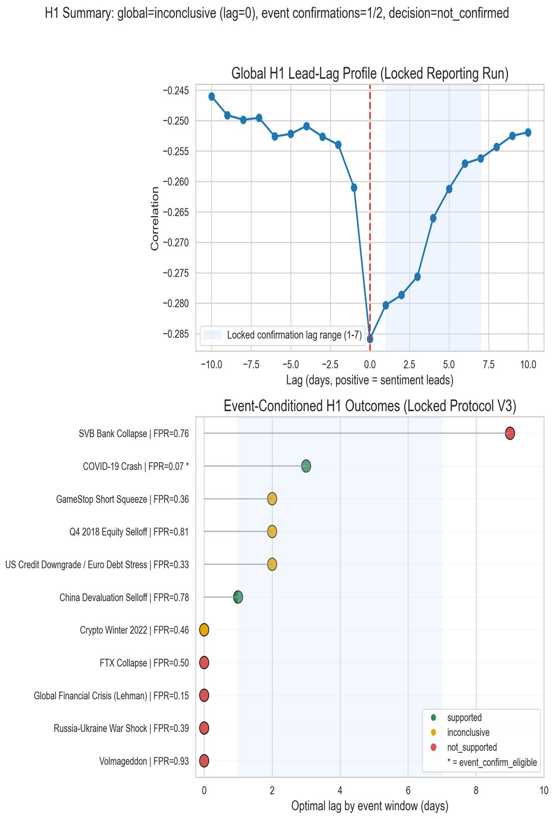

Figure 5.4.2. Regime labels vs. VIX in the COVID stress window.
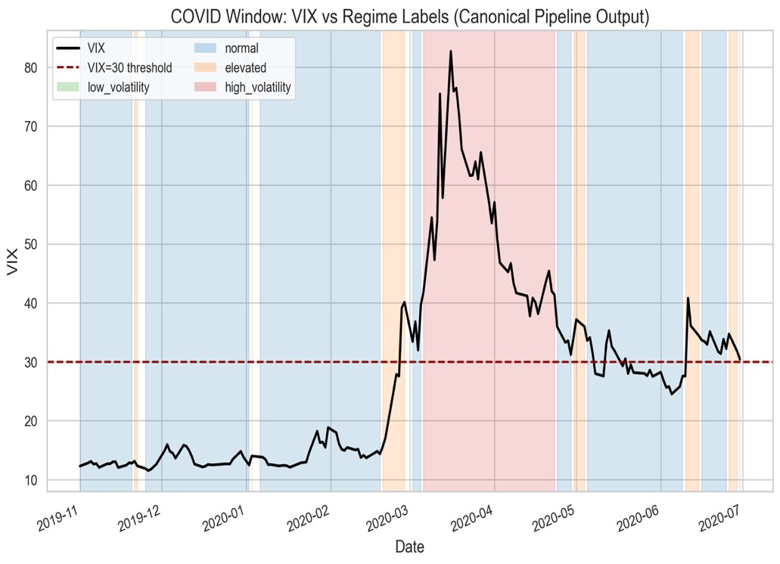
Figure 5.4.3. Transition-performance confusion matrix.
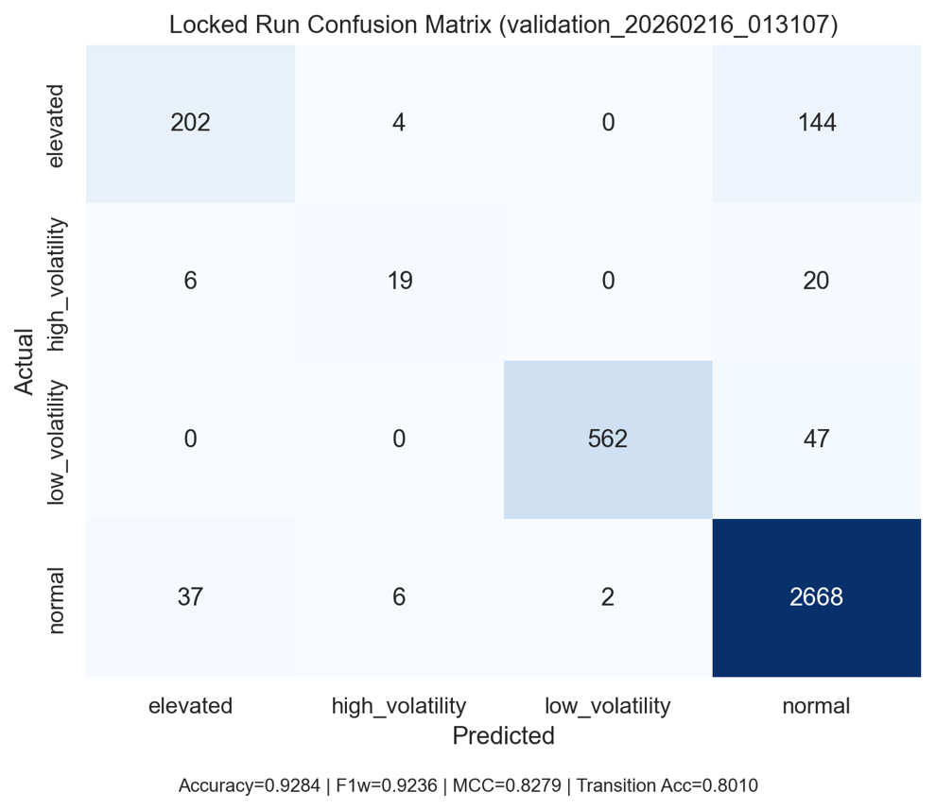
Figure 5.4.4. H2 divergence distribution (pre-transition vs. stable periods).
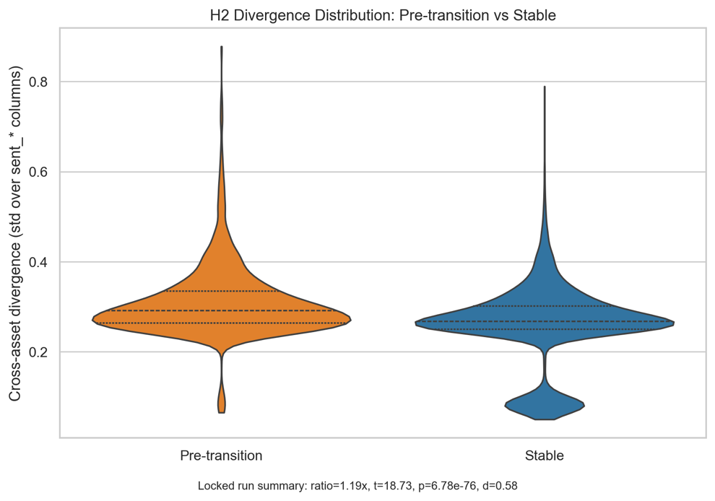
Figure 5.4.5. H3 connectedness comparison (stable vs. transition regimes).
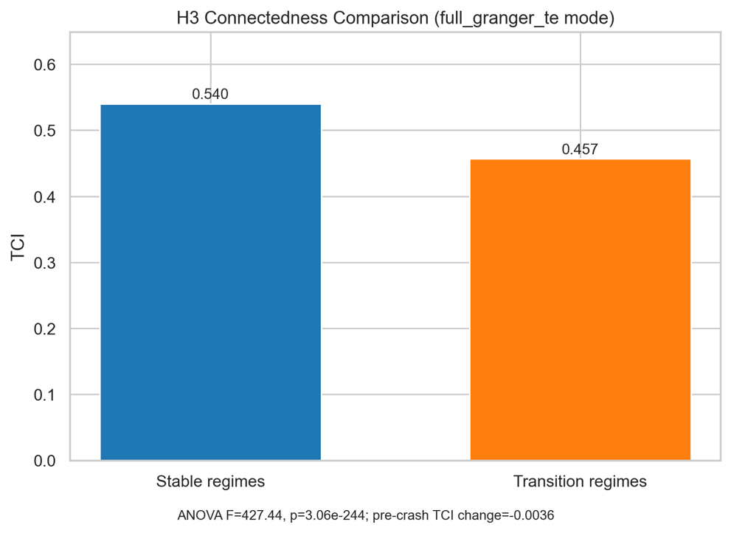
Appendix A contains execution commands, run registries, and artifact-level traceability for all tables and figures.

5.5 Results Synthesis
The empirical evidence supports H2 and H3 across baseline and robustness configurations, while H1 remains unconfirmed under the locked project rule. The main contribution is therefore a reproducible cross-asset regime-detection framework with strong divergence and connectedness diagnostics, along with an explicitly bounded interpretation of lead-time claims.
6. Discussion
6.1 Implemented System
The project has a working canonical pipeline that transforms source-aligned sentiment and market data into reproducible regime outputs. Canonical artifact generation for feature export and regime labeling results/pipeline_output/, fitted volatility and jump-model summaries in run metadata results/pipeline_output/pipeline_summary.json, and audit traceability in docs/RESULTS_MANIFEST.json jointly establish that the core engineering workflow is functional and reproducible.
6.2 Evidence Boundaries
The strongest support is for reproducible pipeline execution and coherent regime segmentation. At the hypothesis level, H1 remains unconfirmed across all locked global confirmation passes despite targeted remediation, while H2 and H3 remain supported in both canonical and A/B feature-mode runs. This pattern indicates that the core classifier is robust for regime discrimination, but broad lead-time confirmation relative to VIX has not been established under the pre-registered project decision rule. Interpretation, therefore, remains limited: directional event-conditioned lead behavior exists, but global H1 claims are not made.
6.3 Practical Implications (Conditional on Validation)
The framework enables earlier risk-state detection for portfolio rebalancing, monitors cross-asset instability through connectedness and divergence diagnostics, and offers a transparent, reproducible alternative to black-box sentiment dashboards. In this study, it is positioned as research-grade decision support rather than production-grade automated trading infrastructure.
6.4 Limitations and Constraints
Several limitations still exist. Tuning jump penalties and rolling validation are computationally costly for repeated time-series cross-validation, and transformer inference latency may limit near-real-time operation on large data streams. Mixed-frequency alignment between irregular text arrivals and regular market bars introduces noise, especially during periods of sparse news. Data quality and representativeness are also affected by bots, sarcasm, and selection bias in public discourse, and observed relationships may be correlational rather than causal.
6.5 Ethical Considerations
Ethical risks include potential manipulation of public sentiment, ongoing information-access disparities even with open tools, and misalignments between public posting behaviors and user expectations regarding downstream financial inference. These issues should stay clear in deployment governance and within the defined boundaries interpretation.
7. Conclusion and Future Work
7.1 Research Contributions
This research fills a vital gap in financial sentiment analysis by creating a system that combines multi-source, cross-asset sentiment to identify market regimes. It features a practical two-layer regime detector that combines GARCH(1,1)-based volatility metrics with a Statistical Jump Model for persistence-aware discrete-state classification, extending to asymmetric GARCH-MIDAS. Empirically, it shows consistent support across assets for the connectedness and divergence mechanisms, particularly for H2 and H3 in the reporting analyses. Additionally, it formalizes and operationalizes a lead-time evaluation framework to test whether sentiment structures can predict VIX-confirmed stress transitions. Using four asset classes and multiple text sources, these components establish a reproducible regime-analysis framework with limited claims: H2 and H3 are supported, but global H1 confirmation is not achieved under fixed criteria.
The real-time dashboard deployment ensures accessibility for retail investors, traders, and risk managers, potentially reducing the information advantage currently held by institutional players who rely on costly sentiment analysis tools.
7.2 Future Work
Future work should focus on adaptive model weighting, such as IMCA-style recalibration, multimodal signals like earnings-call audio, and high-frequency decomposition to determine if lead-time effects remain at intraday levels. The framework could also be expanded to include additional asset classes like bonds and REITs, extended to multilingual financial discourse, and enhanced with more rigorous causal identification to distinguish sentiment-to-price influence from reverse effects.
Acknowledgments
Dr. David (King Ip) Lin, PhD - Capstone Advisor
Jacquelyn Cheun, PhD - Capstone Professor
SMU MANEFRAME team - HPC support
References
Araci, D. (2019). FinBERT: Financial sentiment analysis with pre-trained language models [Preprint]. arXiv. https://doi.org/10.48550/arXiv.1908.10063
Baker, M., & Wurgler, J. (2007). Investor sentiment in the stock market. Journal of Economic Perspectives, 21(2), 129–151. https://doi.org/10.1257/jep.21.2.129
Bollen, J., Mao, H., & Zeng, X. (2011). Twitter mood predicts the stock market. Journal of Computational Science, 2(1), 1–8. https://doi.org/10.1016/j.jocs.2010.12.007
Caferra, R. (2022). Sentiment spillover and price dynamics: Information flow in the cryptocurrency and stock market. Physica A: Statistical Mechanics and its Applications, 593, 126983. https://doi.org/10.1016/j.physa.2022.126983
Cai, Y., Tang, Z., & Chen, Y. (2024). Can real-time investor sentiment help predict the high-frequency stock returns? Evidence from a mixed-frequency-rolling decomposition forecasting method. North American Journal of Economics and Finance, 70, 102147. https://doi.org/10.1016/j.najef.2024.102147
Cao, J., He, G., & Jiao, Y. (2025). Too sensitive to fail: The impact of sentiment connectedness on stock price crash risk. Entropy, 27(4), 345. https://doi.org/10.3390/e27040345
Cicekyurt, E., & Bakal, G. (2025). Enhancing sentiment analysis in stock market tweets through BERT-based knowledge transfer. Computational Economics. https://doi.org/10.1007/s10614-025-10901-8
Dakalbab, F., Kumar, A., Talib, M. A., & Nasir, Q. (2025). Advancing forex prediction through multimodal text-driven models and attention mechanisms. Intelligent Systems with Applications, 25, 200518. https://doi.org/10.1016/j.iswa.2025.200518
Delgadillo, J., Kinyua, J., & Mutigwe, C. (2024). FinSoSent: Advancing financial market sentiment analysis through pretrained large language models. Big Data and Cognitive Computing, 8(8), 87. https://doi.org/10.3390/bdcc8080087
Dong, Z., Fan, X., & Peng, Z. (2024). FNSPID: A comprehensive financial news dataset in time series [Preprint]. arXiv. https://doi.org/10.48550/arXiv.2402.06698
Ehsan, A., Habib, S., & Sohail, A. (2025). Financial news sentiment analysis using NLP and machine learning for asset price prediction: A systematic review. VFAST Transactions on Software Engineering. https://doi.org/10.21015/vtse.v13i3.2165
Ergun, Z. E., & Sefer, E. (2025). FinSentiment: Predicting financial sentiment through transfer learning. Intelligent Systems in Accounting, Finance and Management, 32(1), e70015. https://doi.org/10.1002/isaf.70015
Fatouros, G., Soldatos, J., Kouroumali, K., Makridis, G., & Kyriazis, D. (2023). Transforming sentiment analysis in the financial domain with ChatGPT. Machine Learning with Applications, 14, 100508. https://doi.org/10.1016/j.mlwa.2023.100508
Fottner, A., Okhrin, Y., Pfahler, J., & Wustl, J. (2022). Reddit financial image post sentiment dataset. Data in Brief, 45, 108759. https://doi.org/10.1016/j.dib.2022.108759
Gu, G., & Song, Y. (2026). Enhancing exchange rate forecasting with contextual sentiment indices: A fine-tuned FinBERT approach. Applied Soft Computing. https://doi.org/10.1016/j.asoc.2026.114556
Kengmegni, D. L. (2024). Limitations of news sentiment analysis for next-day stock prediction [Preprint]. arXiv. https://arxiv.org/abs/2411.05791
Keynes, J. M., & Royal Economic Society (Great Britain). (1973). The general theory of employment, interest, and money. Cambridge University Press.
Konstantinidis, T., Iacovides, G., Xu, M., Constantinides, T. G., & Mandic, D. (2024). FinLlama: Financial sentiment classification for algorithmic trading applications [Preprint]. arXiv. https://arxiv.org/abs/2403.12285
Kraaijeveld, O., & De Smedt, J. (2020). The predictive power of public Twitter sentiment for forecasting cryptocurrency prices. Journal of International Financial Markets, Institutions and Money, 65, 101188. https://doi.org/10.1016/j.intfin.2020.101188
Liu, C., Arulappan, A., Naha, R., Mahanti, A., Kamruzzaman, J., & Ra, I.-H. (2024). Large language models and sentiment analysis in financial markets: A review, datasets, and case study. IEEE Access, 12, 134041–134061. https://doi.org/10.1109/ACCESS.2024.3445413
Loughran, T., & McDonald, B. (2011). When is a liability not a liability? Textual analysis, dictionaries, and 10-Ks. The Journal of Finance, 66(1), 35–65. https://doi.org/10.1111/j.1540-6261.2010.01625.x
Luo, W., & Gong, D. (2024). Pre-trained large language models for financial sentiment analysis [Preprint]. arXiv. https://arxiv.org/abs/2401.05215
Mahendran, M., Gokul, A., Lakshmi, P. S., & Preethi, S. (2025). Comparative advances in financial sentiment analysis: A review of BERT, FinBERT, and large language models. In 2025 International Conference on Devices, Circuits and IoT (IDCIoT) (pp. 1–6). IEEE. https://doi.org/10.1109/idciot64235.2025.10914764
Micaletti, R. C. (2022). Relative sentiment and machine learning for tactical asset allocation. SSRN Electronic Journal. https://doi.org/10.2139/ssrn.3475258
Mishev, K., Gjorgjevikj, A., Vodenska, I., Chitkushev, L. T., & Trajanov, D. (2020). Evaluation of sentiment analysis in finance: From lexicons to transformers. IEEE Access, 8, 131662–131682. https://doi.org/10.1109/ACCESS.2020.3009626
Moradi-Kamali, H., Rajabi-Ghozlou, M.-H., Ghazavi, M., Soltani, A., Sattarzadeh, A., & Entezari-Maleki, R. (2025). Market-derived financial sentiment analysis: Context-aware language models for crypto forecasting [Preprint]. arXiv. https://doi.org/10.48550/arXiv.2502.14897
Nasiopoulos, D. K., Roumeliotis, K. I., Sakas, D. P., & Athanasopoulou, N. I. (2025). Financial sentiment analysis and classification: A comparative study of fine-tuned deep learning models. International Journal of Financial Studies, 13(2), 75. https://doi.org/10.3390/ijfs13020075
Nyakurukwa, K., & Seetharam, Y. (2025). Investor sentiment networks: Mapping connectedness in DJIA stocks. Financial Innovation, 11(1), 4. https://doi.org/10.1186/s40854-024-00675-7
Olaiyapo, O. E. (2024). Applying news and media sentiment analysis for generating forex trading signals. Review of Business and Economics Studies, 11(4), 84–94. https://doi.org/10.26794/2308-944X-2023-11-4-84-94
Pankwaen, K., Thongkairat, S., & Saijai, W. (2025). Global cross-market trading optimization using an iterative combined algorithm: A multi-asset approach with stocks and cryptocurrencies. Mathematics, 13(8), 1317. https://doi.org/10.3390/math13081317
Raheman, A., Kolonin, A., Fridkin, I., Ansari, W., Vishwas, M., Tulabandhula, T., & Bahrami, S. (2022). Social media sentiment analysis for cryptocurrency market prediction [Preprint]. arXiv. https://arxiv.org/abs/2204.10185
Renault, T. (2017). Intraday online investor sentiment and return patterns in the U.S. stock market. Journal of Banking & Finance, 84, 25–40. https://doi.org/10.1016/j.jbankfin.2017.07.002
Roumeliotis, K. I., Nasiopoulos, D. K., & Tselikas, N. D. (2024). LLMs and NLP models in cryptocurrency sentiment analysis: A comparative classification study. Big Data and Cognitive Computing, 8(6), 63. https://doi.org/10.3390/bdcc8060063
Sarfarazurrehman, S., Mane, V., & Doshi, A. (2025). AI and machine learning models in cross-asset class investment risk analysis: A case study of real estate and equities markets. In 2025 IEEE International Conference on Smart Systems and Applications (ICSSAS) (pp. 1–6). IEEE. https://doi.org/10.1109/icssas66150.2025.11081061
Shao, Z., Yao, X., Chen, F., Wang, Z., & Gao, J. (2024). Revisiting time-varying dynamics in stock market forecasting: A multi-source sentiment analysis approach with large language models. Decision Support Systems, 187, 114362. https://doi.org/10.1016/j.dss.2024.114362
Shen, Y., & Zhang, P. K. (2024). Financial sentiment analysis on news and reports using large language models and FinBERT. In IEEE International Conference on Power, Intelligent Computing and Systems (pp. 717–721). IEEE. https://doi.org/10.1109/ICPICS62053.2024.10796670
Shi, C. (2025). Understanding gold and dollar price movements: A sentiment-based GARCH-MIDAS approach. In Proceedings of the 2025 International Conference on Economics and Business Management (p. 47). https://doi.org/10.2991/978-94-6463-835-6_47
Shu, Y., Yu, C., & Mulvey, J. M. (2024). Downside risk reduction using regime-switching signals: A statistical jump model approach. Journal of Asset Management, 25(5), 493–507. https://doi.org/10.1057/s41260-024-00376-x
Sibande, X., Gupta, R., Demirer, R., & Bouri, E. (2021). Investor sentiment and (anti) herding in the currency market: Evidence from Twitter feed data. Journal of Behavioral Finance, 24(1), 56–72. https://doi.org/10.1080/15427560.2021.1917579
Suárez-Cetrulo, A. L., Quintana, D., & Cervantes, A. (2023). Machine learning for financial prediction under regime change using technical analysis: A systematic review. International Journal of Interactive Multimedia and Artificial Intelligence, 8(2), 117–138. https://doi.org/10.9781/ijimai.2023.06.003
Sun, Y., Yuan, H., & Xu, F. (2025). Financial sentiment analysis for pre-trained language models incorporating dictionary knowledge and neutral features. Natural Language Processing Journal, 10, 100148. https://doi.org/10.1016/j.nlp.2025.100148
Todd, A., Bowden, J., & Moshfeghi, Y. (2024). Text-based sentiment analysis in finance: Synthesising the existing literature and exploring future directions. Intelligent Systems in Accounting, Finance and Management. https://doi.org/10.1002/isaf.1549
Trushkovskyi, V. (2025). Application of social media sentiment analysis for stock price prediction. SSRN Electronic Journal. https://doi.org/10.57017/jaes.v20.3(89).11
Wang, X., Wang, R., & Zhang, Y. (2024). Cross-asset momentum and the hybrid fund transmission mechanism in China’s stock and bond markets. PLOS ONE, 19(3), e0300781. https://doi.org/10.1371/journal.pone.0300781
Xu, W., Xiang, D., Liu, Y., Wang, X., Ma, Y., Zhang, L., Hu, S., Xu, C., & Zhang, J. (2025). FinMultiTime: A four-modal bilingual dataset for financial time-series analysis [Preprint]. arXiv. https://doi.org/10.48550/arXiv.2506.05019
Yang, J., Tang, Y., Li, Y., Zhang, L., & Zhang, H. (2025). Cross-asset risk management: Integrating LLMs for real-time monitoring of equity, fixed income, and currency markets [Preprint]. arXiv. https://arxiv.org/abs/2504.04292
Zhang, R., Yi, C., & Chen, Y. (2020). Explainable machine learning for regime-based asset allocation. In 2020 IEEE International Conference on Big Data (pp. 5480–5485). IEEE. https://doi.org/10.1109/BigData50022.2020.9378332
Appendix A. Reproducibility Commands and Run Registry
A.1 Canonical Run Registry
Analysis Component | Artifact ID(s)
Canonical reporting configuration | validation_20260216_013107
Baseline proxy-network comparison | validation_20260216_012920
Volatility upgrade comparison | validation_20260216_012945
Full-network parameter checks | validation_20260216_013134, validation_20260216_013203, validation_20260216_013252
Lagged-feature robustness | validation_20260215_225156, validation_20260216_002914, robustness_seed11/42/77
Subperiod checks | validation_20260216_013807, validation_20260216_013829, validation_20260216_013837
H1 transform checks | validation_20260216_014501, validation_20260216_014530, validation_20260216_014558
Event-conditioned H1 probe | h1_event_probe_20260216_015024
Locked confirmation V1/V2/V3 | h1_locked_confirmation_20260216_020514, h1_locked_confirmation_20260216_021242, h1_locked_confirmation_20260216_022558
Table A.1 Canonical Run Registry

A.2 Reproducibility Commands
A.2.1 Canonical Validation Execution
PYTHONPATH=src python scripts/run_canonical_validation.py \
--feature-matrix results/pipeline_output/feature_matrix.csv \
--regime-labels results/pipeline_output/regime_labels.csv \
--output-dir results/validation/methodology_ab_backend/network_tuning_pyinform/cfg_default \
--volatility-feature-mode baseline \
--network-feature-mode full_granger_te \
--network-window-days 126 \
--network-step-days 21 \
--network-te-history-length 3 \
--network-te-permutations 10 \
--network-granger-max-lag 3 \
--train-window-days 756 \
--test-window-days 63 \
--step-days 63 \
--purge-days 5 \
--rf-estimators 300 \
--rf-random-state 42 \
--compound-lag-days 10 \
--h1-sentiment-transform compound \
--h1-max-lag-days 10
A.2.2 Locked H1 Confirmation (Horizon Extension Protocol)
PYTHONPATH=src python scripts/run_h1_locked_confirmation.py \
--feature-matrix results/pipeline_output/feature_matrix.csv \
--regime-labels results/pipeline_output/regime_labels.csv \
--output-dir results/validation/h1_confirmation/locked_protocol \
--protocol-id H1_LOCKED_CONFIRMATION_PROTOCOL_V3_HORIZON \
--events-json docs/h1_event_universe_v2.json \
--confirm-lag-min 1 \
--confirm-lag-max 7
A.2.3 Manifest Integrity Check
PYTHONPATH=src python scripts/validate_results_manifest.py \
--manifest docs/RESULTS_MANIFEST.json
A.3 Figure Artifact Traceability
Figure files were generated with:
python scripts/generate_draft11_figures.py
On Apple Silicon systems, full_granger_te execution may require a locally built libinform binary for pyinform-backed transfer entropy. When unavailable, the fallback path should be documented explicitly in reproduction notes.
A.4 Deployment Access Points
Component | URL | Notes
Frontend dashboard | https://sentiment-regime-detector.vercel.app/ | Public interface used for sentiment/regime monitoring.
Table A.4 Deployment Access Points

