A year at Riverside Community Garden
Our volunteers grew more food than ever this year, kept bees for the first time and dug two ponds. These are the figures.
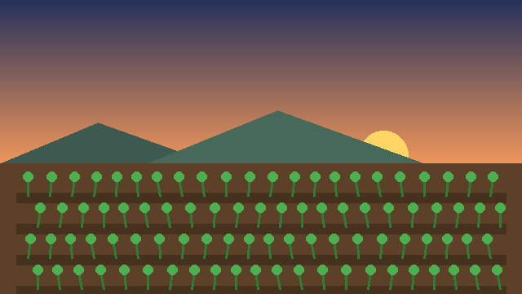
The beds at dawn in May.

Harvest by month
The harvest peaked in August, when the tomatoes, beans and courgettes all came in at once: 152 kg in one month.
Month | Harvest (kg)
Jan | 4
Feb | 6
Mar | 15
Apr | 32
May | 58
Jun | 96
Jul | 140
Aug | 152
Sep | 118
Oct | 64
Nov | 21
Dec | 8
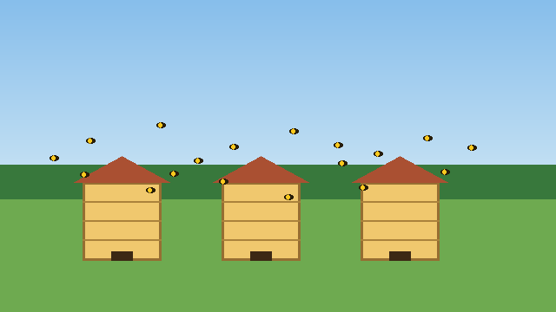
Our three hives, kept by volunteers since March.

Rainfall and soil moisture
A dry summer pulled the soil moisture down to 30% in August; the ponds and the autumn rain brought it back.
Month | Rainfall (mm) | Soil moisture (%)
Jan | 78 | 64
Feb | 61 | 60
Mar | 55 | 55
Apr | 47 | 49
May | 52 | 43
Jun | 44 | 37
Jul | 38 | 31
Aug | 41 | 30
Sep | 57 | 38
Oct | 82 | 52
Nov | 96 | 63
Dec | 88 | 66
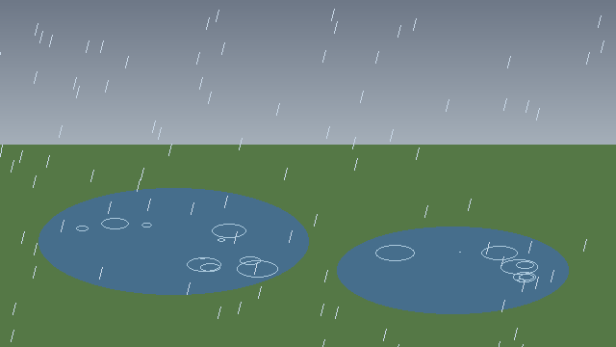
Autumn rain filling the ponds.

Where the harvest went
Most of the harvest went home with the volunteers who grew it, and nearly a third to the food bank.
Destination | Share (%)
Volunteers | 38
Food bank | 31
Market stall | 19
Compost | 12
Figures from the garden’s own records, January to December.

