The Node Garden Handbook
This handbook takes you from bare soil to a garden that looks after itself. Read it in order the first time; later, jump to the part you need.

Before you start
Choose a sunny spot with soil that drains well. A small bed of two by three metres is plenty for a first garden.

Planting your first garden
Loosen the soil to the depth of a spade and work in a layer of compost. Rake it level, then mark rows about thirty centimetres apart.
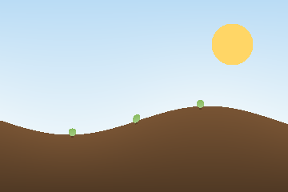
Sow the seeds thinly along each row and cover them with a finger’s depth of fine soil. Water gently, so the seeds stay where you put them.
Keep the soil moist but not wet. In warm weather the first sprouts appear within a week; in cool weather, give them two.
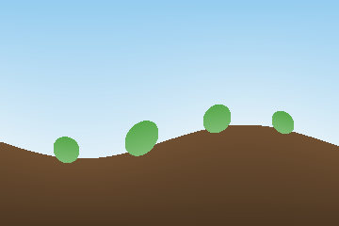
When the seedlings have two true leaves, thin them so each plant has room to grow. The thinnings make a good salad.
From then on, water at the roots in the morning and pull weeds while they are small. Within a couple of months the bed fills out and flowers.


Looking after it
Cut back flowers as they fade, feed the soil with compost each spring, and keep notes of what grew well, so next year is easier still.

