NLP assignment 1

Ram Cohen & Jonathan fuchs

Features we tried:
- Word with Capital first letter – makes sense for entities (Jerusalem, Yossi, Germany…)
lambda sentence: [word[0].isupper() for word in sentence[0]]
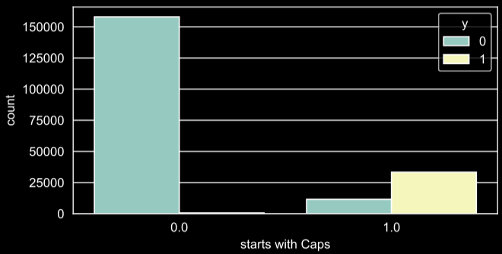
- Word location in the sentence – usually the first is with capital first letter – so together with (1) should help distinguish them.
lambda sentence: [ii for ii in range(len(sentence[0]))],
- Part of speech (pos) – we tried to find one or more a pos that is more frequent with entities or with non-entities.
lambda sentence: [True if pos == 'NNP' else False for pos in sentence[1]]
lambda sentence: [True if pos in ('NN', 'CD', 'IN', 'DT') else False for pos in sentence[1]]
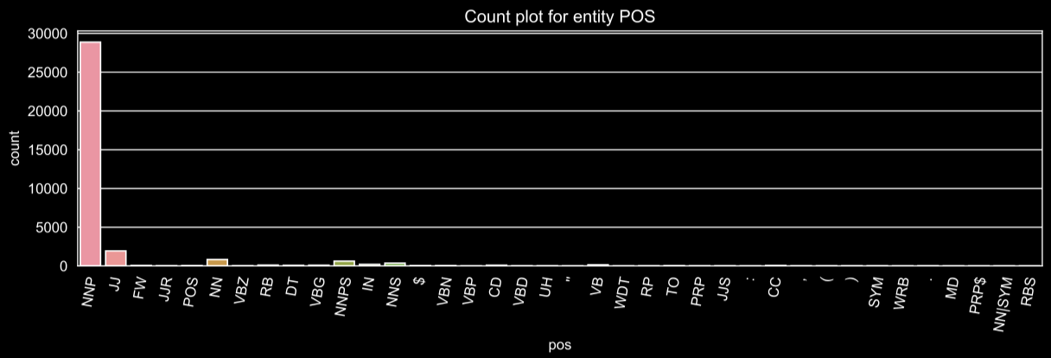
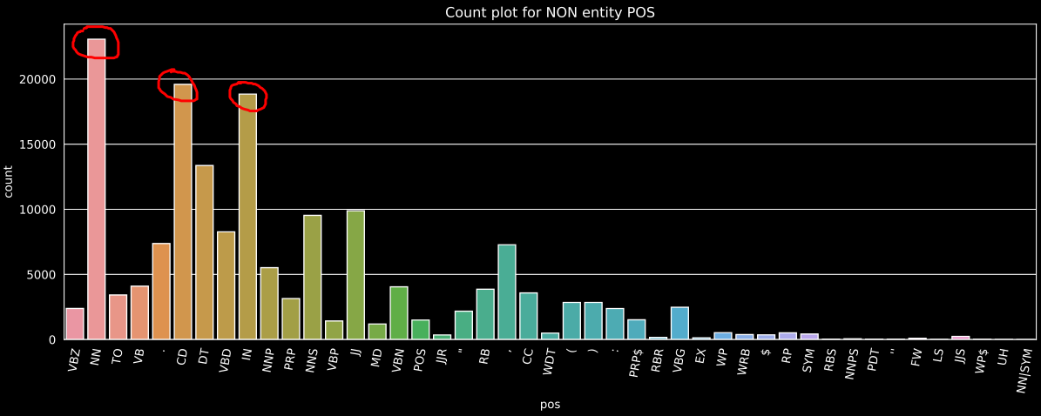
- Last pos – like with (3) only looking at the previous word
- Next pos - like with (3) only looking at the next word
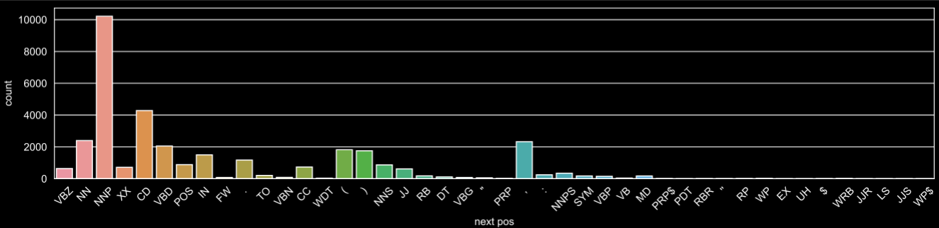
lambda sentence: [True if last_pos == 'NNP' else False for last_pos in sentence[2]],
lambda sentence: [True if next_pos == 'NNP' else False for next_pos in sentence[3]],
- Word length – we tried looking at the word length, and is there a difference between entities or non-entities
lambda sentence: [len(word) > 3 for word in sentence[0]]
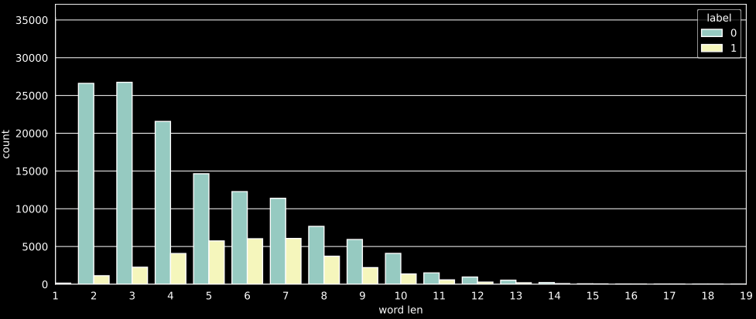
- Sentence length – like with (6), but looking at the sentence length instead, not very promising
lambda sentence: [len(sentence[0]) > 15 for word in sentence[0]]
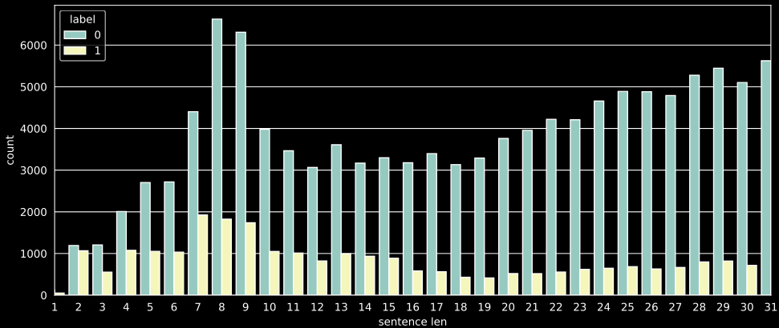
- First letter (lower case) – entities and non-entities have different first letters, not very promising
lambda sentence: [word[0].lower() in 't,f.o' for word in sentence[0]],
lambda sentence: [word[0].lower() in 'jkyzv' for word in sentence[0]]

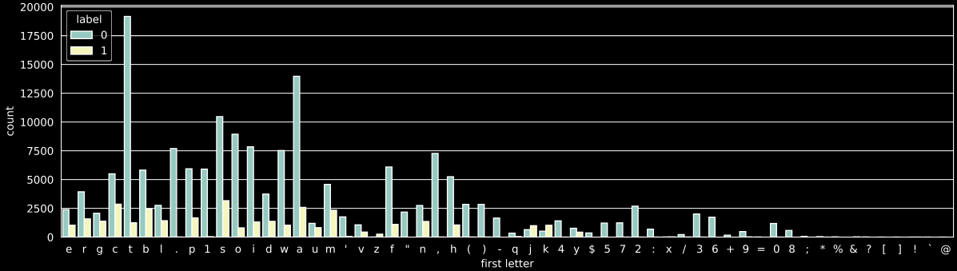
Model and hyper parameters:
Models we tried (with all available features), (random_state=42):
  - GradientBoostingClassifier(max_depth=15): 96.59% on eval
  - AdaBoostClassifier(n_estimators=100): 95.49% on eval
  - KneighborsClassifier(n_neighbors=7): 96.10% on eval
  - SVC(kernel=’rbf’): 95.7% on eval
  - RandomForestClassifier(n_estimators=300, max_depth=13): 97.02%
Choosing Random forest, as it is fast and good for tabular data, a simple hyperparameter optimization search have been conducted (estimators and depth) and the above parameters were chosen.

Selecting top 5 features:
The selection was based on feature importance, some features were combined to reduce the number of features while keeping some of their effect.
- mean decrease in impurity:  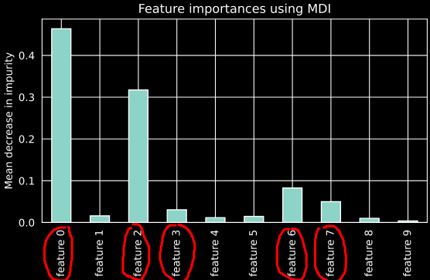 | - Permutation importance:  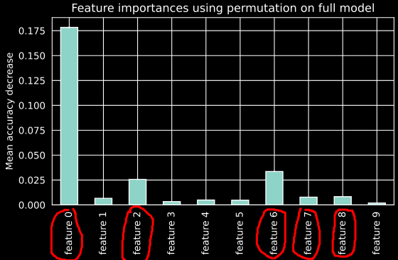

- Final 5 features:
- Feature 0: Capital letter:
lambda sentence: [word[0].isupper() for word in sentence[0]
- Feature 2: Part of speech – for entities:
lambda sentence: [True if pos in ('NNP', 'NNPS', 'JJS') else False for pos in sentence[1]]
- Feature 3: Part of speech – for non entities:
lambda sentence: [True if pos in ('NN', 'CD', 'IN', 'DT') else False for pos in sentence[1]]
- Feature 6: word length:
lambda sentence: [len(word) for word in sentence[0]]
- Feature 7: sentence length:
lambda sentence: [len(sentence[0]) for word in sentence[0]]

Confusion matrix (on eval data-set):
Accuracy: 96.06%, Precision: 84.96% , recall: 92.93%, f1: 88.77%
The model is better at classifying non-entities and a little biased to finding entities at the expense of its accuracy.
