NLP assignment 2

Ram Cohen & Jonathan fuchs

EDA
The datasets are IMDB reviews labeled positive/negative which are dispersed equally:
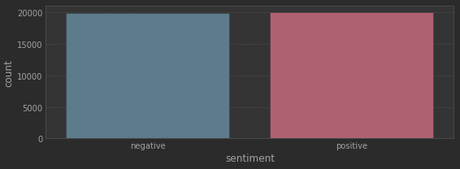
Each review is composed of words, with varying number of word count:
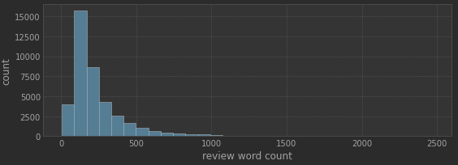
This large variation in word count will affect the feature choosing ahead

Word embedding
As required, we used a pre-trained tokenizer for the word embeddings. Due to the large variation in sentence lengths we choose to use a single vector in the size of the embedding for each review. Therefore to embed a lot of information in a single vector we chose a large embedding: the -
”glove-twitter-200” with a 200 size.
Tokenizing has been performed so for each review there is a single vector containing the mean of the embeddings of the entire review. Each word is changed to lower case, stripped of punctuation characters and passed to the tokenizer. The method is a @staticmathod so it can be used by the class for post training inference on new reviews.
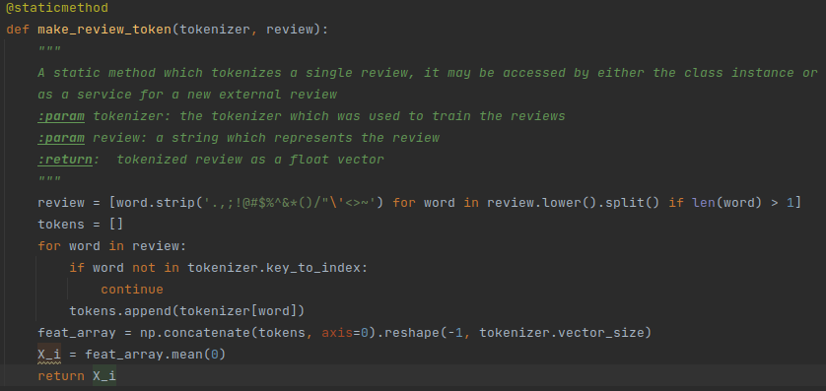

Model and hyper-parameters
We used a 4-layer fully connected NN (200-512-1024-512-2) to allow room for a lot of learning. Relu as activation and Cross-entropy as loss. We chose a 2 class output and not a binary cross-entropy so in the future we can enlarge the model for more calsses.
Optimizer – Adam, lr=0.001 – we had to choose a small value for the network to actually start learning. Batch size of 128 seems as a good value and 100 epochs are enough.
We also built a training function with a checkpoint indicator so the best model will be saved.

Training
Using a GPU the training was relatively fast (a couple of minuets), training was steady with loss decreasing and accuracy increasing steadily. A small acceptable overfit was recorded.
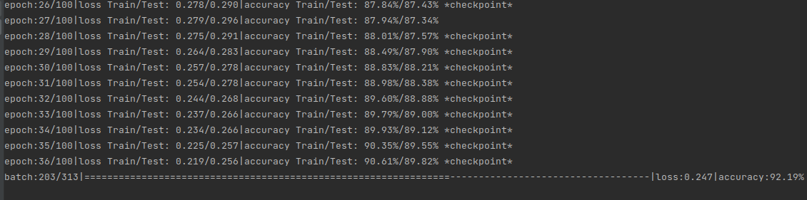
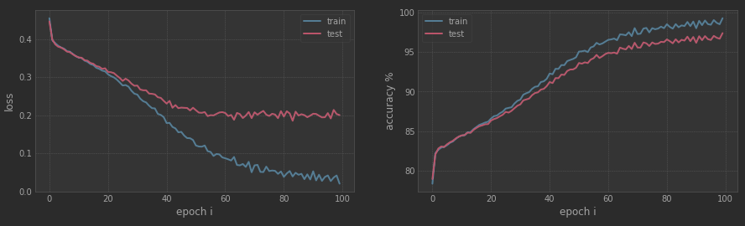

Final results
Final results (epoch 100/100):
loss Train/Test: 0.020/0.200|accuracy Train/Test: 99.30%/97.41%
To decided to test two new reviews (a 2 star and a 10 review), the trained model did well:

