NLP assignment 1

Ram Cohen & Jonathan fuchs

# Features we tried:

1. **Word with Capital first letter** – makes sense for entities (Jerusalem, Yossi, Germany…)

lambda sentence: [word[0].isupper() for word in sentence[0]]

1. 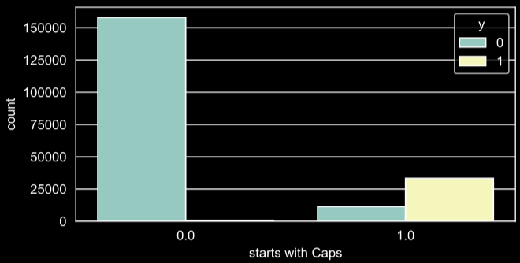**Word location in the sentence** – usually the first is with capital first letter – so together with (1) should help distinguish them.

lambda sentence: [ii for ii in range(len(sentence[0]))],

1. **Part of speech (pos) –** we tried to find one or more a pos that is more frequent with entities or with non-entities.

lambda sentence: [True if pos == 'NNP' else False for pos in sentence[1]]

lambda sentence: [True if pos in ('NN', 'CD', 'IN', 'DT') else False for pos in sentence[1]]

1. 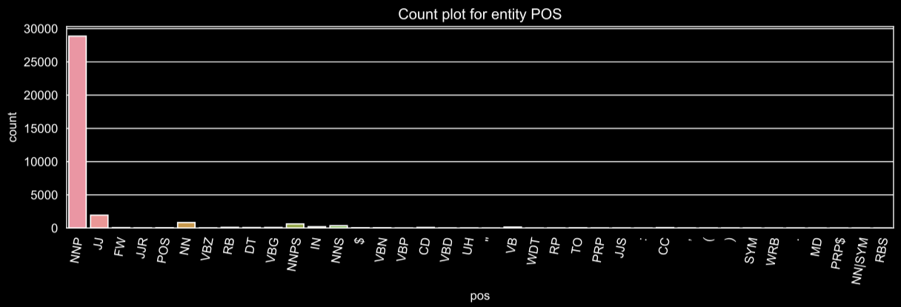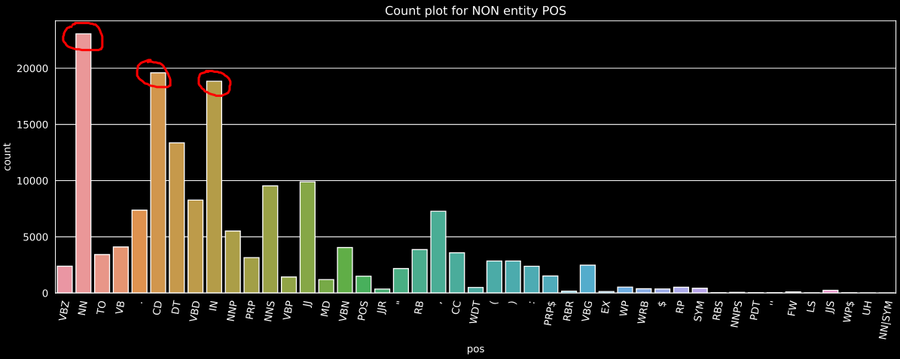**Last pos** – like with (3) only looking at the previous word
2. **Next pos** - like with (3) only looking at the next word

lambda sentence: [True if last_pos == 'NNP' else False for last_pos in sentence[2]],  
lambda 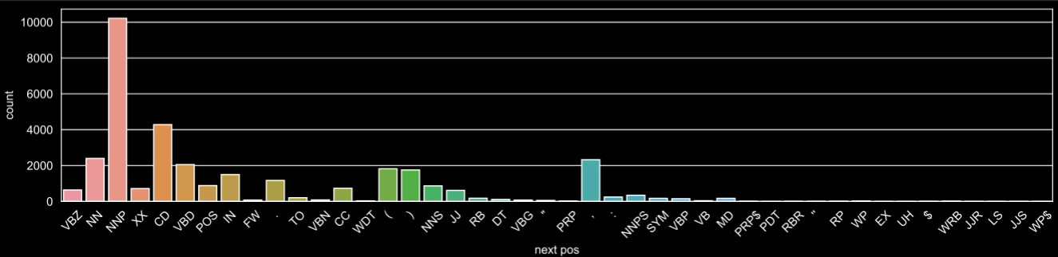sentence: [True if next_pos == 'NNP' else False for next_pos in sentence[3]],

1. **Word length –** we tried looking at the word length, and is there a difference between entities or non-entities

lambda sentence: [len(word) > 3 for word in sentence[0]]

1. 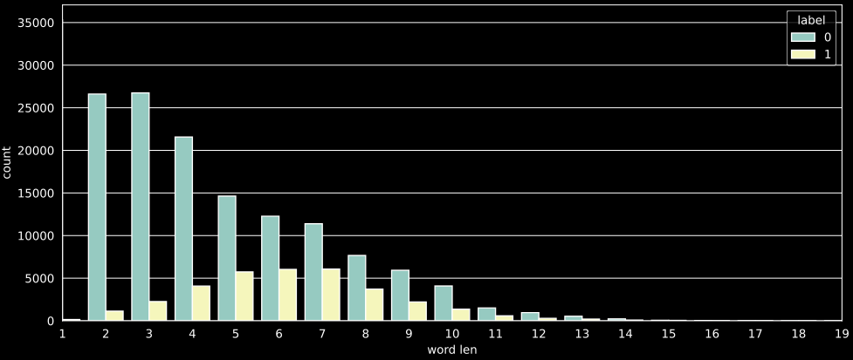**Sentence length** – like with (6), but looking at the sentence length instead, **not very promising**

lambda sentence: [len(sentence[0]) > 15 for word in sentence[0]]

1. 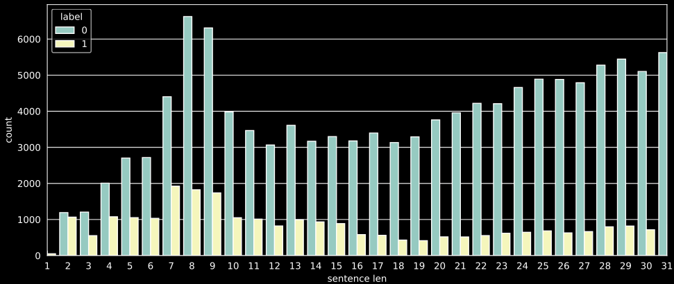**First letter (lower case)** – entities and non-entities have different first letters,  **not very promising**

lambda sentence: [word[0].lower() in 't,f.o' for word in sentence[0]],  
lambda sentence: [word[0].lower() in 'jkyzv' for word in sentence[0]]

# Model and hyper parameters:

Models we tried (with all available features), (random_state=42):

* + GradientBoostingClassifier(max_depth=15): 96.59% on eval
  + AdaBoostClassifier(n_estimators=100): 95.49% on eval
  + KneighborsClassifier(n_neighbors=7): 96.10% on eval
  + SVC(kernel=’rbf’): 95.7% on eval
  + RandomForestClassifier(n_estimators=300, max_depth=13): **97.02%**

Choosing Random forest, as it is fast and good for tabular data, a simple hyperparameter optimization search have been conducted (estimators and depth) and the above parameters were chosen.

# Selecting top 5 features:

The selection was based on feature importance, some features were combined to reduce the number of features while keeping some of their effect.

|  |  |
| --- | --- |
| * 1. mean decrease in impurity: | 1. Permutation importance: |

1. **Final 5 features:**
2. Feature 0: Capital letter:

lambda sentence: [word[0].isupper() for word in sentence[0]

1. Feature 2: Part of speech – for entities:

lambda sentence: [True if pos in ('NNP', 'NNPS', 'JJS') else False for pos in sentence[1]]

1. Feature 3: Part of speech – for non entities:

lambda sentence: [True if pos in ('NN', 'CD', 'IN', 'DT') else False for pos in sentence[1]]

1. Feature 6: word length:

lambda sentence: [len(word) for word in sentence[0]]

1. Feature 7: sentence length:

lambda sentence: [len(sentence[0]) for word in sentence[0]]

# Confusion matrix (on eval data-set):

Accuracy: 96.06%, Precision: 84.96% , recall: 92.93%, f1: 88.77%

The model is better at classifying non-entities and a little biased to finding entities at the expense of its accuracy.

# 