FEA – Learning:

EDA on the new data:
- There are 884 experiments containing 100 points of (pressure, height)
- Pressure vectors are identical, 100 equally spaced pressure points between 3 and 300 [kPa]
- Height vectors are unique, values between 0.06 and 1632.7 [mm]
- Labels distribution:
  - new:
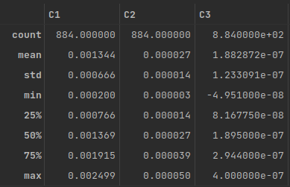
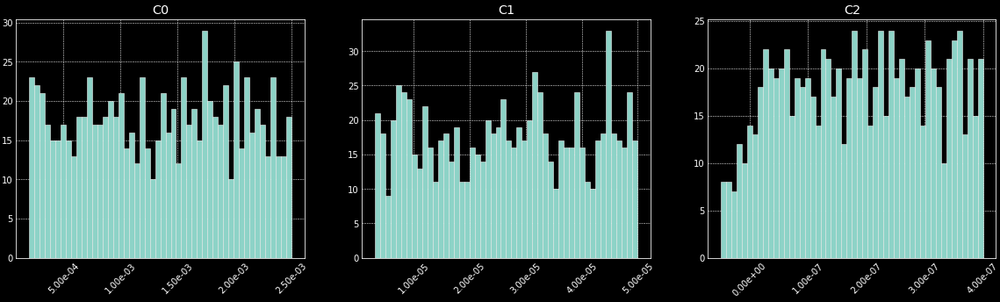
  - old:
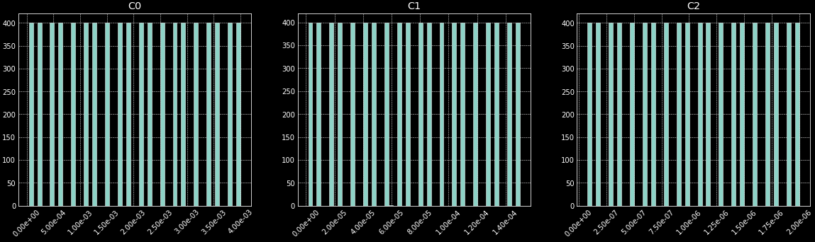

- old data vs. new data: the data is significantly different, both in ranges of pressure and height and with the labels
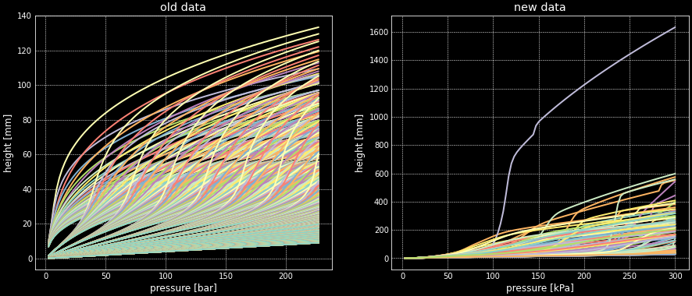
- New data vs. experiment data: not matching (pressure-height data):
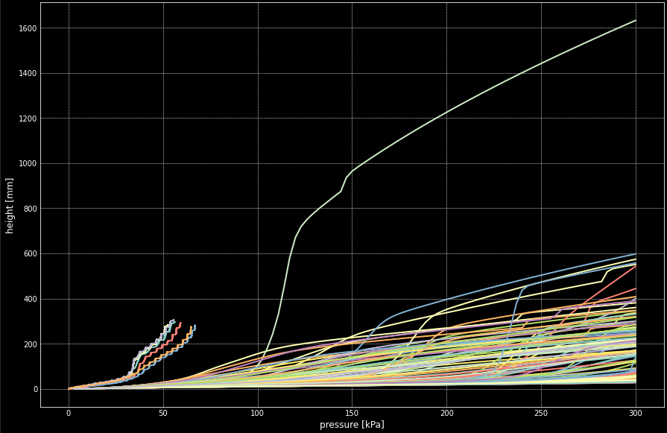
Exp. data

