Fixed Asset Assignment

Date:13 Dec 2024

**1. Define Asset Categories:**

Before assigning assets, you need to ensure that asset categories are set up. These categories define the type of asset, depreciation methods, etc.

1. Navigate to: Fixed Assets > Setup > Asset Categories

// Path: Assets > Setup > Asset System > Asset Category

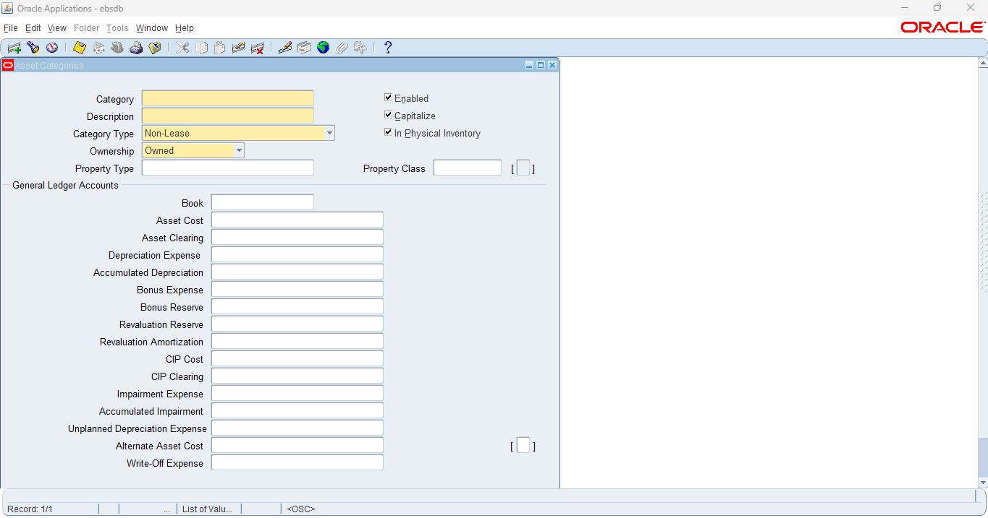

1. Click Create to define a new asset category (if needed), and configure details like:
   * Category Code
   * Description
   * Depreciation method
   * Useful life
   * Book (e.g., Corporate Book)

Configured necessary details to define asset category

**2.Define Locations (Optional)**

Asset locations can be defined for organizational purposes. This can help in tracking assets by location.

1. Navigate to: Fixed Assets > Setup > Locations

// Path: Assets > Setup > Asset System > Locations

1. Define a new location or review the existing ones.

Step 3: Add an Asset

After categories and locations are set, you can now assign an asset. This is typically done by entering an asset record with all necessary details such as its category, location, acquisition cost, etc.

1. Navigate to: Fixed Assets > Assets > Add Assets

// Path: Assets > Assets > Asset Workbench

1. Enter details for the asset:
   * Asset Category: Select the category from the drop-down.
   * Location: Optionally select the asset location.
   * Asset Description: Provide a name or description.
   * Asset Cost: Input the cost of the asset.
   * Acquisition Date: Date when the asset was acquired.
   * Book: The book where the asset will be tracked (e.g., Corporate Book).

// Fill necessary information on Books and Select Continue 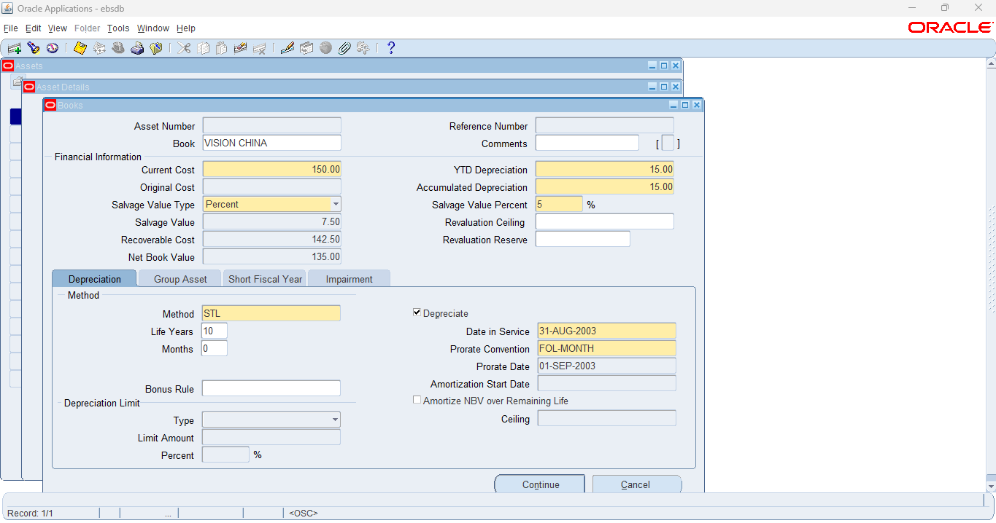

1. Click Save to save the asset details.

// Fill necessary information and Select Done

**\*4: Assign Asset to the User (if applicable)**

If the asset is being assigned to a user or department, you can track this by creating a Transfer or Asset Assignment record.

1. Navigate to: Fixed Assets > Transactions > Asset Transfer

1. Select the asset to transfer and define:
   * From Location and To Location.
   * Transfer Date.

1. Click Save to update the assignment.

**5: Verify one of the Asset Details [Asset Book: US FEDERAL]**

Once the asset is added and assigned, you can review its details.

1. Navigate to: Fixed Assets > Assets > View Assets

// Fill Asset Book Information, and select Find

// Select an Asset, then Select Open to view Asset Details

1. Enter search criteria such as asset number or description to find and verify the asset details.

// Navigate to Asset Form and query an asset

This is a very basic way to create and assign assets in Oracle EBS. Depending on your organization’s setup, the process may involve more complex configuration, but these are the fundamental steps for simple asset assignment.

**6: For Asset Book: US FEDERAL how many Assets are there?** Provide count with screen shot evidence.

There are 12 assets in US FEDERAL Book.

**8.Show me the all-Key Flex fields Details for Fixed Asset [ With Screen shot].**

// Category flexfield and Asset Key flexfield is captured in Asset Details.

// The Location flexfield is captured in the assignments.

**9.For Asset Book: US FEDERAL find the following details…with screen shot**

**a) Depreciation Calendar.**

// Navigate to Setup, Select Asset System, then Select Book Controls.

**b) Prorate Calendar**

// Navigate to Setup, Select Asset System, then Select Book Controls.

**10.What is Last Depreciation run for the Asset Book: US FEDERAL & what is the status?**

**Provide all the details with screen shot.**

// Navigate to Setup, Select Asset System, then Select Book Controls.

The Status of the Last Depreciation Run is Submitted.

**11.What Ledger associated with US FEDERAL Asset Book. (Provide the details with screen shot).**

// Navigate to Setup, Select Asset System, then Select Book Controls.

**12. What is Chart of accounts for US FEDERAL Asset Book. (Provide the details with screen shot).**

// Navigate to Setup, Select Asset System, then Select Book Controls.

**13. System Control details for VISION ENTERPRISES.**

// Navigate to Setup, Select Asset System, and Select System Controls.