Assignments for Oracle E-Business Suite Accounts Receivables (AR).

Assignment file naming convention: JOSEPH_ONYENSO_AR_Assignment

1.Create an AR Transaction (Invoice) for an existing Customer & show the Distribution for this Transaction. [Incorporate each & every step with screen shot evidences]

// Navigate to Receivables Responsibility. Select Transactions, then Open Transactions.

// Fill Necessary Fields, including Type: Invoice. Save.// Select Line Items, Fill Necessary Fields, then Save.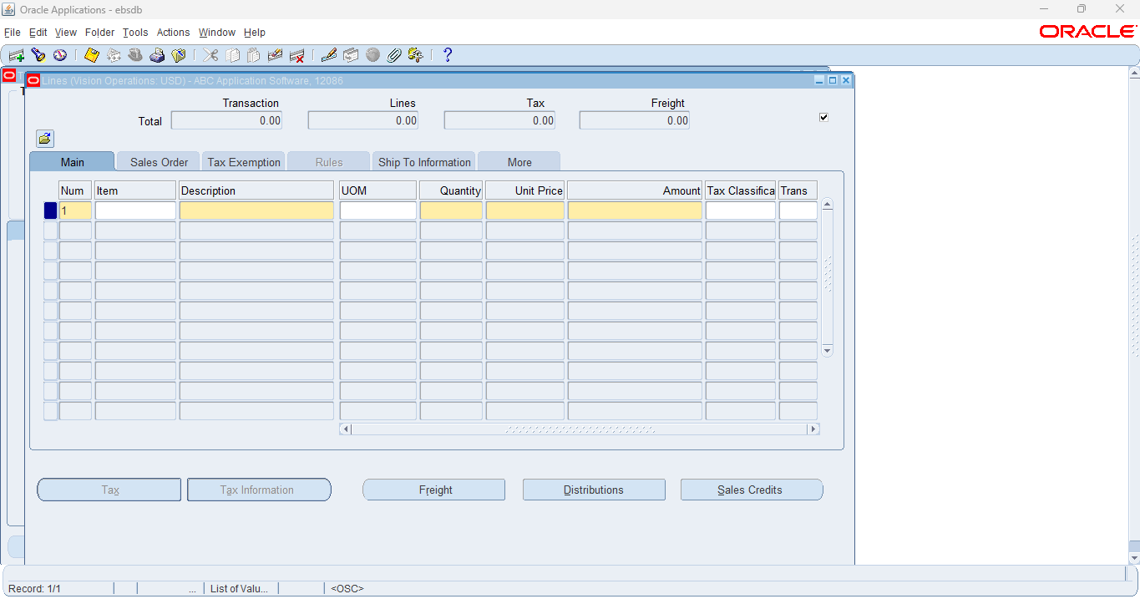

// Navigate back to Transactions Form. Select Complete.

2. Do the Create accounting for the above Transaction, Trans to GL & show the accounting entry.

[Incorporate each & every step with screen shot evidences]

// Select Tools, then Select Create Accounting.

// Navigate to Transactions Form. Select Tools, then select View Accounting.

3.Create a credit memo for a customer to adjust an invoice amount.

[Incorporate each & every step with screen shot evidences]

// Navigate to Transactions Form and Fill Necessary Fields, including Class: Credit Memo. Save.

// Fill Line Information, then Save.

// Select Tools, then Select Create Accounting. Select Final Accounting Post to GL. Select OK.

4. Create one Cash Receipt for an existing Customer & apply to Customer Transaction.

[Incorporate each & every step with screen shot evidences]

// Navigate to Receivables. Select Receipts, then open Receipts.

5. Create one Debit Memo for the same Customer for whom you have created the AR Transaction.

[Incorporate each & every step with screen shot evidences]

// Navigate to Receivables. Select Transactions, then Open Transactions.

// Fill Necessary Fields, including Type: Debit Memo. Save.

// Select Tools, Select Create Accounting, Select Create Final Accounting Post to GL, then Select OK.

6. Generate an Aging Report

* Navigate to: Receivables > Reports > Aging.
* Generate an aging report for outstanding customer invoices.

// Navigate to Receivables Responsibility. Select Reports, then Open Accounting.

// Select Submit.

7. Close an Open Period: what is the Current Open AR period?

[Incorporate each & every step with screen shot evidences]

// Navigate to Receivables. Select Control, Select Accounting, then Open Open/Close Periods.

8. What are all AR Transaction Sources has been created?  
[Provide the list with screen shot evidences]

// Navigate to Receivables. Select Control, Select Accounting, then Open Revenue Accounting.

9. Create one Deposit Transaction for one existing Customer.

[Incorporate each & every step with screen shot evidences]

// Navigate to Receivables. Select Transactions, then Open Transactions.

// Fill Necessary Fields, including Type: Deposit. Save.

// Select Tools, then Select Create Accounting. Select Create Final Accounting Post to GL, then Select OK.

10.Explain the Month end closure process step by steps.

1. Review and Resolve Pending Transactions

2. Run the AR Period Close Reports

3. Confirm All Transactions Are Posted

4. Review and Reconcile Open Receivables

5. Review Customer Account Balances

6. Generate and Post Month-End Journal Entries

7. Run the AR Period Close Process

8. Review the Month-End Reconciliation

9. Finalize and Close the GL Period

10. Generate Final Month-End Reports

11. Backup and Document the Closure

12. Confirm System Lock

11. Create a new Transaction “MANUAL” Transaction Type

[Incorporate each & every step with screen shot evidences]

// Navigate to Receivables Responsibility. Select Setup, Select Transactions, then Open Transaction Types.

// Fill Necessary Fields and Save.

12. Set Up a Payment Method

* Navigate to: Receivables > Setup > Payment Methods.
* Create and set up a new payment method (e.g., Credit Card, Bank Transfer).

// Navigate to Receivables. Select Setup, Select Transactions, then Open Payment Terms.

13. What are Receipt Sources are there in the System?

[Provide the list with screen shot evidences]

// Navigate to Receivables. Select Setup, Receipts, then Open Receipt Sources.

There are two types of receipt sources. Manual and Automatic.