**Oracle EBS Payables Assignment**

**Date: 06th Dec 2024:**

**Each & Every assignment needs to explain with necessary screen shots.**

**Name:** Joseph Onyenso

1. **Create an Invoice Standard: [Payment team: Immediate].**

// Path: Payables > Invoice > Entry > Invoice

// Fill necessary fields in header, including payment term

// Save invoice

1. **Validate the Invoice:**
   * Validate the invoice you just created to ensure there are no errors and it's ready for payment.

1. **Do Create Accounting & Transfer to General Ledger:**

// Select Actions, Check Create Accounting, Select Final Post, then press OK.

1. **Create A debit Memo** (Validate & Create accounting) .. Explain each & every step with screen shot.

// Fill necessary fields in header. Ensure invoice amount is negative. Save invoice.

// Fill necessary fields in Lines.

// Select Actions, Check Create Accounting, Select Final Post, then Select OK.

1. **Create a Credit Memo** (Validate & Create accounting) .. Explain each & every step with screen shot.

// Fill necessary fields in header. Ensure invoice amount is negative. Save invoice.

// Fill necessary fields in Lines.

// Select Actions, Check Create Accounting, Select Final Post, then Select OK.

1. **Query a PO based Invoice & check the Po match details.**

// Query a list of invoices and Select Match.

1. **Create a PRE-Payment Invoice [Temporary].**

// Fill Necessary Fields in header, including payment term.

1. **Make single Payment for Standard Invoice** 
   * Navigate to the **Payments** window.
   * Create a payment for the invoice

// Select Actions, Check Pay in Full, then Select OK.

// Select Actions, Check Create Accounting, Select Final Post, and then Select OK.

1. **Review Payment Status:**
   * Check the payment status in the **Payments** window.
   * Verify that the payment has been successfully processed and issued.

// Navigate to 4th Tab called View Payments and select Payment Overview.

1. **Review the Accounting Entries:**
   * Review the accounting entries for the invoice and payment.
   * Ensure that the correct debits and credits are applied to the appropriate accounts (e.g., Expense and Bank accounts).

// Select Tools, then Select View Accounting Events.

// Select View Journal Entries.

1. **In Invoice Workbench how many types of Invoices are there?**

There are 8 types of invoices.

1. **Troubleshoot a Payables Issue: Hold**Invoice line level variances [Hold] Release hole with Invoice Re-Validation

// Query an Invoice for check Holds.

Line Amount will be different from Invoice Amount to Incur Hold.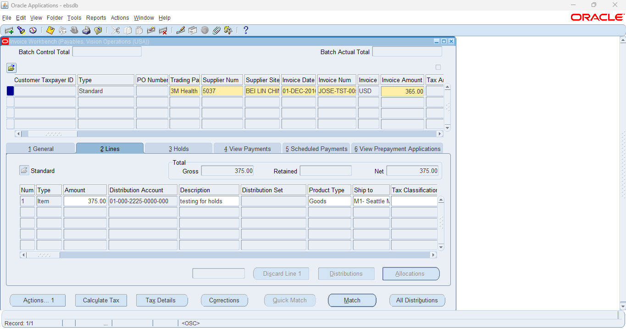// Select Actions, Check Validate, then Select OK. Once validated, check Holds.

// To release holds, change Line Amount to correct Invoice Amount.

// Select Actions, Check Validate, and then Select OK.

The holds have been released through this process.

1. **In the PAYMENT Work Bench query the payment Document # (the Payment which you have done for Standard Invoice.**

// Query an invoice that has a payment associated with it. Navigate to View Payments.

// Scroll right. Note Document Number.

// Query using Document Number that was noted.

1. **Review the Payment accounting details.**

// Open Tools, then select View Accounting Events.

**Cash Management:**

1. **Review the Bank account Details (Disbursement Bank) which you use for Payment.**

// Navigate to Cash Management Responsibility.

**

// Query the Bank Name.