GRIT-Scan: Risk tracker for STE and her various executives, Business Areas and LOBs.

Purpose:
To scan for risks in the environment, externally and internally later, that would impact STE’s business performance.

Philosophy: Replicate M365-Copilot Ontology-driven method
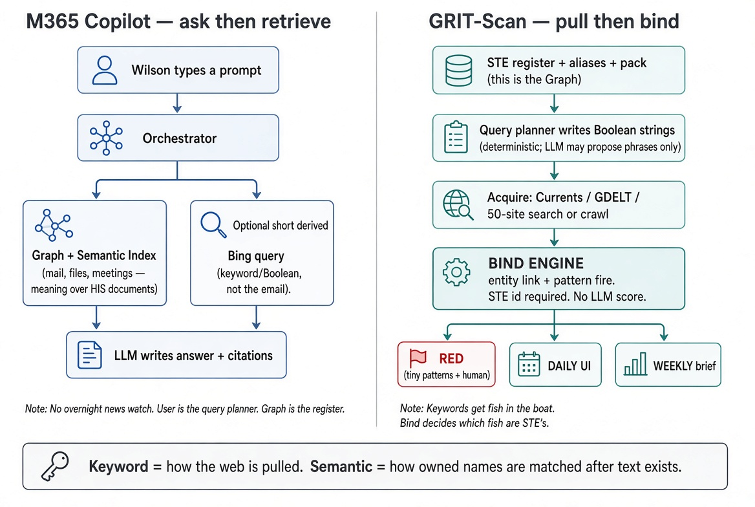

Structure:
Deterministic layer above six agents: (1) Supervisor (2) Researcher (3) Assessor (4) Critic (5) Profiler (Memory) (6) Reporter
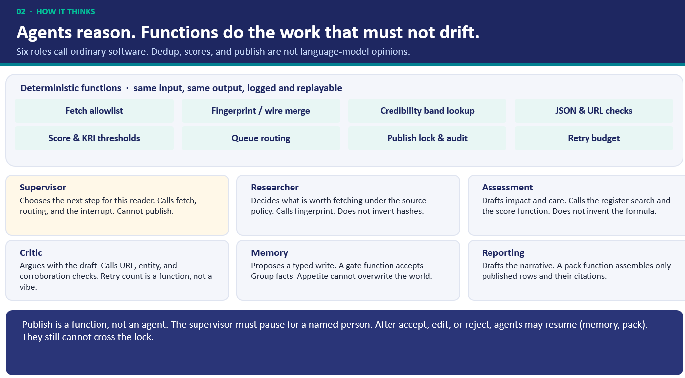

Interfaces:
- RED: Top urgent events e.g. pandemics, China invading Taiwan written in urgent emails to relevant executives such as CFO, R&A-Head, URS-TW head.
- Weekly brief: Weekly packs to various personnel in Office format e.g. Word report, PPT slides, Excel list
- Dashboard UI for usage by R&A personnel, and there should be a chat interface beneath it.
- Chat interface: Additional interface for user to ask questions, and also to key in Management Concerns, Topics, Trends, Keywords etc.
- Webapp to collectivize all of the above. Use Streamlit for POC now, later Next.js (React) + Tailwind + shadcn/ui for MVP (production stage).

Structure:
- Ontology, Loop-refinement of filtered signals, Scoring parameters for filering of signals to be reported. Semantics-embedder calls Gemini to vectorize the signals.
- Signals-pool in which signals are collected; database is Dataverse in Microsoft M365 GHQ R&A environment. Vectors stored in Dataverse also.
- User Profile e.g. R&A-Head (Wilson), URS-R&A-BP (Hwaimay), URS-Head (Gareth), URS-TW-Head (KS Yong) etc. which, other than a basic profile in script, would build up memory of signals approved or rejected by the user to remember his preferences and thus customize reports and dashboards accordingly.
- Impact_scorer, Harm_scorer, OpportunityCost for RED emails, but these scores would be tied to each signal in the pool.
- Risk tracking of signals: Condition-match, Exposure/Theme binding, Trend, Risk-level, Relevance for Weekly Reports, but these scores would be tied to each signal in the pool.
- BA profiles are done, and currently for Urban Solutions (URS) the profile is shared. In the file you would find the organizational structure, entities, customers, suppliers, competitors, keywords, news sources (primary, secondary, specific industry), annual risks, severity definition, likelihood definition, management focus).
- Sources for signal: Webcrawl through Brave-search, Currents, GDELT, Sphera.
- Risk items / themes are structured by groupwide (101 items), BA-wide (now it is only for URS), entity-wide (for URS-TW now), in ascending order of weightage, to be linked with Ontology and thus the signals as well.
- Query-plan turns Ontology and Risk themes into Search queries.
- Additional product: Signals approved by BA-Head are to be packaged and readied to be imported into AIRIS (AI Risk Intelligence System (AIRIS) - A single intelligent workspace unifying the full risk-management lifecycle for STE).

