WORKSHOP -2
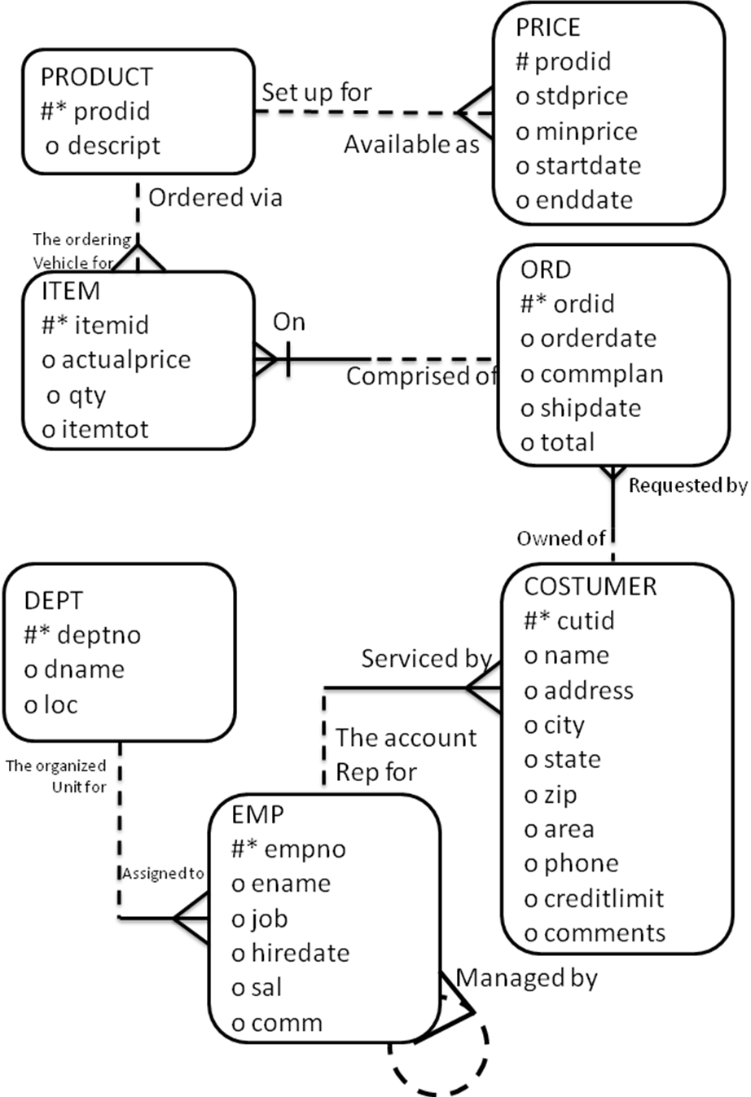
- Create user SALES with a password of oracle2008. Make sure that any objects and temporary segments created by SALES are not created in the system TABLESPACE. Also, ensure that SALES can log and create object.

- Create tables on the table instance charts below. Choose the appropriate data types and be sure to add integrity constraint. Download and run the scripts to create the tables, constraints and data.

- In this practice, create a program to add a new order into the ORD table.

- Create a stored procedure called ADD_ORDER to enter a new order into the ORD table. The procedure should accept two parameters. The first parameter holds a valid customer ID number. The second parameter holds a commission plan whose default value is null, You can generate the order ID by using the ORDID sequence. Use today's date to insert a value into the ORDERDATE column. Do not provide any values for SIDPDA TE and TOTAL columns.

- Invoke the procedure to place a new order for customer 108.

- Verify that a row was added and remember the new ORDID for use in the next exercise.

- In this practice, create a program that modifies the amount of a product ordered.

- Create a stored procedure called CHANGE_ITEM_QTY to change the quantity of a product for an order in the ITEM table.
The procedure should accept three arguments: an order number, a product number, and a quantity representing the new amount for the product. Include exception handling for the following two cases:

- Attempting to order a non-existent product number/order number combination.
- Attempting to update a row that is locked.

- Execute the procedure. You can use the following data:

Note: Your order ID number may differ from the value of 622 shown.

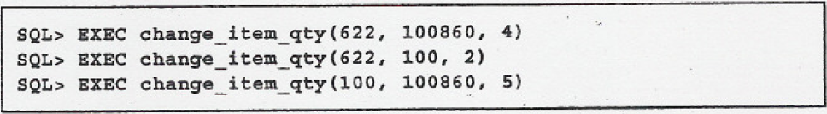

- In this practice, create a program to associate a price with a product in the PRICE table.

- Create a stored procedure called ADD_PRICE to add a price for a specific product in the PRICE table.
If a product already has one or more prices, update the PRICE table to ensure that the last price is terminated by changing the end date to yesterday's date. Then, insert a new row with the product number, the new standard price, the new minimum price, and a start date for the new price (use today's date). Pass three parameters to the procedure: the product number, a new standard price, and a new minimum price for the product. Add exception handling to account for an invalid product number in the PRODUCT table. Also provide an appropriate message that will be displayed if the row in the PRICE table is locked and cannot be changed.

- Execute the procedure. You can use the following data:

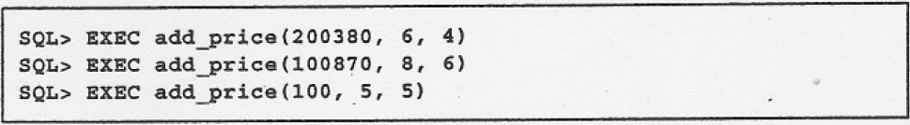

- In this practice, create a program to monitor if customers have exceeded their credit limits.

- Add a column to the CUSTOMER table by executing the following command:

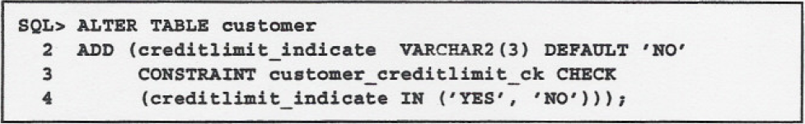

- Write a stored procedure called CHECK_CREDITLlMIT which checks each customer's credit limit from the CUSTOMER table against the total amount that this customer has ordered in the ORD table and updates the CREDITLIMIT_INDICA TE column in the CUSTOMER table when this customer has exceeded his credit limit.
Create a cursor to hold customer numbers and their credit limits. Find the total amount ordered for a customer from the ORD table. Compare the total amount ordered per customer to their credit limit and if the credit limit is less than the amount ordered, set the customer's CREDITLIMIT_INDICATE column to YES; otherwise, set it to NO. Add exception handling to account for a record being locked.

- Execute the procedure and test the results.

- Create a program to retrieve the amount of a line item.

- Create a stored function called GET_ITEM_TOTAL to retrieve the total amount for a specific line item.
The function should accept two parameters: the first parameter holds the order number, the second parameter holds a line number value. The function should return the item total for the given order number and line number. Add error handling to account for an invalid order number or item number.

- Invoke the function. You can use the following data:

Note: Your order ID number may differ from the value of 622 shown.

SQL > SELECT get_item_total(622,1), get_item_total(622,1),
get_item_total(622,1), get_item_total(62,1)
FROM DUAL;

- In this practice, create a program to retrieve the number of products ordered by a customer.

- Create a stored function called GET_PRODDCT_COUNT to retrieve the total number of different products that a customer has ordered.
The function should accept one parameter to hold the customer number. The function will return the total number of different products that a customer has ordered. Add exception handling to account for an invalid customer number and a customer with zero products ordered.

- Invoke the function. You can use the following data:

SQL > SELECT get_product_count(107), get_product_count(108),
get_product_count(10)
FROM DUAL;

