Class06

Brandon Jones

1/24/2020

## This is a level 2 heading

This is **regular** old *text*

and a list of stuff

plot(1:5, col="blue", type="o")

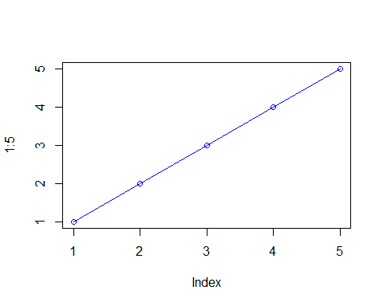

* a
* b
* b

let’s insert a code chunk with the shortcut option-cmd-i:

x<-c(1:10)  
x

## [1] 1 2 3 4 5 6 7 8 9 10

mean(x)

## [1] 5.5

##More on reading input files

We will use the read.table

x1<-read.csv("test1.txt")  
x2<-read.table("test2.txt", sep="$", header = TRUE)  
x3<-read.table("test3.txt", header=FALSE)

## Our First Function

This is an example function named add with input x and y

add<-function(x, y=1) {  
 ##gona add x to y becuz thats what we do  
 x+y  
}

let’s try using it

add(6,4)

## [1] 10

## Making a function and stuff

rescale<- function(x) {  
 rng<- range(x)  
 (x-rng[1])/(rng[2]-rng[1])  
}  
  
rescale( c(1:10))

## [1] 0.0000000 0.1111111 0.2222222 0.3333333 0.4444444 0.5555556 0.6666667  
## [8] 0.7777778 0.8888889 1.0000000

rescale( c(1:10,NA))

## [1] NA NA NA NA NA NA NA NA NA NA NA

x<- c(1:10, NA)  
rng<- range(x, na.rm=TRUE)  
rng

## [1] 1 10

rescale2<- function(x) {  
 rng<- range(x, na.rm=TRUE)  
 (x-rng[1])/(rng[2]-rng[1])  
}  
  
rescale2(x)

## [1] 0.0000000 0.1111111 0.2222222 0.3333333 0.4444444 0.5555556 0.6666667  
## [8] 0.7777778 0.8888889 1.0000000 NA

## some more function

rescale3 <- function(x, na.rm=TRUE, plot=FALSE) {  
 if(na.rm) {  
 rng <-range(x, na.rm=TRUE)  
 } else {  
 rng <-range(x)  
 }  
 print("Hello")  
 answer <- (x - rng[1]) / (rng[2] - rng[1])  
 print(answer)  
 print("is it me you are looking for?")  
 if(plot) {  
 print("Please don't sing again")  
 plot(answer, typ="b", lwd=4)  
 }  
 print("I can see it in ...")  
}  
  
  
  
rescale3(x,plot=TRUE)

## [1] "Hello"  
## [1] 0.0000000 0.1111111 0.2222222 0.3333333 0.4444444 0.5555556 0.6666667  
## [8] 0.7777778 0.8888889 1.0000000 NA  
## [1] "is it me you are looking for?"  
## [1] "Please don't sing again"

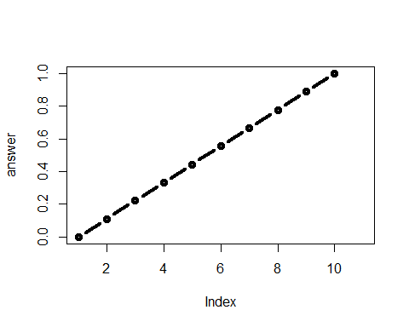

## [1] "I can see it in ..."

## This is a level 3 MArkdwon

This is an R Markdown document. Markdown is a simple formatting syntax for authoring HTML, PDF, and MS Word documents. For more details on using R Markdown see <http://rmarkdown.rstudio.com>.

When you click the **Knit** button a document will be generated that includes both content as well as the output of any embedded R code chunks within the document. You can embed an R code chunk like this:

summary(cars)

## speed dist   
## Min. : 4.0 Min. : 2.00   
## 1st Qu.:12.0 1st Qu.: 26.00   
## Median :15.0 Median : 36.00   
## Mean :15.4 Mean : 42.98   
## 3rd Qu.:19.0 3rd Qu.: 56.00   
## Max. :25.0 Max. :120.00

## Including Plots

You can also embed plots, for example:



Note that the echo = FALSE parameter was added to the code chunk to prevent printing of the R code that generated the plot.