|  |  |  |
| --- | --- | --- |
| **INPUT** | **PROCESS** | **OUTPUT** |
| -Contact Informations  (From DBTC Programs) | -Add New Contact Info  -Delete Existing Contact info  -Change Contact Info of Existing Contact  -Retry When Given the Wrong Command  -Exits When The User Input a Certain Code  -Display Selected Contact Info  -Display Changed Contact Info  -Display Added New Contact Info | -User’s Demanded Contact Information  (From DBTC Programs) |

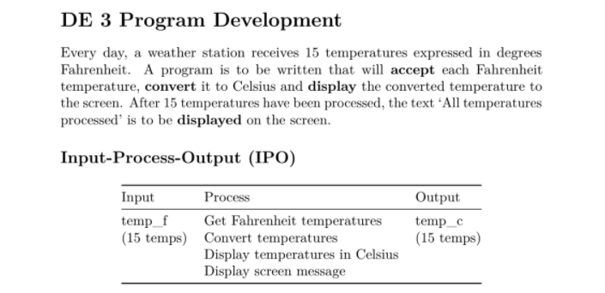**BASIS**