

**JOSEPH DEBRAH (2316178)**

**CMM531 DATAWAREHOUSING COURSEWORK**

TribalTastes

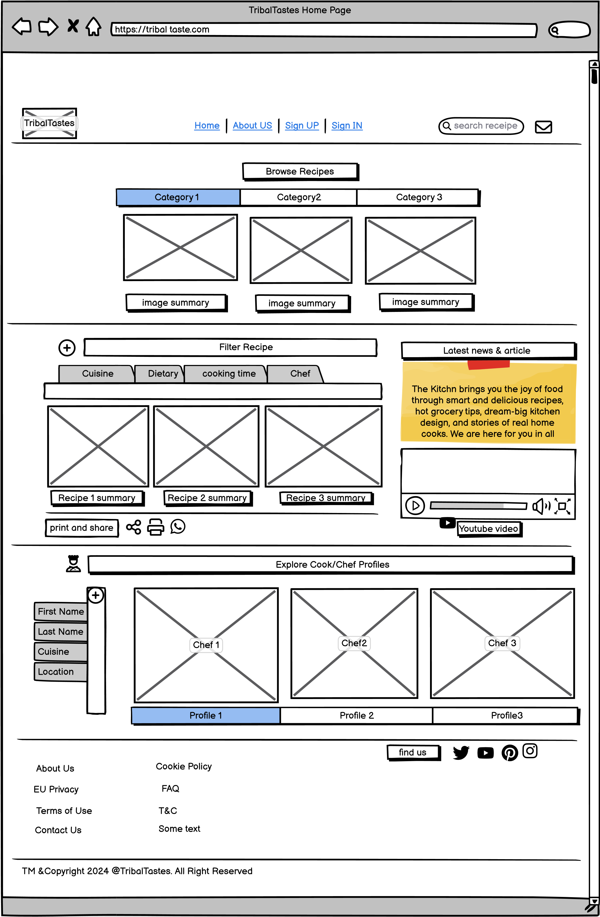

I want to design a food blog website, it has at least 2 types of users: Recipe seekers and a Cook or Chef. Recipe seekers are the applications basic user and can view Recipes, while Cook or chef can also upload and publish information about their chosen food or recipe. List all the possible functionalities to have on the website.

Recipe Seekers:

* **User Authentication**-Allow users to register, log in, and manage their accounts.
* **Browse Recipes**: Categorized recipes (e.g., by course, cuisine, occasion) with clear visuals and summaries.
* **Filter Recipes**: Allow users to filter recipes based on categories such as cuisine type, dietary restrictions, cooking time, etc.
* **View Recipe Details**: Users can view detailed information about each recipe, including ingredients, cooking instructions, serving size, nutritional information, and user ratings/reviews.
* **Save Favorite Recipes**: Provide an option for users to save their favorite recipes for future reference.
* **Shopping List Generator**-Automatically generate shopping lists based on selected recipes.
* **Print & Share-Option** to print recipes and share them on social media platforms
* **User Ratings & Reviews-Enable** users to rate and review recipes based on their cooking.
* **Explore Cook/Chef Profiles**: Users can view profiles of cooks/chefs to learn more about them and their culinary expertise.

For Cooks/Chefs:

* **User Authentication:** Allow cooks/chefs to register, log in, and manage their accounts.
* **Upload Recipes**: Provide a platform for cooks/chefs to upload their own recipes, including images, ingredients, cooking instructions, and additional notes.
* **Manage Profile**: Allow cooks/chefs to edit their profiles, including adding a profile picture, bio, contact information, and links to their social media accounts.
* Live Streaming & Video Tutorials: Allow cooks to host live cooking sessions or share pre-recorded video tutorials.

Additional functionalities

* **Social Media Integration:** Connect with social media platforms for broader reach and engagement.
* **Contact & Support:** Provide clear contact information and support channels for users.

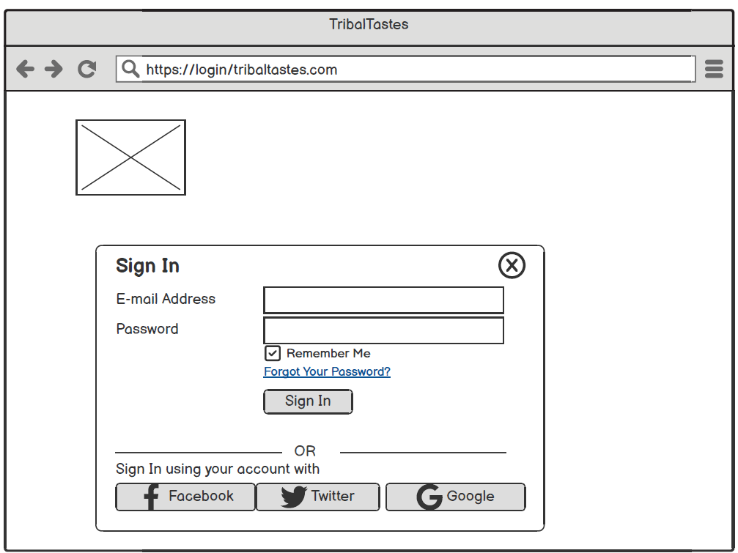

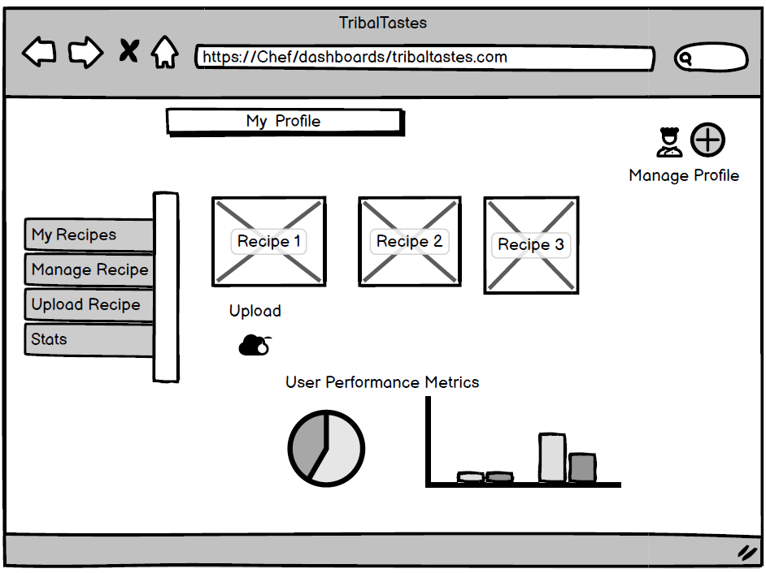

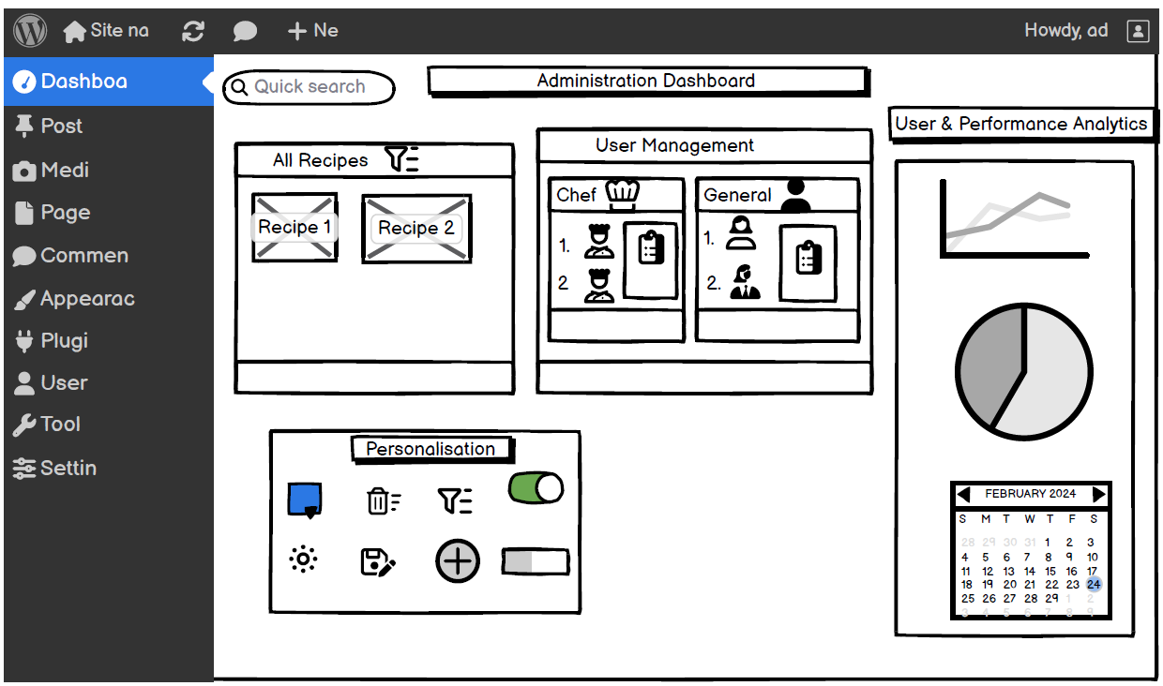

Administrator Panel

- System Information

- Number of Recipes

- Number of Chefs

- Manage Users

- Edit User Roles

- Delete Users

- Manage Recipes

- View All Recipes

- Edit Recipes

- Delete Recipes