CDK4/6 inhibitors and endocrine therapy in the treatment of metastatic cancer: A real-world and Propensity Score-Adjusted comparison

João Coutinho-Almeida

Ana Sofia Silva

Patricia Redondo

Ana Ferreira

Pedro Pereira Rodrigues

# Introduction

Currently, metastatic breast cancer is difficult to treat. Patients with Hormone Receptor-positive (HR+) and Human Epidermal Growth Factor Receptor 2-negative (HER2-) breast cancer, the most common subtype, typically undergo endocrine therapy. Therefore, new treatments can be very useful in improving quality of life, reducing toxicity, and decreasing scenarios of hormonal resistance. Medications from the group of cyclin-dependent kinase inhibitors appear as a potential improvement in the therapeutic approach to advanced breast cancer. Within this group, there are palbociclib, ribociclib and abemaciclib. Cyclin-dependent kinases 4 and 6 $($ CDK4/6 $)$ are responsible for regulating the cell cycle at the transition between the G1 and S phases. In many neoplasms, this cycle is deregulated, and it promotes uncontrolled cell proliferation. It is then possible for these medications to have better effectiveness. These medications were approved by INFARMED, I.P. after an analysis of the therapeutic value they offer. This decision was made based on data provided by clinical trials done with these medications. The MONALEESA (Hortobagyi et al. 2018; Slamon et al. 2018; Tripathy et al. 2018) studies were used for ribociclib, PALOMA (Verma et al. 2016; Rugo et al. 2018; Finn et al. 2015) for palbociclib, and MONARCH (Goetz et al. 2017; Sledge et al. 2017) for abemaciclib. These studies focused on testing the hypothesis of treating CDK4/6 inhibitors in combination with an aromatase inhibitor or fulvestrant as an alternative to the gold standard. In these research findings, it was determined that there was a notable enhancement in effectiveness, supporting their application in clinical practice. However, this evaluation was based on clinical trials with very specific inclusion and exclusion criteria and in a highly controlled environment. It is then vital to study how these new molecules compare to current practice in terms of treatment effectiveness in a real-world setting. In the meticulously controlled setting of clinical trials, patient selection often skews towards relatively healthier individuals with fewer comorbidities. However, in real-world clinical practice, patients present a diverse range of health profiles, co-existing illnesses, and medication histories that may influence drug efficacy and safety. Real-world data, drawn from electronic health records, insurance claims databases, and patient registries, offers the advantage of reflecting a more heterogeneous patient population, thus potentially uncovering insights not readily apparent in clinical trial settings. Understanding the effectiveness and safety of CDK4/6 inhibitors in real-world conditions is crucial for tailoring more individualized treatment regimens, optimizing outcomes, and enhancing the quality of life for patients with HR+, HER2- breast cancer (Harbeck et al. 2021). Nevertheless, observational studies have inherent limitations, such as confounding by indication, which can lead to biased estimates of treatment effects. To tackle this, there are causality-based assessments that can be employed in order to better estimate the causal effects of treatments. Incorporating statistical techniques like Inverse Probability of Treatment Weighting (IPTW) can play an essential role in enhancing the quality of real-world evidence by accounting for treatment selection bias and balancing observed covariates between treatment groups. IPTW, grounded in the framework of causal inference, allows for the mimicking of a randomized control trial-like setting within observational studies. By assigning weights to individual patients based on their propensity scores—the likelihood of receiving a particular treatment given a set of observed characteristics—analyses can achieve a balance between different treatment arms, thereby reducing bias and confounding factors. Establishing causality, rather than mere association, is vital for the robust interpretation of real-world data. As we strive to understand the long-term impact, efficacy, and safety of CDK4/6 inhibitors in HR+, HER2- breast cancer, the rigorous application of IPTW and causal inference methods can substantially augment the validity of real-world findings, making them a more reliable basis for clinical decision-making (Peter C. Austin 2011; Peter C. Austin 2014) So in this paper, we propose:

* To compare the effectiveness of the CDK4/6 inhibitors drug class in terms of progression-free survival $($ PFS $)$ and overall survival $($ OS $)$;
* Asess the Hazard Ratio of using the CDK4/6 inhibitors drug class in terms of PFS and OS.
* To compare the effectiveness of CDK4/6 inhibitors in combination with an aromatase inhibitor or fulvestrant with the current standard of care in terms of PFS and OS in patients with HR+, HER2- advanced breast cancer.
* assess the differences in effectiveness between the three CDK4/6 inhibitors in combination with an aromatase inhibitor or fulvestrant in terms of PFS and OS with causality principles in mind, especially the counterfactual theory and IPTW ;

# Materials and Methods

## Study Design

This retrospective study was designed in 2022. The study aimed to evaluate the clinical benefit and long-term survival of patients with HR+/HER2 $−$ that started treatment with CDK46 inhibitors plus endocrine therapy in different lines of treatment between the 14th of March 2017 and the 31st of December 2021. The follow-up period was set until June 2022. Inclusion criteria: women and men, Hormone receptor-positive and HER2 negative in the primary tumor or metastatic site after biopsy. Exclusion criteria: Patients that had only ambulatory medication, and patients involved in clinical trials, diagnosed with other neoplasms or with active treatment during the study period. The comparison group was defined by a population of patients, that were treated with hormone therapy as first-line (due to bone metastases) between 2015 and 13 of match 2017.

The evaluation of effectiveness will involve overall survival and progression-free analysis. We will compare the three different cyclin-dependent kinase inhibitors in terms of efficacy in real-world patients and will also compare the effectiveness of this class of drug against traditional endocrine therapy.

## Data collection

All data were collected from original medical records from baseline to last visit or death. The data was collected from Instituto Português de Oncologia – Porto (IPO-P). Table 1 shows a comparison between the groups.

Data included for population treated with CDK46 inhibitors plus endocrine therapy: demographic information, age at first diagnosis and age at the beginning of treatment, clinical characteristics and performance status by Eastern Cooperative Oncology Group scale (ECOG), treatment line and treatment schema - CDK46 inhibitor and endocrine therapy, stage of cancer, site of metastases (bone, soft tissue, visceral, central nervous system-CNS with or without another site).

Data included for the population treated with endocrine therapy as first-line: demographic information, age at first diagnosis and age at the beginning of treatment, clinical characteristics and performance status by Eastern Cooperative Oncology Group scale (ECOG), stage of the cancer.

For comparison purposes, we used palbociclib and ribociclib since we had a small number of patients treated with abemaciclib (12).

Descriptive statistics of cyclin-dependent kinase inhibitors group and endocrine therapy group. The Drug/combination refers to the actual drug or the combination for CDK4/6

|  | ET | Palbociclib | Ribociclib |
| --- | --- | --- | --- |
|  | (N=44) | (N=246) | (N=106) |
|  |  |  |  |
| Mean (SD) | 59.7 (12.7) | 59.2 (11.7) | 58.2 (10.7) |
| Median [Min, Max] | 61.5 [34.0, 85.0] | 60.0 [28.0, 84.0] | 58.0 [32.0, 79.0] |
|  |  |  |  |
| Post-menopause | 36 (82 %) | 201 (82 %) | 83 (78 %) |
| Pre-menopause | 8 (18 %) | 41 (17 %) | 21 (20 %) |
| Peri-menopause | NA | 1 (0 %) | NA |
| Missing | 0 (0%) | 3 (1.2%) | 2 (1.9%) |
|  |  |  |  |
| No | NA | 161 (65 %) | 74 (70 %) |
| Yes | NA | 85 (35 %) | 32 (30 %) |
| Missing | 44 (100%) | 0 (0%) | 0 (0%) |
|  |  |  |  |
| No | NA | 121 (49 %) | 49 (46 %) |
| Yes | NA | 125 (51 %) | 57 (54 %) |
| Missing | 44 (100%) | 0 (0%) | 0 (0%) |
|  |  |  |  |
| I | 3 (7 %) | 22 (9 %) | 7 (7 %) |
| II | 21 (48 %) | 75 (30 %) | 22 (21 %) |
| III | 11 (25 %) | 74 (30 %) | 18 (17 %) |
| IV | 2 (5 %) | 65 (26 %) | 46 (43 %) |
| Missing | 7 (15.9%) | 10 (4.1%) | 13 (12.3%) |
|  |  |  |  |
| Anastrozol | 3 (7 %) | NA | NA |
| Exemestane | 4 (9 %) | NA | NA |
| Fulvestrant | 5 (11 %) | 180 (73 %) | 10 (9 %) |
| Letrozol | 32 (73 %) | 66 (27 %) | 96 (91 %) |

## Statistical Analysis

R was used for statistical analysis. Demographic, clinical characteristics and side effects were analyzed using descriptive statistics (count, percentages, and median/range). Kaplan–Meier test was used to determine the median PFS and OS in the entire population and subgroups. Log-rank test was used for comparisons of PFS and OS among different subgroups. Cox Regression was used to assess feature importance and impact. All statistical tests were two-sided, and the significance level was 0.05. The evaluation of the proportional hazards assumptions was done by Schoenfeld residues analysis. We applied propensity score weights to achieve a more robust comparison between the two groups of CDK46i. We used the existence of visceral metastases, menopausal status, combination, treatment line, age at treatment start, ECOG, and stage. Likewise, we used the WeightIt package for R (Greifer 2023). Furthermore, we applied the weights to get the ATE which is $E\left[Y_{i}\left(1\right)−Y_{i}\left(0\right)\right]$, the average effect of moving an entire population from untreated to treated, or from one drug to the other. Weights were used instead of matching since it is more suited for calculating ATE and the need to preserve the sample size since it is already small from the start. The formula for calculating the weights was through propensity score weighting with GLM. Multiple comparisons were done with the Benjamini-Hochberg (BH) method.

# Results

The median OS in the entire population treated with CDK4/6 inhibitors was 46 months (95%CI 39.4–55.6). Median PFS was 20.1 months (95%CI 18.3–24.2). Following this, we compared Palbociclib and riboclib as first-line treatments. We found that regarding OS, there is no significant difference between the two, but ribociclib is significantly better in terms of PFS (p-value $≤$ 0.001) (figure 1). Additionally, we compared the same CDK4/6 inhibitors with letrozol as a combination only. Regarding this scenario, we found out that both were similar in terms of OS and PFS.

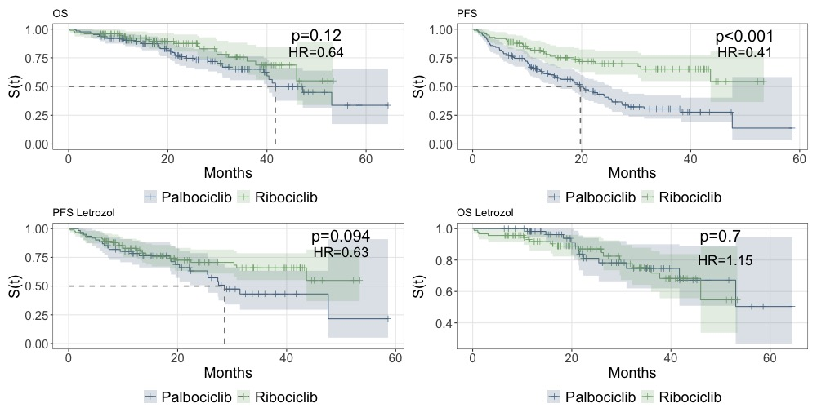

Survival curves for Palbociclib and Ribociclib (1st line) - Progression Free Survival and Overall Survival

We then compared both with a cox regression, where OS shows no significant difference between palbociclib and ribociclib but a significantly better PFS for ribociclib (figure [tab:cox]) HR 0.60 [95%CI 0.36-0.97] when adjusted to the stage, visceral metastases, age, treatment line, combination and ECOG. This data implies that ribociclib reduces the risk of the disease progression by 40% compared to palbociclib when adjusted for the variables mentioned. The proportional hazards assumption was confirmed with p values all over 0.10.

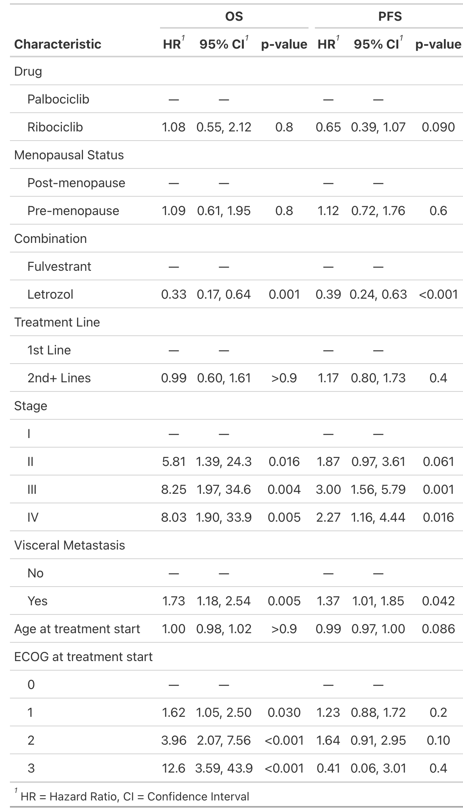

When comparing endocrine therapy with CDK4/6 inhibitors as first-line treatment (figure 2), we see that only Ribociclib is significantly better in terms of PFS and OS (p-value $≤$ 0.001). When comparing palbociclib as the first line, we see that there is no significant difference in terms of PFS and OS (p=0.6 and 0.47). We also applied the same analysis as above, comparing only the letrozol combination with letrozol alone. We found that both ribociclib and palbociclib are significantly better in terms of PFS (HR 0.51 for palbociclib and 0.28 for ribociclib).

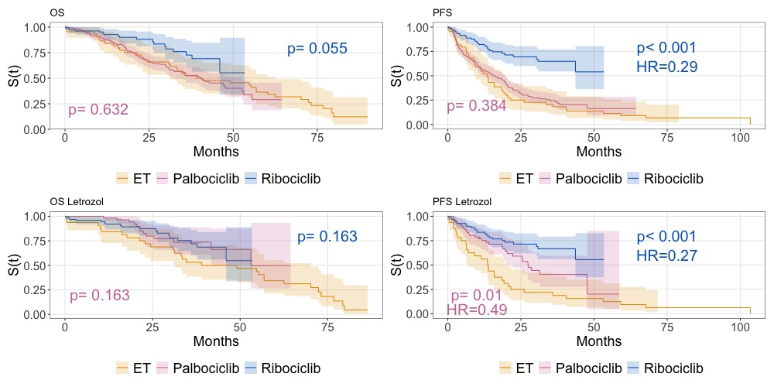

Survival curves (OS and PFS) comparing endocrine therapy (ET) to CDK4/6 inhibitors as 1st line. p values shown as pairwise vs. ET.

When comparing palbociclib and ribociclib adjusted for ATE weights, we found a different scenario from previous assessments. There is a significant difference between the two in terms of OS and PFS (figure 3). The weights were calculated as stated in the methods section.

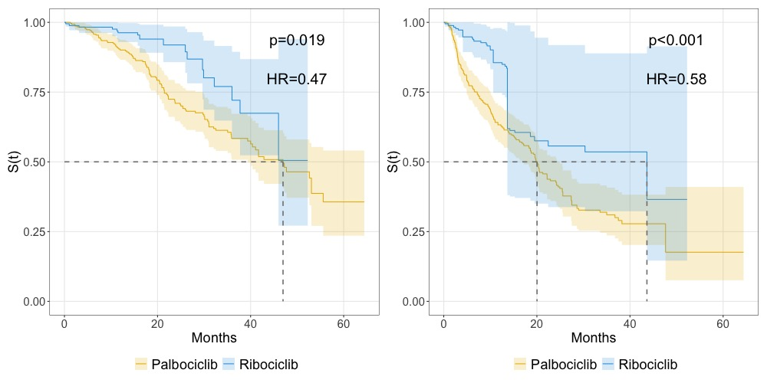

Comparison of palbociclib and ribociclib survival curves adjusted for propensity scores

The Cox regression adjusted for the variables and with the weights applied to render an HR=0.55 [95% CI 0.28-1.09;p=0.085] for OS. The HR for PFS is 0.56 [95% CI 0.32-1;p=0.05].

# Discussion

This study aimed to evaluate the real-world use of palbociclib and ribociclib in combination with ET for HR+/HER2 $−$ and compare this drug class with traditional endocrine therapy. Few real-world evidence studies of palbociclib and ribociclib used in daily clinical practice have been published identifying clinical benefits, patient profiles, and sequencing of treatment, with even less evidence for the Portuguese population.

When comparing with clinical trials, regarding patient profile, in our study, 51% had visceral metastasis and 35% had bone-only metastases compared with 49% and 38% in PALOMA-2, and 60% and 25% in PALOMA-3, respectively (Rugo et al. 2018; Cristofanilli et al. 2016). As for ribociclib and bone-only metastases, MONALEESA-7 (Tripathy et al. 2018) has 24% and MONALEESA-2 has 40% (Hortobagyi et al. 2018) and our study has 30%. Regarding menopausal status, our study has 20% premenopausal and 80% postmenopausal. The trials were conducted with postmenopausal women only.

Of note, the range of median PFS for first-line palbociclib was 15.5–25.5 months, which is shorter than 27.6 months observed in a post hoc analysis of the PALOMA-2 clinical trial with extended follow-up (Rugo et al. 2018), but in line with RWE studies (13.3–20.2 months) (Harbeck et al. 2021). When assessed with only letrozol as a combination, the median PFS increased to 28.6 months [95% CI 25.5-not reached]. Additionally, analyzing the postmenopausal women subgroup, palbociclib showed a median PFS of 16.3 months [95% CI 12.9 -20]. Furthering analysis of the postmenopausal and with letrozol, the median was 47.6 months [95% 25.6-2–not reached].

As for ribociclib, median survival time was not reached whether in OS and PFS. So we can at least say that the median PFS is longer than 50 months. This is longer than the median progression-free survival of 23.8 months (95% CI 19.2–not reached) reported in the MONALEESA-7 trial (Tripathy et al. 2018) and longer than 25.3 months (95% CI 23.0–30.3) in the MONALEESA-2 trial (Hortobagyi et al. 2018). Regarding the subgroup analysis of postmenopausal women and postmenopausal women treated ribociclib in combination with letrozol, the median was not reached.

When directly comparing ribociclib and palbociclib without any adjustments, one might deduce that ribociclib is superior to palbociclib. However, after adjusting for confounding variables, there is no significant difference between the two inhibitors in terms of Progression-Free Survival (PFS) or Overall Survival (OS) as indicated in [tab:cox]. This observation is further corroborated by the lower plots in 1, where even a subgroup analysis of CDK4/6i combined solely with letrozole reveals a trend towards nonsignificance.

In the first-line comparison between Endocrine Therapy (ET) and CDK4/6 inhibitors (CDK4/6i), there is no significant impact on Overall Survival (OS) by either treatment, whether the CDK4/6i is combined with both agents or solely with letrozole. With respect to Progression-Free Survival (PFS), ribociclib demonstrates superior efficacy in both combination therapies (HR=0.29) as well as when paired only with letrozole (HR=0.28). Additionally, palbociclib exhibits significant improvement in PFS when combined with letrozole (HR=0.50).

When comparing with propensity scores weighting, we found out that ribociclib is significantly better than palbociclib for PFS and OS, providing a median OS of over 40 months and median PFS of around 42 months. Adjusted for the weighted variables, Ribociclib is no longer significantly better for OS and has a p-value of exactly 0.05 for PFS. This is in line with the results of the Cox regression analysis.

# Conclusions

In conclusion, our findings underscore the efficacy of CDK4/6 inhibitors in real-world settings. While we cannot definitively assert that palbociclib surpasses endocrine therapy in terms of Overall Survival—a facet not extensively explored in prominent clinical trials—we can confidently affirm the impact of CDK4/6i on Progression-Free Survival. This assertion aligns with clinical trial outcomes and real-world data further substantiates these findings.

Delving deeper into the characteristics of the patient population, including safety profiles, economic implications, and quality of life metrics, would be insightful. Additionally, a thorough examination of biomarkers within the population could offer invaluable insights. We intend to explore these facets in subsequent publications.

It’s imperative to note that our data is sourced from a singular institution, limiting the generalizability of our results to a broader population. Nonetheless, we posit that this study lays a foundational groundwork for future research in this domain. While our evidence is rooted in observational data and we’ve made adjustments for known confounders, the potential for residual confounding remains. Although the use of propensity score matching enhances the comparative robustness between the groups, the presence of unmeasured confounders cannot be entirely ruled out. Furthermore, the small sample size of our study limits the statistical power of our findings. We hope that our study will serve as a springboard for future research in this domain, and we look forward to furthering our research in this area.

# Declarations

## Authors’ contributions

J.A., A.S., P.R. and A.F. conceived the idea; P.R. contributed to the experimental design and was in charge of overall direction and planning; All authors contributed to discussion and data analysis; J.A. wrote the main manuscript; All authors read and agreed to the published version of the manuscript.

## Availability of data and materials

The data is not publicly available due to privacy or ethical restrictions. The code is available at .

## Acknowledgements

...

## Ethics approval and consent to participate

This project was approved by the hospital ethics committee and privacy officers with the reference number CES 193/022. The need for informed consent was waived by the ethics committee.

## Funding

Not applicable

## Competing interests

Not applicable

# Figure

# Table

# Supplementary Material

Austin, Peter C. 2014. “The Use of Propensity Score Methods with Survival or Time-to-Event Outcomes: Reporting Measures of Effect Similar to Those Used in Randomized Experiments.” *Statistics in Medicine* 33 (7): 1242–58. <https://doi.org/10.1002/sim.5984>.

Austin, Peter C. 2011. “An Introduction to Propensity Score Methods for Reducing the Effects of Confounding in Observational Studies.” *Multivariate Behavioral Research* 46 (3): 399–424. <https://doi.org/10.1080/00273171.2011.568786>.

Cristofanilli, Massimo, Nicholas C. Turner, Igor Bondarenko, Jungsil Ro, Seock-Ah Im, Norikazu Masuda, Marco Colleoni, et al. 2016. “Fulvestrant Plus Palbociclib Versus Fulvestrant Plus Placebo for Treatment of Hormone-Receptor-Positive, HER2-negative Metastatic Breast Cancer That Progressed on Previous Endocrine Therapy (PALOMA-3): Final Analysis of the Multicentre, Double-Blind, Phase 3 Randomised Controlled Trial.” *The Lancet. Oncology* 17 (4): 425–39. <https://doi.org/10.1016/S1470-2045(15)00613-0>.

Finn, Richard S, John P Crown, Istvan Lang, Katalin Boer, Igor M Bondarenko, Sergey O Kulyk, Johannes Ettl, et al. 2015. “The Cyclin-Dependent Kinase 4/6 Inhibitor Palbociclib in Combination with Letrozole Versus Letrozole Alone as First-Line Treatment of Oestrogen Receptor-Positive, HER2-negative, Advanced Breast Cancer (PALOMA-1/TRIO-18): A Randomised Phase 2 Study.” *The Lancet Oncology* 16 (1): 25–35. <https://doi.org/10.1016/S1470-2045(14)71159-3>.

Goetz, Matthew P., Masakazu Toi, Mario Campone, Joohyuk Sohn, Shani Paluch-Shimon, Jens Huober, In Hae Park, et al. 2017. “MONARCH 3: Abemaciclib As Initial Therapy for Advanced Breast Cancer.” *Journal of Clinical Oncology: Official Journal of the American Society of Clinical Oncology* 35 (32): 3638–46. <https://doi.org/10.1200/JCO.2017.75.6155>.

Greifer, Noah. 2023. *WeightIt: Weighting for Covariate Balance in Observational Studies*.

Harbeck, Nadia, Meaghan Bartlett, Dean Spurden, Becky Hooper, Lin Zhan, Emily Rosta, Chris Cameron, Debanjali Mitra, and Anna Zhou. 2021. “CDK4/6 Inhibitors in HR+/HER2- Advanced/Metastatic Breast Cancer: A Systematic Literature Review of Real-World Evidence Studies.” *Future Oncology* 17 (16): 2107–22. <https://doi.org/10.2217/fon-2020-1264>.

Hortobagyi, G., S. Stemmer, H. Burris, Y. Yap, G. Sonke, S. Paluch-Shimon, M. Campone, et al. 2018. “Updated Results from MONALEESA-2, a Phase III Trial of First-Line Ribociclib Plus Letrozole Versus Placebo Plus Letrozole in Hormone Receptor-Positive, HER2-negative Advanced Breast Cancer.” *Annals of Oncology : Official Journal of the European Society for Medical Oncology*. <https://doi.org/10.1093/annonc/mdy155>.

Rugo, H. S., V. Diéras, K. A. Gelmon, R. S. Finn, D. J. Slamon, M. Martin, P. Neven, et al. 2018. “Impact of Palbociclib Plus Letrozole on Patient-Reported Health-Related Quality of Life: Results from the PALOMA-2 Trial.” *Annals of Oncology: Official Journal of the European Society for Medical Oncology* 29 (4): 888–94. <https://doi.org/10.1093/annonc/mdy012>.

Slamon, Dennis J., Patrick Neven, Stephen Chia, Peter A. Fasching, Michelino De Laurentiis, Seock-Ah Im, Katarina Petrakova, et al. 2018. “Phase III Randomized Study of Ribociclib and Fulvestrant in Hormone Receptor-Positive, Human Epidermal Growth Factor Receptor 2-Negative Advanced Breast Cancer: MONALEESA-3.” *Journal of Clinical Oncology: Official Journal of the American Society of Clinical Oncology* 36 (24): 2465–72. <https://doi.org/10.1200/JCO.2018.78.9909>.

Sledge, George W., Masakazu Toi, Patrick Neven, Joohyuk Sohn, Kenichi Inoue, Xavier Pivot, Olga Burdaeva, et al. 2017. “MONARCH 2: Abemaciclib in Combination With Fulvestrant in Women With HR+/HER2- Advanced Breast Cancer Who Had Progressed While Receiving Endocrine Therapy.” *Journal of Clinical Oncology: Official Journal of the American Society of Clinical Oncology* 35 (25): 2875–84. <https://doi.org/10.1200/JCO.2017.73.7585>.

Tripathy, Debu, Seock-Ah Im, Marco Colleoni, Fabio Franke, Aditya Bardia, Nadia Harbeck, Sara A. Hurvitz, et al. 2018. “Ribociclib Plus Endocrine Therapy for Premenopausal Women with Hormone-Receptor-Positive, Advanced Breast Cancer (MONALEESA-7): A Randomised Phase 3 Trial.” *The Lancet. Oncology* 19 (7): 904–15. <https://doi.org/10.1016/S1470-2045(18)30292-4>.

Verma, Sunil, Cynthia Huang Bartlett, Patrick Schnell, Angela M. DeMichele, Sherene Loi, Jungsil Ro, Marco Colleoni, et al. 2016. “Palbociclib in Combination With Fulvestrant in Women With Hormone Receptor-Positive/HER2-Negative Advanced Metastatic Breast Cancer: Detailed Safety Analysis From a Multicenter, Randomized, Placebo-Controlled, Phase III Study (PALOMA-3).” *The Oncologist* 21 (10): 1165–75. <https://doi.org/10.1634/theoncologist.2016-0097>.