Comparative Analysis of Palbociclib and Ribociclib: A real world data and Propensity Score-Adjusted Evaluation with endocrine therapy"

Author One

Author Two

Author Three

Author Four

# Introduction

Currently, metastatic breast cancer is difficult to treat. Patients with Hormone Receptor-positive (HR+) and Human Epidermal Growth Factor Receptor 2-negative (HER2-) breast cancer, the most common subtype, typically undergo endocrine therapy. Therefore, new treatments can be very useful in improving quality of life, reducing toxicity, and decreasing scenarios of hormonal resistance. Medications from the group of cyclin-dependent kinase inhibitors appear as a potential improvement in the therapeutic approach to advanced breast cancer. Within this group, there are palbociclib, ribociclib and abemaciclib. Cyclin-dependent kinases 4 and 6 CDK4/6 are responsible for regulating the cell cycle at the transition between the G1 and S phases. In many neoplasms, this cycle is deregulated, and it promotes uncontrolled cell proliferation. It is then possible for these medications to have better effectiveness. These medications were approved by INFARMED, I.P. after an analysis of the therapeutic value they offer. This decision was made based on data provided by clinical trials done with these medications. The MONALEESA (Hortobagyi et al. 2018; Slamon et al. 2018; Tripathy et al. 2018) studies were used for ribociclib, PALOMA (Verma et al. 2016; Rugo et al. 2018; Finn et al. 2015) for palbociclib, and MONARCH (Goetz et al. 2017; Sledge et al. 2017) for abemaciclib. These studies focused on testing the hypothesis of treating CDK4/6 inhibitors in combination with an aromatase inhibitor or fulvestrant as an alternative to the gold standard. In these research findings, it was determined that there was a notable enhancement in effectiveness, supporting their application in clinical practice. However, this evaluation was based on clinical trials with very specific inclusion and exclusion criteria and in a highly controlled environment. It is then vital to study how these new molecules compare to current practice in terms of treatment effectiveness in a real-world setting. In the meticulously controlled setting of clinical trials, patient selection often skews towards relatively healthier individuals with fewer comorbidities. However, in real-world clinical practice, patients present a diverse range of health profiles, co-existing illnesses, and medication histories that may influence drug efficacy and safety. Real-world data, drawn from electronic health records, insurance claims databases, and patient registries, offers the advantage of reflecting a more heterogeneous patient population, thus potentially uncovering insights not readily apparent in clinical trial settings. Understanding the effectiveness and safety of CDK4/6 inhibitors in real-world conditions is crucial for tailoring more individualized treatment regimens, optimizing outcomes, and enhancing quality of life for patients with HR+, HER2- breast cancer (Harbeck et al. 2021). Nevertheless, observational studies have inherent limitations, such as confounding by indication, which can lead to biased estimates of treatment effects. To tackle this, there are causality-based assessments that can be employed in order to better estimate the causal effects of treatments. Incorporating statistical techniques like Inverse Probability of Treatment Weighting (IPTW) can play an essential role in enhancing the quality of real-world evidence by accounting for treatment selection bias and balancing observed covariates between treatment groups. IPTW, grounded in the framework of causal inference, allows for the mimicking of a randomized control trial-like setting within observational studies. By assigning weights to individual patients based on their propensity scores—the likelihood of receiving a particular treatment given a set of observed characteristics—analyses can achieve balance between different treatment arms, thereby reducing bias and confounding factors. Establishing causality, rather than mere association, is vital for the robust interpretation of real-world data. As we strive to understand the long-term impact, efficacy, and safety of CDK4/6 inhibitors in HR+, HER2- breast cancer, the rigorous application of IPTW and causal inference methods can substantially augment the validity of real-world findings, making them a more reliable basis for clinical decision-making (Peter C. Austin 2011; Peter C. Austin 2014) So in this paper, we propose:

* To compare the effectiveness of the CDK4/6 inhibitors drug class in terms of progression-free survival PFS and overall survival OS;
* Asess the Hazard Ratio of using the CDK4/6 inhibitors drug class in terms of PFS and OS.
* To compare the effectiveness of CDK4/6 inhibitors in combination with an aromatase inhibitor or fulvestrant with the current standard of care in terms of PFS and OS in patients with HR+, HER2- advanced breast cancer.
* assess the differences in effectiveness between the three CDK4/6 inhibitors in combination with an aromatase inhibitor or fulvestrant in terms of PFS and OS with causality principles in mind, especially the counterfactual theory and IPTW ;

# Materials and Methods

## Study Design

This retrospective study was designed in 2022. The aim of the study was to evaluate the clinical benefit and long-term survival of patients with HR+/HER2 that started treatment with CDK46 inhibitors plus endocrine therapy in different lines of treatment between the 14th of March 2017 and the 31st of December 2021. The follow-up period was set until June 2022. Inclusion criteria: postmenopausal women, men, Oestrogen Receptor positive % (defined by ER expression 1 % of tumour cell by immunohistochemistry, IHC) and HER2 negative (by IHC and/or amplification assay) in the primary tumour or metastatic site after biopsy. Exclusion criteria: Patients that had only ambulatory medication, and patients involved in clinical trials, diagnosed with other neoplasms or with active treatment during the study period. The comparison group was defined by a population of patients, that were treated with hormone therapy as first-line (due to bone metastases) between 2015 and 13 of match 2017.

The evaluation of effectiveness will involve overall survival and progression-free analysis. We will compare the three different cyclin-dependent kinase inhibitors in terms of efficacy in real-world patients and will also compare the effectiveness of this class of drug against traditional endocrine therapy.

## Data collection

All data were collected from original medical records from baseline to last visit or death. The data was collected from Instituto Português de Oncologia – Porto (IPO-P). Table 1 shows a comparison between the groups. Data included for population treated with CDK46 inhibitors plus endocrine therapy : demographic information, age at first diagnosis and age at the beginning of treatment, clinical characteristics and performance status by Eastern Cooperative Oncology Group scale (ECOG), treatment line and treatment schema - CDK46 inhibitor and endocrine therapy, stage of the cancer, site of metastases (bone, soft tissue, visceral, visceral and bone, central nervous system-CNS with or without another site). Data included for population treated with endocrine therapy as first-line: demographic information, age at first diagnosis and age at the beginning of treatment, clinical characteristics and performance status by Eastern Cooperative Oncology Group scale (ECOG), stage of the cancer.

For comparison purposes, we used palbociclib and ribociclib since we had a small number of patients treated with abemaciclib (12).

Descriptive statistics of cyclin-dependent kinase inhibitors group and endocrine therapy group. The Drug/combination refers to the actual drug or the combination for CDK4/6

|  | ET | Palbociclib | Ribociclib |
| --- | --- | --- | --- |
|  | (N=43) | (N=247) | (N=106) |
|  |  |  |  |
| Mean (SD) | 60.1 (12.4) | 59.2 (11.7) | 58.2 (10.7) |
| Median [Min, Max] | 62.0 [34.0, 85.0] | 60.0 [28.0, 84.0] | 58.0 [32.0, 79.0] |
|  |  |  |  |
| + | 42 (98 %) | 247 (100 %) | 106 (100 %) |
| - | 1 (2 %) | NA | NA |
|  |  |  |  |
| + | 27 (63 %) | 192 (78 %) | 80 (75 %) |
| - | 16 (37 %) | 55 (22 %) | 26 (25 %) |
|  |  |  |  |
| No | NA | 161 (65 %) | 74 (70 %) |
| Yes | NA | 86 (35 %) | 32 (30 %) |
| Missing | 43 (100%) | 0 (0%) | 0 (0%) |
|  |  |  |  |
| No | NA | 122 (49 %) | 49 (46 %) |
| Yes | NA | 125 (51 %) | 57 (54 %) |
| Missing | 43 (100%) | 0 (0%) | 0 (0%) |
|  |  |  |  |
| I | 3 (7 %) | 22 (9 %) | 7 (7 %) |
| II | 20 (47 %) | 75 (30 %) | 22 (21 %) |
| III | 11 (26 %) | 75 (30 %) | 18 (17 %) |
| IV | 2 (5 %) | 65 (26 %) | 46 (43 %) |
| Missing | 7 (16.3%) | 10 (4.0%) | 13 (12.3%) |
|  |  |  |  |
| Anastrozol | 3 (7 %) | NA | NA |
| Exemestane | 4 (9 %) | 1 (0 %) | NA |
| Fulvestrant | 5 (12 %) | 180 (73 %) | 10 (9 %) |
| Letrozol | 31 (72 %) | 66 (27 %) | 96 (91 %) |

## Statistical Analysis

R was used for statistical analysis. Demographic, clinical characteristics and side effects were analysed using descriptive statistics (count, percentages and median/range). Kaplan–Meier test was used to determine the median PFS and OS in the entire population and subgroups. Log-rank test was used for comparisons of PFS and OS among different subgroups. Cox Regression was used to assess feature importance and impact. All statistical tests were two-sided, and the significance level was 0.05. The evaluation of the proportional hazards assumptions was done by Schoenfeld residues analysis. We applied propensity scores weights for achieving a more robust comparison between the two groups of CDK46i. We used the existence of visceral metastases, treatment line, age at treatment start and stage. We used the WeightIt package for R. We applied the weights to the Kaplan-Meier curves and to the Cox Regression. We applied the weigths to get the ATE which is , the average effect of moving an entire population from untreated to treated, or from one drug to the other. We used weigths instead of matching since it is more suited for calculating ATE and the need to preserve the sample size, since it is already small from the start. The formula for calculating the weights was through propensity score weighting with GLM. Multiple comparasion was done with the Benjamini-Hochberg (BH) method.

# Results

Median OS in the entire population treated with CDK4/6 inhibitors was 46 months (95%CI 39.4–55.6). Median PFS was 20.3 months (95%CI 18.3–24.2). The median OS in the entire population after removing abemaciclib changed very little. Following this, we compared Palbociclib and riboclib as first line treatment. We found that regarding OS, there is no significant difference among the two, but ribociclib is significantly better in terms of PFS (p-value 0.001) (figure 1).

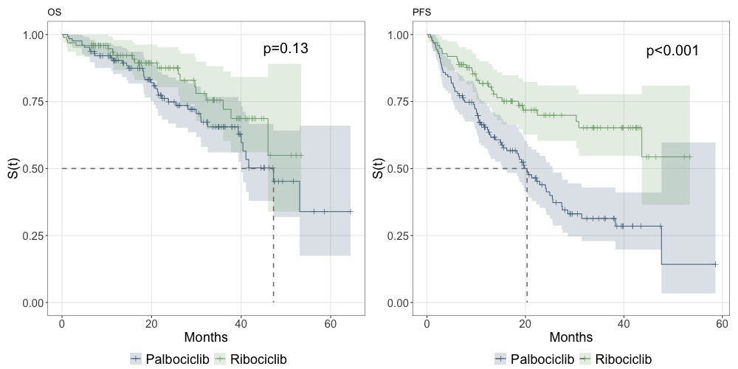

Survival curves for Palbociclib and Ribociclib (1st line) - Progression Free Survival and Overall Survival

We then compared both with a cox regression, checking that the trend seen in figure 1 continues where OS shows no significant difference between palbociclib and ribociclib but a significantly better PFS for ribociclib (figure [tab:cox]). When adjusted to stage, visceral metastases, age and ECOG, ribociclib is associated to an HR of 0.44, implying that ribociclib as a first line treatment reduces the risk of the disease progression by 60% compared to palbociclib as first line treatment. The proportional hazards assumption was confirmed with p values all over 0.10.

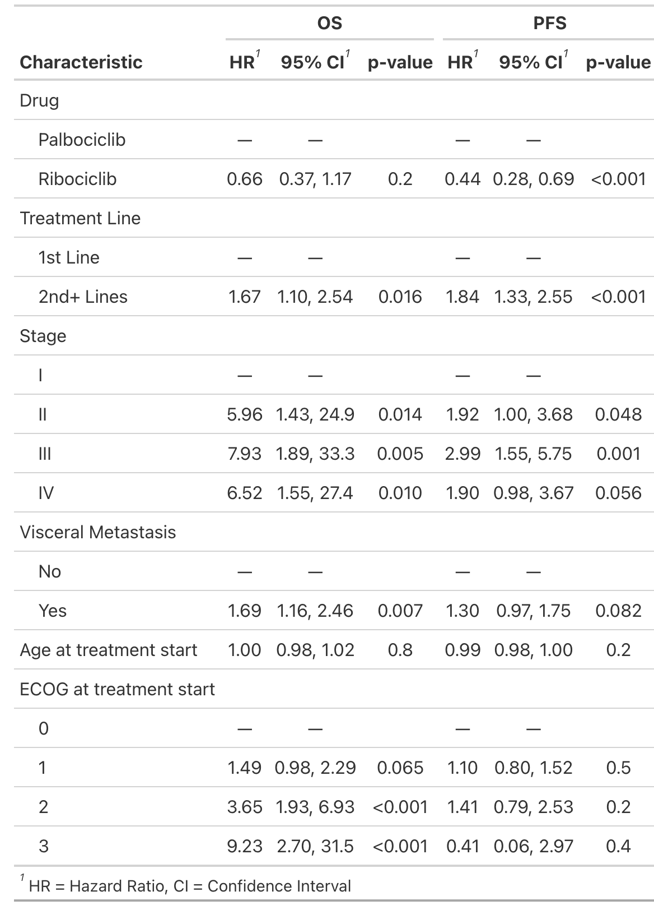

When comparing endocrine therapy with CDK4/6 inhibitors as first line treatment, we see that only Ribociclib is significantly better in terms of PFS and OS (p-value 0.001). When comparing palbociclib as first line, we see that there is no significant difference both in terms of PFS and OS (p=0.08 and 0.6) (figure 2).

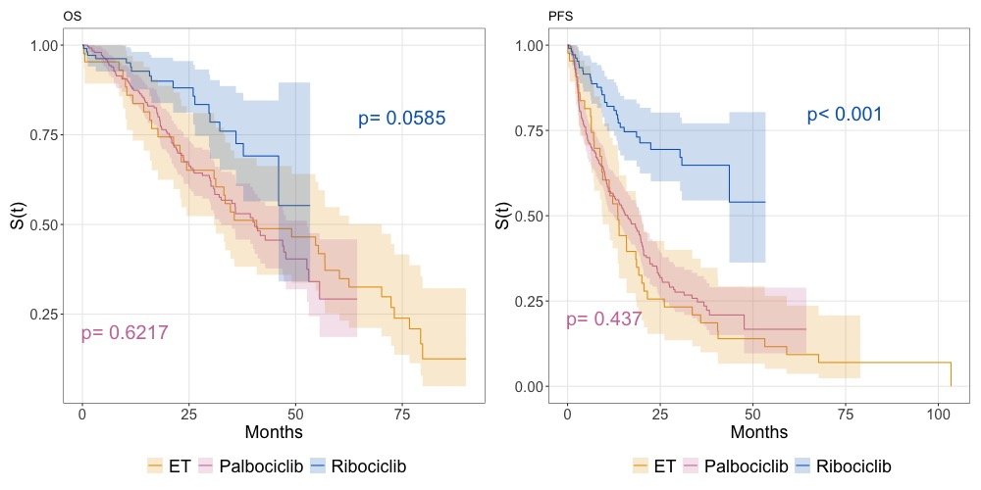

Survival curves (OS and PFS) comparing endocrine therapy (ET) to CDK4/6 inhibitors as 1st line. p values shown as pairwise vs HT.

When comparing palbociclib and ribociclib adjusted for ATE weights, we found a different scenario from previous assessments. There is a significant difference between the two in terms of OS and PFS (figure 3). We calculated the weights taken into account stage, age at treatment start, treatment line and ECOG.

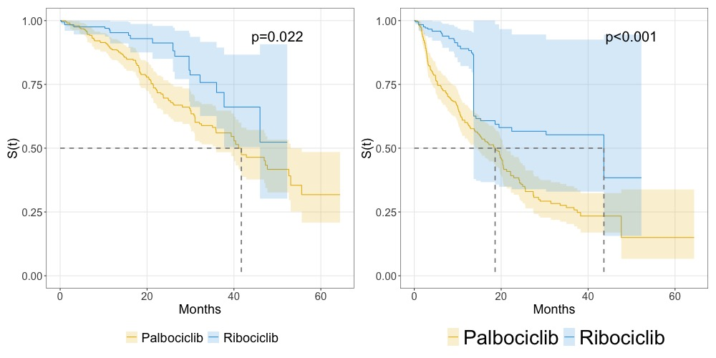

Comparison of palbociclib and ribociclib survival curves adjusted for propensity scores

The Cox regression adjusted for weigths shows that ribociclib is associated to an HR of 0.47 [0-26-0.87], implying that ribociclib reduces the risk of the death by 50% compared to palbociclib. The HR for PFS is 0.44 [0.26-0.62], implying that ribociclib reduces the risk of the disease progression by 60% compared to palbociclib, which also indicates the adjustment caused little to no effect on the results (figure [tab:cox]). Proportional hazards assumptions confirmed as well.

# Discussion

The aim of this study was to evaluate the real-world use of palbociclib and ribociclib in combination with ET for HR+/HER2 and comparing this drug class with traditional endocrine therapy. Few real-world evidence studies of palbociclib and ribociclib used in daily clinical practice have been published identifying clinical benefit, patient profile and sequencing of treatment, with even less evidence of use of palbociclib in Portugal.

When comparing with clinical trials, regarding patient profile, in our study, 51% had visceral metastasis and 35% had bone only metastases comparing with 49% and 38% in PALOMA-2, and 60% and 25% in PALOMA-3, respectively (Rugo et al. 2018; Cristofanilli et al. 2016). As for ribociclib, MONALEESA-7 (Tripathy et al. 2018) has 24% and MONALEESA-2 has 40% (Hortobagyi et al. 2018) and our study has 30%.

Regarding the clinical outcomes, the range of median PFS for first line palbociclib was 15.5–25.5 months, which is shorter than 27.6 months observed in a post hoc analysis of the PALOMA-2 clinical trial with extended follow-up (Rugo et al. 2018), but in line with RWE studies (13.3–20.2 months) (Harbeck et al. 2021). Regarding ribociclib, the median survival time was not reached for both OS and PFS. It is possible to say that the median PFS for ribociclib is longer than 50 months. This is longer that the median progression-free survival of 23.8 months (95% CI 19.2–not reached) reported in the MONALEESA-7 trial (Tripathy et al. 2018) and longer than 25.3 months (95% CI 23.0–30.3) in the MONALEESA-2 trial (Hortobagyi et al. 2018). However, the ET group has a median PFS of 13.6 months, which is in tune with the reported values in the literature.

Regarding the comparison between ET and CDK4/6i first line, we found out that neither OS and PFS have significant changes when compared ET and Palbociclib 1st line. This is an unexpected result, since we would expect that the addition of palbociclib would increase at least the PFS significantly. However, the difference is significant for Ribociclib. We also made a cox regression, adjusted for drug (inside HT) which was not significant with p values over 0.2. This is an interesting result, but we must take into account the differences in patients. We should not only take into account differences with measured covariates but also possibly unmeasured ones, like the fact the patients prescribed Palbociclib could already be patients with resistance to ET.

When comparing with propensity scores weighting, we found out that ribociclib is significantly better than palbociclib both in terms of OS and PFS. Our findings suggest that ribociclib could be the optimal approach for treating HR+, HE- metastic breast cancer, providing a median OS of over 40 months and median PFS of around 42 months. When adjusted to stage, visceral metastases, age and ECOG, ribociclib is associated to an HR of 0.41 for PFS and 0.47 for OS.

# Conclusions

For conclusions and next steps, we feel that we have demonstrated that ribociclib is a good alternative to palbociclib. We still dot not have sufficient evidence to state that palbociclib is actually better than endocrine therapy regarding OS. However, it is sufficient to state that CDK4/6i have impact on PFS on the studied population. Further information about the population could be interesting to collect, as well as calculate metrics and outcomes about safety, economic impact and quality of life. For this, characterization of the population in terms of biomarkers could be very useful. We aim to address those issues in sequencing papers. Finally, since all of this data was collected from a single institution, we cannot generalize the results to the entire population. However, we believe that this study can be used as a starting point for further research with real world data and CDK4/6 inhibitors. Additionally, this evidence was generated from observational data. Although we adjusted for confounding factors, we cannot exclude the possibility of residual confounding. Even though the propensity scores weighting allows for a more robust comparison between the two groups, there is still the possibility of unmeasured confounders.

# Author contributions

# Institutional review

This work was approved by the ... Ethics Committee...

# Data availability

...

# Funding

This work was supported ... For the purpose of open access, the author has applied a CC BY public copyright licence to any Author Accepted Manuscript version arising from this submission.

# Acknowledgments

...

# Conflicts of interest

The authors declare no conflict of interest.

# Figure

# Table

# Supplementary Material

Austin, Peter C. 2014. “The Use of Propensity Score Methods with Survival or Time-to-Event Outcomes: Reporting Measures of Effect Similar to Those Used in Randomized Experiments.” *Statistics in Medicine* 33 (7): 1242–58. <https://doi.org/10.1002/sim.5984>.

Austin, Peter C. 2011. “An Introduction to Propensity Score Methods for Reducing the Effects of Confounding in Observational Studies.” *Multivariate Behavioral Research* 46 (3): 399–424. <https://doi.org/10.1080/00273171.2011.568786>.

Cristofanilli, Massimo, Nicholas C. Turner, Igor Bondarenko, Jungsil Ro, Seock-Ah Im, Norikazu Masuda, Marco Colleoni, et al. 2016. “Fulvestrant Plus Palbociclib Versus Fulvestrant Plus Placebo for Treatment of Hormone-Receptor-Positive, HER2-negative Metastatic Breast Cancer That Progressed on Previous Endocrine Therapy (PALOMA-3): Final Analysis of the Multicentre, Double-Blind, Phase 3 Randomised Controlled Trial.” *The Lancet. Oncology* 17 (4): 425–39. <https://doi.org/10.1016/S1470-2045(15)00613-0>.

Finn, Richard S, John P Crown, Istvan Lang, Katalin Boer, Igor M Bondarenko, Sergey O Kulyk, Johannes Ettl, et al. 2015. “The Cyclin-Dependent Kinase 4/6 Inhibitor Palbociclib in Combination with Letrozole Versus Letrozole Alone as First-Line Treatment of Oestrogen Receptor-Positive, HER2-negative, Advanced Breast Cancer (PALOMA-1/TRIO-18): A Randomised Phase 2 Study.” *The Lancet Oncology* 16 (1): 25–35. <https://doi.org/10.1016/S1470-2045(14)71159-3>.

Goetz, Matthew P., Masakazu Toi, Mario Campone, Joohyuk Sohn, Shani Paluch-Shimon, Jens Huober, In Hae Park, et al. 2017. “MONARCH 3: Abemaciclib As Initial Therapy for Advanced Breast Cancer.” *Journal of Clinical Oncology: Official Journal of the American Society of Clinical Oncology* 35 (32): 3638–46. <https://doi.org/10.1200/JCO.2017.75.6155>.

Harbeck, Nadia, Meaghan Bartlett, Dean Spurden, Becky Hooper, Lin Zhan, Emily Rosta, Chris Cameron, Debanjali Mitra, and Anna Zhou. 2021. “CDK4/6 Inhibitors in HR+/HER2- Advanced/Metastatic Breast Cancer: A Systematic Literature Review of Real-World Evidence Studies.” *Future Oncology* 17 (16): 2107–22. <https://doi.org/10.2217/fon-2020-1264>.

Hortobagyi, G., S. Stemmer, H. Burris, Y. Yap, G. Sonke, S. Paluch-Shimon, M. Campone, et al. 2018. “Updated Results from MONALEESA-2, a Phase III Trial of First-Line Ribociclib Plus Letrozole Versus Placebo Plus Letrozole in Hormone Receptor-Positive, HER2-negative Advanced Breast Cancer.” *Annals of Oncology : Official Journal of the European Society for Medical Oncology*. <https://doi.org/10.1093/annonc/mdy155>.

Rugo, H. S., V. Diéras, K. A. Gelmon, R. S. Finn, D. J. Slamon, M. Martin, P. Neven, et al. 2018. “Impact of Palbociclib Plus Letrozole on Patient-Reported Health-Related Quality of Life: Results from the PALOMA-2 Trial.” *Annals of Oncology: Official Journal of the European Society for Medical Oncology* 29 (4): 888–94. <https://doi.org/10.1093/annonc/mdy012>.

Slamon, Dennis J., Patrick Neven, Stephen Chia, Peter A. Fasching, Michelino De Laurentiis, Seock-Ah Im, Katarina Petrakova, et al. 2018. “Phase III Randomized Study of Ribociclib and Fulvestrant in Hormone Receptor-Positive, Human Epidermal Growth Factor Receptor 2-Negative Advanced Breast Cancer: MONALEESA-3.” *Journal of Clinical Oncology: Official Journal of the American Society of Clinical Oncology* 36 (24): 2465–72. <https://doi.org/10.1200/JCO.2018.78.9909>.

Sledge, George W., Masakazu Toi, Patrick Neven, Joohyuk Sohn, Kenichi Inoue, Xavier Pivot, Olga Burdaeva, et al. 2017. “MONARCH 2: Abemaciclib in Combination With Fulvestrant in Women With HR+/HER2- Advanced Breast Cancer Who Had Progressed While Receiving Endocrine Therapy.” *Journal of Clinical Oncology: Official Journal of the American Society of Clinical Oncology* 35 (25): 2875–84. <https://doi.org/10.1200/JCO.2017.73.7585>.

Tripathy, Debu, Seock-Ah Im, Marco Colleoni, Fabio Franke, Aditya Bardia, Nadia Harbeck, Sara A. Hurvitz, et al. 2018. “Ribociclib Plus Endocrine Therapy for Premenopausal Women with Hormone-Receptor-Positive, Advanced Breast Cancer (MONALEESA-7): A Randomised Phase 3 Trial.” *The Lancet. Oncology* 19 (7): 904–15. <https://doi.org/10.1016/S1470-2045(18)30292-4>.

Verma, Sunil, Cynthia Huang Bartlett, Patrick Schnell, Angela M. DeMichele, Sherene Loi, Jungsil Ro, Marco Colleoni, et al. 2016. “Palbociclib in Combination With Fulvestrant in Women With Hormone Receptor-Positive/HER2-Negative Advanced Metastatic Breast Cancer: Detailed Safety Analysis From a Multicenter, Randomized, Placebo-Controlled, Phase III Study (PALOMA-3).” *The Oncologist* 21 (10): 1165–75. <https://doi.org/10.1634/theoncologist.2016-0097>.