A Study on Estimating Reasonable Insurance Price Based on the XGBoost Algorithm

JooHo Park, SeMyung Park and JuHee Choi
Sangmyung University, Cheonan, Korea
* Corresponding Author (Email: jhplus@smu.ac.kr)

Abstract-- In modern society, people sign up for multiple insurances. However, many people do not know which options they should include. So, insurance applicants accept the insurance planner’s suggestions. The purpose of this study is to develop a model for the insurance applicants’ characteristics. At first, we use ‘age’, ‘bmi’, ‘children’, and ‘smoker’ as a variable. And then, we add ‘exercise_freq’ and ‘self_health’ as extra features. To draw a conclusion, we utilize “XGBoost”, “Linear Regression”, “Ensemble” technique. Through the test, we find that “XGBoost” shows the best performance.

- Introduction
[1]A necessary component of the medical industry is medical insurance. On the other hand, it is challenging to predict medical spending because most of the money comes from patients. To make accurate insurance charges, both insurers and policyholders need to figure out every circumstance. However, the traditional methods often fail to account for individual factors such as income, exercise frequency, awareness of health conditions, etc. And it leads them to estimate inaccurately. This study applies machine learning models including Linear Regression, Random Forest, XGBoost and LightGBM to predict charges of insurance using an extended dataset with additional personal health information. By comparing model performances, we target to demonstrate how incorporating new variables can improve accuracy of predictions.

- Background
  - Random Forest
[2] Random Forest is a tree-based ensemble learning technique which is used for classification and regression problems. The Random Forest Classifier builds several decision trees simultaneously and takes predictions from each tree.
  - Multiple Linear Regression
[3] Multiple regression may be an applied mathematics technique which will be wont to analyze the link between one variable and a number of other freelance variables
C. XGBoost
[4] eXtreme Gradient Boosting(XGBoost) which changed the way gradient boosting was done. [4] XGBoost is a machine learning method that is widely used for classification problems and handle missing values without an imputation preprocessing.

Indicator | Basic Version | Upgrade Version
MAE | $1,940.29 | $1,955.05
RMSE | $4,321.05 | $4,334.26
$R^{2}$Score | 0.8797 | 0.8790
Fig. 1. Comparison of XGBoost adding new variables
Fig.1 is the result after adding new features compared to the previous version. The upgraded version includes more variables such as ‘exercise_freq’, and ‘self_health’. These variables enable more accurate and convincing predictions than existing models. However, the difference between previous models and new models is not significant, so, we cannot be said that it has a positive effect on model performance.
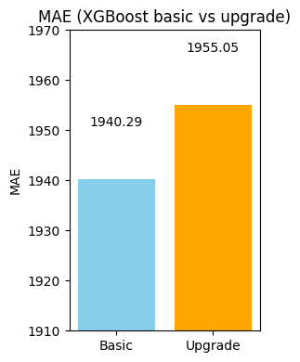
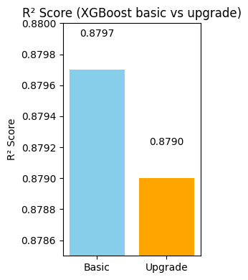
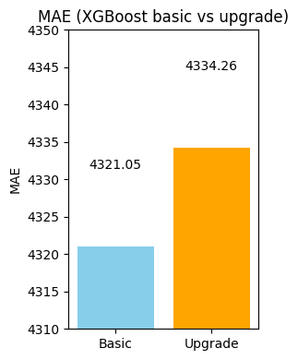

Model | MAE | RMSE | $R^{2}$Score
Random Forest | 2090.65 | 4359.79 | 0.8776
LightGBM | 2229.19 | 4464.83 | 0.8716
XGBoost | 2481.90 | 4991.08 | 0.8395
Linear Regression | 3888.44 | 7814.06 | 0.6067
Fig. 2. Result of Predicted Insurance Charges.ipynb
Fig.2 is the result before we add extra features. And Fig.3 is the result after we add extra values. When we see the changes of MAE, RMSE, and $R^{2}Score$ in XGBoost, MAE and RMSE are decreasing. Especially, we can see that the range of changes in RMSE is large. Also $R^{2}Score$ is increased compared to the previous model. However, other models do not show positive results because these models’ range of changes is not significant.
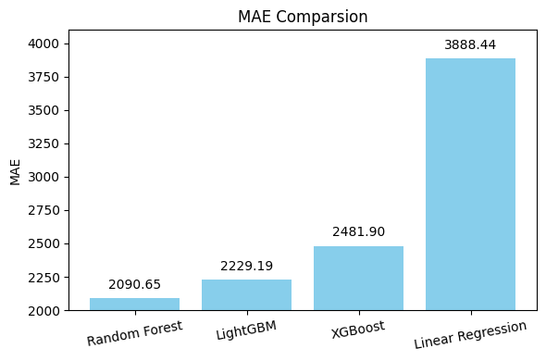
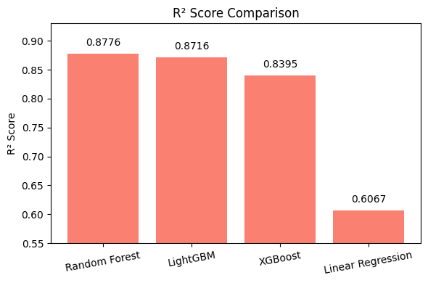
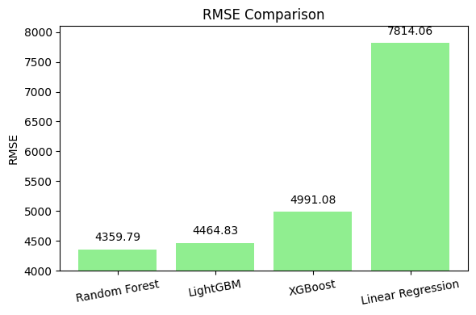

Model | MAE | RMSE | $R^{2}$Score
Random Forest | 2181.34 | 4446.08 | 0.8727
LightGBM | 2197.64 | 4469.49 | 0.8713
XGBoost | 2440.52 | 4651.51 | 0.8606
Linear Regression | 3890.16 | 7779.89 | 0.6101
Fig. 3. Result of New Predicted Insurance Charges.ipynb
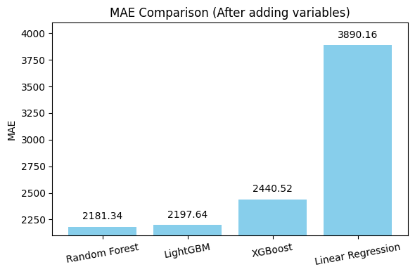
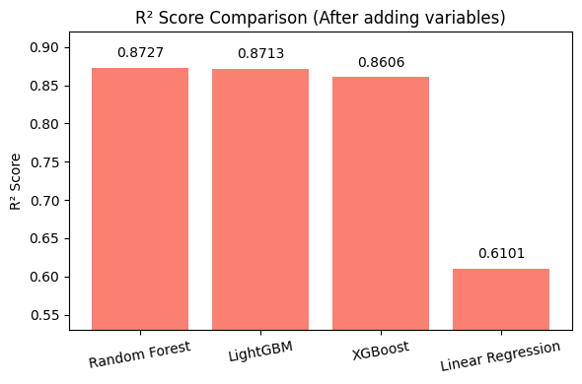
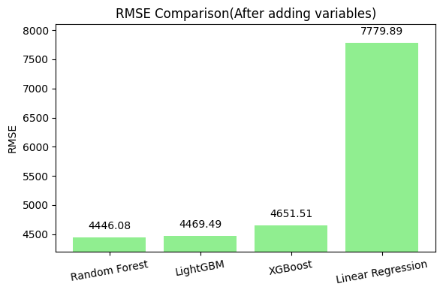
- Contribution
This study shows the following differences and contributions compared to the existing studies.
The biggest difference is that this study improves the data preprocessing methods. [6] Regression analyses are frequently employed for forecasting and prediction, with significant overlaps between their application and machine learning. However, this study applies ‘One-Hot Encoding’ to reflect the characteristics of actual medical insurance data. Also, the log transformation was applied to the dependent variables (Charges) to improve the predictive stability and skewness.
And this study focuses on a single regression problem and analyzes the model’s performance focusing on practical applicability.
These differences allow us to provide a realistic and practical approach and to construct predictive models that are more suitable for real situations.
- Conclusion
To improve the accuracy of insurance prediction, we use various kinds of machine learning algorithms. Some algorithms show meaning results. But some algorithms do not show positive results. Particularly, XGBoost shows the most excellent performance. Although hypothetical additional variables are used in this study, most results show no significant changes compared to before adding extra features.
With these results, we discover that estimating reasonable insurance prices is difficult. The reason is that each person has their own situation. And the insurance planner cannot recognize everything. The best way to design a reasonable insurance price is to gather as much data as possible to create an objective basis.

ACKNOWLEDGMENT
This research was supported by Sangmyung University.
References
[1] Sazzad Hossen. (2023). Medical Insurance Cost Prediction Using Machine Learning, pp1.
https://www.researchgate.net/publication/374553777
[2] Rahul Sahai, Ali Al-Ataby, Sulaf Assi, Manoj Jayabalan, Panagiotis Liatsis, Chong Kim Loy, Abdullah Al-Hamid, Sahar Al-Sudani, Maitham Alamran. (2023). Insurance Risk Prediction Using Machine Learning
[3] Mukund Kulkarni, Dhammadeep D. Meshram, Bhagyesh Patil, Rahul More, Mridul Sharma, Pravin Patange. (2022). Medical Insurance Cost Prediction using Machine Learning. International Journal of Innovative Research in Engineering and Technology(IJIRSET), 10, pp.453.
Medical_Insurance_Cost_Prediction_using_Machine_Learning-libre.pdf
[4] Ramraj Sa Nishant Uzirb Sunil Rb and Shatadeep Banerjeeb. (2016). Experimenting XGBoost Algorithm for Prediction and Classification of Different Datasets. International Journal of Control Theory and Applications, 9, pp.651.
[5] Deandra Aulia Rusdah, Hendri Murf. (2020). XGBoost in handlimg missing values for life insurance risk prediction. Engineering: Intelligent System, Soft Computing and Optimization, 2, pp.1
[6] Jonelle Angelo S. Cenita, Paul Richie F.Asuncion, Jayson M. Victoriano. (2023). Performance Evaluation of Regression Models in Predicting the Cost of Medical Insurance. International Journal of Computing Science and Research,7, pp2057.
https://arxiv.org/abs/2304.12605

