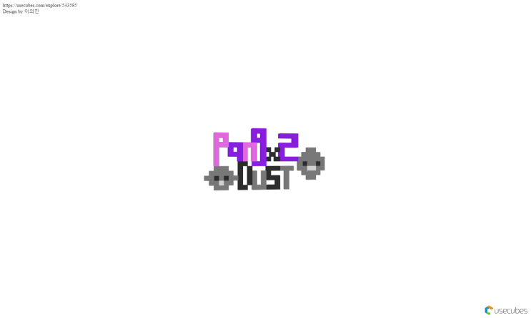

**TABLE OF CONTENTS:**

**EXECUTIVE SUMMARY**

High Concept -----------------------------------------------4

Game Synopsis-----------------------------------------------4

Key Features -----------------------------------------------4

Development Platform and Environment---------------------------- 4

Target Audience---------------------------------------------- 5

Excepted ESRB Rating------------------------------------------5

**STORY**-------------------------------------------------------5

**GAMEPLAY**

Core GamePlay-----------------------------------------------6

Game Mechanics----------------------------------------------7

Game Controls------------------------------------------------7

**GAME RESOURCE**

Character System---------------------------------------------8

Equipment System--------------------------------------------9

Item System------------------------------------------------10

**GAME DESIGN**

Behavior Design---------------------------------------------11

Physics Design----------------------------------------------12

Multiplayer Design-------------------------------------------12

**Visual Design**

Summary--------------------------------------------------12

Game Characters--------------------------------------------13

Enemy Design----------------------------------------------13

Game Environment-------------------------------------------14

Title Screen------------------------------------------------14

HUD Layout------------------------------------------------15

**SOUND**

Audio Design-----------------------------------------------15

**EXECUTIVE SUMMARY**

## **High Concept**

“Pang Pang Dust” is a shooting and catching arcade game. The game is set in Korea and the main character is leaving to clean up the world by catching the fine dust with a vacuum cleaner.

## **Game Synopsis**

People are suffering from the increase of fine dust in Korea in 2025. You has created a vacuum cleaner that cleans fine dust and try to purify fine dust for the people. Can you clean up all the fine dust?

## **Key Features**

* Maintain Clean Gauge System
* Attack Enemy(DUST) System
* Catching Score System
* Three Life System
* Korea Fine Dust Adventure

## **Development Platform and Environment**

* Microsoft Windows 10 Education
* Intel(R) Core(TM) i7-4790 CPU @ 3.60GHz 3.60GHz
* 8.00 GB RAM
* 64-bit Operating System, x64-based processor
* Microsoft Visual Studio 2017
* Microsoft Word 2010
* Microsoft Paint

## **Target Audience**

Almost koreans are suffering and worried about fine dust that is the theme of game “Pang Pang Dust”. This game will get sympathy from many Koreans who suffer from fine dust. And with cute characters and easy control, it will be popular with young children. Therefore, the target audience of the game “Pang Pang Dust” is KOREANS and KIDS.

## **Expected ESRB Rating**

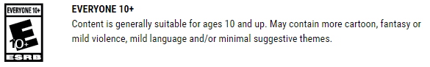

-This game has a depiction of the character dying, but there is no real expression of blood.

-The characters and items in this game will use cute images.

-It is instructive because it is game that knows the danger of fine dust.

# **STORY**

The main character (player) has developed a vacuum cleaner that purify fine dust for Korean people who suffering from fine dust. The main character(player) will use this vacuum cleaner to absorb and attack fine dust to reduce fine dust levels in Korea.

**GAMEPLAY**

## **Core Gameplay**

## “Pang Pang Dust” consists of one tutorial stage, three main stage set in the Korean city and one special stage. The player has a vacuum cleaner with the ability to attack and catch fine dust. With this vacuum cleaner, the player can catch automatically (without pressing any key) and purify fine dust, and the ultra fine dust (red dust) can be first attacked and caught and then purified. The vacuum cleaner automatically performs cleanup, and the main character simply needs to catch fine dust. Fine dust just flies from the right side of the map towards the player, and the player must catch all fine dust. Ultra fine dust is fixed in a map and appears suddenly. "Pang Pang Dust" has life (heart) and score (clean gauge). If the player misses fine dust, the clean gauge will decrease, which will affect the ending. If the player fails to purify ultra fine dust or is hit with ultra fine dust, life and clean gauge decrease at the same time and more clean gauge decrease than normal fine dust. Life gives you three chances, and if you lose all three chances, the game would be over. After finishing three main stages, you can play a special stage after watching the ending. Special Stage is a stage set at the Keimyung University. If the player catches eight fine dust during the game, he or she can get three filter (we call the bullets a filter) that can attack ultra fine dust when the bullet gauge is charged. Without this filter, the player cannot clean up the ultra fine dust, which leads to clean gauge and loss of life. Players can also acquire items that help or cause damage during game playing.

## 

## **Game Mechanics**

Main character moves by receiving keyboard input in game “Pang Pang Dust”. Character’s movement and jump are decided with direction key. During playing this game, if player can not catching fine dust, clean gauge will be decreased. In case of Ultra fine dusts, player has to attack and catching them. If player cannot purify ultra fine dust, life will reduce and clean gauge will be greatly reduced. In case that player just cannot purify (cannot catching) fine dust, clean gauge is decreased 5%, In case of ultra fine dust, gauge is reduced 15%. When clean gauge is became 0 or all of lives is spent, this game will be over. According to player’s score, ending story will be determined.

## 

## **Game Controls**

The player can move using the direction keys. If the UP key is pressed, the character will jump. Also, if the RIGHT key is pressed, the character will move to the right. Players can also use the Q, W, E, R and I keys. If the Q key is pressed, the character will attack, if the W, E, R keys are pressed the character will use each item and if the I key is pressed, player can open inventory.

**GAME RESOURCE**

## **Character System**

The player has an inventory where the player can check the items that the player have acquired and can take items out of this inventory and use them.

**Attacking**: The player should attack ultra fine dust. If the player shoot a bullet but the player do not get ultra fine dust, the bullet decreases, but does not damage ultra fine dust and does not change the state of ultrafine dust. Through an attack, ultrafine dust can be changed into normal fine dust to catch it.

**Catching**: The player should catch all the fine dust in a game. As mentioned earlier, ultra fine dust should be caught after an attack, and normal fine dust will be caught automatically when the character overlaps with fine dust.

**Life**: There are 3 opportunities in total, and if all of these opportunities are lost, the game will be over.

**Clean Gauge**: Clean gauge means the player's score. If the player miss the fine dust, the clean gauge will be reduced. This will affect the ending and affect the third stage.

**Equipment System**

The player has a vacuum cleaner to absorb fine dust. Additional items are not allowed on this cleaner, but the type of cleaner will change when the game stage changes.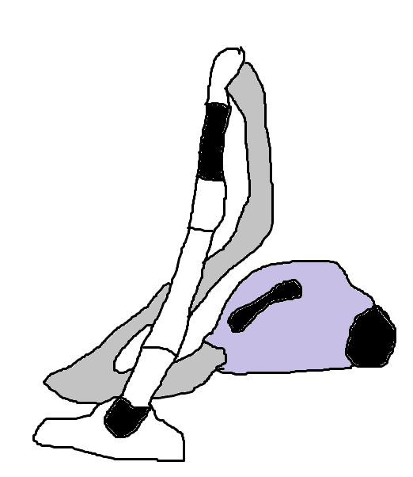

**Wired Cleaner**: In the first stage, the player will use a wired cleaner. There is a line to limit the movement distance of the player.



**Wireless Cleaner**: In the second and third stages, the player will use the wireless cleaner. The wireless cleaner has no wires, so the player can move freely within the map.

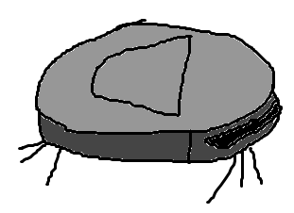

**Robot Cleaner**: IIf the player gets a score above a certain level in the first, second and third stages,

it will automatically be applied on the fourth stage. Although the robot cleaner can not be operated directly by the player, it automatically absorbs fine dust (ultra-fine dust is not absorbed automatically).

**Ultra Filter**: Ultra fine dust can be made into fine dust. As mentioned earlier, the player needs to absorb a certain amount of fine dust to get an ultrafilter, and one ultrafilter is used for each shoot.

**Item System**

Players can get items in the map. Platers can get it automatically when the Player is in the same position as the items. Items are automatically added to the inventory, so players can use the item by using the keyboard at the timing players want.

**Ultra Filter Charger** : Items that fill all ultra filter gauges at once, So players can get Ultra Filter that cleans up ultrafine dust.

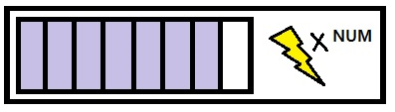

**Filter Bullet** : Players can get one Ultra filter bullet that attack ultrafine dust.

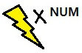

**Gas Mask** : If players use this item, players will be able to absorb ultrafine dust without attack it. This condition is called invincible.



**GAME DESIGN**

**Behavior Design**

The character takes input from the keyboard and moves left ,right, up and down. The character jumps in a straight line. When the character fires the Ultra Filter, the Ultra Pillar goes straight. Fine dust is randomly output from the right side of the screen, and fine dust also moves in a straight line. The ultrafine dust is stuck on the screen and automatically appears when the Player is closer than a certain distance.

(run motion)The character moves by taking the left and right key moving with crossing arms and legs.

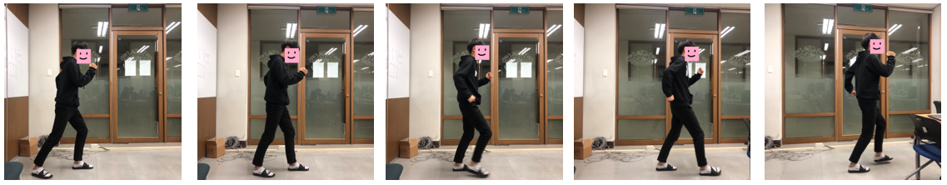

(jump motion) Bend main character's knees and jump up the ground with momentum. Take a motion to raise your arms high.

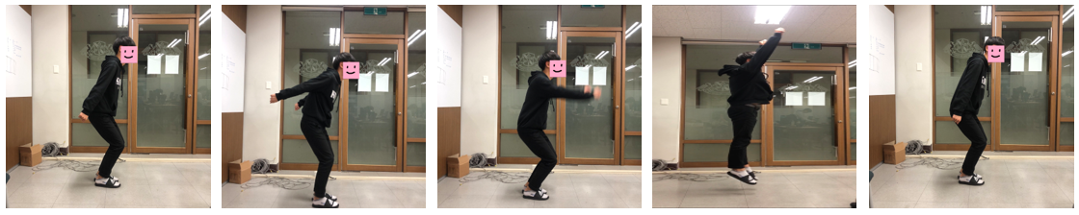

(shooting motion) Stretch out your arm and use a vacuum cleaner to shoot the filter.

(shooting with jump) Shoot a filter bullet with jumping. 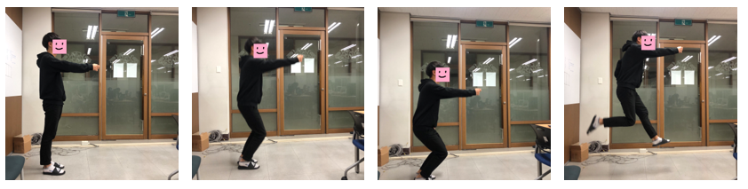

**Physics Design**

Principal of action and reaction : When the character shoots the bullet(ultra filter), the character is pushed back.

**Gravity** : It's necessary for the character to jump down to the ground.

**Jump** : The character bends knees before jumping. When player move during jumping, the character moves as player’s input.

**Action & Reaction**

When a shot is fired, a reaction occurs where the character is pushed back by the action of the bullet moving forward. The character is pushed back and landed.

**Multiplayer Design**

Multiplayer is not supported because Pang Pang dust is a story about one player to purify fine

**VISUAL DESIGN**

**Summary**

This game is 2D- platform game. The point of view is third person observer. Camera is fixed when player moves forward or backward, however, when player jumps, camera follows player movement. ”Pang Pang Dust” is real-based game. The overall visual concept of Pang Pang dust is cute. Enemy and the main characters will be deformed real people and dust to express cute. When the find dust is attacked, a special effect will be used special effect of dust blowing.

**Game Characters**

 Main character has a special vacuum cleaner that can attack and purify the fine dust.

Player can not change character’s speed and jump capacity. In other words, character’s ability is fixed. this character have a mission that character must purify the fine dust for all Korean in Korea which is in danger because of fine dust problem as a Korean.

**Enemy Design**

The main enemy in a game divided in two, one is fine dust and another is a ultra fine dust. The dust that appears as a main part of the game is divided into fine dust and ultra fine dust. The fine dust is caught automatically when characters and positions overlap, and ultrafine dust is caught in the same principle as fine dust after a single attack.

**Red ultra fine dust Gray fine dust**

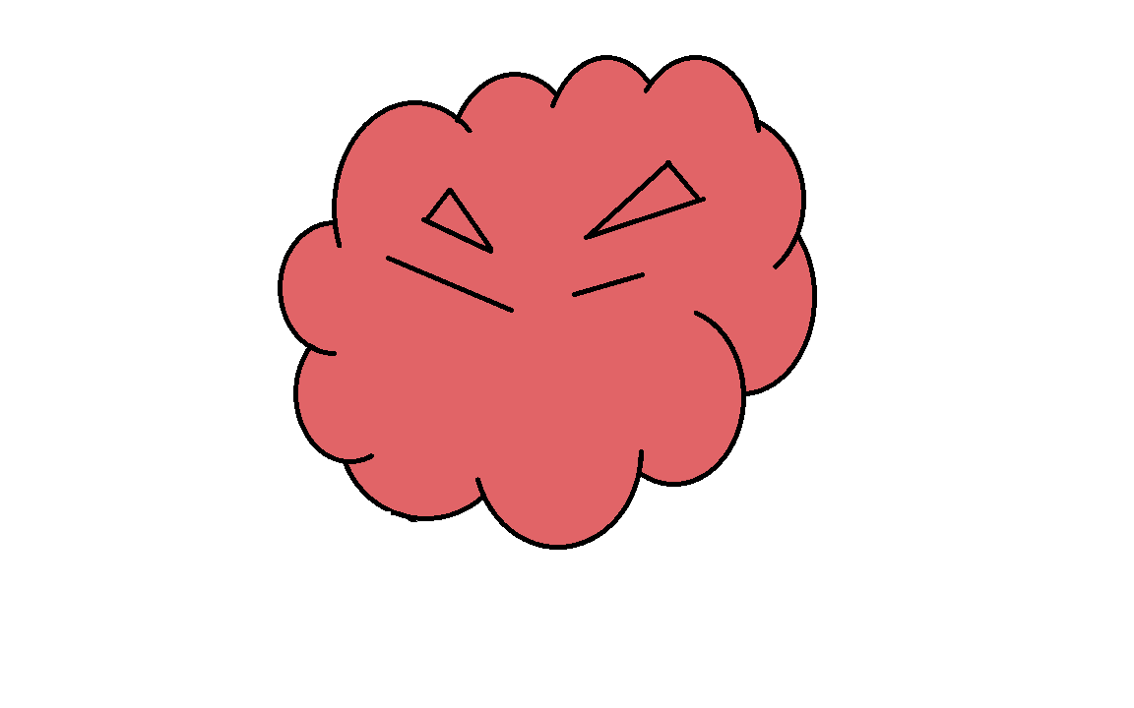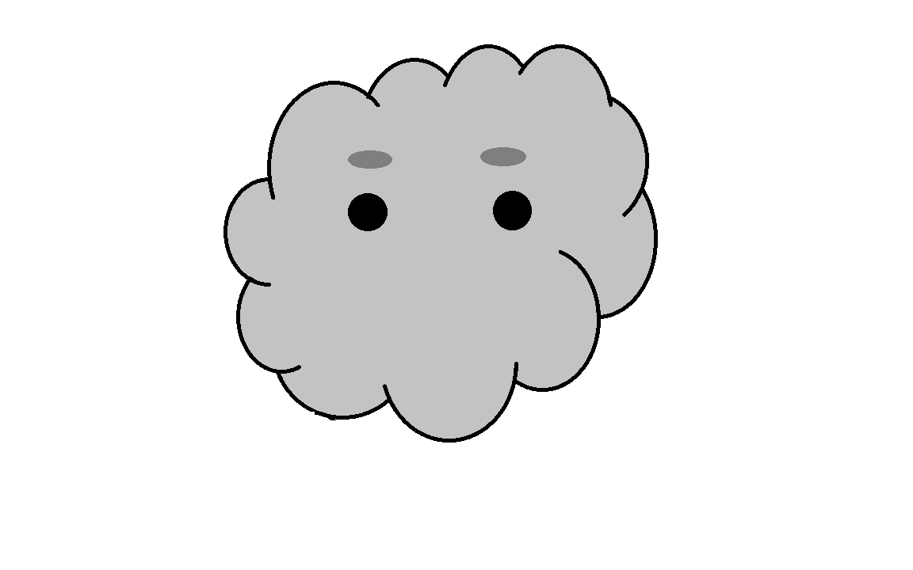

**Game Environment**

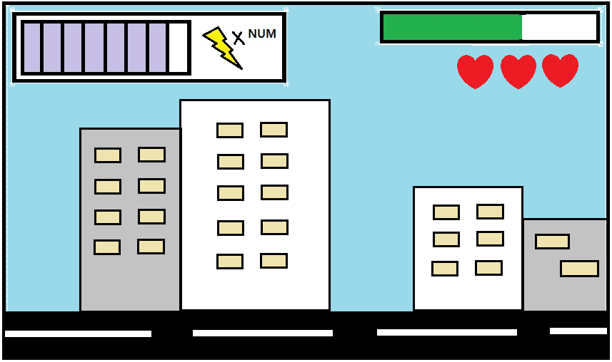

The main stage of the game is Korea which is polluted with fine dust. In order to bring more empathy to the players, the main stage has been chosen as the city where many people live, and all the play will be played on the city map, except for the special stage set at the Keimyung University.

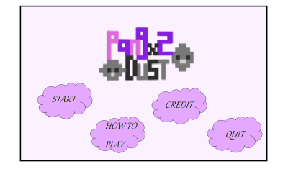**Title Screen**

This is the title screen. It include buttons like an enemy in the game. There are buttons to start and end the game, buttons to how to play, and buttons for credit, and logos at the top.

**HUD Layout** 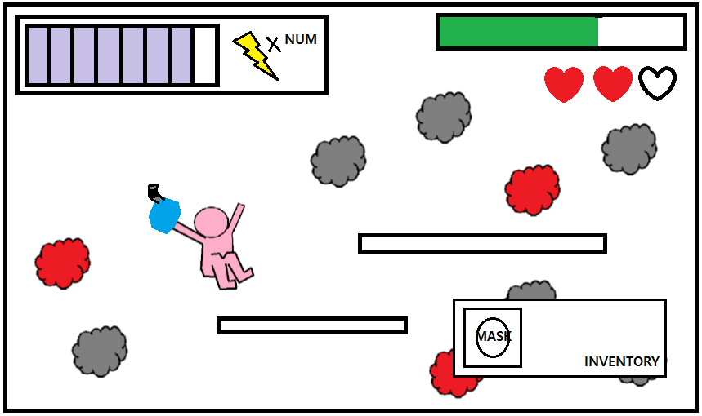

In the upper left of the screen, there is a gauge of the bullet filter and a box showing the number of bullets.(shapes of thunder and number(num)). In the upper right-hand corner of the screen, there is a clean gauge and life. Also, if the player presses I key, player can check the inventory in the lower right corner. At the center of the map is a space where the player can jump up.

**SOUND**

**Audio Design**

The sound of this game will be used by FMOD. Background music will be applied free source music. Alos, the effects sound will be recorded by 99 team members and applied to the game. The overall of the game is bright and casual, so the music will be casual.