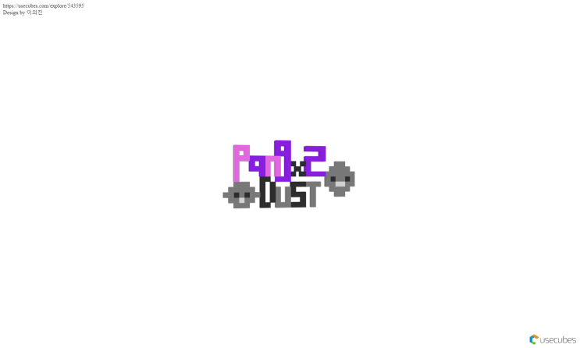

## ***Release 1: Prototype***

Release Duration:2 weeks

### Must Have Features

1.Move the character(<M>)

jump and move right, left

: when walking or running, the character moves legs and arms. player can jump, move at left and right. When the player press the left and right keys, the character will move at left and right. When the player press the up arrow key, the character will jumps.

2. Fine dust that randomly generated (<L>)

:fine dusts have to be caught by player during playing game.

dusts fly from right to left to character. fine dusts are printed form that fly from right to character. according to difficulties, different number of fine dust are printed.

### Should Have Features

1.Make Ultra Fine Dust(<M>)

: When the game starts, ultrafine dust will be hidden. However, if the player's coordinates are close to the coordinates of the hidden ultrafine dust, ultrafine dust will be printed. This raises the overall game difficulty and gives the player an interest.

e.g) When the coordinates of ultrafine dust are (10.5), When the coordinates of the player x and y are (7.3), ultrafine dust will appear.

2. Make a start and main menu screen (<S>)

: At the start of the game, the start screen is displayed and then the main menu screen is displayed. On the start screen, the player can see the game logo, the Digipen logo. Also, in main menu screen, the player can choose to start the game, see how to play, or see the credits.

### Nice to Have Features

1.The character with a vacuum cleaner(<M>)

: The player needs a vacuum cleaner to absorb the fine dust and attack the fine dust. The character will run with the vacuum cleaner. Make wired cleaner and wireless cleaner.

## ***Release 2: Alpha***

Release Duration:2 weeks

### Must Have Features

1. Absorb find dust(<XXL>)

: Makes the character absorb the fine dust. If the coordinates of the player and fine dust coordinates are the same, the cleaner absorbed fine dust that means the fine dust disappears . In addition, fine dust that is not absorbed by the vacuum cleaner flies back to the character.

2. Attack Ultra Fine Dust

: When the player shoots ultrafine dust using a filter bullet, the ultrafine dust(red) will become gray. Gray fine dust becomes absorbable by the vacuum cleaner.

3. Filter Bullet & Filter Gauge

: Filter bullet is the tools that allow the player to attack ultrafine dust. In the upper left corner, pop up the number of filter bullets and gauge, and if the player absorbs 8 fine dusts, the player can get 3 filter bullets(filter gauge). The player can attack red dust using this filter bullet.

### Should Have Features

1. Make a clean gauge and heart (score& life)(<M>)

: Clean gauges are scored according to the success of the attack and absorption. Clean gauges are displayed in the upper right-hand corner of the screen, and if players fail to absorb ultrafine dust or fine dust, clean gauges will be reduced. Also, if a player fails to attack ultrafine dust, life is reduced one by one. The player is given three lives and is marked in heart shape under the top right-hand clean gauge.

2. Make items(<XL>)

: It allows players to absorb and use various items during the game. Items such as adding gas masks, adding bullets and adding filter gauges appear inside the map, allowing players to be automatically absorbed when the coordinates of the items are the same, such as fine dust.

### 

### Nice to Have Features

1.Make an inventory(<L>)

: Allow players to check items that acquired during the game. When they press the keyboard "I" and also enable them to use items, players can check the number of items left over.

2. Make stages

: There are three stages in the game with different difficulty levels. The player must pass the first stage to go to the second stage. Also, the player have to pass the second stage to get to the third stage. When the scores for the first and second stage are added is higher than certain score, player can get a new vacuum cleaner to use in the third stage. This game has a different vacuum cleaner and map used on each stage.

## ***Release 3: Beta***

Release Duration:2 weeks

### Must Have Features

1. Make stages

: three different difficulties of stages.

player has to pass one stage in order to go next stage. player can get additional item in third stage by score that sum up first and second stage. structure of map and vacuum cleaner used in each stages.

2. Characterize wired, wireless vacuum cleaner(<M>)

: wire and wireless vacuum cleaner are given characteristic. when player uses wire vacuum cleaner, character cannot move more than some distance, however, character who use wireless vacuum cleaner free to move.

3. Add audio(<S>)

: during the game, background music is played, corresponding sound and background sounds are printed whenever a character performs certain actions such as jump and catching the dust.

### Should Have Features

1.Robot cleaner(<S>)

: A robot cleaner that automatically catches the fine dust from the bottom of the game. If player get a certain score in the first and second round of the game, the player can get the robot cleaner.

2. Design maps(<L>)

: We should adjust the difficulty level on each stage. Each stage has a different frequency of obstacles, and the player has a higher level of difficulty.

3. fix error(<XL>)

: Correct errors and warnings in the game for smooth game play and progress. After this process, there should be no errors when compiled.

### Nice to Have Features

1. Make endings(<M>)

: According to the total scores up to the last 3rd stage, the corresponding endings are printed out. When the game is over, the endings that match the score are automatically printed.

## ***Release 4: Final***

Release Duration:2 weeks

### Must Have Features

1.fix error(<XL>)

: Team 99 will fix errors and warnings of game for smooth game play. After this process, there is no error in this game when it compile.

2. Design maps(<L>)

: Team 99 adjust the difficulty on each stages. The frequency of obstacles varies from stage to stage and the level of difficulty that is feel by players increases.

3. Make endings(<M>)

: ending story will be outputed by score combined up from first stage to third stage. when the game is over, ending story will be printed automatically according to score .

### Should Have Features

1.Add extra stage(<S>)

: After the game is over, ending story is printed and extra stage will be provided that set at Keimyung University. that stage is a kind of reward for player who have completed their play.

### Nice to Have Features

1.various background images(<M>)

: Make different background so that players are not bored by same backgrounds. Various pictures can be printed in the background such as night, day, and other cities.