

Poo Poo Pipe

Game Plan Document

Playtest date: July 15, 2020

GAM250F20KR

SPRING 2020

**Name Title Coding Responsibility**

**Kim HaGyeong   Producer   Game programmer**

**Son JuHye Graphic programmer Graphics**

**Lee UiJin Technical Director     Game programmer**

**Hong eunjin Designer             Design, Sound**

**Project status**

Currently, our game has all the features necessary for gameplay(for example, movement, rotation, and pipe connect checks). Our game engine is a component based engine with custom object, and each puzzle is implemented as a object with component. Each level is managed by a stage manager. We will implement three additional plans to further develop the game:

1)Add items and traps

2) more levels

3) Add various graphical effects for polishing (animation, etc.)

4) Add fun factor

We assigned each member a role to successfully complete these plans.

**Team Responsibility and Structure**

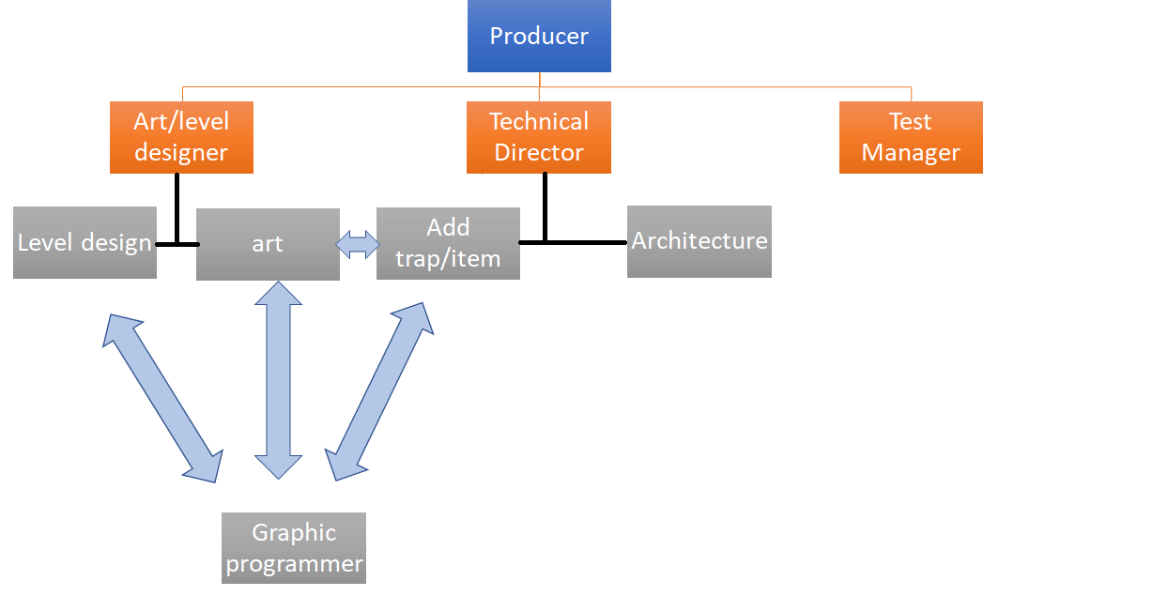

-The producer oversees everything related to the engine and the game.

- Each member of the team tells the producer if there is a change in their responsibilities.

-Each team member double checks the work they are responsible for.

- Graphic programmers work with other team members when they work on graphics, such as level design, art, adding traps and items. Also, add graphic effects that other team members need.

-The test manager manages bugs related to the game.

**Team Responsibility:**

|  |  |  |  |
| --- | --- | --- | --- |
| Eunjin Hong | Hagyeong Kim | Joohye Son | Uijin Lee |
| Lead Designer/  Art | Producer/  Test manager | Graphic programmer | Technical Director |
| Art design | Add level | Graphic | Sound |

**Project Risks and Mitigations**

Risk #1 Memory increases too much.

Mitigation #1 Consult with professors.

Mitigation #2 Search on the Internet (stackoverflow, etc.)

Risk #2 Lack of Level Design Ideas

Mitigation #1 Meeting with team member

Mitigation #2 Ask others for their opinions

Risk #3 We don't have enough time to concentrate fully on the game project.

Mitigation #1 We have time to do a game project regularly with the members.

Mitigation #2 We have a team meeting every Monday and Friday.