**GAM250 Playtest Report**

**Team : 99** **Project Name:** PooPooPiPe

**Date:** 5/4/20 **Project Version:** Pre-Alpha(v1.0)

**Playtest Goals**

* Ensure level difficulty is adequate.
* Ensure that the graphics and sounds of the game blend well with the concept of the game.
* To check the UIs work well to the player.

**Playtest Notes**

**Test #1: Haegyeong Kim (**[**yoho0538@naver.com**](mailto:yoho0538@naver.com)**)**

Playtest were held Friday afternoon. She was my family, so we used our house computer as a device for play test. She was one of the play testers who kept playing our game during development. She is over 50s, and does not have many experiences of game, therefore, she gave various questions during the game. One of the questions was that she had hard time knowing the way of rotating the pipes, which is one of our most important controls to our game. Therefore, this gave us a conclusion to put more descriptions in the tutorial.

It took approximately 25 minutes playing the whole level. Because she was new about puzzle games, she had hard time understanding to clear the single level. We gave her an explanation to match the pipes from start to end, and then she showed she understood. She also asked that she do not know where the start and the end point is. This made us think about the polishing, changing the pipe UIs much clear.

After the play test, she stated that it was hard to understand at the first time but did not wanted to give up because she was interested by the cute drawings of the game. Moreover, after understanding the controls she did not had much hard time to play the game. However, she gave her opinion that she does wants more explanations in the tutorial.

**Test #2: Son Seongjin**

Play test were held at Saturday afternoon. He was also after 50s, and not used to English, but has experience to famous games such as Warcraft and Starcraft, therefore, he did not have much time compared to the previous play tester (Haegyeong Kim). He ignored the tutorial and went through the game. However, he showed having a hard time to understand the controls, so we had to show him the tutorial.

He played from start to end, and it spent approximately 20 minutes. He solved the first level, but because the ‘clear’ image was too small, he did not realize that he could go to the next level. Moreover, our game still had a line written, ‘Press space to continue’. Because of this, he continued pressing the space button, even though when we only used them for debugging. This situation gave us to get rid of the line and graphics which are not in use. Moreover, he stated that it is uncomfortable because he could go to the level select, but hard to realize what level is he in, and wish there were a notification what level the players are in playing.

After the play test, he gave more honest advices. He praised that the game had more functions than he thought and made him amazed. The concept, character design was silly and fun, which made him happy while playing. However, he said it is sad because the levels were not enough and felt too short.

**Test #3: Hanbyeol Son**

The playtest was held on Sunday morning. It was hard for face-to-face, so we used the zoom meeting for the process. She is 20s Korean, and loves video games, therefore, she showed deep interest about our game. First sight, she stated that the background music matched with the graphics which is jolly and cute, which made her absorb to the game.

It took around 15 minutes playing the whole game. She gave many compliments about the UI designs. First, she stated that she loves the detail where the UIs change its color when the mouse collides with the button. However, she wished that there were also sound effects when pressing the buttons. I thought her idea was very good, and gave her a response that we are planning to add them. Moreover, she said adding a level select was a good idea, but there were few levels that not worked. Therefore, she gave an advice that we should fix it.

After the play test she gave her total assessment about the game. First, when looking at the main menu she thought the game was not a student project, but by professionals. If there were more levels, she said that it would be good to be in the market. However, the game is still in development, therefore, there were few misses we did such as the fail screen does not appear in certain levels. She stated that we should be more detailed toward our game.

**Syllabus result (above 3 people)**

1. 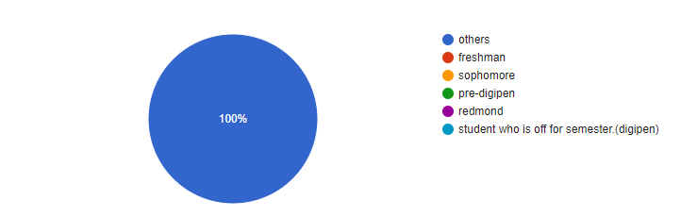Choose your Status

**Others:3**

1. How long did you play the game?

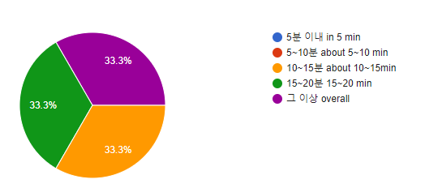

1. Do you think the way play games is easy to understand? (1:easy ~ 5:hard)

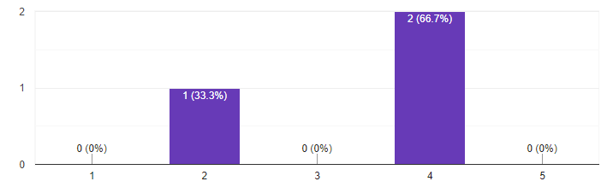**3-1)** If you chose difficult to understand in step 3, what is the reason?

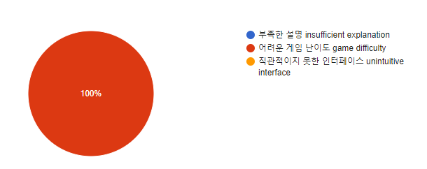

1. 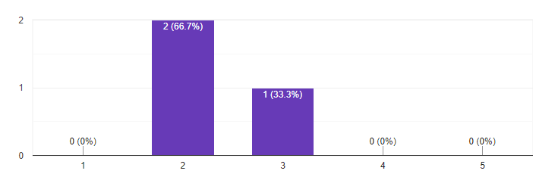Do you think the control of game playing is easy? (1:easy~5:difficult)
2. do you think the difficulty of game is enough? (1:easy~5:difficult)

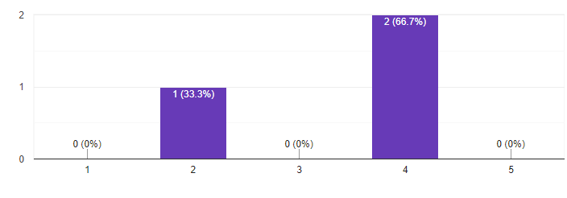

**5-1)** If you chose game was too easy in question 5, why?

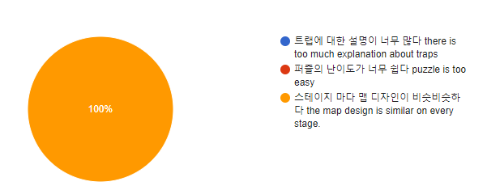

**1 person: the map design is similar on every stage**

**5-2**) If you chose game was too difficult in question 5, why?

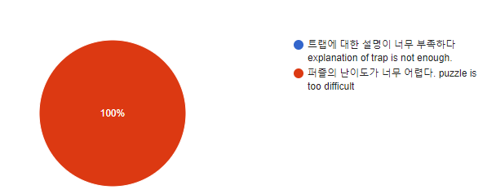

**1 person: puzzle is too difficult**

1. 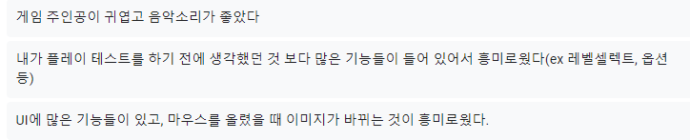If there was something interesting about the game, what is it?

**The main character was cute, and the music sounded good.**

**It was interesting because it contained more features than I thought before I did the playtest (ex: level select, options, etc.)**

**It was interesting to note that there are many features in the UI, and the image changes when the mouse is hovered.**

1. What do you think we need to improve?

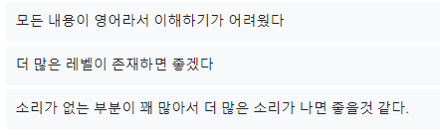

**It was difficult to understand because everything was in English**

**I wish there were more levels**

**There are quite a few parts without sound, so I think it would be better to make more sounds.**

**Playtest analysis**

1. **Unkind for people whose first language is not English**

This problem does not apply to many people, but it can be a big problem for people who are very old or very young. Since our game is a puzzle game with 'poopoo' as the main character, it is a game that everyone can enjoy. For this reason, people who are very young or very old are also targets of our game. Because some of these people may not speak English, our team should try to solve this problem. I was thinking about some way to solve this problem, and there seems to be two main solutions. The first solution I thought was to minimize the text by using as many pictures as possible when explaining the game. Using this method has the advantage that people who play games can focus more on the game and have more fun, and that people who do not know English can play with fun. And the second way is to support multiple languages ​​so that people can choose the language in the game. This way, more people will be able to enjoy the game.

1. **Unnecessary images still exist**

The second problem is that there are still unnecessary images in our game. I think this is because our game continues to collect feedback and is moving in a better direction. I think it is necessary to playtest frequently to solve this problem. Our team members, including myself, focus on production rather than playing the game, so the familiar parts of the game are overlooked even if we no longer use them. However, because play testers focus only on gameplay, they can immediately see what they don't need, so if more playtests proceed, these problems will disappear naturally.

1. **Lack of Sound Effects**

The last problem with our game right now is the lack of sound effects. When playing a game, the better the relationship between sound and game, the more players can focus on the game. However, since our game doesn't exist where there should be sound, such as UI buttons or transitions, we think players may have difficulty concentrating on the game, and a play tester actually pointed out that. To solve this problem, our team decided to have a team member who is only responsible for sound and will put the sound in places where sound is lacking. It will also fill in the shortcomings by putting questions about the sound in the upcoming playtests.