**GAM250 Playtest Report**

**Team : 99** **Project Name:** PooPooPiPe

**Date:** 6/21/20 **Project Version:** Beta(v0.0)

**Playtest Goals**

* Whether the game gave enough explanations and feedbacks which doesn’t make confusion of the player.
* Whether the play time was long enough to the player and the level design was balanced.
* Whether the theme and the concept were well matched and doesn’t gave discomfort.

**Playtest Notes**

**Test #1: Ga Yeon Park**

The play test was held at Sunday noon. The overall game playing cost much time than I thought, because she often showed confusion while playing the game. She was a play tester which was not a ‘gamer’. As our game concept is friendly and easy, I thought she would be a good play-tester.

While playing, she gave her opinion that she likes the artwork, and realizes that I drew them all. When I gave a brief information about the game theme, she showed laughter and enjoyed it. She stated that she likes silly concepts and makes her joyful. Even though she is not used to game, she said that she knows what pipe games are like, saying that she felt that she doesn’t need to get a tutorial. At first two stages, she played it smooth, with no harsh. However, after 3 levels, she showed confusion. It was the level when the trap appears. She asked me ‘what does this color pipe do?’, however, I replied that I can’t spoil that because it is one of the surprises. When playing the ‘lever’ button, then she realized what the color pipes do. She gave her opinion that it felt unfair, because there was no description but just ‘be careful’. After that level, she showed another surprising expression because there were other color pipes, which is now red. However, different from before, it was able to know before playing the ‘lever’ button, which means, the player doesn’t need to fail to know what the trap is. When playing, she said it feels like it suddenly got hard. However, liked the idea of the trap, which is very unique.

After playing the game, I gave her few questions and gave her a survey. After doing the survey, she gave her additional opinions that the level design felt unbalanced. Which means, the first few levels were easy, but suddenly got hard. Especially, the level which uses yellow pipe was quite unfair. She said she understood that it is a surprise. However, to understand the trap, the player needs to fail at least one time. She gave her opinion that the game needs to give a chance to a player to at least guess what the yellow pipe does, so they don’t need to fail the game at the first time.

**Test #2: Geonhwi Sim (geonhwi.sim@digipen.edu) – pre-digipen student**

The play test was held on Saturday( Jun, 20th ) 5:00 PM through the zoom. Her first reaction was surprised by the cuteness of the game prologue cutscene. Before main menu screen, she said the cut scene was very fun. because, the contents of the prologue cut scene harmonized well with the title of our game and imagined what to talk about in the future during the game playing. And she played the tutorial. In first tutorial, she played well with left mouse click in order to drag and fit in. because, the left click is familiar in control. However, in second tutorial, there was no explanation about rotation and right click is not familiar in control. Thus, she said she was quite uncomfortable finding out that she should use the right click to rotate. She said she will easily understand if there is the addition of a right click description.

She played the whole game from level1 to level 8, and it took her a total of 17 minutes to play the whole game. She solved the puzzle within 30 seconds per level from level1 to level4 with her interested, and she has a big fun with moving poopoo and poop dropping transition when she clear the puzzle. She looked more focused and she slowed down from level 5 that unexpected traps were hidden. I was more cautious about her reaction because from level 5, we always be pointed out with insufficient explanation. She cleared the levels by looking at the “watch the pipes with colored!” guide we added through the professor’s feedback, making various predictions and learning form failures. At the level of remote rotation, she praised the idea of remote rotation, saying it was so novel and interesting. Also, the flush button that is play button was surprised to see that was Kevin’s feedback in pre-alpha presentation.

After game playing, I got the feedback from her. She said the difficulty of the whole game is moderate and each stage becomes gradually difficult. Through this, I thought the leveling was well in the game. In game, she said prologue cut scene was interesting and attractive. She replied that cute graphics, puzzles, various traps and the right sound made the game fun. She pointed out the lack of the explanation in tutorial and she wanted to play more because the game is so fun. As for the insufficient explanation of the unexpected trap, she gave the opinion that it would have been fun to deduce, although insufficient. If the explanation of unexpected trap would be detailed, the game will be not fun enough. She thought that the current state of insufficient explanation made the game more fun.

**Test #3: Harim Kim (gkfla0310@naver.com) – sister**

PooPooPiPe's play test was held at 8 p.m. on Saturday. I met the tester in person and conducted the test, and the tester played the game right away without listening to any explanation. I recommended that you proceed with the tutorial first, but the tester pressed the play button without playing the tutorial. I was worried because I heard a lot about lack of explanation of this game, but contrary to my worries, the tester clicked the mouse a few times and figured out how to rotation and move the blocks in less than 30 seconds. When I asked if it was difficult to operate the mouse without any explanation, the tester said it was not difficult because it only needed a simple click. Also, it is very similar to other puzzle game operation that use mouse click, so she got to know it quickly. I did not think much explanation was needed for manipulation because PooPooPiPe was just a game using mouse clicks.

She played all the levels that existed in the game. It took about 20 minutes to get through all levels. At the first two levels, the game proceeded quickly without any blockages, and from the third level it took about one to two minutes. From the fifth level, a trap appears. The tester made more than three restarts to identify this trap, which took a considerable amount of time. I purposely removed the detailed description of the trap and told the tester that there was a trap and induced a restart so PooPooPiPe was going as intended. However, I received feedback that tester hope the fail-window will leave behind a time gap so that test can see how obstacles, such as auto-rotation, change after pressing the play button. Also, the more difficult the level have the longer the play time. She took about 10 minutes to play the last level, Levels 7 and 8. I was to place the levels by difficulty, so I could see that the layout worked out as intended.

We conducted a survey after all game plays were over. I provided a questionnaire and after this survey we had time to give and receive feedback. First, the weak point of the game is the lack of explanation about traps. I only told her there was a trap, and I got feedback that it would be better to give them more clues to what kind of trap it is. She also said that the sound effect was too small. The sound of the toilet falling is the fun point of the game, but she said she wanted the sound of the sound effect to be louder since it is buried in the background music. As an advantage of the game, she chose a novel idea with poo as the main character and said that the process of solving puzzles was fun. The cute graphic blends well with the theme of the game. Moreover, the tester's major is a composition, she said the background music and sound effect is good for the game. Lastly, she said that she would like to have more levels because it is a puzzle game. Overall, she said that everyone can enjoy the game.

**Test #4** **Jeongmin Son (Juhye’s brother)**

The playtest was conducted using zoom at lunchtime on Saturday, the first thing he did was to go into options and try to reduce the sound. He said it was difficult to communicate because the sound was too loud compared to my voice. I told him that our team had spent a lot of time playing the sound normally, so we still haven't gotten the ability to adjust the sound. Next, he played the tutorial, which took a long time to figure out how to do the rotation, because the tutorial doesn't have a lot of instructions. As I looked at it, I felt that the puzzle drag/drop function was more easily understood by people even if there was no explanation, but the rotation function seems to require more detailed explanation.

He played the game from start to finish, and it took about 15 minutes to pass through 8 levels. He showed a more focused expression as the time to play the game increased. In addition, when there was a level that was difficult for him to understand, he showed interest in the game by playing the previous level again using the level select function. Also, when the first Success screen appeared, he showed a happy smile. On the other hand, when a new trap came out, he seemed embarrassed. For example, if there are two levels with the same trap, it took longer for the first new trap to be used. In particular, at the level where the puzzle rotates when the button is pressed, the fail screen appeared before he knew that the puzzle was rotated. For this reason, he was struggling to understand even when he moved on to the next level. Eventually I let him know that the current levels are rotation levels when the play button is pressed. In fact, the level where the new trap is used is written as “watch the pipes with colors!” as a mini tutorial function, but I found that it is difficult to progress the game by just explaining it.

After playing the game, I asked the survey questions myself and received some feedback. He said the originality and excitement of the game character “poopoo” as an advantage, but the disadvantage was that it was difficult to play at first because of the lack of explanation in the tutorial. The last question was whether there was an element he wanted to improve, and he said it was inconvenient to press the right mouse button 5 times to reverse the puzzle. He also suggested that the game would be much more fun to play if there were more detailed explanations.

**Syllabus result (13 people)**

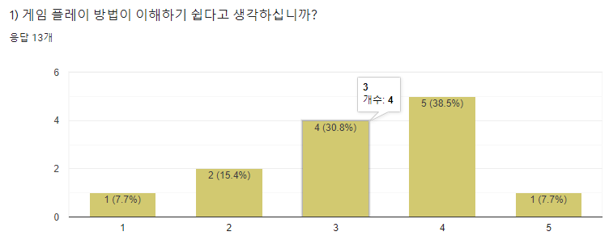

1. Was the game play was easy enough to understand?

Really easy : 1 / Easy : 2 / Middle : 4 / Hard : 5 / Too Hard 1

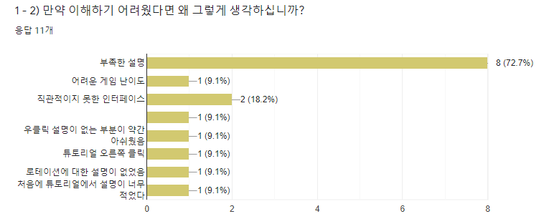

1. If it was hard to understand, why?
2. Lack of information : 8
3. Hard game level : 1
4. Unintuitive interface : 2
5. No right-click description : 1
6. No right-click tutorial : 1
7. No rotation description : 1
8. The tutorial had lack of information.

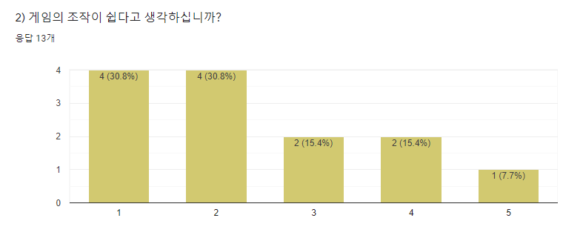

1. Do you think the game control was easy enough?

Very easy : 4 / Easy : 4 / Middle : 2 / Hard : 2 / Too hard : 1

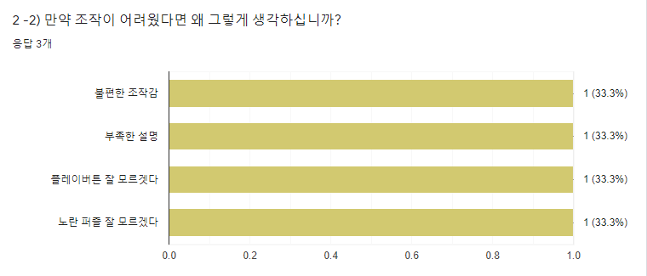

1. If you thought the control was hard, why?

1: Uncomfortable controls

2: Lack of information

3: Didn’t know the play button

4: Didn’t know what the yellow puzzle was.

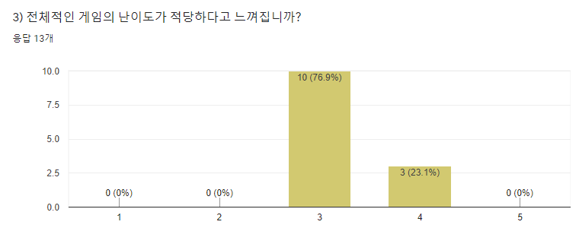

1. Do you think the difficulty of the game was good enough?

Very easy : 0 / Easy : 0 / Middle : 10 / Hard : 3 / Too hard : 0

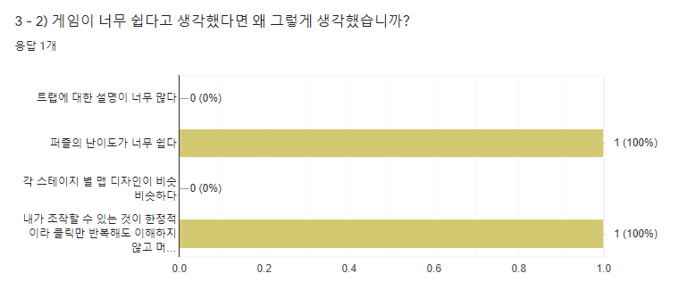

1. If you thought the game was too easy, why?

1. The puzzles were too easy

2. The controls was so limited so even just repeating clicking it could be solved : 1

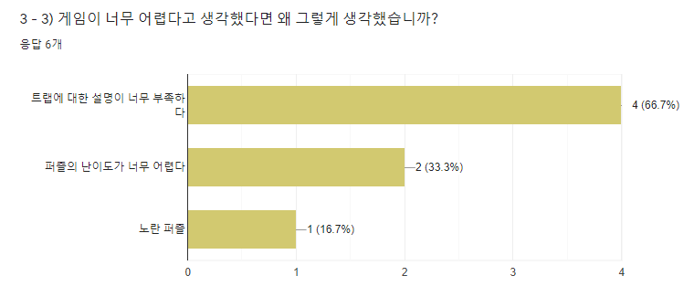

1. If you thought it was hard, why?
2. There were less trap description : 4
3. The puzzles were hard : 2
4. Yellow puzzle : 1

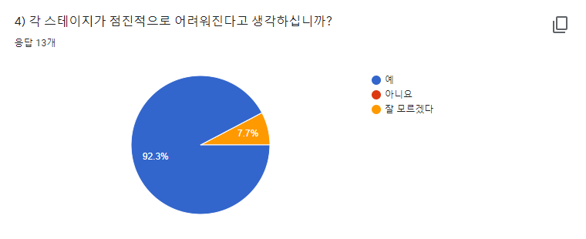

1. Do you think the stages got harder and harder?

1: Yes : 92.3 % / 2: Don’t know : 7.7%

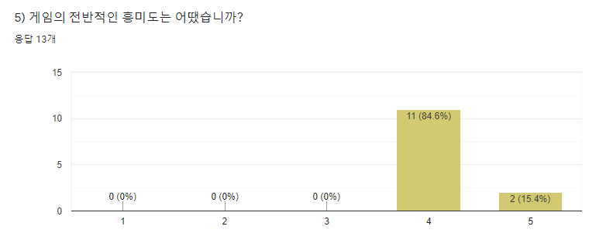

1. How was the overall interest towards the game?

Interesting : 11 / Very interesting : 2

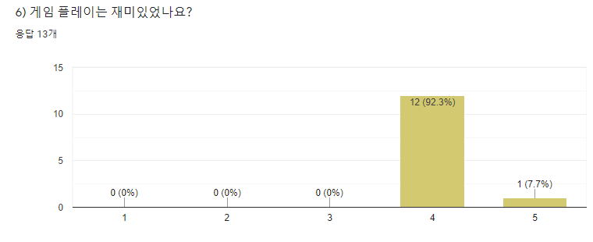

1. Was the game play enjoyable?

Enjoyable : 12 / Very enjoyable : 1

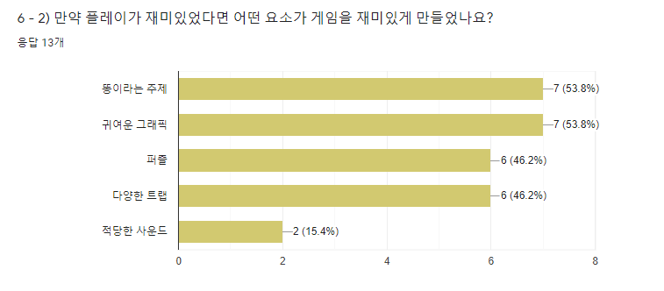

1. If you answered ‘enjoyable’, what’s the reason?
2. The poo theme : 7
3. Cute graphics : 7
4. Puzzles : 6
5. Variety of traps : 6
6. Good sounds : 2

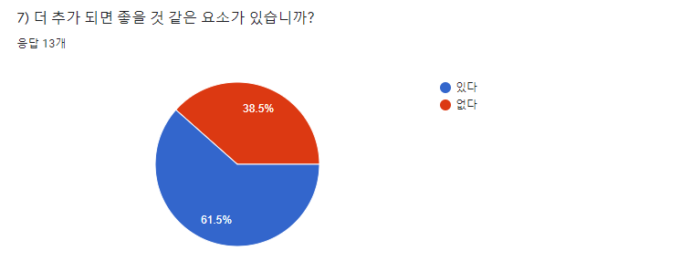

1. Do you have anything you wish to be added in the game?

Yes : 61.5% / No : 38.5%

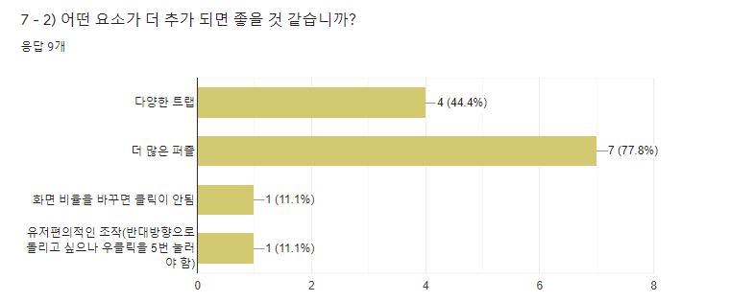

1. What things do you wish to be added?
2. More traps : 4
3. More puzzles : 7
4. When changing the resolution of the game, the click doesn’t works : 1
5. More comfortable controls (To rotate to its original form, the player needs to click extra 5 times which was uncomfortable).

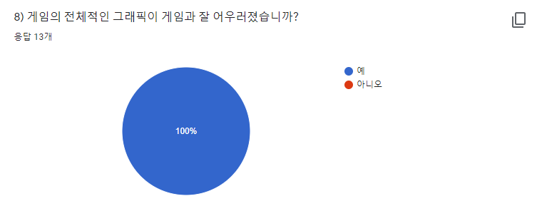

1. Was the graphics matched with the games overall theme?

Yes : 100%

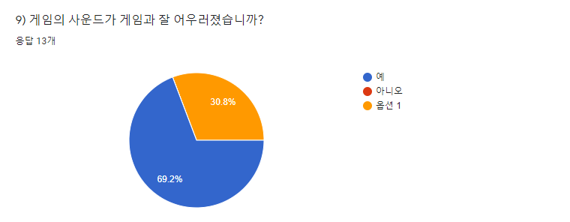

1. Was the sound matched with the overall theme?

Yes : 69.2 % / Etc : 30.8%

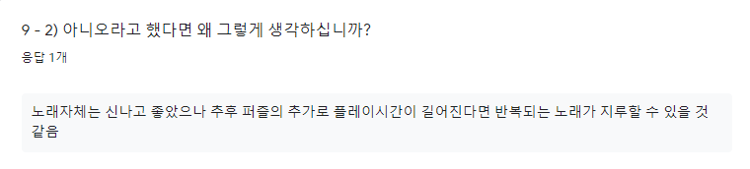

1. If you answered no, why?

The music itself was good, however, keep repeating same music could be boring enough.

**Playtest analysis**

1. **Lack of feedback and descriptions in game itself.**

By the playtest and the syllabus result, it was easy to know that the players had hard time playing our game because of the lack of feedback. Especially the yellow pipe, which is one of the traps of the game. The purpose of the ‘lack of feedback’ was to give a surprise to the players. However, after several meetings with the professor, the professor gave his opinion that the game needs to give at least a chance to guess or realize what the trap is, by its graphics, sounds, or whatever. We only distinguished the trap by its color, and add an extra text saying ‘beware of color pipes’, which is more like a warning than a description. However, we currently realized that the yellow pipe was hard to even realize after failing, because the fail image covers the puzzle, which makes the player hard to know what the yellow pipe does. The only way to realize what the yellow pipe trap does it to fail at least once. However, even after failing, the players were hard to realize. Therefore, this makes a conclusion that we need additional feedback, especially about the yellow pipe trap.

1. **It's hard to notice the trap because it's hidden in the fail scree**n.

current our game print the screen that show the failure when player fail to match the puzzles during the game playing.In the actual play test, if the player failed to match the puzzle together, the picture was printed out and the picture was large and covered the puzzle behind it. When the player presses the play button, the Auto Rotation Puzzle automatically rotates at a certain angle, and the path that player made is changed. and then, pipe connection will be fail. As a large failure screen print out large, the player is unable to determine how far the automatic rotation puzzle has rotated, which makes it impossible to know exactly why the player failed this level and how to clear it. To solve this problem, we decided to print the fail picture after a certain amount of time after the play button was pressed.

1. **lack of the description in tutorial**

In fact, while conducting the playtest, I found that players had difficulty playing games due to lack of explanations about the tutorials. Many people found that the first stage of the tutorial, the puzzle drag/drop, was easily solved, but they had a hard time in the second stage, the rotation. There were even players who couldn't solve the problem until we told them. We decided to add a more detailed explanation to the tutorial to solve this problem.In more detail, for example, the rotation section will include words such as "Click the right mouse button."